Predicting sludge generation pattern and carbon reduction potential under shared socio-economic pathways

**ABSTRACT:** China now has the world’s largest wastewater treatment capacity, but the rapid increase in sludge generation, insufficient disposal capacity, and low level of resource utilization poses a challenge to the county’s solid waste management. Resource recovery of sludge is an important tool to promote the sustainable development of the wastewater treatment industry. Predicting spatial and temporal trends in sludge generation will assist regional planning of sludge treatment and the potential reduction of carbon emissions. Data from 3495 wastewater treatment plants were used to screen sludge driving factors, and a random forest (RF) regression model was used to predict future sludge generation and associated carbon emission at the provincial level under different shared socioeconomic pathways (SSPs). The results show that urban form, economic development, urbanization level, and food consumption are the main factors influencing sludge generation, which is expected to continue its upward trend to 2060 but at a decreasing rate. Sludge generation in five alternative scenarios is predicted to reach between 1.95 and 2.41 times the 2017 level. Differentiated strategies can help reduce carbon emissions based on regional sludge generation and increasement. With the rapid growth rate in Central and Western China, the proportion of sludge continues to rise. The sludge generation should be controlled at the source by a reasonable dietary structure and urban compact development to reduce carbon emissions. While in Eastern China, with a high urbanization rate, sludge generation tends to be stable. It is necessary to further promote anaerobic digestion and improve the sludge resource treatment capacity to reduce carbon emissions. Combining anaerobic digestion and low carbon disposal methods can contribute to reduce about 50Mts CO2 -eq GHG emission of mid-century carbonreduction.

**KEYWORDS:** Sludge, Carbon emission, GeoDetector, Random Forest, Shared socioeconomic pathways

**HIGHLIGHTS:**

* Influencing factors of sludge generation in China were identified.
* Provincial-level sludge generation was forecast based on RF and SSP analysis.
* Sludge continues to grow until 2060 but at a decreasing rate.
* A differentiated GHGreduction strategy is proposed in classified sludge patterns.
* Anaerobic digestion and sludge recycling may reduce potential carbon emissions by 75%.

# Introduction

Urban wastewater treatment is a major energy-consuming sector, accounting for about 3% of global power consumption and 1.75% of greenhouse gas emissions (Lu et al., 2018; McCarty et al., 2011). The Chinese government is actively seeking to promote the sustainable development of the entire wastewater treatment industry by increasing sludge recovery (Guang et al., 2015; Jin et al., 2014). In 2017, China’s urban wastewater treatment plants (WWTPs) produced about 10.49 Mts dry sludge, compared to about 6.99 Mts in the European Union (Eurostat., 2020). Sludge generation in China since 2010 has been increasing by about 10% per year (MOHURD, 2019). Sludge treatments have been an urgent affair in China.

Sludge generation is highly related to wastewater treatments, which is a complex process, influenced by multiple factors including economic progress (Geng et al., 2014; Duarte et al., 2014; Kangkang et al., 2009), social development (Xu et al., 2019), industrial structure (Lili et al., 2019; Tiziano et al., 2018), treatment technology (Jin et al., 2014), residents' lifestyles (Xiao et al., 2020) and so on. But the degree of influence in uncertain in different regions. Thus, a comprehensive analysis of sludge driving factors is key to resolving when making projections of future sludge generation. Due to the spatial heterogeneity in population and economic development between regions, exploring the driving factors based on spatial characteristics can allow for targeted sludge management policies. Besides, predicting sludge generation and its potential for GHG emissions can plan and optimize sludge treatment capacity and find effective carbon reduction pathways.

There are currently few quantitative studies on the expected growth of sludge and associated carbon emissions in China, and data gathered by previous research varies significantly and has a limited spatial resolution. Moreover, existing studies have mostly explored a single factor influencing sludge generation, such as economics or technology (Yu et al., 2007). Simply considering the linear relationship between sludge and its influencing factors such as urbanization rate, population, or GDP (Wei et al, 2020) cannot accurately reflect the spatial differences in sludge generation and provide targeted sludge planning. As a result, the accuracy of sludge prediction is not sufficient to make targeted plans for sludge management.

Several models have been undertaken to predict waste generation (Guo et al., 2021; Younes et al., 2015; Chang et al., 2011), including regression analysis (Rimaityte et al, 2012), system dynamics (Kollikkathara et al., 2010) and autoregressive integrated moving average (Xu et al., 2013). More recently, machine learning (ML) methods have been used to predict solid waste generation with better accuracy. For example, the accuracy of the Artificial Neural Network (ANN) and Decision Tree (DT) model of predicting municipal solid waste generation is as high as 84% and 81% respectively (Kannangara et al., 2018). Support Vector Machine (SVM) and Random Forest (RF) models also had a good performance when predicting weekly municipal waste generation and plastic waste generation (Abbasi et al., 2013; Kumar et al, 2018). the socio-economicsregional-specific

This paper used nationwide plant-level data to reveal the driving factors of sludge generation by GeoDetector modeling. GeoDetector is a set of statistical methods that reveal the spatially stratified heterogeneity of features and explore the driving forces behind them (Wang et al., 2017; Wang et al., 2016), and has been widely used in spatial stratified heterogeneity analysis, for example, in the environment (Wu et al., 2016), geology (Luo et al., 2016), health (Wang et al., 2010; Huang et al., 2014) and other fields.

To eliminate the uncertainties related to future social development, scenario analysis is used to help assess environmental interactions of human activity and the effectiveness of different pollution treatment methods (Zhang et al., 2021). Shared Socioeconomic Pathways (SSPs) is a widely used framework for environmental scenario analysis (Zhang et al., 2021; Puijenbroek et al., 2019; Detlef et al., 2012; Elmar et al., 2012; Xu et al., 2019; Zhang et al., 2017; O’Neill et al., 2015), as they provide an overall framework of future social-economic growth, making it possible to compare sludge growth in different regions.

The contributions made by this article can be summarized as follows. First, we calculated sludge generation data at the prefecture-level city scale in China and explored its spatial distribution characteristics and driving factors. Second, we combined the global framework of SSPs and China's characteristics to predict future sludge generation and associated GHG emissions. Finally, by regulating the key influencing factors of sludge generation and development characteristics, we provide guidance for sludge reduction and efforts to reverse the trend of rapid sludge increase, reduce GHG emissions generated by sludge disposal, and help achieve GHG reduction targets. This paper presents a new perspective on the sludge generation pattern in China, which will help to rationally plan sludge treatment capacity and provide a scientific basis for the construction of zero-waste cities. Calculating and predicting greenhouse gas emissions in the sludge treatment process can elucidate sludge GHG emission potential and plan rational sludge GHG reduction paths.

# Data and Methods

## 2.1 Data Resources

Sludge data for urban areas were obtained from the *Chinese Statistical Yearbook* of *Urban and Rural Construction* (MOHURD, 2019) . County-level data was collected from the *2018* *Urban Drainage Statistical Yearbook*, and each treatment plant’s coordinates (longitude and latitude) were determined through Baidu Maps to identify the county where the WWTP is located. Where WWTP data was missing, we used the high positive correlation between wastewater treatment capacity and sludge generation to estimate missing data (**Fig. S2.**). The relationship between sludge generation and the quantity of wastewater treatment is given by:

(1)

Where *Ds* represents dry sludge, *F* is the flow of wastewater treatments and *s* is the conversion coefficients which were obtained from *Urban Drainage Statistical Yearbook* (**Table S1**).

Historical socio-economic data were obtained from the China City Statistical Yearbook (National Bureau of Statistics, 2020). China's gross domestic product (GDP) and population projection in the SSPs framework were based on Jiang et al. (2017 and 2018), which projected China's GDP (**Fig. S3.**) and population (**Fig. S4.**) from 2020 to 2100 based on SSP1-SSP5 scenarios and a Cobb-Douglas production function model.

## 2.2 Methods

This study used three steps to explore the driving factors of sludge generation in China and predict its future trends.

### 2.2.1 Sludge Prediction

(1) GeoDetector model

In general, sludge generation is mainly influenced by the economic level, industrial structure, social development, treatment technology, and food consumption structure. We selected nine indicators to explore the extent and the ranking of the driving forces(**Table 2**). These factors can be classified into four categories. The development of socioeconomic will stimulate the need for water use, directly contributing to the growth of sludge generation (Duarte et al., 2014; Kangkang et al., 2009; Xu et al., 2019). Urban form determines the wastewater collection area, its expansion will increase sludge generation. Household lifestyle, especially food predilection will affect the GHG emission to wastewater, leading to the increase of sludge contents (Xiao et al., 2020). In the process of wastewater treatment, different technology contributes to a different level of sludge generation rate. (Jin et al., 2014)

In view of the significant spatial variation of sludge generation in China, we used a GeoDetector model to explore the spatial heterogeneity of different sludge influencing factors and the degree of influence on sludge generation. The Factor Detector is measured by q-statistics as follows:

(2)

Where is the strata of or ; and are the number of units of whole strata and stratum respectively; and are the variance in whole strata and stratum respectively. For , a higher value of q indicates a stronger spatially stratified heterogeneity of Y. The significance of the q value was determined by an F-test Wang et al., 2017.

**Table. 2** Indicator Description

|  |  |  |
| --- | --- | --- |
| **Classification** | **Indicator** | **Source** |
| Socioeconomic | Gross domestic product (GDP) | China City Statistical Yearbook |
| Population (POP) | China City Statistical Yearbook |
| Proportion of primary industry (PPI) | China City Statistical Yearbook |
| Urbanization rate (UR) | China Statistical Yearbook |
| Urban form | Length of drainage pipeline (LDP) | China City Statistical Yearbook |
| Built-up area (BA) | China City Statistical Yearbook |
| Lifestyle | Food consumption expenditure (FCE) | China City Statistical Yearbook |
| Carbon contents of food (CCF)* | China City Statistical Yearbook |
| Technology | Reduction rate of COD (RCOD) | Urban Darainage Statistical Yearbook |

*Carbon contents of food were calculated by the formula:, F is the volume of food consumption, C is the carbon contents of specific food.

(2) Machine learning

Sludge prediction is a multivariable regression problem with sludge driving factors as the independent variables. We used SSPs and logistic growth to fit trends in the driving factors. The relationship between sludge generation and its driving factor was obtained by a Random Forest Algorithm (RFA), which is an Ensemble Learning algorithm based on a Decision Tree, and which has the advantages of high accuracy, robustness to outliers and noise, and insensitivity to overfitting(Science., 2016; Yu et al., 2021). Firstly, a few sample datasets were randomly selected from the original dataset (the training dataset in this paper was the dataset of sludge generation and its driving factors in each province from 2006 to 2017, including the seven features). Second, other out-of-bag (OOB) data were used as a test set. We used sklearn to build the model and selected hyperparameters based on Grid Search. Bootstrapping was used to avoid overfitting (Sumanta et al., 2018; Li et al., 2019). The accuracy of our model was 80.2% (MAPE) on our test set. Finally, we calculated the corresponding GHG emission of sludge disposal by multiplying sludge generation by its conversion coefficients under different disposal methods.

To distinguish different growth patterns in different regions, we used K-means to cluster China’s provinces based on sludge generation in 2060 and the ratio of sludge generation in 2060 to 2017 under different scenarios which were calculated by dividing the sludge generation in 2060 to 2017. Four future sludge growth patterns can be distinguished as a high generation with high growth (HH), high generation with low growth (HL), low generation with low growth (LL), and low generation with high growth (LH).

### 2.2.2 Scenario analysis

Scenario analysis can help assess the environmental response to human activities and the effectiveness of different pollution management methods (Zhang et al., 2021). SSPs are one of the most widely used scenario frameworks proposed by the IPCC, and provide an overall framework for future socio-economic development, making it possible to compare the characteristics of sludge changes between different regions. SSPs are a multilateral system incorporating population, economy, policy, technology, environment, and resources, and these frameworks can simulate the complexity of sludge growth and its natural and social driving factors. The SSPs contain five types of social and economic development paths: SSP1 (Sustainability), SSP2 (Middle of the road), SSP3 (Regional Rivalry), SSP4 (Inequality), and SSP5 (Fossil-fueled development) (O’Neill et al., 2015). SSPs adopt multiple elements, including population, economy, technology, environment, and resources, to model the complexity of future sludge growth and the various socio-economic factors.

The growth trend of the sludge drivers was predicted by setting different parameters of the Logistic model (the parameters under the five paths are shown in Table S2). The Logistic growth expression is:

（3）

Where *K* is the limit of growth, *P0*is the initial value (2002 was the first year in this paper), *t* is the year and *r* is the growth rate. The *K* of BA (Zheng et al., 2013), LDP, CCF, FCE, UR were all based on Logistic growth and predicted using Ordinary Least Squares (**Fig. S3. – Fig. S9.**). According to the development trend of each province, we set the corresponding growth rate *r* with growth inflection points around 2030, 2040, and 2050 (corresponding to Low, Medium, and High in the parameter settings, respectively; see **Table 3**).

**Table. 3** Overview of SSPs’ China’s characteristics.

|  |  |  |  |  |  |  |  |
| --- | --- | --- | --- | --- | --- | --- | --- |
|  | **GDP** | **BA** | **LDP** | **POP** | **CCF** | **FCE** | **UR** |
| SSP1 | Medium | Low | Low | Low | Low | Low | Low |
| SSP2 | Medium | Medium | Medium | Medium | Medium | Medium | Medium |
| SSP3 | Low | High | High | High | High | High | High |
| SSP4 | Medium | Medium | Medium | Low | Medium | Medium | Medium |
| SSP5 | High | High | High | Low | High | High | High |

*Detailed coefficients for each province were shown in Table S2

To evaluate the potential for Greenhouse Gas Emission Reduction (PGER) when implementing anaerobic digestion and improving sludge disposal methods, we defined another Low Carbon Disposal (LCD) scenario which assumed all sludge was treated with anaerobic digestion and improved disposal methods (5%, 5%, 70%, 10% for Landfill, Incineration, Land application, and Building material respectively). Compared with sludge disposal methods at present, increasing the proportion of Land application is an effective way to reduce the GHG emission of sludge treatments (Wei et al., 2020).

# Results and Discussion

## Spatial distribution of sludge generation in China

The Eastern region in China contributes to about 70 % sludge generation of China, which is significantly higher than the central and western regions. (**Fig. 1. (b)**). Most WWTPs generate 2000 to 5000 tons of sludge a year (**Fig. 1. (a)**). WWTPs with huge sludge generation (> 5000 tons a year) are concentrated in Jiangsu, Shanghai, Shandong, Henan, and Liaoning. Compared with China’s GDP distribution, sludge generation has a higher GINI coefficient (0.512) (**Fig. 1. (c)**) than GDP (0.402). Sludge tends to have greater unbalance distribution than the economy in China.

## 3.2. Regional driving factors of sludge generation

The results of factor detection showed that all nine indicators passed the significance test at the 95% confidence level in GeoDetector (**Fig. 2.**). BA and GDP had q-values of 0.654 and 0.638, respectively, and were the two most influential factors. The q-values of LDP (0.573), CCF (0.515), FCE (0.512) and POP (0.501) were all above 0.500 and had a strong driving effect on sludge generation. Urban expansion leads to an increase in the wastewater collection area, and economic and population growth leads to higher residential water consumption and more wastewater generation, which in turn leads to higher sludge generation, which is the primary cause of sludge increment.

The q-values of both CCF and FCE were greater than 0.500, indicating a very close association between the resident’s dietary habits and sludge generation. At present, China is transitioning from a diet dominated by coarse grains and carbohydrates with minimal animal-source foods to one in which reﬁned rice and wheat and animal-source foods have increased signiﬁcantly. (Li et al., 2016). The decrease in the proportion of carbonated grains can reduce the carbon content of food consumption and thus reduce sludge generation. However, China's food culture is diverse and regional food consumption habits vary greatly, with food carbon consumption being higher in the Western region (for example, consumption in the Tibetan region is higher than the 60-100 g daily carbon intake standard recommended by China's Residents’ Diet Report. A shift from a high-carbon to a low-carbon diet can slow sludge growth.

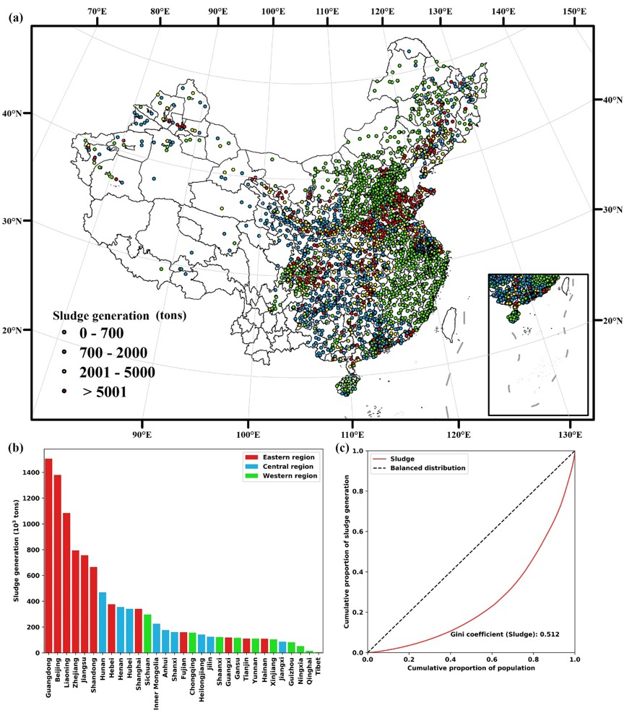

**Fig. 1．** (a) Locations of China's wastewater treatment plants and its sludge generation in 2017; (b) Sludge generation in different provinces in 2017; (c) Gini coefficient of sludge per capita in 2017 at the city level

UR (0.263) and PPI (0.162) had a relatively lower q-value. The result is consistent with (Wei et al., 2020) which indicates economic development exhibited a more significant effect on sludge generation in China. However, the effect of RCOD (which reflects the treatment technology level) was minuscule (0.065). China has a certain number of WWTP which operate with a relatively advanced treatment technology, so technological improvements can only have a limited effect on sludge generation in the future. We, therefore, selected seven factors with a q-value greater than 0.2 as the features of sludge prediction.

3.3. Sludge generation in SSP1-SSP5 scenarios

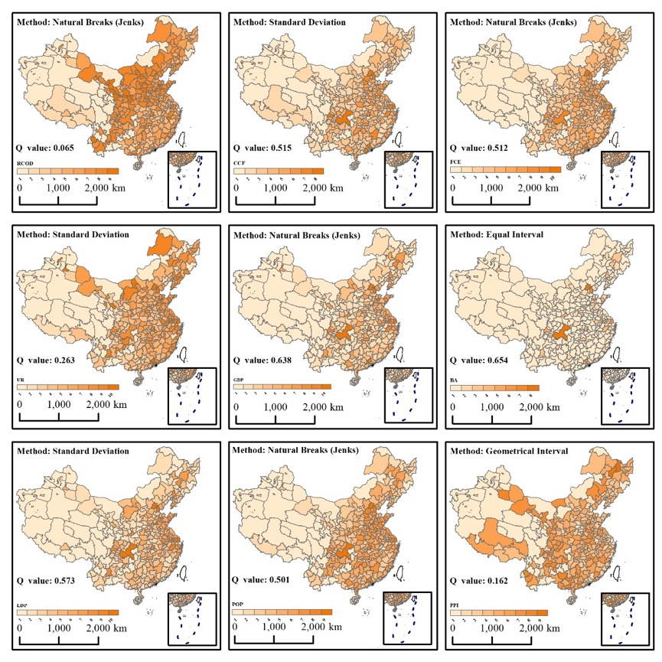

**Fig.2.** Discretization methods and q-values of sludge driving factors.

Sludge generation under different SSP scenarios has similar growth trends (**Fig. 3.**). In order to quantify the uncertainty of the prediction results, we took the upper and lower 5% intervals for the predicted independent variables, respectively, to re-predict the sludge generation. Under all SSPs, sludge continues to grow at a decreasing rate. SSP5 had the highest sludge generation in 2060 (25.25 0.6 Mts), followed by SSP3 and SSP4 (which generated 23.79 1.2 Mts and 23.12 1.3 Mts respectively) while the totals for SSP2 and SSP1 were the lowest (21.56 0.5 Mts and 20.56 0.6 Mts respectively). China’s total sludge generation in 2060 will therefore increase substantially compared to the 2017 total of 10.49 Mts. As the SSP1 scenario had the least sludge generation and lower sludge growth rate, it is a suitable development path for sludge mitigation.

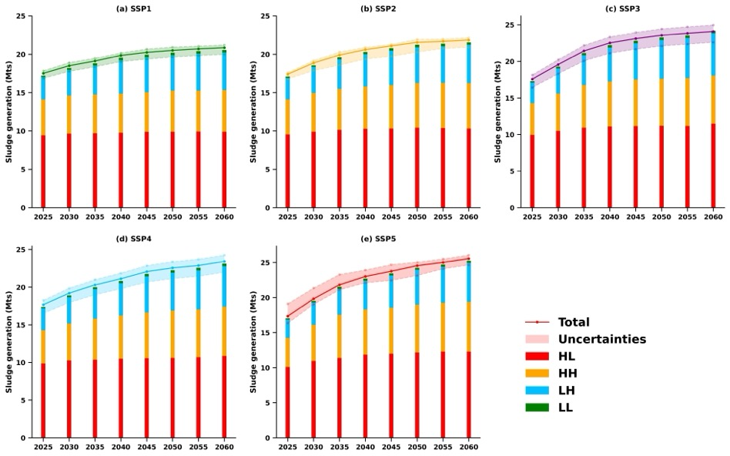

**Fig.3.** The trend of sludge generation under different scenarios.



We classified China’s sludge growth into four patterns – a high generation with high growth (HH), high generation with low growth (HL), low generation with low growth (LL), and low generation with high growth (LH). HL includes 11 provinces including Guangdong, Jiangsu, and Zhejiang, which are mainly distributed in eastern China (**Fig. 4.**). These provinces contributed 78% of total sludge generation in 2017 but only 48% in 2060 as their total generation is expected to remain stable. However, these areas are still the largest sludge contributors in China and face a severe situation of sludge reduction. For example, Zhejiang is predicted to have a small growth in sludge generation under SSP3 and SSP5 but stable generation under other scenarios. Avoiding the path dominated by regional competition (SSP3) and fossil fuels (SSP5) can reduce sludge generation by 100 to 200 Kts a year. Further reducing sludge generation from WWTPs by advanced technology is an important tool for local sludge reduction if the population and urbanization growth rate is relatively stable in HL regions.

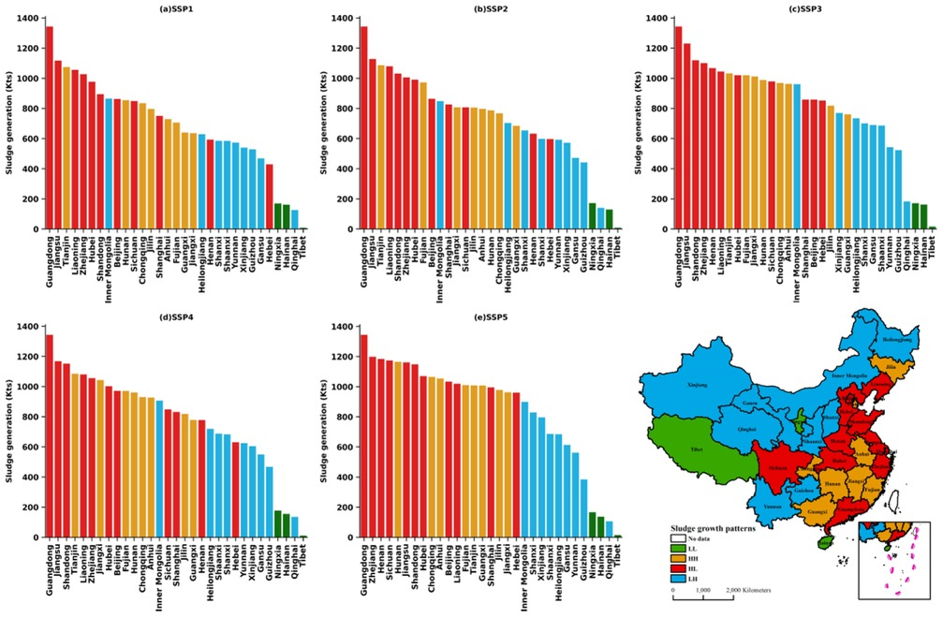

**Fig. 4.** Sludge generation in different province in 2060.

LH and HH are provinces where sludge generation is expected to increase rapidly. The contribution of sludge generation is predicted to increase from 10% and 9% in 2017 to 24% and 26% in 2060 in LH and HH respectively. Most provinces in western and northern China show this kind of trend. Under SSP3, SSP2 and SSP5, sludge grows rapidly after 2030 due to rapid economic growth and urbanization, which boosts the generation of wastewater. The rapid growth after 2030 should be the focus in terms of achieving Carbon Peak in 2030. The relatively high carbon content of food in the Midwest and the transition of residents’ dietary habits to the recommended dietary structure can reduce sludge generation at the source. Combined with the advancement of wastewater treatment technology, forming a sludge reduction path from source to end is an important means to cope with rapid sludge growth.



LL includes Tibet, Ningxia, and Hainan, which have relatively lower sludge generation. However, landfilling is the dominant disposal method in Tibet and Ningxia. Forming a waste-to-resource treatment system is a reasonable direction for sludge management in LL regions.



## 3.4. Greenhouse gas emissions from sludge disposal

In 2017, 29.67 Mts CO2 -eq would be released from sludge if they were treated without Anaerobic Digestion (AD), a contribution of 0.3% to total GHG emissions in China (**Fig. 5.**). Landfill, incineration, land application, and building material generated 9.68 Mts, 10.57 Mts, 1.25 Mts, and 8.17 Mts CO2 -eq respectively. 9.67 Mts CO2 -eq would be released from sludge disposal if they were generated with AD, and the other four disposal methods would generate 2.76 Mts, 7.23 Mts, 0.86 Mts, and 1.18 Mts respectively. The total potential of greenhouse gas emission reduction (PGER) can reach up to 17.64 Mt CO2 -eq, 6.92 Mts, 3.34 Mts, 0.39 Mts and 6.99 Mts from the respective disposal methods. AD contributes 59.5% GHG reduction from sludge treatment. At the provincial level, Guangdong, Zhejiang, and Jiangsu ranked in the top three for PGER, at 3.45 Mts, 1.72 Mts, and 1.61 Mts respectively, compared to just 0.02 Mts and 0.04 Mts CO2 -eq in Qinghai and Hainan respectively. Other provinces ranged from 0.05 to 1.45 Mts (**Fig. 5.**).

**Fig.5.** Greenhouse gas emission from sludge disposals under different provinces in 2017.

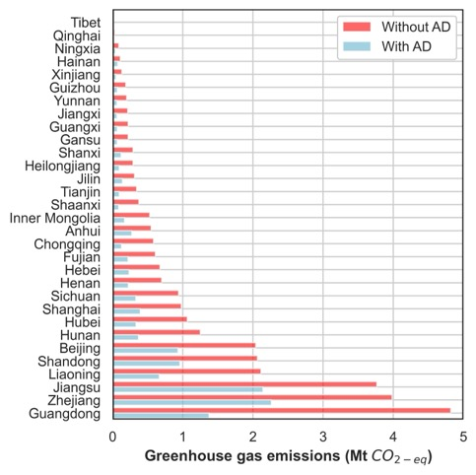

Fig. 6. illustrates GHG emissions from sludge treatment and disposal under the five SSP pathways. GHG emissions will increase under all five pathways, with growth rates ranging from 10% to 50%. The sludge disposal method is an important factor affecting GHG emissions. Landfills not only consume many land resources but also have potential damage to groundwater and can affect human health. Therefore, this disposal method will be restricted in the future. Incineration leads to a large number of GHG emissions, but at present, about 15% of sludge is still treated and incinerated directly. The use of sludge for building materials requires incineration treatment, which also has the disadvantage of wasting the chemical elements in sludge (Jin et al., 2014). Land application, such as composting, will be an important method of sludge resource utilization in the future and can reduce GHG emissions from sludge disposal by more than 90% compared to incineration.

## 3.5. Policy Implications

Currently, landfill, incineration, land application, and building material account for about 55%, 15%, 20%, and 10% of sludge disposal in China respectively, with significant regional variations (Wei et al., 2020). To ameliorate the rapid growth of GHG emissions from sludge treatments, different strategies should be implemented. In the mainly LH regions in the central and western regions of China, about 80% of sludge is ended up in landfill sites. As sludge generation rises, another disposal capacity should be enhanced. With the rapid growth rate, the sludge generation should be controlled at the source by a reasonable dietary structure and urban compact development to reduce GHG emissions.

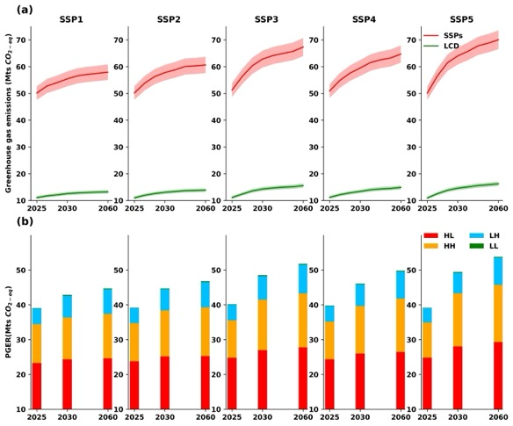

**Fig.6.** (a) Greenhouse gas emission from sludge disposals under different scenarios (SSPs– Without Anaerobic digestion and improved disposal methods, LCD – low carbon development, 5% uncertainty were shown). (b) Potential GHG emission reduction in different area.

**Table. 3** Required prevalence of AD in 2060 to achieve no change in sludge GHG emissions from 2017 (stable sludge GHG emissions in LL will require additional measures)

|  |  |  |  |  |
| --- | --- | --- | --- | --- |
|  | **HH (%)** | **HL (%)** | **LH (%)** | **LL (%)** |
| SSP1 | 18 | 41 | 67 | / |
| SSP2 | 29 | 55 | 79 | / |
| SSP3 | 38 | 74 | 92 | / |
| SSP4 | 30 | 64 | 91 | / |
| SSP5 | 44 | 84 | 96 | / |

# 4.Conclusions

To provide a picture of sludge generation and its GHG emissions in China, this paper expanded on existing research to forecast sludge generation in 30 provinces until 2060. The high spatial resolution means that the results should provide an accurate picture of future sludge generation and GHG emission reduction potential.

The main conclusions of this study are as follows. (1) Under the SSP5 pathway, sludge generation will reach 25.25 0.6 Mts in 2060 compared to 10.49 Mts in 2017, and the resulting 70.04 Mts CO2-eq will make it more difficult to achieve GHG emission reduction targets. However, under the SSP1 scenario, the GHG emission can be controlled at about 20 Mts if the sludge is treated by AD, which is most favorable for sludge and GHG emission reduction. (2) Sludge growth trends in different regions of China can be divided into four patterns, with the central and western, and northern regions having greater urbanization potential and higher sludge growth rates. Combining lower-carbon eating habits and improvements to wastewater treatment technologies to reduce sludge generation and form a sludge reduction path from source to end will be an important means to reverse the trend of rapid sludge growth. (3) Improving land application in sludge disposal and popularizing AD disposal technology (LCD scenario) have a reduction potential of up to 50 Mts CO2-eq or more and are important means of GHG reduction in areas where sludge reduction is difficult, such as areas with high economic development and rapid growth in water demand. (4) In order to reverse the increasing trend of sludge GHG emission, HH, HL, LH, and LL regions will have different priorities for local AD and improvement of sludge disposal. LL provinces must improve sludge disposal methods to reduce GHG emissions, whereas HH, HL, and LH provinces require greater use of AD while the sludge disposal method remains unchanged.

**References**

Atul Kumar,S.R. Samadder,Nitin Kumar & Chandrakant Singh.(2018).Estimation of the generation rate of different types of plastic wastes and possible revenue recovery from informal recycling. *Waste Management*. doi:10.1016/j.wasman.2018.08.045.

Basu Sumanta,Kumbier Karl,Brown James B & Yu Bin.(2018).Iterative random forests to discover predictive and stable high-order interactions.. Proceedings of the National Academy of Sciences of the United States of America(8). doi:10.1073/pnas.1711236115.

Bo Li,Zhang-Tao Fan,Xiao-Long Zhang,De-Shuang Huang. Robust dimensionality reduction via feature space to feature space distance metric learning[J]. Neural Networks,2019,112.

China Urban Water Supply and Drainage Association(2019).2018 Urban Drainage Statistical Yearbook.China Urban Water Association. (in Chinese)

National Bureau of Statistics.(2020). China Statistical Yearbook. <http://www.stats.gov.cn>

Chinese Nutrition Society.(2021).The Chinese Dietary Guidelines. Chinese Nutrition Society.

Da Zhang,Qingxu Huang,Chunyang He & Jianguo Wu.(2017).Impacts of urban expansion on ecosystem services in the Beijing-Tianjin-Hebei urban agglomeration, China: A scenario analysis based on the Shared Socioeconomic Pathways. Resources, Conservation & Recycling. doi:10.1016/j.resconrec.2017.06.003.

Detlef P. van Vuuren,Marcel T.J. Kok,Bastien Girod,Paul L. Lucas & Bert de Vries.(2012).Scenarios in Global Environmental Assessments: Key characteristics and lessons for future use. Global Environmental Change(4). doi:10.1016/j.gloenvcha.2012.06.001.

Duarte,Pinilla & Serrano.(2014).Looking backward to look forward: water use and economic growth from a long-term perspective. Applied Economics(2). doi:10.1080/00036846.2013.844329.

Elmar Kriegler,Brian C. O’Neill,Stephane Hallegatte,Tom Kram,Robert J. Lempert,Richard H. Moss & Thomas Wilbanks.(2012).The need for and use of socio-economic scenarios for climate change analysis: A new approach based on shared socio-economic pathways. Global Environmental Change(4). doi:10.1016/j.gloenvcha.2012.05.005.

Eurostat.(2020).[https://ec.europa.eu/eurostat/data/database?node_code%C2%BCten00030[DB/OL]](https://ec.europa.eu/eurostat/data/database?node_code%C2%BCten00030%5bDB/OL%5d0)

Hao-nan Guo,Shu-biao Wu,Ying-jie Tian... & Hong-tao Liu.(2021).Application of machine learning methods for the prediction of organic solid waste treatment and recycling processes: A review. Bioresource Technology. doi:10.1016/j.biortech.2020.124114.

Huang Jixia et al. Identification of health risks of hand, foot and mouth disease in China using the geographical detector technique.[J]. International journal of environmental research and public health, 2014, 11(3) : 3407-23.

Huimin Li,Tong Wu,Xiao Wang & Ye Qi.(2016).The Greenhouse Gas Footprint of China's Food System: An Analysis of Recent Trends and Future Scenarios. Journal of Industrial Ecology(4). doi:10.1111/jiec.12323.

Ingrida Rimaitytė,Tomas Ruzgas,Gintaras Denafas... & Dainius Martuzevicius.(2012).Application and evaluation of forecasting methods for municipal solid waste generation in an eastern-European city. Waste Management & Research(1). doi:10.1177/0734242X10396754.

JingFeng Wang, ChengDongXu.(2017).Geodetector: Theory and Perspectives[J].Acta Geographica Sinica. (in Chinese)

Jin-Feng Wang,Tong-Lin Zhang & Bo-Jie Fu.(2016).A measure of spatial stratified heterogeneity. Ecological Indicators. doi:10.1016/j.ecolind.2016.02.052.

Jin-Feng Wang,Xin-Hu Li,George Christakos... & Xiao-Ying Zheng.(2010).Geographical Detectors-Based Health Risk Assessment and its Application in the Neural Tube Defects Study of the Heshun Region, China. International Journal of Geographical Information Science(1). doi:10.1080/13658810802443457.

Jin Yu Pan.(2020). Research on the development trend and influencing factors of China's economy under the path of shared social economy. Nanjing University of Information Engineering.(in Chinese)

Kangkang Gu,Jingshuang Liu & Yang Wang.(2009).Relationship between economic growth and water environmental quality of Anshan city in Northeast China. Chinese Geographical Science(1). doi:10.1007/s11769-009-0017-0.

Liangliang Wei,Fengyi Zhu,Qiaoyang Li... & Shunwen Bai.(2020).Development, current state and future trends of sludge management in China: Based on exploratory data and CO 2 -equivaient emissions analysis. Environment International. doi:10.1016/j.envint.2020.106093.

Lilai Xu,Peiqing Gao,Shenghui Cui & Chun Liu.(2013).A hybrid procedure for MSW generation forecasting at multiple time scales in Xiamen City, China. Waste Management(6). doi:10.1016/j.wasman.2013.02.012.

Lili Ding,Zhanlei Lv,Meng Han... & Wei Wang.(2019).Forecasting China's wastewater discharge using dynamic factors and mixed-frequency data. Environmental Pollution(Pt 1). doi:10.1016/j.envpol.2019.113148.

Lingyun Jin,Guangming Zhang & Huifang Tian.(2014).Current state of sewage treatment in China. Water Research. doi:10.1016/j.watres.2014.08.014.

LiShan Xiao，Lin Chen，Shinichiro Nakamura.(2020).Tracing the consumption origins of wastewater and sludge for a Chinese city based on waste input-output analysis.. Environmental science & technology. doi:10.1021/acs.est.0c01517.

Lu Lu,Jeremy S. Guest,Catherine A. Peters... & Zhiyong Jason Ren.(2018).Wastewater treatment for carbon capture and utilization. Nature Sustainability(12). doi:10.1038/s41893-018-0187-9.

P.J.T.M. van Puijenbroek,A.H.W. Beusen & A.F. Bouwman.(2019).Global nitrogen and phosphorus in urban waste water based on the Shared Socio-economic pathways. Journal of Environmental Management. doi:10.1016/j.jenvman.2018.10.048.

McCarty Perry L,Bae Jaeho & Kim Jeonghwan.(2011).Domestic wastewater treatment as a net energy producer--can this be achieved?. Environmental science & technology(17). doi:10.1021/es2014264.

Miyuru Kannangara,Rahul Dua,Leila Ahmadi & Farid Bensebaa.(2018).Modeling and prediction of regional municipal solid waste generation and diversion in Canada using machine learning approaches. Waste Management. doi:10.1016/j.wasman.2017.11.057.

MOHURD, 2019. Chinese Statistical Yearbook of Urban and Rural Construction (In Chinese), <http://www.mohurd.gov.cn/xytj/tjzljsxytjgb/jstjnj>.

Naushad Kollikkathara,Huan Feng & Danlin Yu.(2010).A system dynamic modeling approach for evaluating municipal solid waste generation, landfill capacity and related cost management issues. Waste Management(11). doi:10.1016/j.wasman.2010.05.012.

Ni-Bin Chang,Ana Pires & Graça Martinho.(2011).Empowering Systems Analysis for Solid Waste Management: Challenges, Trends, and Perspectives. Critical Reviews in Environmental Science and Technology(16). doi:10.1080/10643381003608326.

O’Neill Brian C.,Kriegler Elmar,Ebi Kristie L.,Kemp Benedict Eric,Riahi Keywan,Rothman Dale S.... & Solecki William.(2014).The roads ahead: Narratives for shared socioeconomic pathways describing world futures in the 21st century. Global Environmental Change. doi:10.1016/j.gloenvcha.2015.01.004.

Rina Wu,Jiquan Zhang,Yuhai Bao & Feng Zhang.(2016).Geographical Detector Model for Influencing Factors of Industrial Sector Carbon Dioxide Emissions in Inner Mongolia, China. Sustainability(2). doi:10.3390/su8020149.

Science. (2016). Researchers from University of Aegean Discuss Findings in Applied Geoscience (Urban land cover thematic disaggregation, employing datasets from multiple sources and RandomForests modeling). Science Letter.

Second National Communication on Climate Change of the People’s Republic of China; Climate Change Division of National Development and Reform Commission of the People’s Republic of China, China Economic Press: Beijing, China, 2013.(in Chinese)

Tiziano Distefano & Scott Kelly.(2017).Are we in deep water? Water scarcity and its limits to economic growth. Ecological Economics. doi:10.1016/j.ecolecon.2017.06.019.

Tong Jiang., et al.(2017).IPCC Predicting population change in China and sub-provinces under shared socio-economic pathways. Advances in Climate Change Research. (in Chinese).

Tong Jiang., et al.(2018).Projections of economic changes in China and sub-provinces under shared socio-economic pathways[J] . Advances in Climate Change Research. (in Chinese).

Wei Luo,Jaroslaw Jasiewicz,Tomasz Stepinski... & Xuezhi Cang.(2016).Spatial association between dissection density and environmental factors over the entire conterminous United States. Geophysical Research Letters(2). doi:10.1002/2015GL066941.

XinQI Zheng et al.(2013).The Limiting Scale of Urban Land Growth in China.China Population, Resources and Environment. (in Chinese).

Xu Xiaocong and Zhang Yuanying and Chen Yimin.(2020).Environmental Management; Findings from Sun Yat-sen University Provide New Insights into Environmental Management (Projecting China's future water footprint under the shared socio-economic pathways). Ecology Environment & Conservation.

Yan Ru Fang,Songbo Li,Yixuan Zhang & Guang Hui Xie.(2019).Spatio-temporal distribution of sewage sludge, its methane production potential, and a greenhouse gas emissions analysis. Journal of Cleaner Production(C). doi:10.1016/j.jclepro.2019.117895.

Yang Guang，Zhang Guangming，Wang Hongchen，Current state of sludge production， management， treatment and disposal in China[J]，Water research，2015， 78:60-73.

Yang Xu,Anastacia Rochelle Naidoo,Xu-Feng Zhang & Xiang-Zhou Meng.(2019).Optimizing sampling strategy for Chinese National Sewage Sludge Survey (CNSSS) based on urban agglomeration, wastewater treatment process, and treatment capacity. Science of the Total Environment(C). doi:10.1016/j.scitotenv.2019.133998.

Yong Geng,Meiling Wang,Joseph Sarkis... & Huijuan Dong.(2014).Spatial-temporal patterns and driving factors for industrial wastewater emission in China. Journal of Cleaner Production. doi:10.1016/j.jclepro.2014.04.047.

Younes Mohammad K,Nopiah Z M,Basri N E Ahmad... & Maulud K N A.(2015).Prediction of municipal solid waste generation using nonlinear autoregressive network.. Environmental monitoring and assessment(12). doi:10.1007/s10661-015-4977-5.

Yu Fubo,Wei Changhong,Deng Peng,Peng Ting & Hu Xiangang.(2021).Deep exploration of random forest model boosts the interpretability of machine learning studies of complicated immune responses and lung burden of nanoparticles.. Science advances(22). doi:10.1126/SCIADV.ABF4130.

Yu, J.; Tian, N.; Wang, K.; Ren, Y. Analysis and discussion of sludge disposal and treatment of sewage treatment plants in China. Chin. J. Environ. Eng. 2007, 1, 5.

Zhang Xiaoxin,Yi Yujun,Yang Ying,Liu Hongxi & Yang Zhifeng.(2021).Modelling phosphorus loading to the largest shallow lake in northern China in different shared socioeconomic pathways. Journal of Cleaner Production. doi:10.1016/J.JCLEPRO.2021.126537.