**Predicting sludge generation patterns and carbon reduction potential n China: a Shared Socio-economic Pathways scenario analysis**

**ABSTRACT:**

Sludge management accounts for a large share of economic costs and energy consumption in wastewater treatment and has become an important challenge for urban sustainability. Accurately predicting regional sludge generation by incorporating spatial characteristics to find carbon reduction potential can help improve the sustainability of wastewater treatment and formulate tailored mitigation strategies. This is especially true in China, which along with the world’s largest wastewater treatment capacity, also faces rapid growth in sludge generation, insufficient disposal capacity, and low recycling rates. In this study, data from 3,495 wastewater treatment plants were used to screen sludge driving factors in 338 Chinese cities, and a random forest regression model was used to predict future sludge generation and associated carbon emissions at the provincial level under Shared Socio-economic Pathways (SSPs). The results show that urban form, economic development, and food consumption are the major factors influencing sludge generation, which is expected to be between 1.95 and 2.41 times the 2017 level by 2060 in the five SSP scenarios. As regional sludge generation and rates of increase vary, differentiated strategies can help reduce carbon emissions. In Central and Western China, it may be possible to control sludge generation at the source given expected changes in dietary structure and urban compact development change, while in Eastern China greater use of anaerobic digestion and sludge-to-resource treatment may be more effective. Combining anaerobic digestion and low carbon disposal methods could reduce about 50 Mts GHG emissions in China in 2060.

**KEYWORDS:** Sludge Management; Carbon Reduction Potential; Driving forces; Machine Learning; Shared Socioeconomic Pathways

# HIGHLIGHTS:

* Urban form, GDP, and food consumption are major factors affecting sludge generation.
* RF and SSPs forecast a declining growth in provincial sludge generation to 2060.
* GHG reduction strategies should be based on regional sludge patterns.
* Anaerobic digestion and sludge recycling may reduce potential carbon emissions by 75%.

# Introduction

Urban wastewater treatment is a major energy-consuming sector, accounting for about 3% of global power consumption and 1.75% of greenhouse gas emissions(Lu et al., 2018; McCarty et al., 2011). Sludge management accounts for a large share in operation cost, energy consumption, and environmental emission in wastewater treatment, and become a challenge for urban sustainability (Arias et al., 2021; Corominas et al., 2013). The wastewater treatment industry is actively seeking ways to promote sustainable development by increasing sludge recovery and carbon utilization (Jin et al., 2014; Lu et al., 2018; Yang et al., 2015). With the world’s largest wastewater treatment capacity, China’s produced about 10.49 Mts dry sludge in 2017, 1.5 times higher than that in the European Union (Eurostat., 2020). Sludge generation in China has been increasing by more than 10% per year since 2010 (MOHURD, 2019), significantly faster than the rate of economic development. Landfill accounts for 55% of sludge treatment nationwide but will be not a favored solution in the future due to the adoption of the zero-waste city strategy and Chinese Law on the Prevention and Control of Environmental Pollution by Solid Wastes. As the water content of landfill sludge was required to be less than 60% after 2007 (MOHURD, 2007), a large amount of landfilled sludge cannot meet requirements and is disposed of improperly (Yang et al., 2015). Sludge-to-resource (land application and building material) currently account for only 30% of sludge treatment (Wei et al., 2020). With rapid sludge generation, insufficient disposal capacity, and a low recycling rate, sludge treatment poses a great challenge for urban environmental management in China.

Sludge generation is closely related to wastewater treatment, which is a complex process influenced by economic development (Duarte et al., 2014; Geng et al., 2014; Gu et al., 2009), economic structure (Ding et al., 2019; Distefano and Kelly, 2017), social development (Xu et al., 2019), treatment technology (Jin et al., 2014), resident lifestyles (Xiao et al., 2020) and so on. Due to the existence of significant regional differences, a better understanding of the factors driving sludge production can allow for targeted sludge management policies. Predicting sludge generation and its potential for GHG emissions can help to optimize sludge treatment capacity and find effective carbon reduction pathways.

Few studies have so far attempted to predict the growth of sludge and associated carbon emissions in China, and sludge generation data presented in previous research varies significantly and has a limited spatial resolution. Moreover, existing studies have mostly explored a single factor influencing sludge generation, such as economics or technology (Yu et al., 2007). Simple estimates of linear relationships between sludge generation and urbanization rate, population, or GDP cannot accurately reflect spatial differences in sludge generation or provide targeted sludge planning (Wei et al., 2020). Several models have been used to predict waste generation (Chang et al., 2011; Guo et al., 2021; Younes et al., 2015), including regression analysis (Rimaitytė et al., 2012), system dynamics (Kollikkathara et al., 2010) and autoregressive integrated moving average (Xu et al., 2013). More recently, machine learning (ML) methods have been used to predict solid waste generation with better accuracy and spatial resolution. For example, the accuracy of the Artificial Neural Network (ANN) and Decision Tree (DT) model for predicting municipal solid waste generation is as high as 84% and 81% respectively (Kannangara et al., 2018). Support Vector Machine (SVM) and Random Forest (RF) models also had a good performance when predicting weekly municipal waste and plastic waste generation (Kumar et al., 2018). Due to the high level of regional diversity within China, incorporating regional-specific parameters will improve model accuracy and inform regional sludge planning.

This paper used nationwide plant-level data to reveal the driving factors of sludge generation by GeoDetector modeling. GeoDetector is a set of statistical methods that reveal the spatially stratified heterogeneity of features and explore the driving forces behind them (Wang et al., 2010, 2016), and has been widely used in environment (Wu et al., 2016), geology (Luo et al., 2016), health (Huang et al., 2014; Wang et al., 2010) and other fields.

To eliminate the uncertainties related to future social development, scenario analysis is often used to help assess environmental interactions of human activity and the effectiveness of different pollution treatment methods (Zhang et al., 2021). Shared Socio-economic Pathways (SSPs) is a widely-used framework for environmental scenario analysis (Kriegler et al., 2012; O’Neill et al., 2017; van Puijenbroek et al., 2019; van Vuuren et al., 2012; Zhang et al., 2017, 2021) Xu et al., 2019, as they provide an overall framework of future social-economic growth, making it possible to compare sludge growth in different regions.

The contributions made by this article can be summarized as follows. First, we calculated sludge generation data at the prefecture-level city scale in China and explored its spatial distribution characteristics and driving factors. Second, we combined the global framework of SSPs and China's characteristics to predict future sludge generation and associated GHG emissions in provincial level. Finally, by regulating the key influencing factors of sludge generation and development characteristics, we provide guidance for sludge reduction and efforts to reverse the trend of rapid sludge increase, reduce GHG emissions generated by sludge disposal, and help achieve GHG reduction targets. This paper presents a new perspective on the sludge generation pattern in China, which will help to rationally plan sludge treatment capacity and provide a scientific basis for the construction of zero-waste cities. Calculating and predicting greenhouse gas emissions in the sludge treatment process can elucidate sludge GHG emission potential and plan rational sludge GHG reduction paths.

# Methods

## 2.1 Data Sources

Sludge data for urban areas were obtained from the *Chinese Statistical Yearbook* of *Urban and Rural Construction* (MOHURD, 2019). County-level data were collected from the *2018* *Urban Drainage Statistical Yearbook* *(Sludge generation in 2017)*, and each treatment plant’s coordinates (longitude and latitude) were determined through Baidu Maps to identify the county where the wastewater treatment plant (WWTP) was located (**Fig. S1.**). The high positive correlation between wastewater treatment capacity and sludge generation was used to estimate missing data (**Fig. S2.**). The relationship between sludge generation and the quantity of wastewater treatment is given by:

(1)

Where *Ds* represents dry sludge, *F* is the flow of wastewater treatments and *s* is the conversion coefficients which were obtained from *Urban Drainage Statistical Yearbook* (**Table S1**).

Historical socio-economic data were obtained from the China City Statistical Yearbook (National Bureau of Statistics, 2020). China's gross domestic product (GDP) and population projection in the SSPs framework were based on Jiang et al. (2017 and 2018), which projected China's GDP (**Fig. S3.**) and population (**Fig. S4.**) from 2020 to 2100 based on SSP1-SSP5 scenarios and a Cobb-Douglas production function model.

## 2.2 Methods

This study used three steps to explore the driving factors of sludge generation in China and predict its future trends. First, we used the GeoDetector model to identify driving factors of sludge generation. Second, we combined the Shared Socio-economic Pathways SSP1-SSP5 with China's development characteristics to forecast sludge generation and GHG emission potential by Random Forest. Finally, to understand the sludge growth patterns in different regions, we used K-means to cluster the sludge growth rate with annual sludge generation and classified the future sludge growth patterns in China into four categories. A Low Carbon Disposal (LCD) development scenario was developed to evaluate the potential reduction of GHG emissions from sludge treatment.

### 2.2.1 Sludge Prediction

(1) GeoDetector model

Sludge generation is mainly influenced by socio-economic development, industrial structure, treatment technology, and food consumption structure. We selected nine indicators to explore the driving forces (**Table 1**); these factors can be classified into four categories. Socio-economic development will stimulate the need for water use and so directly contribute to sludge generation (Duarte et al., 2014; Gu et al., 2009; Xu et al., 2019). Urban form determines the wastewater collection area and its expansion also increases sludge generation. Household lifestyles, and especially food preferences, will affect the carbon content of wastewater, leading to an increase in sludge content (Xiao et al., 2020). Different wastewater treatment technologies contribute to different levels of sludge generation (Jin et al., 2014).

In view of the significant spatial variation of sludge generation in China, we used a GeoDetector model to explore the spatial heterogeneity of different sludge influencing factors and the degree of influence on sludge generation. The Factor Detector is measured by q-statistics as follows:

(2)

Where is the strata of or ; and are the number of units of whole strata and stratum respectively, and and are the variance in whole strata and stratum respectively. For , a higher value of q indicates a stronger spatially stratified heterogeneity of Y. The significance of the q value was determined by an F-test (Wang et al., 2017).

**Table 2.** Indicator Description

|  |  |  |
| --- | --- | --- |
| **Classification** | **Indicator** | **Source** |
| Socioeconomic | Gross domestic product (GDP) | China City Statistical Yearbook |
| Population (POP) | China City Statistical Yearbook |
| Proportion of primary industry (PPI) | China City Statistical Yearbook |
| Urbanization rate (UR) | China Statistical Yearbook |
| Urban form | Length of drainage pipeline (LDP) | China City Statistical Yearbook |
| Built-up area (BA) | China City Statistical Yearbook |
| Lifestyle | Food consumption expenditure (FCE) | China City Statistical Yearbook |
| Carbon contents of food (CCF)* | China City Statistical Yearbook |
| Technology | Reduction rate of COD (RCOD) | Urban Drainage Statistical Yearbook |

*Carbon contents of food were calculated by the formula, where F is the volume of food consumption and C is the carbon content of specific foods.

(2) Machine learning

Sludge prediction is a multivariable regression problem with driving factors as the independent variables. We used SSPs and logistic growth to fit trends in the driving factors, and the relationship between sludge generation and its driving factor was obtained by a Random Forest Algorithm (RFA). An Ensemble Learning algorithm based on a Decision Tree has the advantages of high accuracy, robustness to outliers and noise, and insensitivity to overfitting (Gounaridis and Koukoulas, 2016; Yu et al., 2021). Firstly, a few sample datasets were randomly selected from the original dataset (the training dataset in this paper was the dataset of sludge generation and its driving factors in each province from 2006 to 2017, including the seven features). Second, other out-of-bag (OOB) data were used as a test set. We used sklearn to build the model and tuned hyperparameters based on Grid Search and Cross Validation. Bootstrapping was used to avoid overfitting (Basu et al., 2018)( Li et al., 2019). The accuracy of our model was 84.54% (R2) on our test set which was significantly than our linear regression model (ElasticNet R2: 50.88%). Finally, we calculated the corresponding GHG emission from sludge disposal by multiplying sludge generation by conversion coefficients under different disposal methods.

To distinguish different growth patterns in different regions, we used K-means to cluster China’s provinces based on sludge generation in 2060 and the ratio of sludge generation in 2060 to 2017 under different scenarios, which were calculated by dividing the sludge generation in 2060 by sludge generation in 2017. Four future sludge growth patterns were distinguished: high generation with high growth (HH), high generation with low growth (HL), low generation with low growth (LL) and low generation with high growth (LH).

### 2.2.2 Scenario analysis

Scenario analysis can help assess the environmental response to human activities and the effectiveness of different pollution management methods (Zhang et al., 2021). SSPs are one of the most widely used scenario frameworks proposed by the IPCC, and provide an overall framework for future socio-economic development, making it possible to compare the characteristics of sludge changes between different regions. SSPs are a multilateral system incorporating population, economy, policy, technology, environment, and resources, and these frameworks can simulate the complexity of sludge growth and its natural and social driving factors. The SSPs contain five types of social and economic development paths: SSP1 (Sustainability), SSP2 (Middle of the road), SSP3 (Regional Rivalry), SSP4 (Inequality) and SSP5 (Fossil-fueled development) (O’Neill et al., 2017). SSPs adopt multiple elements, including population, economy, technology, environment, and resources, to model the complexity of future sludge growth and the various socio-economic factors.

The growth trend of the sludge drivers was predicted by setting different parameters of the Logistic model (the parameters under the five paths are shown in Table S2). The Logistic growth expression is:

（3）

Where *K* is the limit of growth, *P0*is the initial value (2002 was the first year in this paper), *t* is the year and *r* is the growth rate. The *K* of BA (Zheng et al., 2013), LDP, CCF, FCE, UR were all based on Logistic growth and predicted using Ordinary Least Squares (**Fig. S3. – Fig. S9.**). According to the development trend of each province, we set the corresponding growth rate *r* with growth inflection points around 2030, 2040, and 2050 (corresponding to Low, Medium, and High in the parameter settings, respectively; see **Table 3**).

**Table. 3 Overview of SSPs’ China’s characteristics.**

|  |  |  |  |  |  |  |  |
| --- | --- | --- | --- | --- | --- | --- | --- |
|  | **GDP** | **BA** | **LDP** | **POP** | **CCF** | **FCE** | **UR** |
| SSP1 | Medium | Low | Low | Low | Low | Low | Low |
| SSP2 | Medium | Medium | Medium | Medium | Medium | Medium | Medium |
| SSP3 | Low | High | High | High | High | High | High |
| SSP4 | Medium | Medium | Medium | Low | Medium | Medium | Medium |
| SSP5 | High | High | High | Low | High | High | High |

*Detailed coefficients for each province are shown in Table S2

To evaluate the potential for Greenhouse Gas Emission Reduction (PGER) when implementing anaerobic digestion and improving sludge disposal methods, we defined another Low Carbon Disposal (LCD) scenario which assumed all sludge was treated with anaerobic digestion and improved disposal methods (5%, 5%, 70%, 10% for Landfill, Incineration, Land application, and Building material respectively). Compared with sludge disposal methods at present, increasing the proportion of Land application is an effective way to reduce the GHG emission of sludge treatments (Wei et al., 2020).

# Results and Discussion

## Spatial distribution of sludge generation in China

The Eastern region of China contributes about 70% to total sludge generation (**Fig. 1. (b)**), and most WWTPs generate 2000 to 5000 tons of sludge a year (**Fig. 1. (a)**). WWTPs with very high sludge generation (> 5,000 tons a year) are concentrated in Jiangsu, Shanghai, Shandong, Henan, and Liaoning, and sludge generation has a higher GINI coefficient (0.512) than GDP (0.402) (**Fig. 1. (c)**).

## 3.2. Regional driving factors of sludge generation

Factor detection results showed that all nine indicators passed the significance test in GeoDetector at the 95% confidence level (**Fig. 2.**). BA and GDP had q-values of 0.654 and 0.638, respectively, and were the two most influential factors. The q-values of LDP (0.573), CCF (0.515), FCE (0.512) and POP (0.501) were all above 0.500 and had a strong driving effect on sludge generation. Urban expansion leads to an increase in the wastewater collection area, and economic and population growth leads to higher residential water consumption and more wastewater generation, which in turn leads to higher sludge generation.

The q-values of both CCF and FCE were greater than 0.500, indicating a very close association between the resident’s dietary habits and sludge generation. At present, China is transitioning from a diet dominated by coarse grains and carbohydrates with minimal animal-source foods to one in which reﬁned rice and wheat and animal-source foods have increased signiﬁcantly (Li et al., 2016). The decrease in the proportion of carbonated grains can reduce the carbon content of food consumption and thus reduce sludge generation. However, China's food culture is diverse and regional food consumption habits vary greatly, with food carbon consumption being higher in the Western region (for example, consumption in the Tibetan region is higher than the 60-100 g daily carbon intake standard recommended by China's Residents’ Diet Report. A shift from a high-carbon to a low-carbon diet can slow sludge growth.

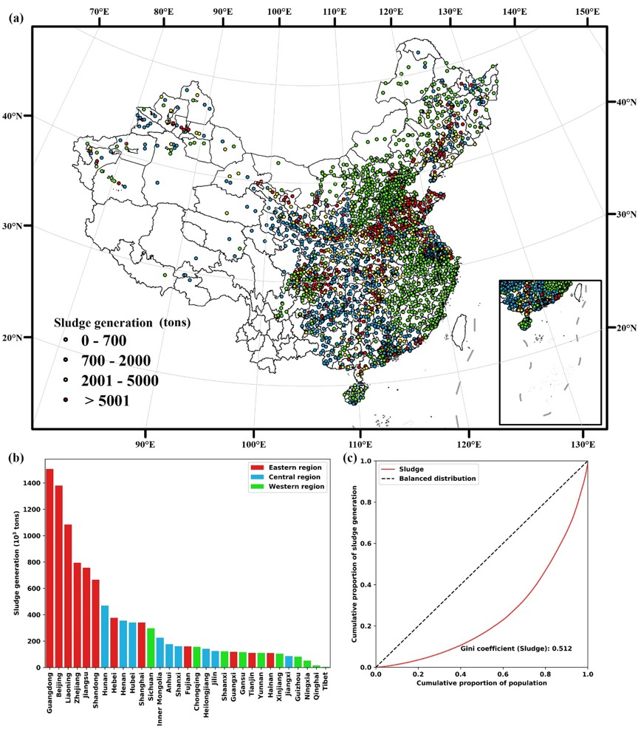

**Fig. 1．** (a) Locations of China's wastewater treatment plants and its sludge generation in 2017; (b) Sludge generation in different provinces in 2017; (c) Gini coefficient of sludge per capita in 2017 at the city level

UR (0.263) and PPI (0.162) had a relatively lower q-value. The result is consistent with (Wei et al., 2020), which indicated that economic development exhibited a more significant effect on sludge generation in China. However, the effect of RCOD (which reflects the treatment technology level) was minuscule (0.065). China has many WWTPs which operate with a relatively advanced treatment technology, so technological improvements can only have a limited effect on sludge generation in the future. We, therefore, selected seven factors with a q-value greater than 0.2 as the features of sludge prediction.

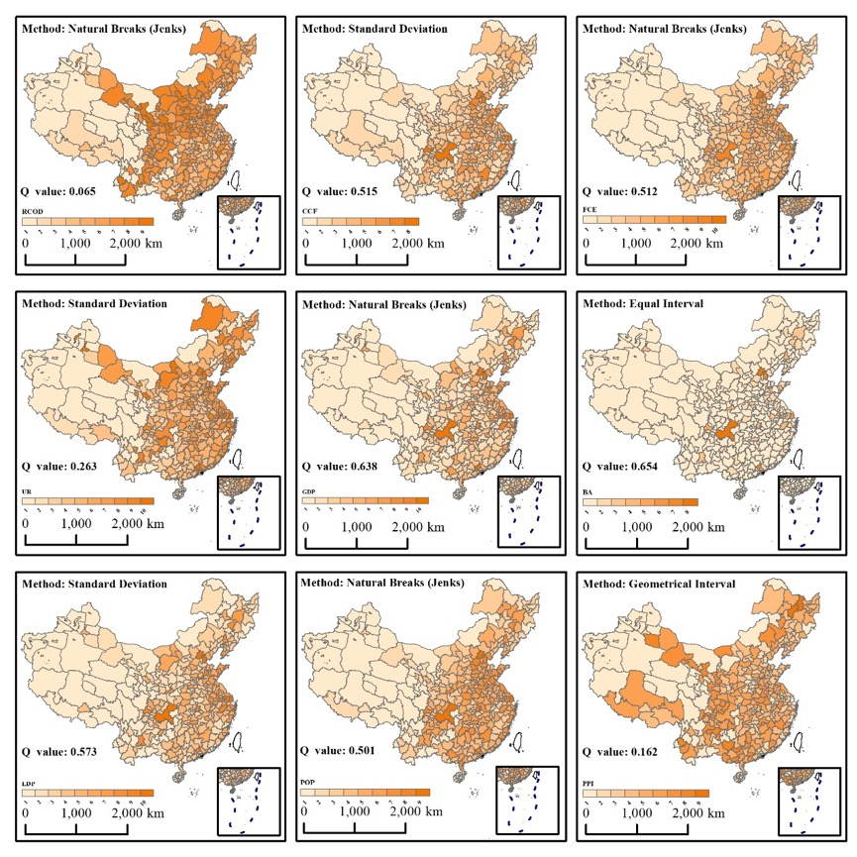

**Fig.2.** Discretization methods and q-values of sludge driving factors.

3.3. Sludge generation in SSP1-SSP5 scenarios

Sludge generation under different SSP scenarios has similar growth trends (**Fig. 3.**). In order to quantify the uncertainty of the prediction results, we took the upper and lower 5% intervals for the predicted independent variables, respectively, to re-predict sludge generation. Under all SSPs, sludge continued to grow at a decreasing rate. SSP5 had the highest sludge generation in 2060 (25.25 0.6 Mts), followed by SSP3 and SSP4 (which generated 23.79 1.2 Mts and 23.12 1.3 Mts respectively) while the totals for SSP2 and SSP1 were the lowest (21.56 0.5 Mts and 20.56 0.6 Mts respectively). China’s total sludge generation in 2060 is therefore expected to increase substantially compared to the 2017 total of 10.49 Mts. As the SSP1 scenario had the least sludge generation and lowest sludge growth rate, it is a suitable development path for sludge mitigation.

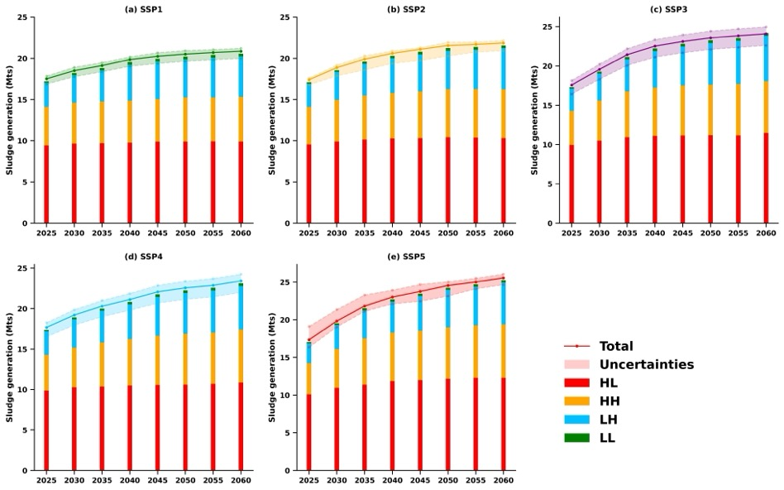

**Fig.3. The trend of sludge generation under different scenarios.**



We classified China’s sludge growth into four patterns – high generation with high growth (HH), high generation with low growth (HL), low generation with low growth (LL) and low generation with high growth (LH). HL includes 11 provinces which are mainly distributed in eastern China (**Fig. 4.**); these provinces contributed 78% of total sludge generation in 2017 but only 48% in 2060 as their total generation is expected to remain relatively stable. However, these areas are still the largest sludge contributors in China and will find it difficult to reduce sludge generation. For example, Zhejiang is predicted to have a small growth in sludge generation under SSP3 and SSP5 but stable generation under other scenarios. Avoiding the path dominated by regional competition (SSP3) and fossil fuels (SSP5) can reduce sludge generation by 100 to 200 Kts a year. Further reducing sludge generation from WWTPs by advanced technology is an important tool for local sludge reduction if the population and urbanization growth rate are relatively stable in HL regions.

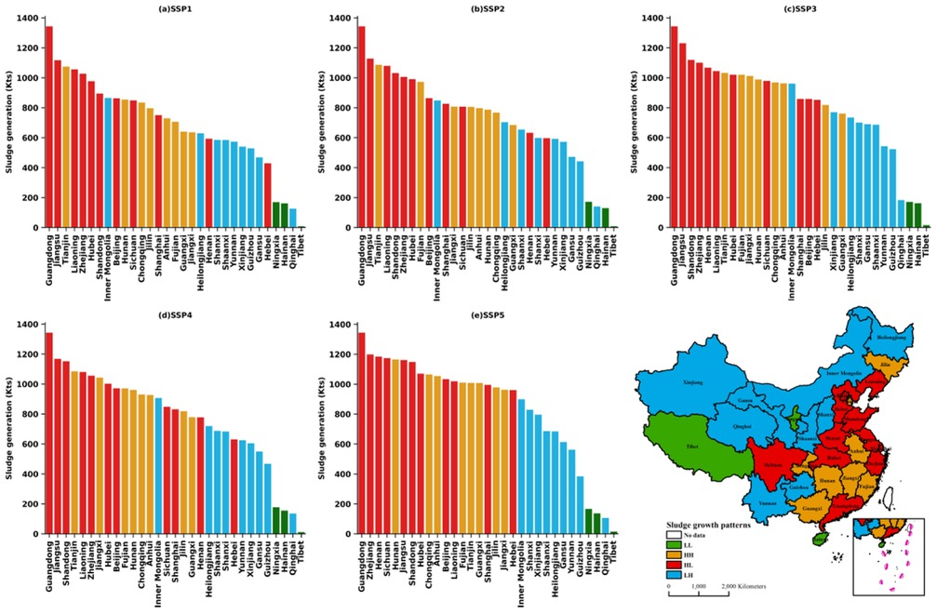

**Fig. 4.** Sludge generation in different provinces under different scenarios in 2060.



LH and HH are provinces where sludge generation is expected to increase rapidly. The contribution of sludge generation is predicted to increase from 10% and 9% in 2017 to 24% and 26% in 2060 in LH and HH respectively. Most provinces in western and northern China show this kind of trend. Under SSP3, SSP2 and SSP5, sludge grows rapidly after 2030 due to rapid economic growth and urbanization, which boosts the generation of wastewater. The rapid growth after 2030 should be the focus in terms of achieving Peak Carbon in 2030. However, given the relatively high carbon content of food in the Midwest and the expected transition to the recommended dietary structure, it should be possible to reduce sludge generation at source. Combined with improvements to wastewater treatment technology, a source-to-end sludge reduction path can help to reduce rapid sludge growth.



LL includes Tibet, Ningxia, and Hainan, which have relatively lower sludge generation. However, landfilling is the dominant disposal method in Tibet and Ningxia, so forming a waste-to-resource treatment system is a reasonable direction for sludge management in LL regions.



3.4. Greenhouse gas emissions from sludge disposal

In 2017, 29.67 Mts CO2 -eq would be released from sludge if it was treated without Anaerobic Digestion (AD), a contribution of 0.3% to total GHG emissions in China (**Fig. 5.**). Landfill, incineration, land application, and building material generated 9.68 Mts, 10.57 Mts, 1.25 Mts, and 8.17 Mts CO2 -eq respectively. 9.67 Mts CO2 -eq would be released from sludge disposal if they were generated with AD, and the other four disposal methods would generate 2.76 Mts, 7.23 Mts, 0.86 Mts, and 1.18 Mts respectively. The total potential of greenhouse gas emission reduction (PGER) can reach up to 17.64 Mt CO2 -eq, 6.92 Mts, 3.34 Mts, 0.39 Mts and 6.99 Mts from the respective disposal methods. AD contributes 59.5% GHG reduction from sludge treatment. At the provincial level, Guangdong, Zhejiang, and Jiangsu ranked in the top three for PGER, at 3.45 Mts, 1.72 Mts, and 1.61 Mts respectively, compared to just 0.02 Mts and 0.04 Mts CO2 -eq in Qinghai and Hainan respectively. Other provinces ranged from 0.05 to 1.45 Mts (**Fig. 5.**).

**Fig.5.** Greenhouse gas emission from sludge disposals under different provinces in 2017.

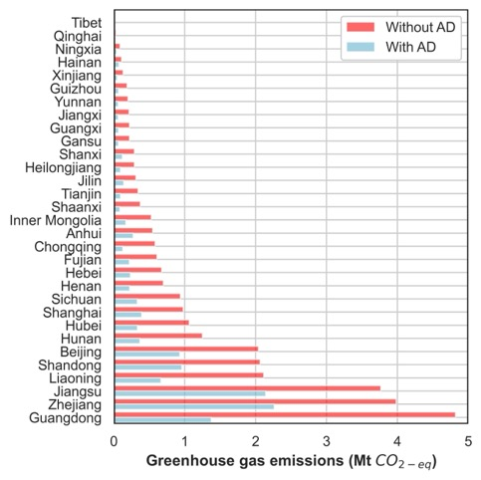

Fig. 6. illustrates GHG emissions from sludge treatment and disposal under the five SSP pathways. GHG emissions will increase under all five pathways, with growth rates ranging from 10% to 50%. The sludge disposal method is an important factor affecting GHG emissions. Landfills not only consume many land resources but may also pollute groundwater and adversely affect human health. Therefore, this disposal method will be restricted in the future. Incineration leads to a large number of GHG emissions, but at present, about 15% of sludge is treated and incinerated directly. The use of sludge for building materials requires incineration treatment, which also has the disadvantage of wasting the chemical elements in sludge (Jin et al., 2014). Land application, such as composting, will be an important method for sludge resource utilization in the future and can reduce GHG emissions from sludge disposal by more than 90% compared to incineration.

We set a Low Carbon Disposal (LCD) scenario to simulate the effective methods to optimize sludge treatment, assuming that all sludge was treated with anaerobic digestion and improved disposal methods (5%, 5%, 70%, 10% for Landfill, Incineration, Land application, and Building material respectively), and which effectively reduced GHG emissions (Fig. 7.). From SSP1 to SSP5, the PGER was 44.38, 46.55, 50.58, 48.74, and 52.30 Mts respectively in 2060, which was about 75% of total GHG emissions in the SSPs scenarios (without anaerobic digestion and improved disposal methods). Until 2030, the anticipated Carbon Peak in China, the annual GHG emission from sludge under SSP1 to SSP5 would be reduced to 17.85, 18.19, 19.27, 18.61, and 19.14 Mts respectively. The significant potential reduction in GHG emissions shows the effectiveness of improving sludge disposal methods.

## 3.5. Policy Implications

To ameliorate the rapid growth of GHG emissions from sludge treatments, different strategies should be implemented. In the mainly LH regions in the central and western regions of China, about 80% of sludge ends up in landfill sites. As sludge generation rises, other disposal methods should be enhanced. Given the expected rapid growth rate, sludge generation should be controlled at the source by changes in dietary structure and more compact urban development to reduce GHG emissions.

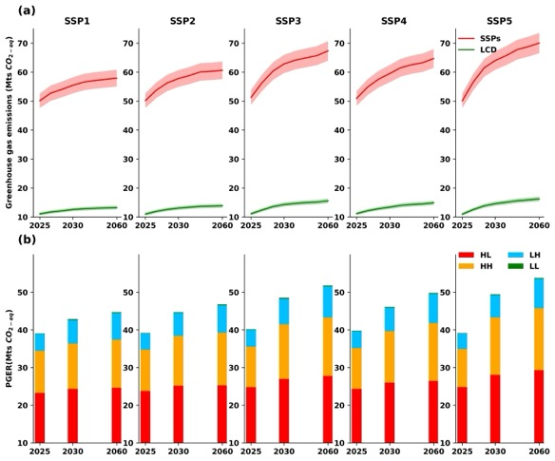

**Fig.6.** (a) Greenhouse gas emission from sludge disposals under different scenarios (SSPs – Without Anaerobic digestion and improved disposal methods, LCD – low carbon development, 5% uncertainty were shown). (b) Potential GHG emission reduction in different area.

The proportion of sludge incineration in the HH region is 20%, which will generate about 4-7 Mts CO2-eq per year. Increasing the proportion of land application and popularizing AD technology are important paths for future sludge GHG reduction.

In summary, to control the growth of GHG emissions from sludge, effective tools include measures to introduce AD and to change sludge emissions. The growth of sludge GHG emissions will slow as AD technology becomes widespread, and sludge GHG emissions will be the same in 2060 as they were in 2017 when each of the four major regions reaches a different portion of AD implementation. Table 3 shows the increase in the AD ratio that will need to be achieved to ensure that sludge GHG emissions remain unchanged if the sludge treatment method is not changed. LH regions require the highest AD capacity, followed by HL and HH.

**Table. 3** Required prevalence of AD in 2060 to achieve no change in sludge GHG emissions from 2017

|  |  |  |  |  |
| --- | --- | --- | --- | --- |
|  | **HH (%)** | **HL (%)** | **LH (%)** | **LL (%)\*** |
| SSP1 | 18 | 41 | 67 | / |
| SSP2 | 29 | 55 | 79 | / |
| SSP3 | 38 | 74 | 92 | / |
| SSP4 | 30 | 64 | 91 | / |
| SSP5 | 44 | 84 | 96 | / |

Note that stable sludge GHG emissions in LL will require additional measures

# 4.Conclusions

To provide a picture of sludge generation and its GHG emissions in China, this paper forecasts sludge generation in 30 provinces until 2060. The high spatial resolution means that the results should provide a reasonably picture of future sludge generation and GHG emission reduction potential.

The main conclusions of this study are as follows. (1) Under the SSP5 pathway, sludge generation will reach 25.25 0.6 Mts in 2060 compared to 10.49 Mts in 2017, and the resulting 70.04 Mts CO2-eq will make it more difficult to achieve GHG emission reduction targets. However, under the SSP1 scenario, the GHG emission can be controlled at about 20 Mts if the sludge is treated by AD, which is most favorable for sludge and GHG emission reduction. (2) Sludge growth trends in different regions of China can be divided into four patterns, with the central, western and northern regions having greater urbanization potential and higher sludge growth rates. Combining lower-carbon eating habits and improvements to wastewater treatment technologies to reduce sludge generation and form a sludge reduction path from source to end will be an important means to reverse the trend of rapid sludge growth. (3) Increasing land application during sludge disposal and popularizing AD disposal technology (LCD scenario) have a reduction potential of up to 50 Mts CO2-eq or more and will be important means of GHG reduction in areas where sludge reduction is difficult, such as areas with high economic development and rapid growth in water demand. (4) In order to reverse the increasing trend of sludge GHG emissions, HH, HL, LH and LL regions will have different priorities for local AD and improvement of sludge disposal. LL provinces must improve sludge disposal methods to reduce GHG emissions, whereas HH, HL, and LH provinces require greater use of AD while the sludge disposal method remains unchanged.

**References**

China Urban Water Supply and Drainage Association(2019).2018 Urban Drainage Statistical Yearbook.China Urban Water Association. (in Chinese)

National Bureau of Statistics.(2020). China Statistical Yearbook.

Chinese Nutrition Society.(2021).The Chinese Dietary Guidelines. Chinese Nutrition Society.

Eurostat.(2020).[https://ec.europa.eu/eurostat/data/database?node_code%C2%BCten00030[DB/OL]](https://ec.europa.eu/eurostat/data/database?node_code%C2%BCten00030%5bDB/OL%5d0)

JingFeng Wang, ChengDongXu.(2017).Geodetector: Theory and Perspectives[J].Acta Geographica Sinica. (in Chinese)

Jin Yu Pan.(2020). Research on the development trend and influencing factors of China's economy under the path of shared social economy. Nanjing University of Information Engineering.(in Chinese)

MOHURD, 2019. Chinese Statistical Yearbook of Urban and Rural Construction (In Chinese), <http://www.mohurd.gov.cn/xytj/tjzljsxytjgb/jstjnj>.

Second National Communication on Climate Change of the People’s Republic of China; Climate Change Division of National Development and Reform Commission of the People’s Republic of China, China Economic Press: Beijing, China, 2013.(in Chinese)

Tong Jiang., et al.(2017).IPCC Predicting population change in China and sub-provinces under shared socio-economic pathways. Advances in Climate Change Research. (in Chinese).

Tong Jiang., et al.(2018).Projections of economic changes in China and sub-provinces under shared socio-economic pathways[J] . Advances in Climate Change Research. (in Chinese).

XinQI Zheng et al.(2013).The Limiting Scale of Urban Land Growth in China.China Population, Resources and Environment. (in Chinese).