CAT II - Assignment 3

Internet and Web Programming

Group #: 3

Slot: B11 + B12 + B13

## 2.

JSON is a subset of JavaScript that is used to transmit data between the server and client in a structured format. JSON package is built in Python. So, JSON data can be easily encoded and decode by using Python script by importing the JSON package. Primitive data types like string, number and compound data types like list, objects, etc. are supported by JSON.

Python object translates into a JSON object by using serialization and the JSON object translates into a Python object by using deserialization.

**Methods**:

load() : This method is used to load data from a JSON file into a python dict.

Loads( ) : This method is used to load data from a JSON variable into a python dict.

dump() : This method is used to load data from the python dictionary to the JSON file.

dumps(): This method is used to load data from the python dictionary to the JSON variable.

**Reading JSON data**

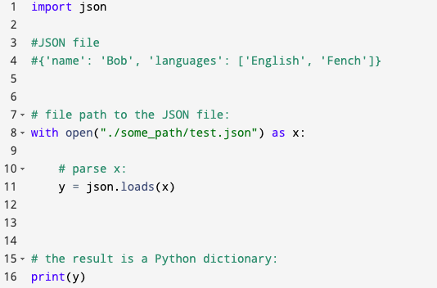

**Converting Python dictionary to JSON**

