Reinforcement Learning Report – FrozenLake Environment

Environment: FrozenLake-v1 (4×4, Slippery=True)
FrozenLake is a classic reinforcement learning benchmark available in OpenAI Gymnasium.
The agent starts at the top-left tile (S) and must reach the goal tile (G). Along the way there are frozen tiles (F) which are safe and holes (H) which terminate the episode and give zero reward.
Because is_slippery=True — the agent’s actions are stochastic.
For example, even if the agent chooses “RIGHT”, it may unintentionally slide DOWN or UP. This makes the problem significantly harder and emphasizes the need for exploration and value approximation.

Reward structure:
Outcome | Reward
Falls into hole or stuck | 0
Reaches goal | 1

Algorithms Implemented
Trained and compared three value-based RL control methods:
Method | Type | Learning style
Monte-Carlo First-Visit Control (MC) | Episodic method | Learns after entire episode returns
SARSA | Temporal Difference (on-policy) | Learns from the action actually taken in the next state
Q-Learning | Temporal Difference (off-policy) | Learns from the best possible next action (greedy) — “learns from imagined ideal behaviour”

1) Monte-Carlo (First-Visit)
- Updates Q-values only after finishing an entire episode.
- Uses complete returns (sum of discounted rewards).
- Slower to converge, but unbiased.
2) SARSA (On-Policy TD)
- Updates step-by-step.
- Next action comes from the same ε-greedy behaviour policy.
- More conservative because it learns values for the actual path agent follows.
3) Q-Learning (Off-Policy TD)
- Also TD update but chooses max(Q) for next state regardless of agent’s behaviour.
- More aggressive — tries to move toward optimal policy faster.

Observation from Learning Curves
- All three algorithms show a slow learning phase initially (0–10,000 episodes).
This is expected — FrozenLake stochasticity makes early exploration hard.
- After ~12,000 episodes, performance increases steadily.
- Q-Learning and SARSA start to outperform MC in the second half of training.
Performance order trending:
Q-Learning ≳ SARSA > Monte-Carlo
Explanation:
- MC updates only at episode end → very delayed learning.
- SARSA learns every step but is risk-averse because of on-policy update.
- Q-Learning uses a greedy bootstrap term → sharper convergence once the agent identifies safe paths.
Also note that even at 20k episodes, the average returns remain around ~0.45 because FrozenLake is inherently stochastic — you can’t get 1.0 reliably even with optimal strategy.

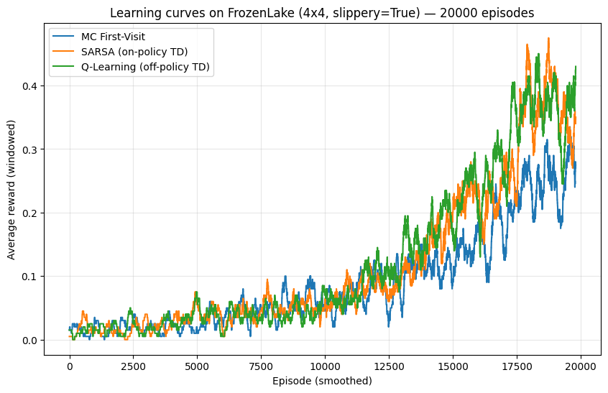

Key Takeaways
Point | Meaning
FrozenLake is a probabilistic navigation puzzle | agent can’t fully control movement due to slipperiness
MC is slowest but most theoretically unbiased | learns only from full episodes
SARSA is safer — on-policy → learns a balanced safe behaviour | tends to avoid risky moves
Q-Learning optimizes for max return – off-policy → fastest improvement | exploits optimal actions more aggressively

