Answer Retrived by the Agent

user: Compare Tesla and Nvidia and tell me which is good for future investment?
finance_research_agent: {"analysttool_response": {"results": ["{\'context\': {\'company_name\': \'Tesla, Inc.\', \'sector\': \'Consumer Cyclical\', \'industry\': \'Auto Manufacturers\'}, \'valuation\': {\'current_price\': np.float64(408.58), \'market_cap\': 1533168582656, \'pe_ratio\': 374.84402, \'forward_pe\': 145.69662, \'price_to_book\': 18.659178}, \'profitability\': {\'profit_margin_pct\': 4.0, \'roe_pct\': 4.93, \'roa_pct\': 2.1}, \'growth\': {\'revenue_growth_pct\': -3.1, \'earnings_growth_pct\': -60.6, \'yearly_price_return_pct\': np.float64(44.91)}, \'health\': {\'current_ratio\': 2.164, \'debt_to_equity\': 17.763, \'free_cash_flow\': 3732624896}, \'risk\': {\'beta\': 1.887, \'52w_high\': 498.83, \'52w_low\': 214.25, \'pct_off_high\': np.float64(-18.09)}, \'key_financials\': {\'revenue_billions\': np.float64(94.83), \'net_income_billions\': np.float64(3.79), \'operating_income_billions\': np.float64(4.85)}}"]}}{"analysttool_response": {"results": ["{\'context\': {\'company_name\': \'NVIDIA Corporation\', \'sector\': \'Technology\', \'industry\': \'Semiconductors\'}, \'valuation\': {\'current_price\': np.float64(184.89), \'market_cap\': 4501516845056, \'pe_ratio\': 45.651848, \'forward_pe\': 17.427935, \'price_to_book\': 37.794357}, \'profitability\': {\'profit_margin_pct\': 53.01, \'roe_pct\': 107.36, \'roa_pct\': 53.53}, \'growth\': {\'revenue_growth_pct\': 62.5, \'earnings_growth_pct\': 66.7, \'yearly_price_return_pct\': np.float64(53.92)}, \'health\': {\'current_ratio\': 4.468, \'debt_to_equity\': 9.102, \'free_cash_flow\': 53282873344}, \'risk\': {\'beta\': 2.314, \'52w_high\': 212.19, \'52w_low\': 86.62, \'pct_off_high\': np.float64(-12.87)}, \'key_financials\': {\'revenue_billions\': np.float64(130.5), \'net_income_billions\': np.float64(72.88), \'operating_income_billions\': np.float64(81.45)}}"]}}
news_researcher_agent: Here's a comparison of Tesla (TSLA) and Nvidia (NVDA) based on the provided financial data and recent news, to help you assess which might be a better future investment:

**Tesla (TSLA)**

* **Context:** Consumer Cyclical, Auto Manufacturers. Also heavily investing in AI/robotics.
* **Valuation:**
* Current Price: $408.58
* Market Cap: $1.53 trillion
* PE Ratio: 374.84 (very high, indicating high growth expectations or overvaluation)
* Forward PE: 145.70
* Price to Book: 18.66
* **Profitability:**
* Profit Margin: 4.0%
* ROE: 4.93%
* ROA: 2.1%
* **Growth:**
* Revenue Growth: -3.1% (negative, a concern)
* Earnings Growth: -60.6% (significant decline, a major red flag)
* Yearly Price Return: 44.91%
* **Health:**
* Current Ratio: 2.16 (good liquidity)
* Debt to Equity: 17.76% (low debt)
* Free Cash Flow: $3.73 billion
* **Risk:**
* Beta: 1.887 (more volatile than the market)
* Off 52w High: -18.09%
* **Recent News Highlights:**
* Concerns about underperforming the S&P 500 in 2026 for Magnificent Seven stocks.
* Mixed analyst price targets ranging from $25 to $600.
* Zero California test miles logged for robotaxi development in 2025, despite repeated promises, leading to a lawsuit against the California DMV over false advertising claims related to FSD/Autopilot.
* Cybertruck sales strategy involves lowering prices for a limited time.
* Company plans to end Model S and Model X production to convert factories for Optimus robot manufacturing.
* Skepticism from some about the "robot opportunity" being a "delusion."

**Nvidia (NVDA)**

* **Context:** Technology, Semiconductors. Dominant in AI chips.
* **Valuation:**
* Current Price: $184.89
* Market Cap: $4.50 trillion
* PE Ratio: 45.65
* Forward PE: 17.43 (significantly lower than current PE, suggesting strong expected future earnings)
* Price to Book: 37.79
* **Profitability:**
* Profit Margin: 53.01% (extremely high)
* ROE: 107.36% (outstanding)
* ROA: 53.53% (outstanding)
* **Growth:**
* Revenue Growth: 62.5% (very strong)
* Earnings Growth: 66.7% (very strong)
* Yearly Price Return: 53.92%
* **Health:**
* Current Ratio: 4.47 (excellent liquidity)
* Debt to Equity: 9.10% (very low debt)
* Free Cash Flow: $53.28 billion (substantially higher than Tesla's)
* **Risk:**
* Beta: 2.314 (more volatile than the market, even more than Tesla)
* Off 52w High: -12.87%
* **Recent News Highlights:**
* Strong earnings and outlook, lifting other Magnificent Seven stocks initially.
* Expected to see "hundreds of billions" in future robotaxi revenue through proliferation of fleets from Tesla, Waymo, and others.
* Nasdaq performance is heavily influenced by Nvidia's movements ("It's All About Nvidia").
* Despite strong performance, concerns about Magnificent Seven stocks underperforming the S&P 500 in 2026.

---

**Which is Good for Future Investment?**

Based purely on the quantitative financial data and recent operational news, **Nvidia (NVDA) appears to be a stronger candidate for future investment than Tesla (TSLA)**.

**Nvidia's Strengths:**

* **Exceptional Profitability:** Nvidia's profit margin, ROE, and ROA are vastly superior to Tesla's, indicating highly efficient operations and strong business fundamentals.
* **Robust Growth:** Nvidia demonstrates impressive revenue and earnings growth, driven by its leadership in the booming AI and semiconductor markets.
* **Strong Financial Health:** Excellent liquidity and very low debt.
* **Attractive Forward PE:** While its current PE is high, its forward PE is significantly lower, suggesting analysts expect continued rapid earnings growth that will make its valuation more reasonable.
* **Industry Leadership:** Dominant position in AI chips, a critical technology for numerous future industries including autonomous vehicles (where it benefits from Tesla's robotaxi ambitions).

**Tesla's Challenges:**

* **Negative Growth Rates:** The negative revenue and earnings growth are significant concerns, especially for a company priced for high growth.
* **Very High Valuation:** Tesla's PE ratio is exceptionally high, particularly in light of its recent negative growth. This implies that investors are paying a premium for future growth that isn't currently materializing in its core automotive business.
* **Operational Headwinds:** Issues with robotaxi permits, falling Cybertruck demand necessitating price cuts, and a pivot to robotics while core auto sales face pressure suggest operational challenges.
* **High Expectations vs. Reality:** The news points to a disconnect between Elon Musk's ambitious promises (robotaxis, "physical AI") and the actual progress or regulatory hurdles.

**Conclusion:**

While both companies operate in high-growth, transformative sectors and carry higher volatility (as indicated by their Beta), **Nvidia's current financial performance, profitability, and growth trajectory are far more compelling.** Its dominant position in the foundational technology for AI provides a strong moat and clear growth drivers.

Tesla, on the other hand, faces significant questions regarding its ability to execute on its ambitious AI/robotics plans while its core automotive business shows signs of slowing growth and profitability challenges. Its extremely high valuation combined with negative growth makes it a higher-risk investment at this juncture.

For future investment, **Nvidia presents a more financially sound and less speculative opportunity.**
investment_analyst: As a Senior Investment Strategist, I've analyzed the financial metrics and news for both Tesla and Nvidia to provide a comparative assessment and recommend which might be a better future investment.

---

### **Tesla, Inc. (TSLA)**

**STRENGTHS:**
1. **Healthy Balance Sheet:** Tesla maintains a strong current ratio of 2.164, indicating good short-term liquidity, and a low debt-to-equity ratio of 17.763%, suggesting manageable leverage.
2. **Significant Free Cash Flow:** With $3.73 billion in free cash flow, Tesla demonstrates its ability to generate substantial cash from its operations, which can be used for reinvestment or debt reduction.
3. **Innovation and Market Presence:** Despite recent challenges, Tesla remains a dominant force in the EV market and continues to pursue ambitious projects in AI, robotics (Optimus), and autonomous driving, which could unlock future value if successfully executed.

**RISKS:**
1. **Declining Growth and Profitability:** The company reported negative revenue growth (-3.1%) and a significant decline in earnings growth (-60.6%), which is a major concern for a stock valued for high growth. Profit margins are also relatively low at 4.0%.
2. **Extreme Valuation:** Tesla's PE ratio of 374.84 and forward PE of 145.70 are exceptionally high, especially in light of its recent negative growth. This suggests significant overvaluation, placing immense pressure on future performance.
3. **Execution and Regulatory Challenges:** News highlights issues like zero robotaxi test miles in California, a lawsuit over FSD/Autopilot claims, and the decision to halt Model S/X production for Optimus, indicating potential delays and skepticism around its ambitious future plans.

**VALUATION:**
Tesla's current price of $408.58 is significantly closer to its 52-week high of $498.83 than its low of $214.25 (18.09% off its high). With a PE ratio of 374.84 and a forward PE of 145.70, especially against negative revenue and earnings growth, the stock appears **extremely expensive**. Investors are paying a premium for future growth that is not currently materializing, making its valuation highly speculative.

**NEWS IMPACT:**
Recent news paints a mixed to negative picture. Concerns about underperformance relative to other "Magnificent Seven" stocks, combined with operational issues like the lack of robotaxi progress, a lawsuit against the California DMV, and strategy shifts (Cybertruck price cuts, ending Model S/X production for Optimus), suggest that the company faces significant execution risks and may struggle to meet its ambitious targets. This news generally weighs negatively on the investment case, increasing uncertainty.

**FINAL RATING:**
**HOLD.** While Tesla has a strong balance sheet and future potential in AI/robotics, its current valuation is exceptionally high given negative growth and operational challenges. Investors should await clearer signs of renewed revenue and earnings growth or a more reasonable valuation before considering a "Buy."

---

### **NVIDIA Corporation (NVDA)**

**STRENGTHS:**
1. **Exceptional Profitability and Efficiency:** Nvidia boasts outstanding profitability metrics, with a profit margin of 53.01%, an ROE of 107.36%, and an ROA of 53.53%. These figures demonstrate highly efficient operations and strong capital utilization.
2. **Robust Growth Trajectory:** The company exhibits phenomenal growth, with revenue growth of 62.5% and earnings growth of 66.7%, driven by its dominant position in the booming AI and semiconductor markets.
3. **Strong Financial Health and Free Cash Flow:** Nvidia maintains excellent liquidity with a current ratio of 4.468 and very low debt (debt-to-equity of 9.102%). Its massive free cash flow of $53.28 billion provides substantial financial flexibility.

**RISKS:**
1. **High Volatility:** With a beta of 2.314, Nvidia is significantly more volatile than the overall market and even Tesla, making it susceptible to larger price swings.
2. **High Valuation (Price-to-Book):** While its PE ratios are more reasonable than Tesla's, its price-to-book ratio of 37.79 is very high, indicating that much of its future growth is already priced into the stock.
3. **Concentration and Competition Risk:** Nvidia's dominance in AI chips, while a strength, also means a high reliance on continued demand from data centers and the AI industry. Increased competition or a slowdown in AI spending could impact its growth.

**VALUATION:**
Nvidia's current price of $184.89 is closer to its 52-week high of $212.19 (12.87% off its high) than its low of $86.62. Its PE ratio of 45.65, while high, is significantly lower than Tesla's, and its forward PE of 17.43 suggests that strong expected earnings growth could make the valuation more attractive in the near future. Overall, the stock appears **expensive**, but its valuation is more justifiable given its exceptional growth and profitability.

**NEWS IMPACT:**
Recent news consistently highlights Nvidia's strong performance and pivotal role in the tech market ("It's All About Nvidia"). Its robust earnings and optimistic outlook continue to drive market sentiment, benefiting not only itself but also other tech giants. The company's technology is also expected to benefit from the broader proliferation of robotaxis from various companies, including Tesla. This news reinforces a strong positive investment case, showcasing its continued market leadership and growth drivers.

**FINAL RATING:**
**BUY.** Nvidia demonstrates exceptional profitability, robust growth, and a strong financial position, solidifying its leadership in the critical AI semiconductor market. Despite its high valuation and volatility, its superior fundamentals and clear growth drivers make it a compelling investment for future growth.

---

exceptional performance and clear future catalysts. Tesla, in contrast, faces significant headwinds with declining growth, extremely high valuation, and operational challenges in executing its ambitious plans, making it a much higher-risk and speculative investment at this time.

---
*Disclaimer: This analysis is based on the provided financial data and news. Investors should conduct their own thorough research and consider their individual risk tolerance before making any investment decisions. Market conditions and company performance can change rapidly.*

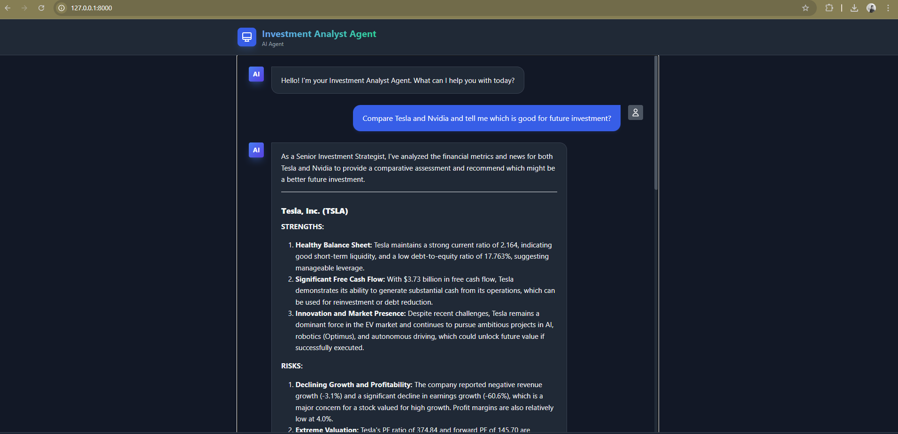

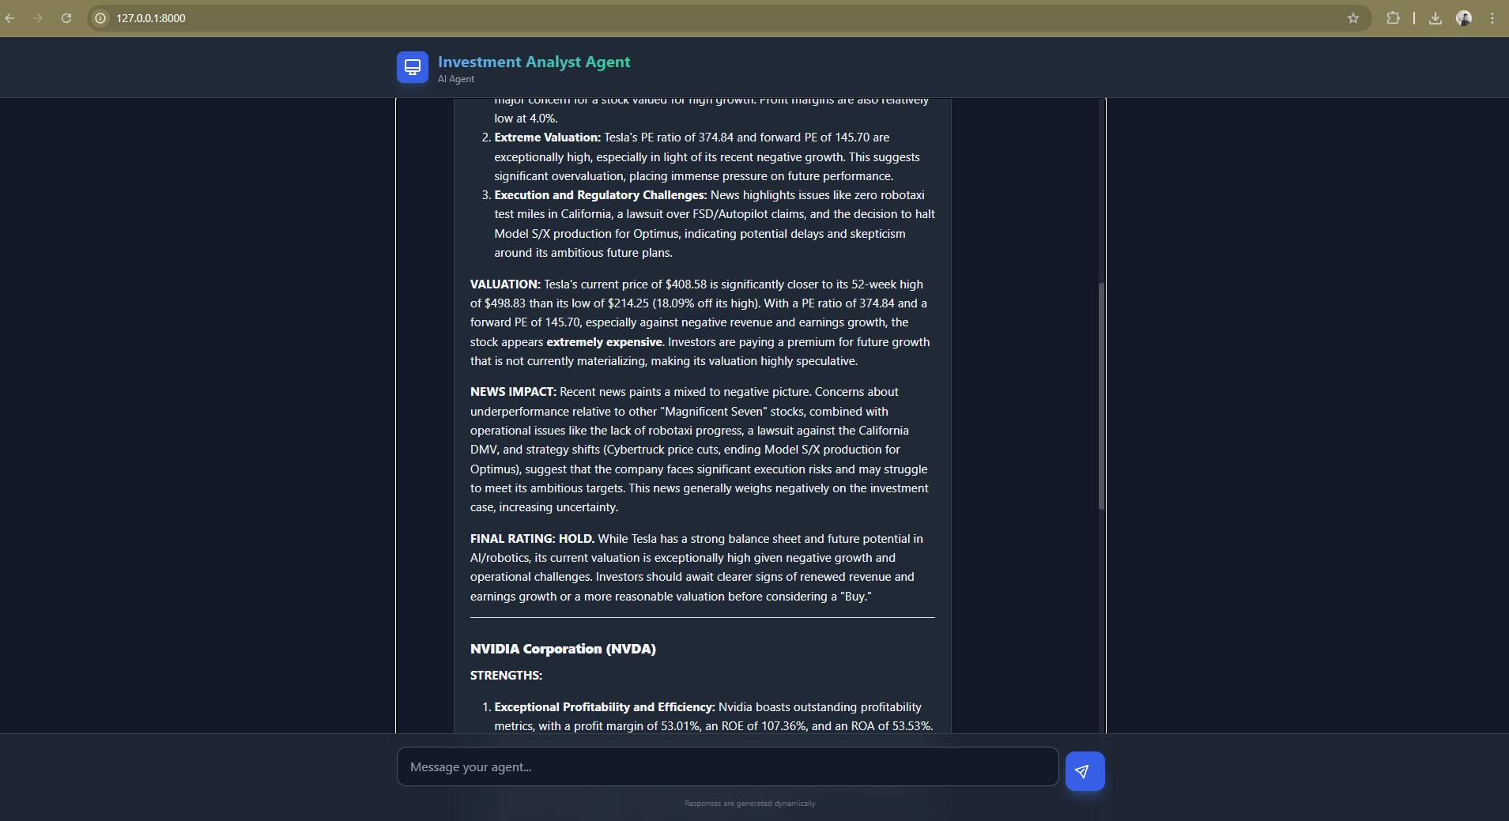

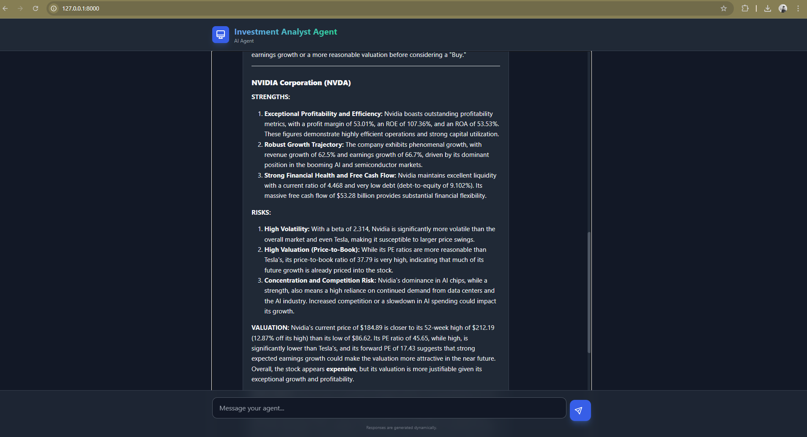

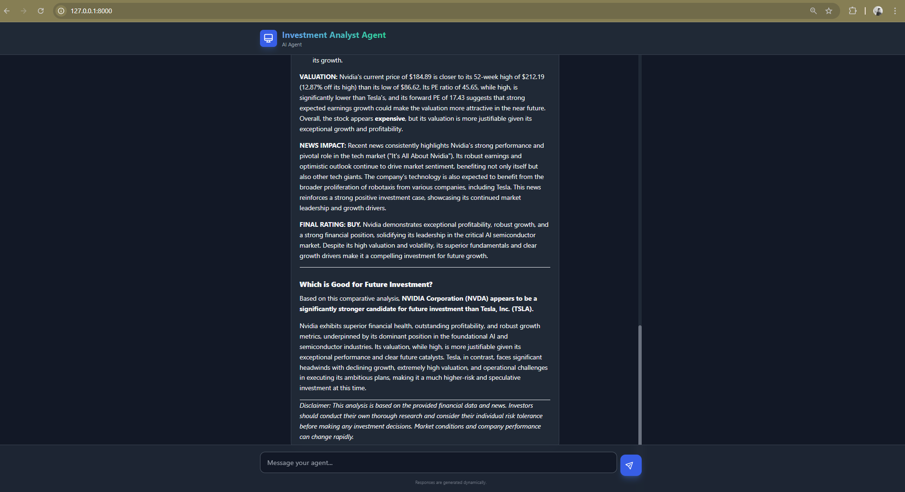

Model’s Answer for the public listed company

