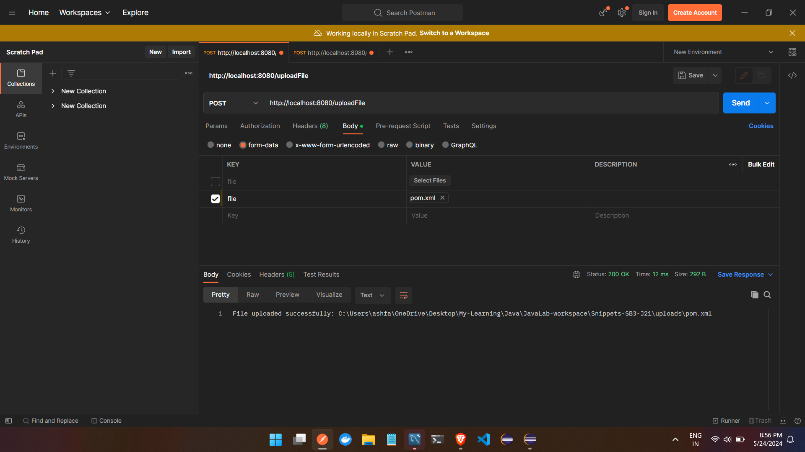

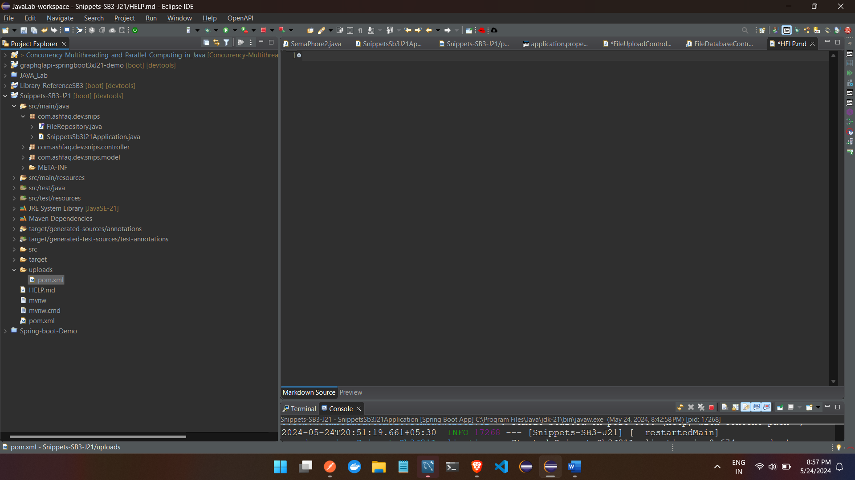

DB

Hibernate: insert into file_entity (data,file_name) values (?,?)

[2m2024-05-24T20:59:27.869+05:30[0;39m [33m WARN[0;39m [35m17268[0;39m [2m---[0;39m [2m[Snippets-SB3-J21] [nio-8080-exec-1][0;39m [2m[0;39m[36mo.h.engine.jdbc.spi.SqlExceptionHelper [0;39m [2m:[0;39m SQL Error: 1406, SQLState: 22001

[2m2024-05-24T20:59:27.869+05:30[0;39m [31mERROR[0;39m [35m17268[0;39m [2m---[0;39m [2m[Snippets-SB3-J21] [nio-8080-exec-1][0;39m [2m[0;39m[36mo.h.engine.jdbc.spi.SqlExceptionHelper [0;39m [2m:[0;39m Data truncation: Data too long for column 'data' at row 1

[2m2024-05-24T20:59:27.886+05:30[0;39m [31mERROR[0;39m [35m17268[0;39m [2m---[0;39m [2m[Snippets-SB3-J21] [nio-8080-exec-1][0;39m [2m[0;39m[36mo.a.c.c.C.[.[.[/].[dispatcherServlet] [0;39m [2m:[0;39m Servlet.service() for servlet [dispatcherServlet] in context with path [] threw exception [Request processing failed: org.springframework.dao.DataIntegrityViolationException: could not execute statement [Data truncation: Data too long for column 'data' at row 1] [insert into file_entity (data,file_name) values (?,?)]; SQL [insert into file_entity (data,file_name) values (?,?)]] with root cause

com.mysql.cj.jdbc.exceptions.MysqlDataTruncation: Data truncation: Data too long for column 'data' at row 1

at com.mysql.cj.jdbc.exceptions.SQLExceptionsMapping.translateException(SQLExceptionsMapping.java:104) ~[mysql-connector-j-8.3.0.jar:8.3.0]

at com.mysql.cj.jdbc.ClientPreparedStatement.executeInternal(ClientPreparedStatement.java:912) ~[mysql-connector-j-8.3.0.jar:8.3.0]

at com.mysql.cj.jdbc.ClientPreparedStatement.executeUpdateInternal(ClientPreparedStatement.java:1054) ~[mysql-connector-j-8.3.0.jar:8.3.0]

at com.mysql.cj.jdbc.ClientPreparedStatement.executeUpdateInternal

when uploading this error

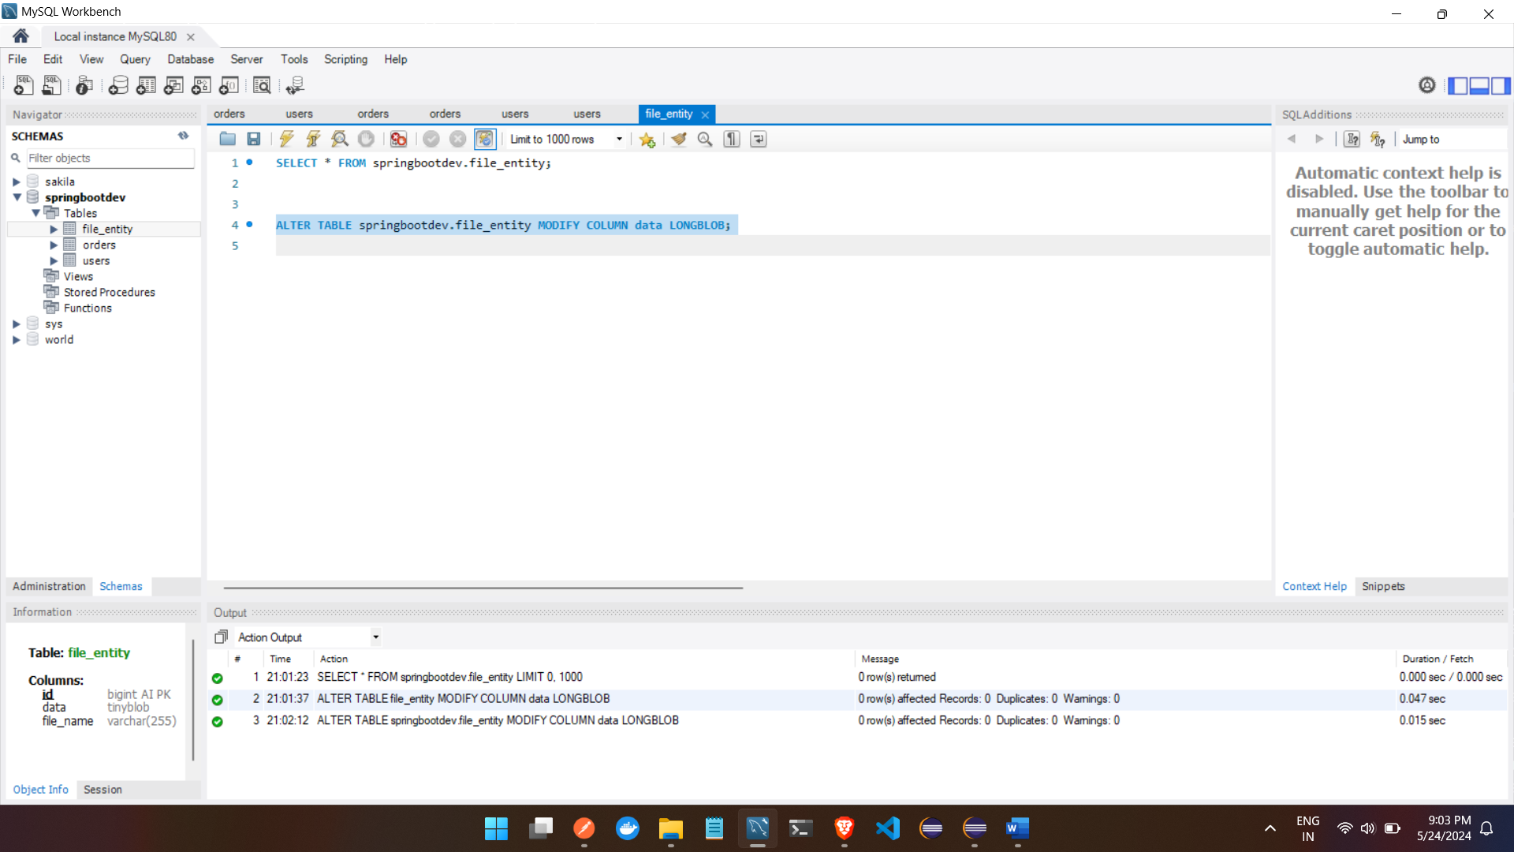

Post

