

American International University- Bangladesh

CSC 3222: Web Technologies

CO1.1 and CO2.1 Evaluation

Project Report

Summer 20-21

Project Title: School Management System

Section: I

|  |  |
| --- | --- |
| Student Name | Student Id |
| Rashid, Ashfat Al | 19-40195-1 |
|  |  |
|  |  |
|  |  |

Introduction:

*Write the answer of why you are doing this project? (No more than 60 words)*

Background Study

*Web Site References and short description of the websites. Here you will describe about the reference websites that you have studied so far in order to get ideas and thoughts about your proposed project.*

Requirement Analysis:

1. User Category:

There are Four types of Users here. They are:

* ADMIN
* TEACHR
* STUDENT
* LIBRARIAN

1. Feature List:

In this project the “ADMIN” has the following features:

* Sign in/Log in & sign out/log out.
* Sign up/Registration.
* Change password & password recovery.
* Edit/View Profile.
* Can add-update-delete teacher
* Can add-update-remove student
* Can add-update-delete subject
* Add General Notice
* Make Routine
* Manage Other employee details

In this project the “TEACHER” has the following features:

* Add Notice
* Check library
* Check routine
* Manage consulting
* View notice to specific student
* View homework

In this project the “STUDENT” has the following features:

* Check Consulting
* Check Library
* Check Routine
* Upload HW
* Add course
* Drop Course

In this project the “STUDENT” has the following features:

* Add book
* Remove book
* Search book
* Update book
* Check shifting time
* Check who borrow book

Design:

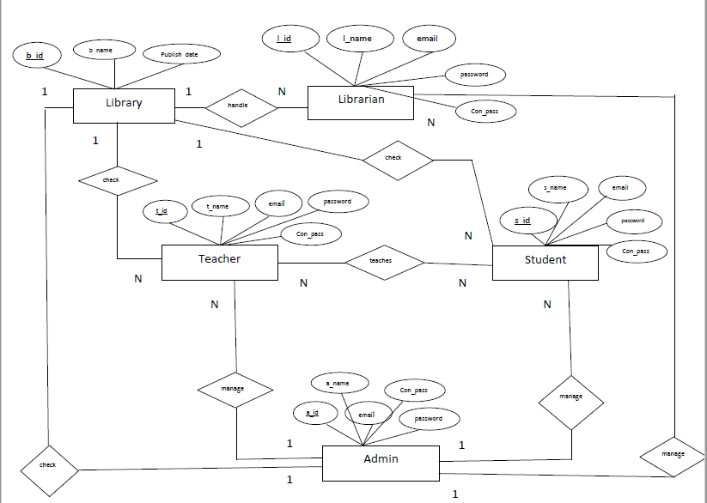

Figure 1:ER Diagram

Tools Used:

To develop this project, we have used the following:

• Sublime Text

• XAMPP

• Chrome

• Git

System Images against the Specification:

Give few screen shots of some GUIs (Midterm project) and write a very small description (Maximum 40 words) for each of the GUIs.

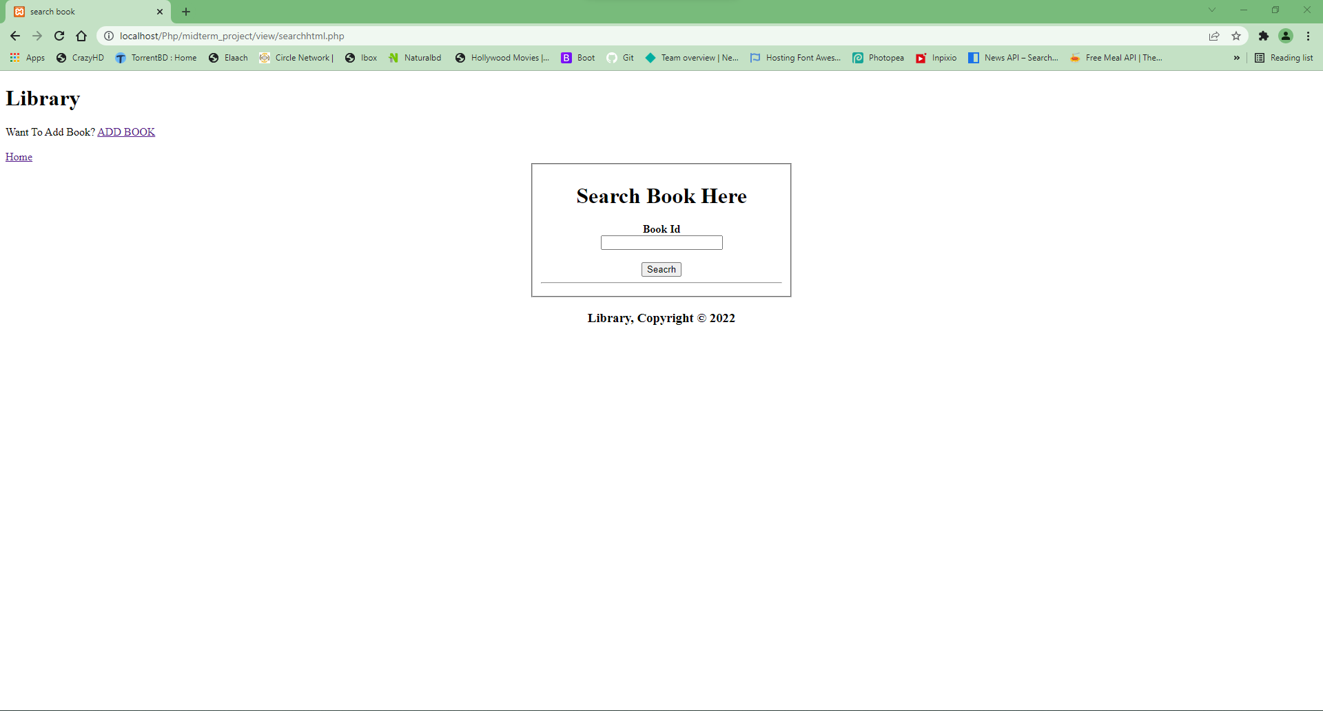

Figure 2: This is search option for library where librarian can search book by book id and it will show the full book information in next page if it exists

Figure 2:This is search option for library Where librarian can search book by book id and it will show the full book information in next page if it exist

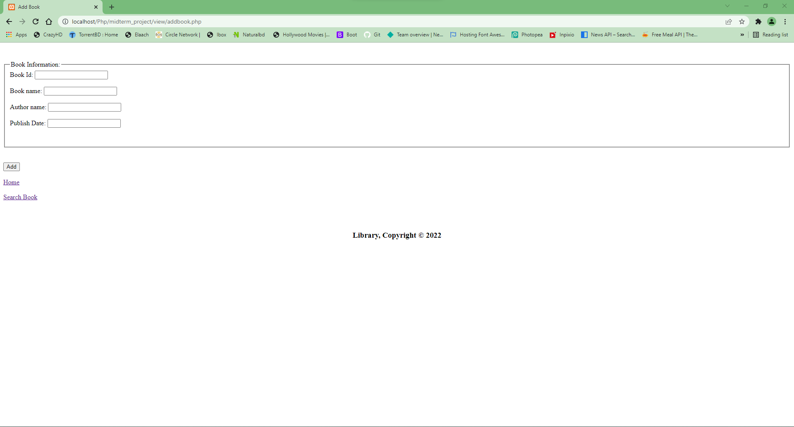

Figure 3: This is add book option where librarian can add the book when new book arrived to the library so all the member can see the book if they needed them

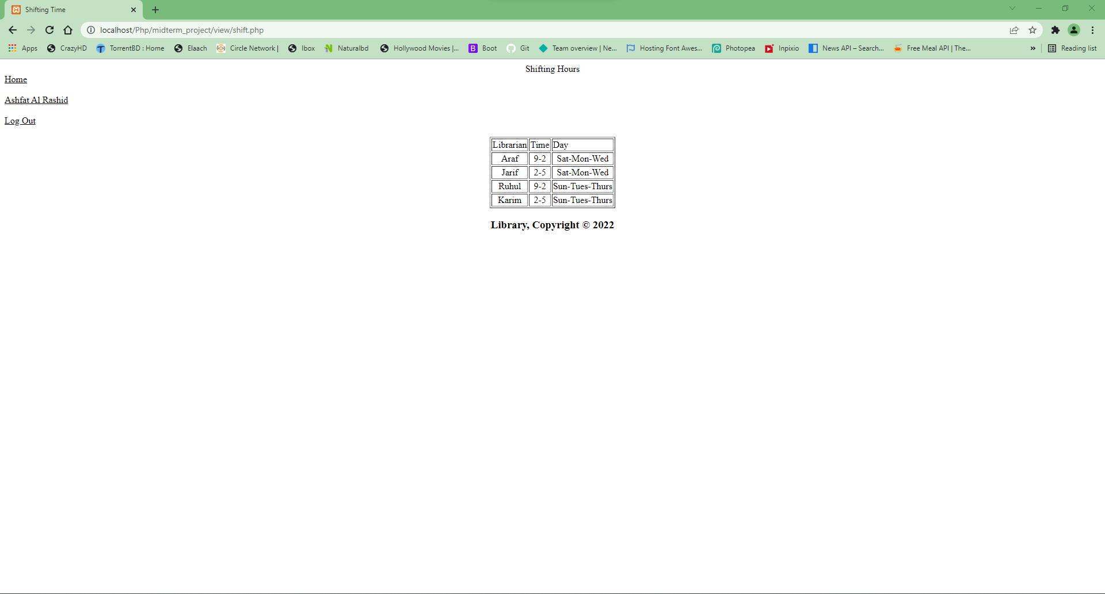

**Figure 4: This is the shifting time option where different shifts are assigned for different librarians. Any librarian can easily see their shift time from the table**

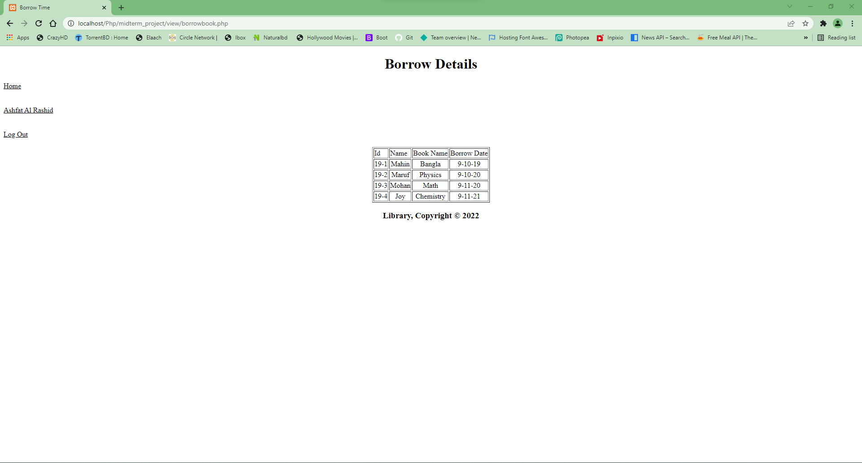

**Figure 5: This is the borrow book option where librarian can borrow the books from the library and register the borrow date**

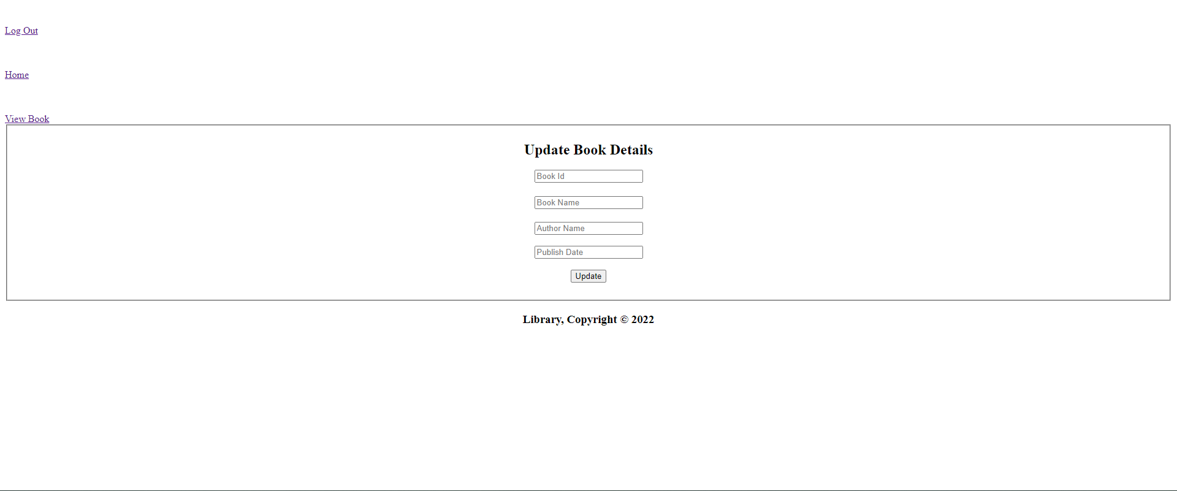

**Figure 6: This is the update book option where librarian can update the books in the library and register the book in a new id, name, author name and publish date**

Impact of this Project:

Describe the increasing importance of your project on modern society and environment.

How will people be benefitted from your project?

All over the world, there are a number of schools. All the educational institutes run with the objective of enlightening students' career and doing so involves too many tasks. In order to offer a better educational experience for students, it is very important to manage all those tasks efficiently. Although it is quite easy to manage all the tasks in the small schools, what if the school organization is too big? Of course, it will involve more complexity that makes it tough to look and manage all the task efficiently.

To ease the task and to maintain better communication with students and parents many schools are adopting the use of school management software. The introduction of school management information has overcome the flaws and drawbacks of manual management of the administrative tasks. This has brought a positive advancement in the school management system and hence in the school.

School Management Software offers a strong backbone to the education system. It integrates information from various areas and brings them under one roof. This reduces the hassle involved in performing the task.

Overall, the seamless user-experience makes it possible to manage the school task easily thus help the school to progress towards success.

Benefits of School Management System

Students are the key that defines the success of any educational firm. They are the primary beneficiary of the school. Availing every possible requirement of the student influence students in a better way and defines their success for years in the future. It helps students to self-evaluate themselves and to work on themselves to improve their skills.

Through the automated system, the teacher would be able to understand the need and learning ability of each and every student in the school. They are able to recognize the students that are brilliant and those lacking behind.  With this tool, the teachers are able to track the progress of each student which help them to decide various strategies for making things clear to each and every student.

School information systems used in schools not only help in identifying and improving weaker student groups but also aid in the everyday school running process.

In all the school management system is bringing a great difference in the lives of students, teachers, parents, and the admin. Good management offers better productivity and hence more progress towards development.

Limitations and Possible Future Improvements:

Instead of many benefits, school management system has some limitations and also there is scope for future improvements.

**Limitations:**

1) The student result management system is prone to hack.

2) Administration can’t edit or modify scores after deadlines.

3) Extensive modules and features make it difficult for a user to utilize the application.

4) Minor technical glitches and issues.

**Future Improvements:**

1) Admissions

2) Assessments

3) Communications

4) Parents

5) Staff

6) Timetable

7) Room Management

8) Homework and Assignments

9) Attendance

10) Billing

11) Contact Management

12) Security