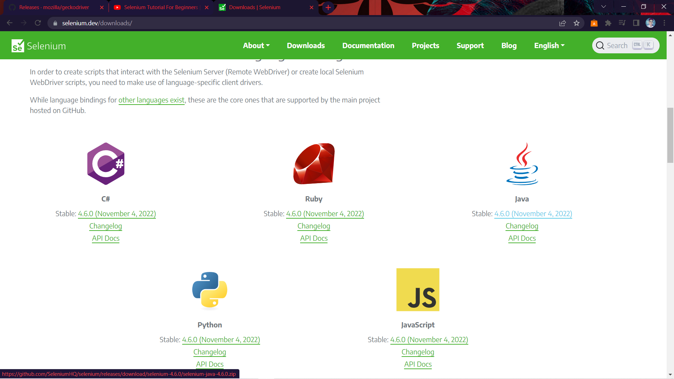

Fig 1.1 : Downloading Selenium Web Driver For Java

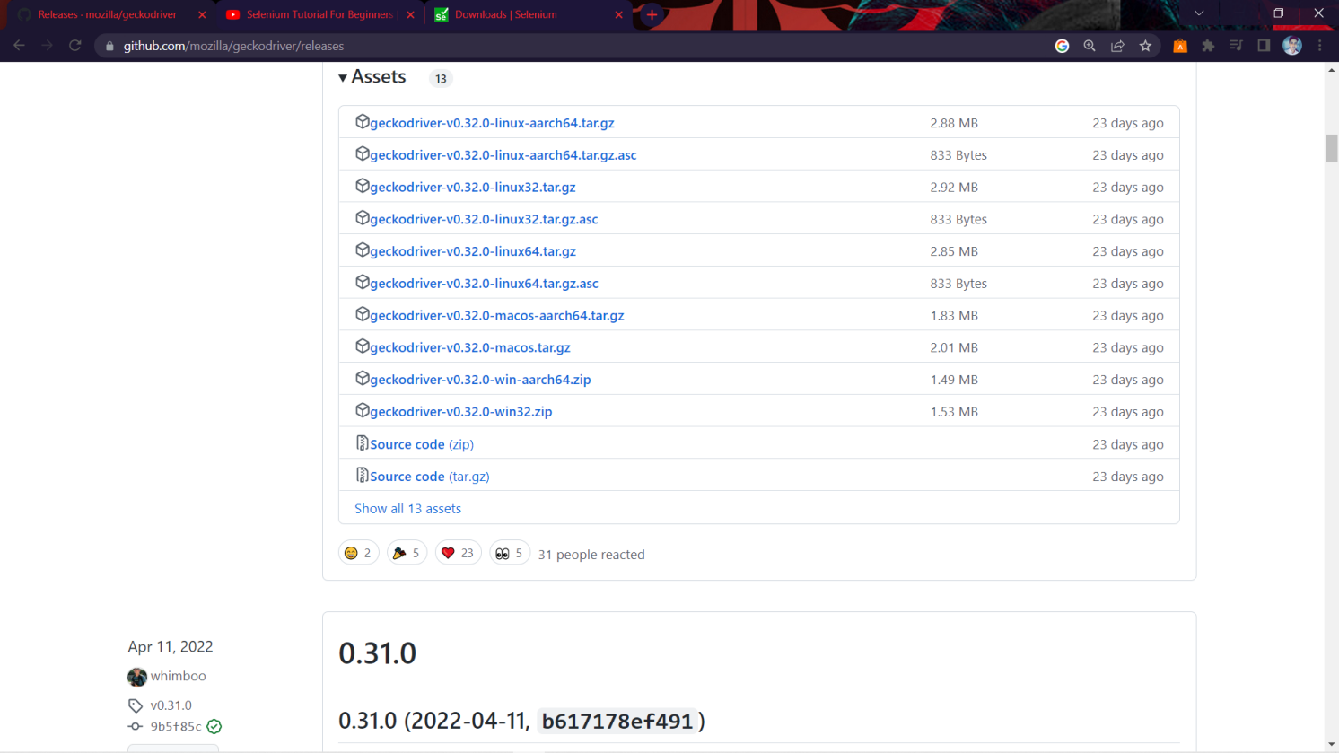

Fig 1.2 : Downloading Gecko Driver(win 64) For Firefox

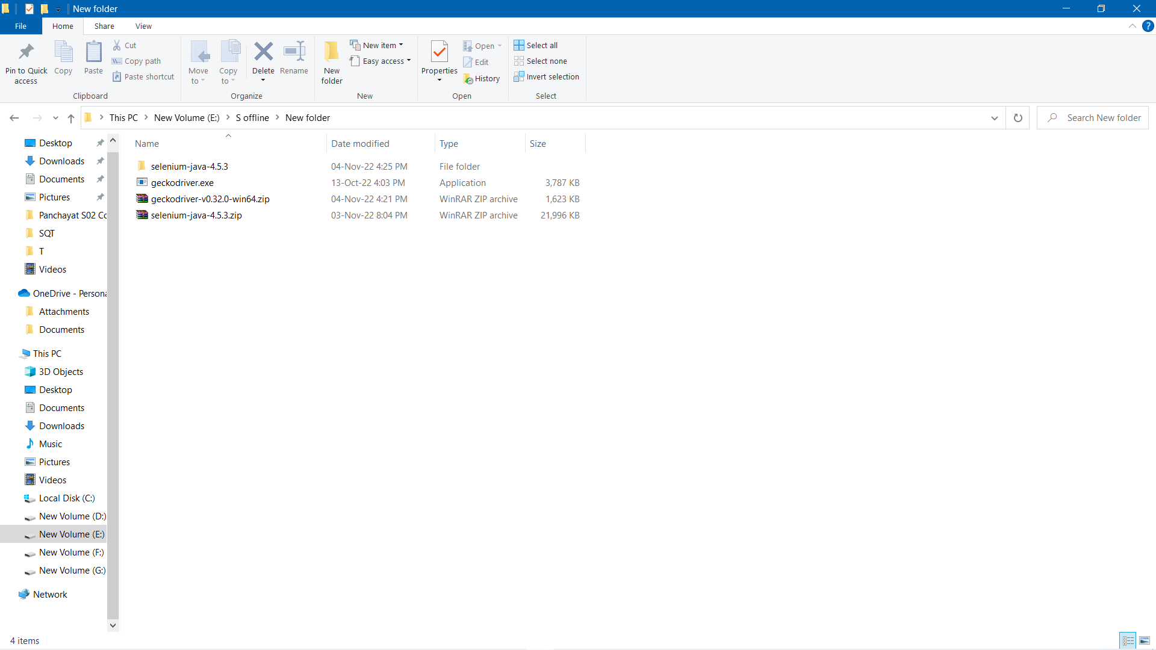

Fig 1.3 : Keeping Selenium And Gecko Driver in a Folder

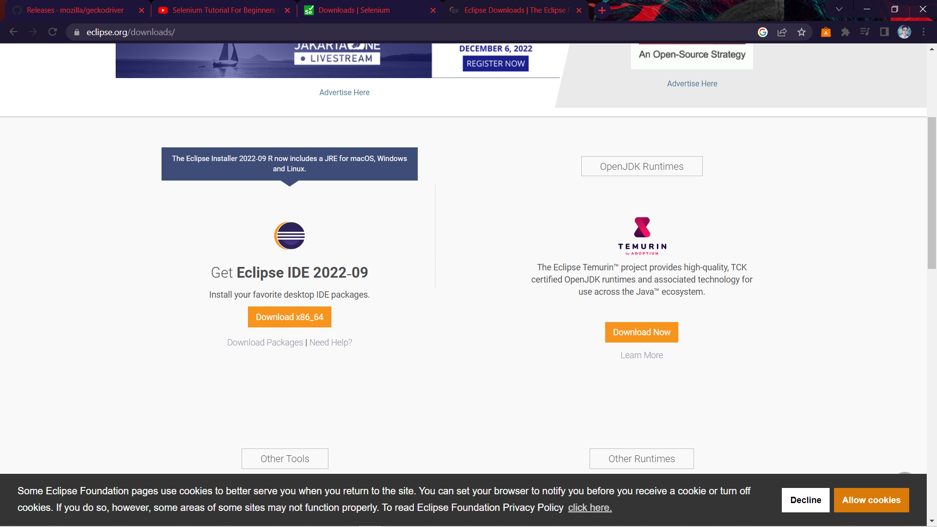

Fig 1.4 : Installation of Eclipse IDE for Java

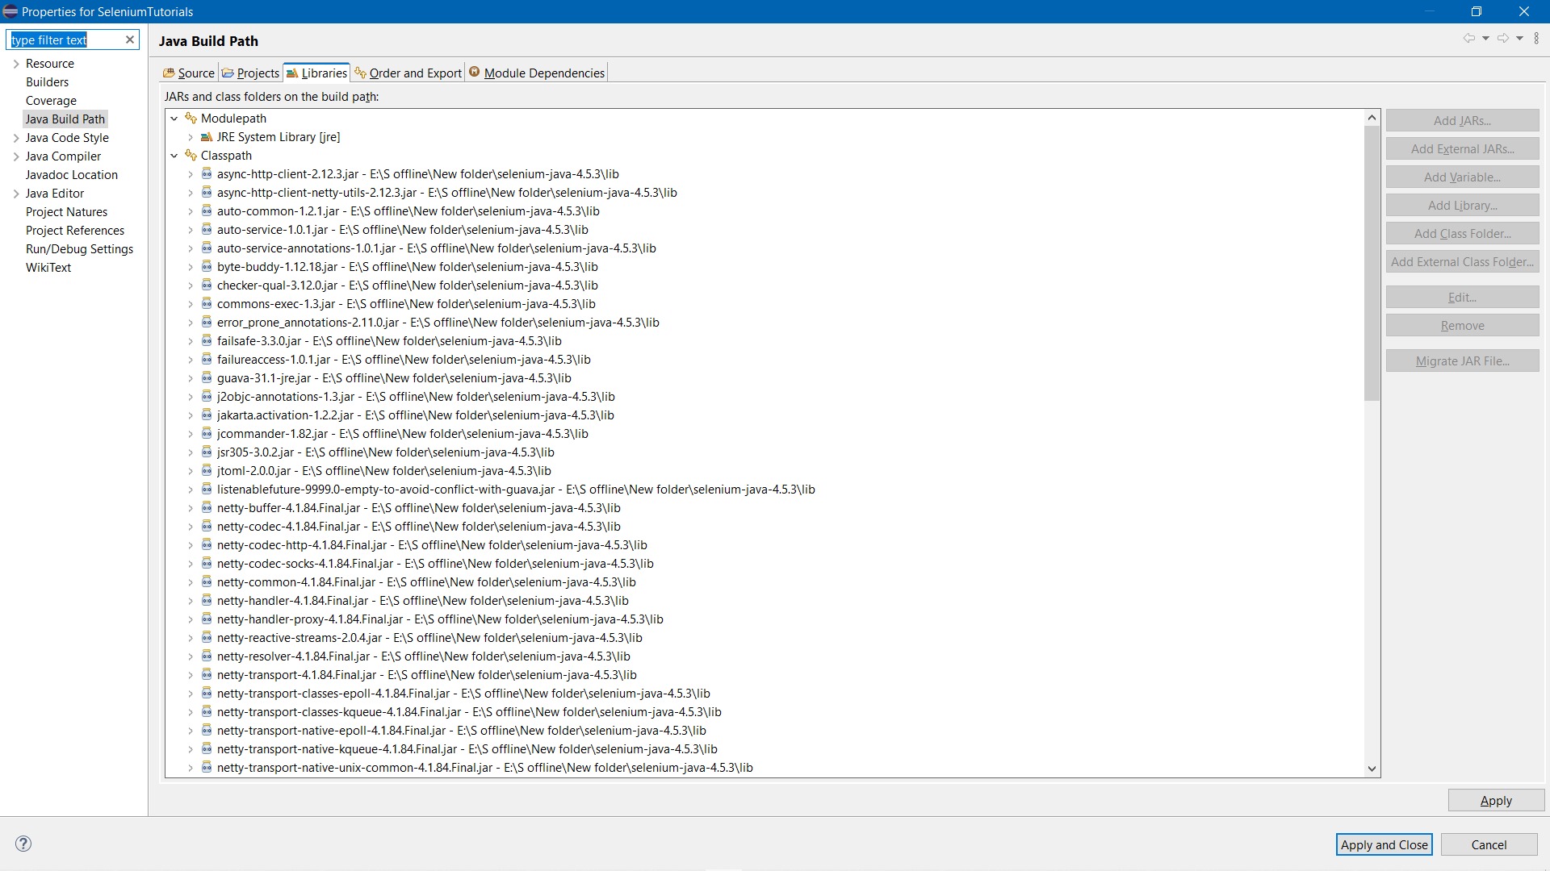

Fig 1.5 : Configuring Build Path for Selenium Web Driver

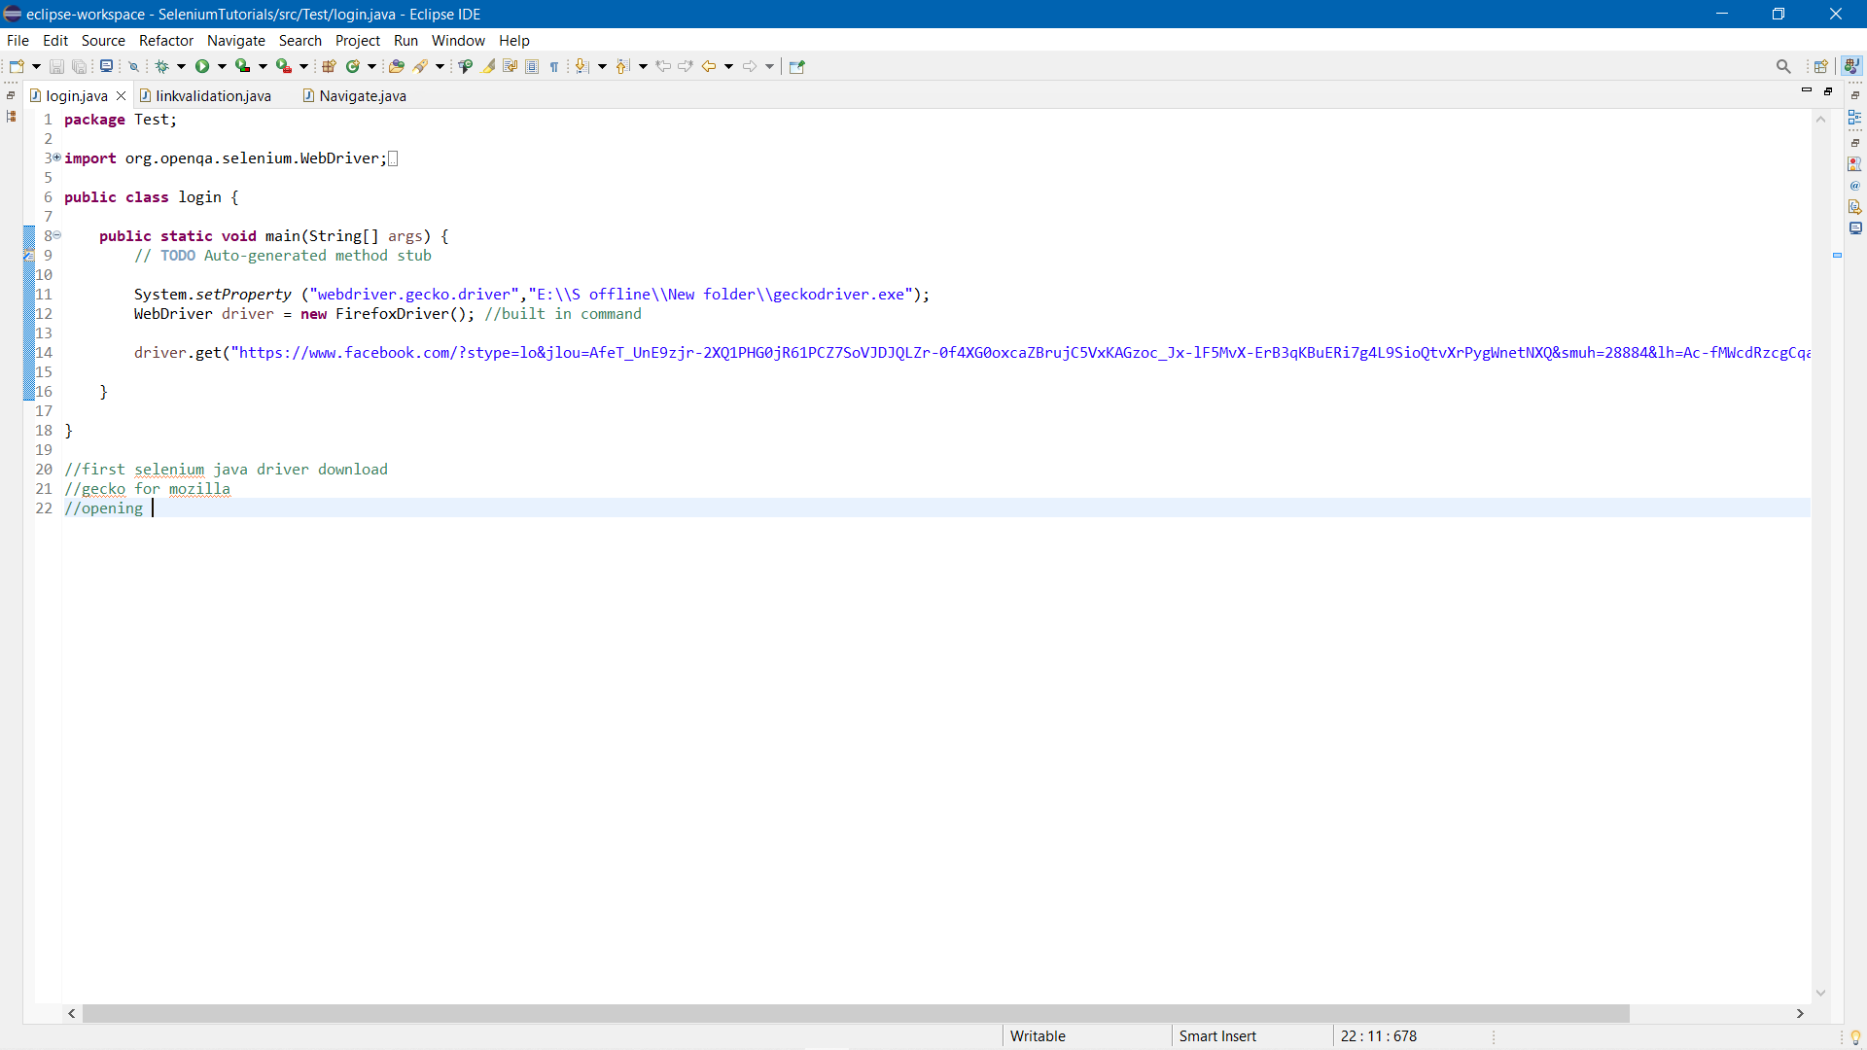

Fig 1.6 : Testing login.java module

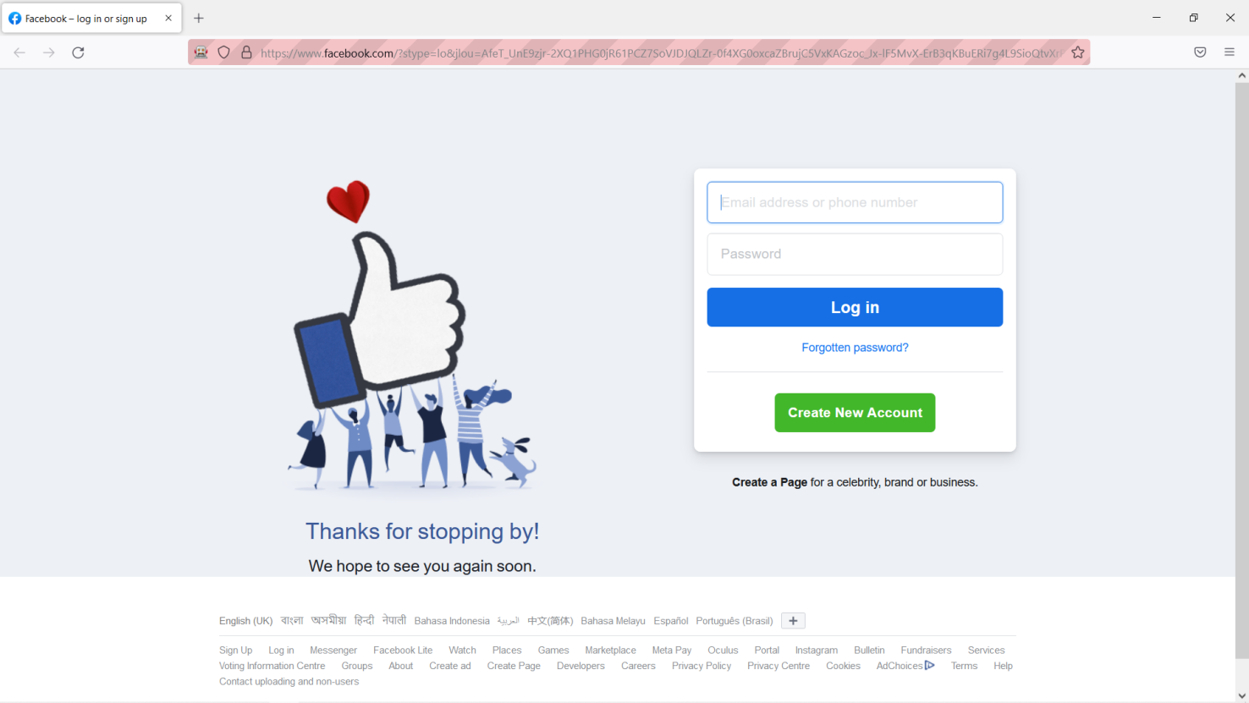

Fig 1.7 : Automatically Redirect to Facebook Login Page

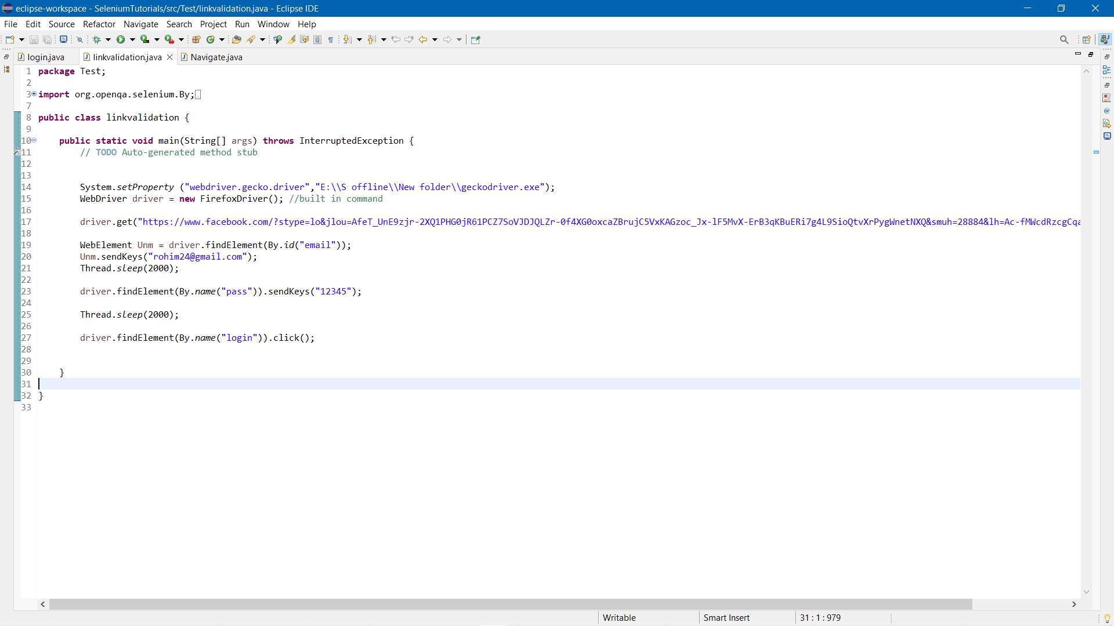

Fig 1.8 : Logging In with Id And Password

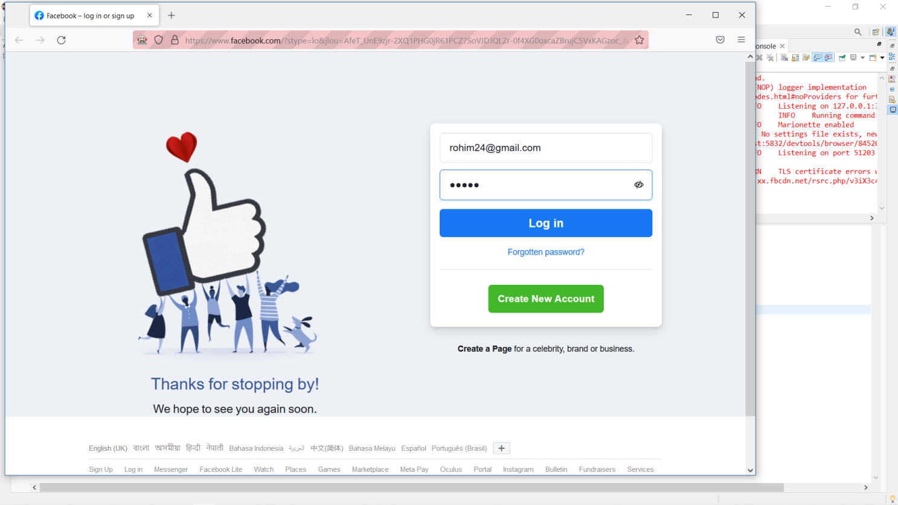

Fig 1.9 : Automatically Taking Input of Id And Password in Input Box Field

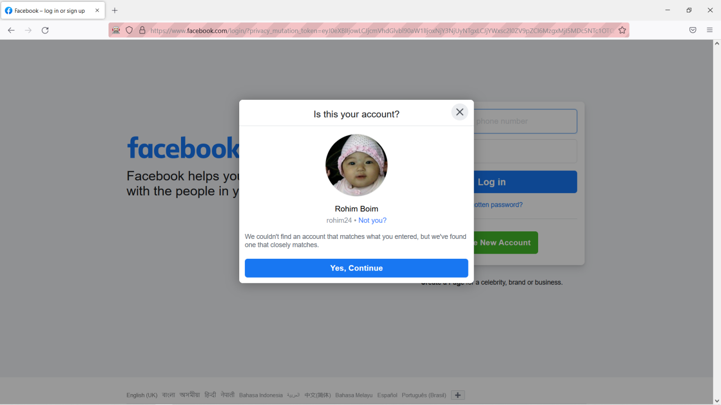

Fig 2.0 : Successfully logging with the Information

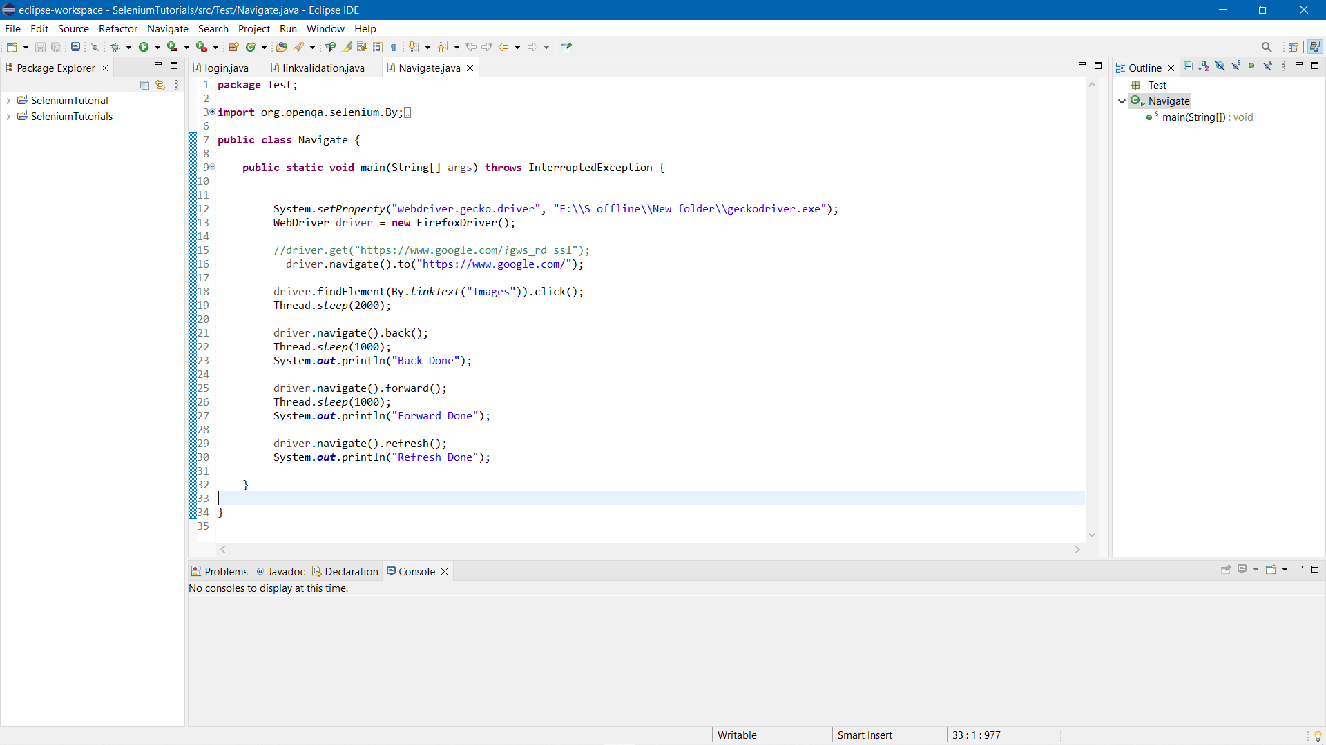

Fig 2.1 : Navigating To Google Search Engine

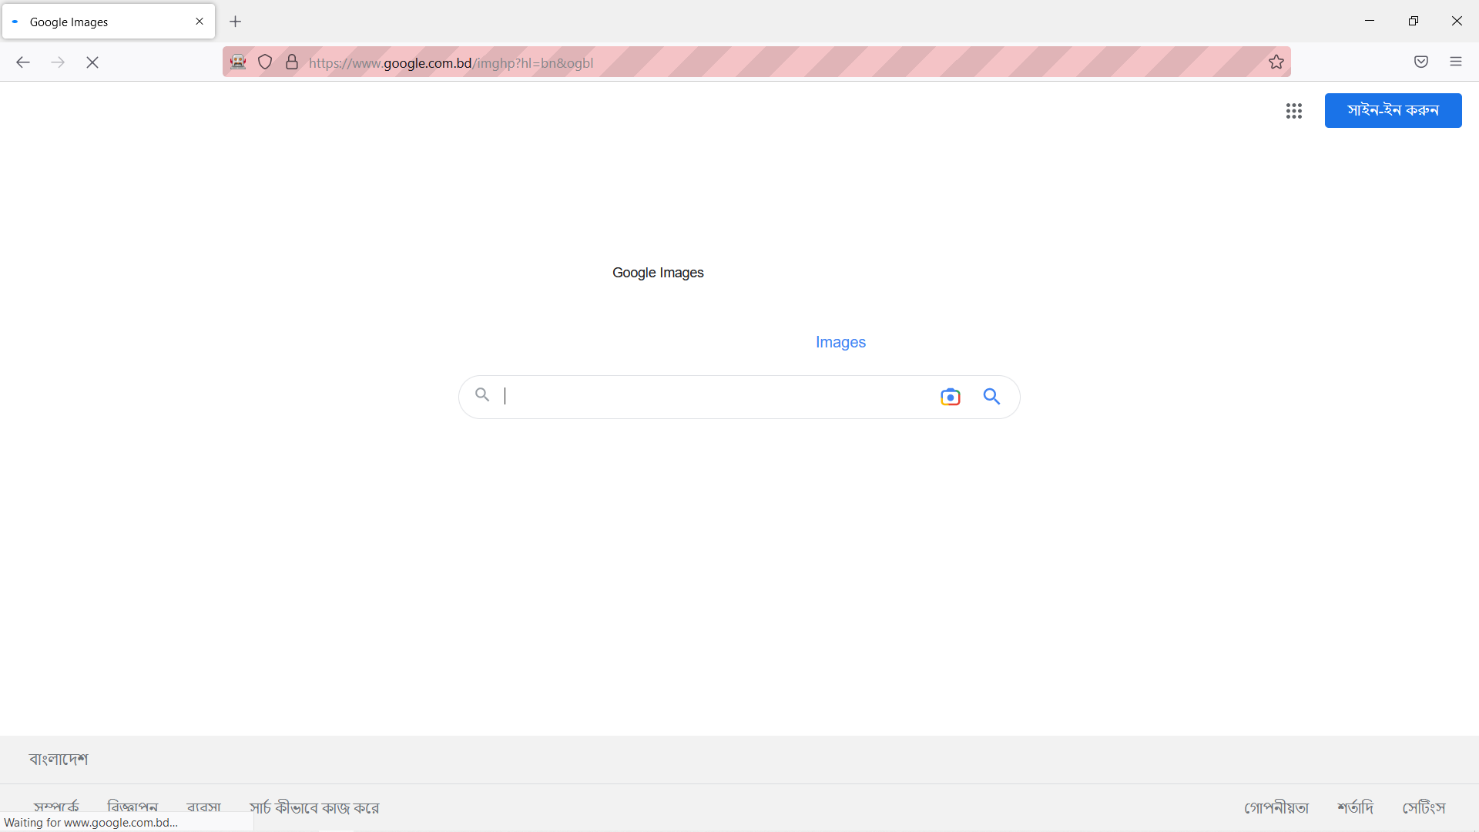

Fig 2.2 : Navigating From Google Search to Google Images Search

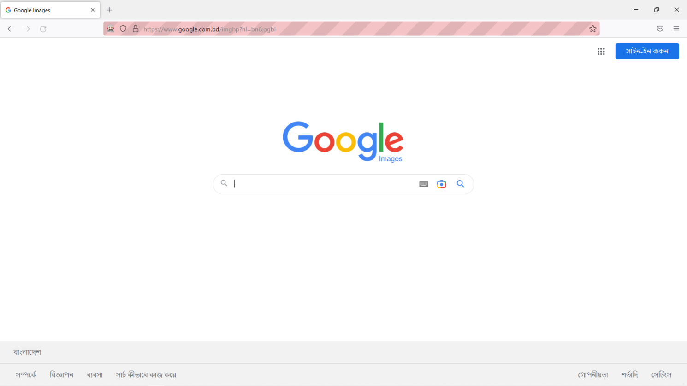

Fig 2.3 : Automatically Navigating Back to Google Search

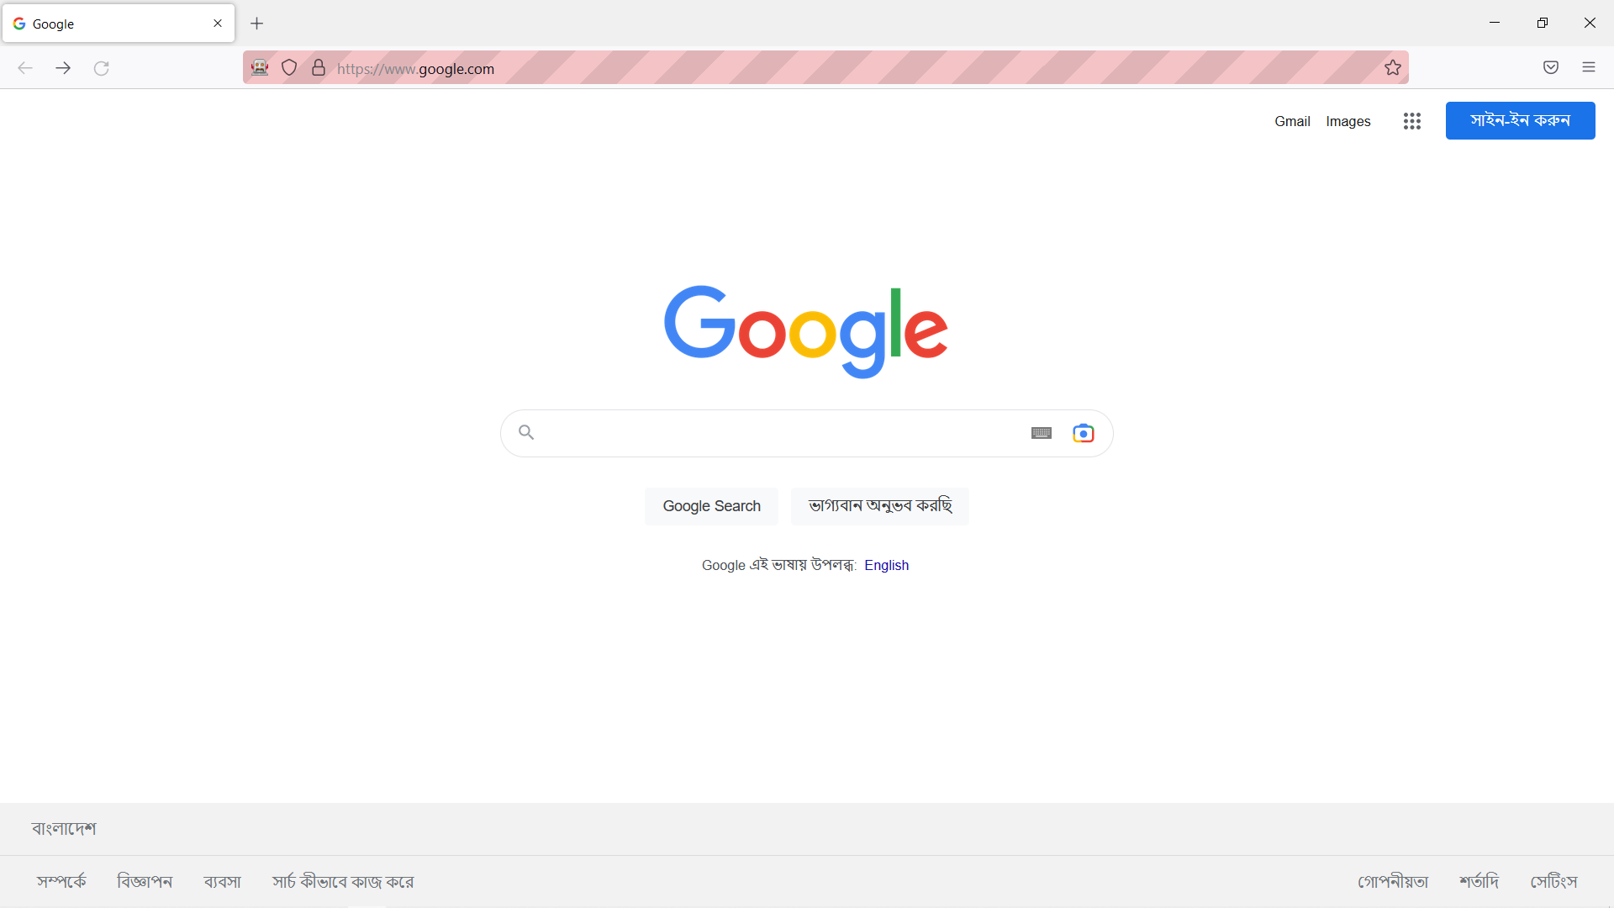

Fig 2.4 : Automatically Forwarded and Refresh Done