

American International University-Bangladesh (AIUB)  
**Department of Computer Science  
Faculty of Science &Technology (FST)  
Summer 21-22**

**ONLINE METRORAIL TICKET BOOKING SYSTEM**

Software Requirement Engineering

Sec: **A**

Project submitted

By

*ADITTO AL ASHIR (19-40049-1)*

*PRISILA SAHA (19-39759-1)*

*ASHFAT AL RASHID (19-40195-1)*

*EITHER RAHMAN (19-39750-1)*

**Checked By Industry Personnel**

Name:

Designation:

Company:

Sign:

Date:

1. **INTRODUCTION**Online Metro rail Ticket Booking System is a web-based system that allows users to purchase online metro-rail tickets from any location in Dhaka City. Online train is a completely new addition to our day-to-day mass transit medium. Because it is a new mass transportation system, we wanted to make it easily available to the people of our nation. Online tickets management system is a full fledge online based system.  
   Our Country is a small part of South Asian region with 165.6 million (2019) people and Dhaka is 3rd most densely populated city in the whole world. People from all over the country comes to the capital in search of livelihood, so public transport is the sole way of many people to travel from home to their workstations and people has to spend their valuable time by waiting in line to get on a bus to go to work also because of the narrow roads and rickshaws traffic jam is meant to happen which doubles the stress and kills more time. As online train is a new addition to the public transport sector people will start to rely on it on daily basis, so to remove the hassle of booking ticket from physical stations and long waiting ticket lines our project will help them on the process. People can sit on their house and book ticket to their respective destination at any given time and depart for their workstations with any hassle.

1. **PROBLEM DOMAIN**
   1. **Background to the Problem**

Online Metrorail Ticket Booking System is an online-based system where users can book an online train ticket from anywhere. In our country, people from all over the country come to the capital Dhaka in search of livelihood, so public transport is the sole way for many people to travel home to workstations. As we know Dhaka is known for traffic jams and overpopulation. To buy train tickets they have to stand and wait in a line and it kills their valuable time. People cannot use other vehicles easily as an option, because they have to face traffic jams. To solve this problem, we want to develop an online-based Metrorail ticket booking system. As the online train ticket is a new addition to the public transport sector people will start to rely on it on daily basis, so to remove the hassle of booking tickets from physical stations and long waiting ticket lines our project will help them in the process.

* 1. **Solution to the Problem**

As the world is daily approaching the peak of technological achievement, our country is trying its best to cope-up with the rest of the world through the digitalization of its traditional systems and people are more into online-based solutions to their problems rather than solving them offline. The online train is a completely new addition to day-toy to day life public transport medium, as it’s a new transport system for the mass we wanted to make easily accessible for the people of our country. The online train ticket management system is a full fledge online-based system. By making an online based ticket booking system for public transport people will find it easy to travel through public transport and which will eventually help to eliminate traffic jams as part of the population will rely less on their personal vehicles. This online booking system will be both available on mobile applications and open browsers, people can access their account to their accounts on both platforms. All the user and system information will be stored in an internal database where people can get information about any online train-related queries with one click.As the whole solution is based on the convenience of the mass it has no business objectives and its sole reason is to make people’s life easier.

1. **SOLUTION DESCRIPTION**
   1. **System Features**

***User:***

The user can register into the system with his/her e-mail

The user log in into the system

The user can log out from the system

They use that can view his or her own profile

The user can view the location of the train

The user can purchase ticket

The user can file a complaint if there is any

The user can see the number of station nearby him and available trains

The user can have both language option Bangla and English

The user can choose to pay for the purchase ticket by MFS or by MasterCard

***Admin:***

Admin can see his own profile

The admin has both login and logout function

The admin can see the total number of purchase ticket

The admin can see the available trains and the schedule of the trains

The admin can see complaints of the users

The admin can see complaints that have already been solved buy that stuff

The admin can change the train time schedule

The admin can also insert or delete users

* 1. **UML Diagrams**
* **Use-Case Diagram:**

In an online train ticket booking management system, a user can choose system interface language which can be in any language a user wants (English/ Bangla). Then user gives email information to register in to the system and the system verifies the username and password and a verification email is sent to user whenever he/she registers for the first time on some software system. Then user logs in to the account with his user id and password, then the system checks if the given user id and password is valid or not. Then the user books ticket by filling information about his destination, and time. After that user applies for available ticket and the system checks if ticket on that specific time is available or not. The user can also get update of current position of the train from an Admin and the admin gives information with help of GPS tracking. After the ticket booking the user has to do payment for the ticket, He can pay by his B-kash wallet, rocket or visa/master card. The user can also register any kind of complain regarding ticket booking and late arrival of train which will be processed by the Admins.

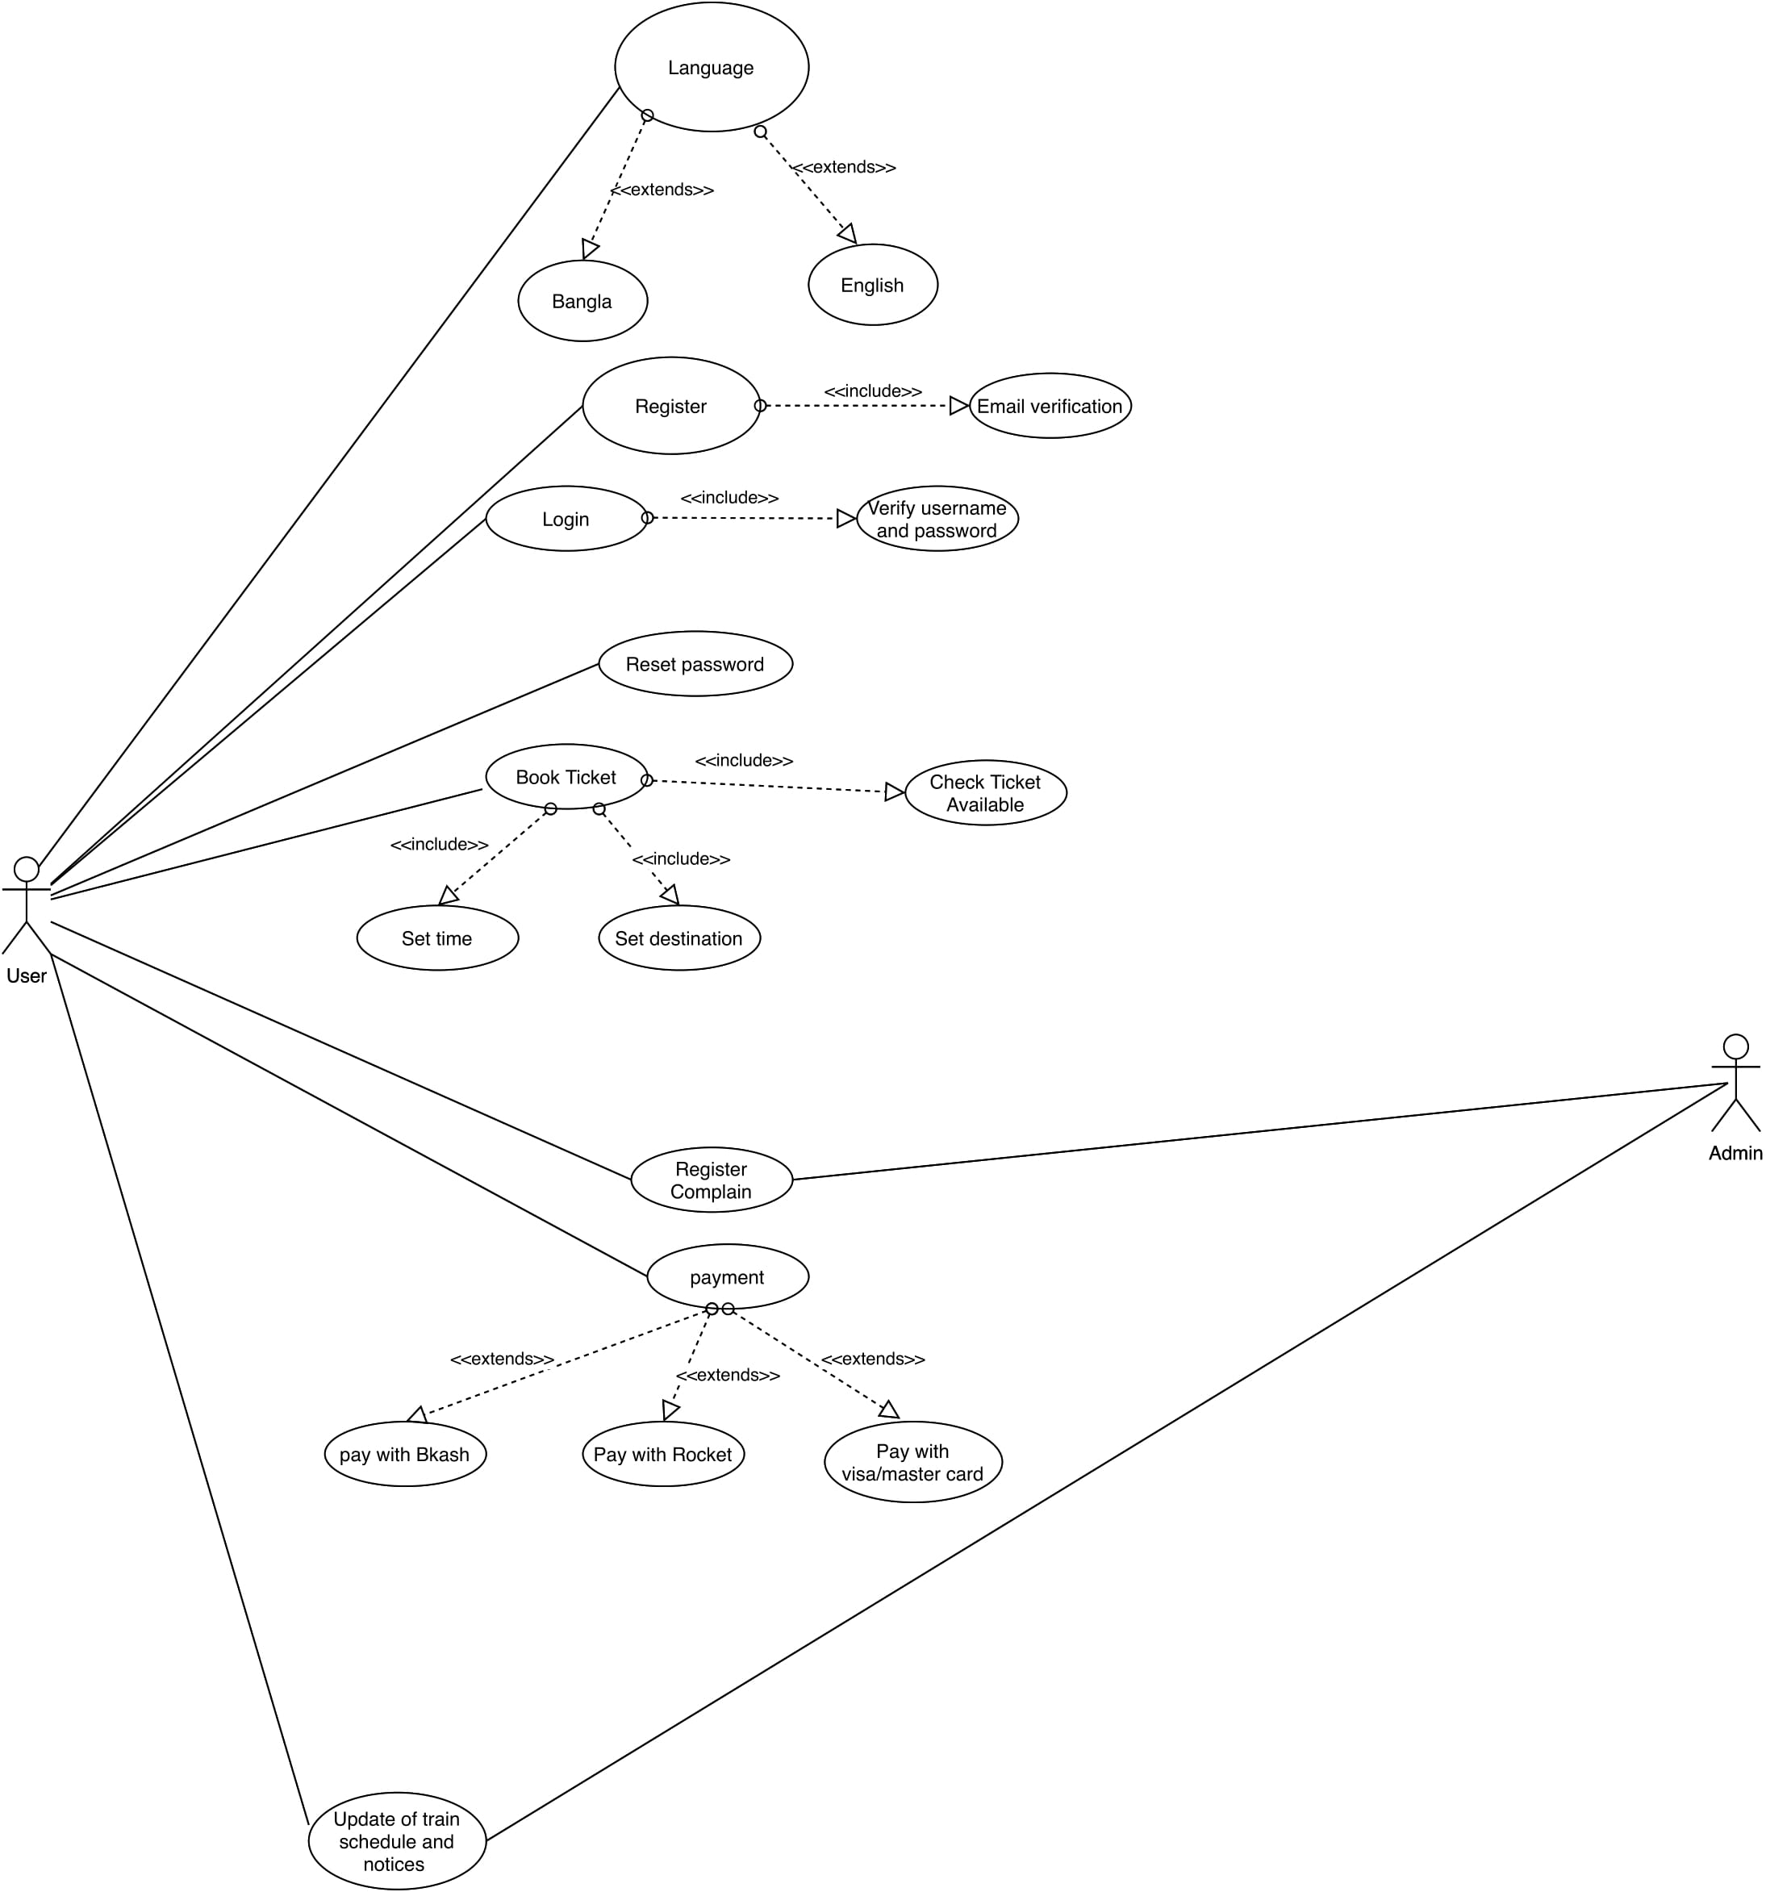

* **Activity Diagram:**  
  The user registers for the first time with email information and the system checks if the information is valid or not uses then he enters login id and password to login to the system. The system checks if the login id is valid or not if the information is valid the user has logged in the system successfully. Then the user selects the destination and time to book a ticket. Then the system checks if the ticket is available for certain time. If the ticket is available, the user proceeds to make payment for the ticket otherwise the user has to request ticket for different time and date. After that the user can proceed to make payment. If the payment is successful, the system sends notification to the user with confirmation and Ticket Number. If the payment is unsuccessful the user is requested to make the payment again.  
  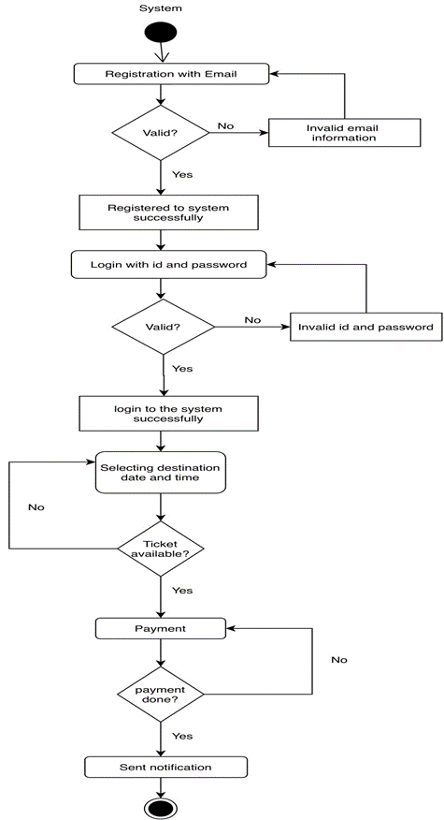
* **Class Diagram**In an online train ticket booking management system, a user registers for the first time with email information and the system checks if the information is valid or not then the user logs in to the account with his user id and password, then the system checks if the given user id and password is valid or not. Then the user books ticket by filling information about his destination, and time. One user can book 1 or more tickets. The user can also get update of current position of the train and the system gives information with help of GPS tracking. After the ticket booking the user has to do payment for the ticket, the user can also register any kind of complain regarding ticket booking and late arrival of train which will be inspected by the Admin. A user can register 1 or more complains.  
  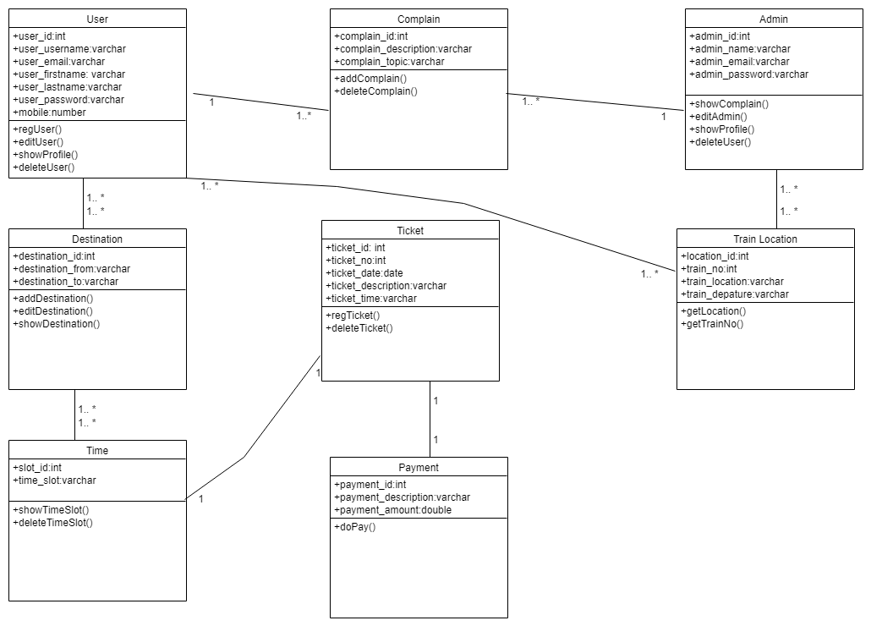
* **E-R diagram:**Our System is to book tickets for online train system. Our primary goal is to make booking ticket easy for the passengers. The passenger will select a destination for booking ticket. Then he/she has to choose time to book the ticket and lastly make payment to finalize it. There will also be an admin who will oversee train schedule. The passenger can also register complain in the system which will be overseen by admin.  
  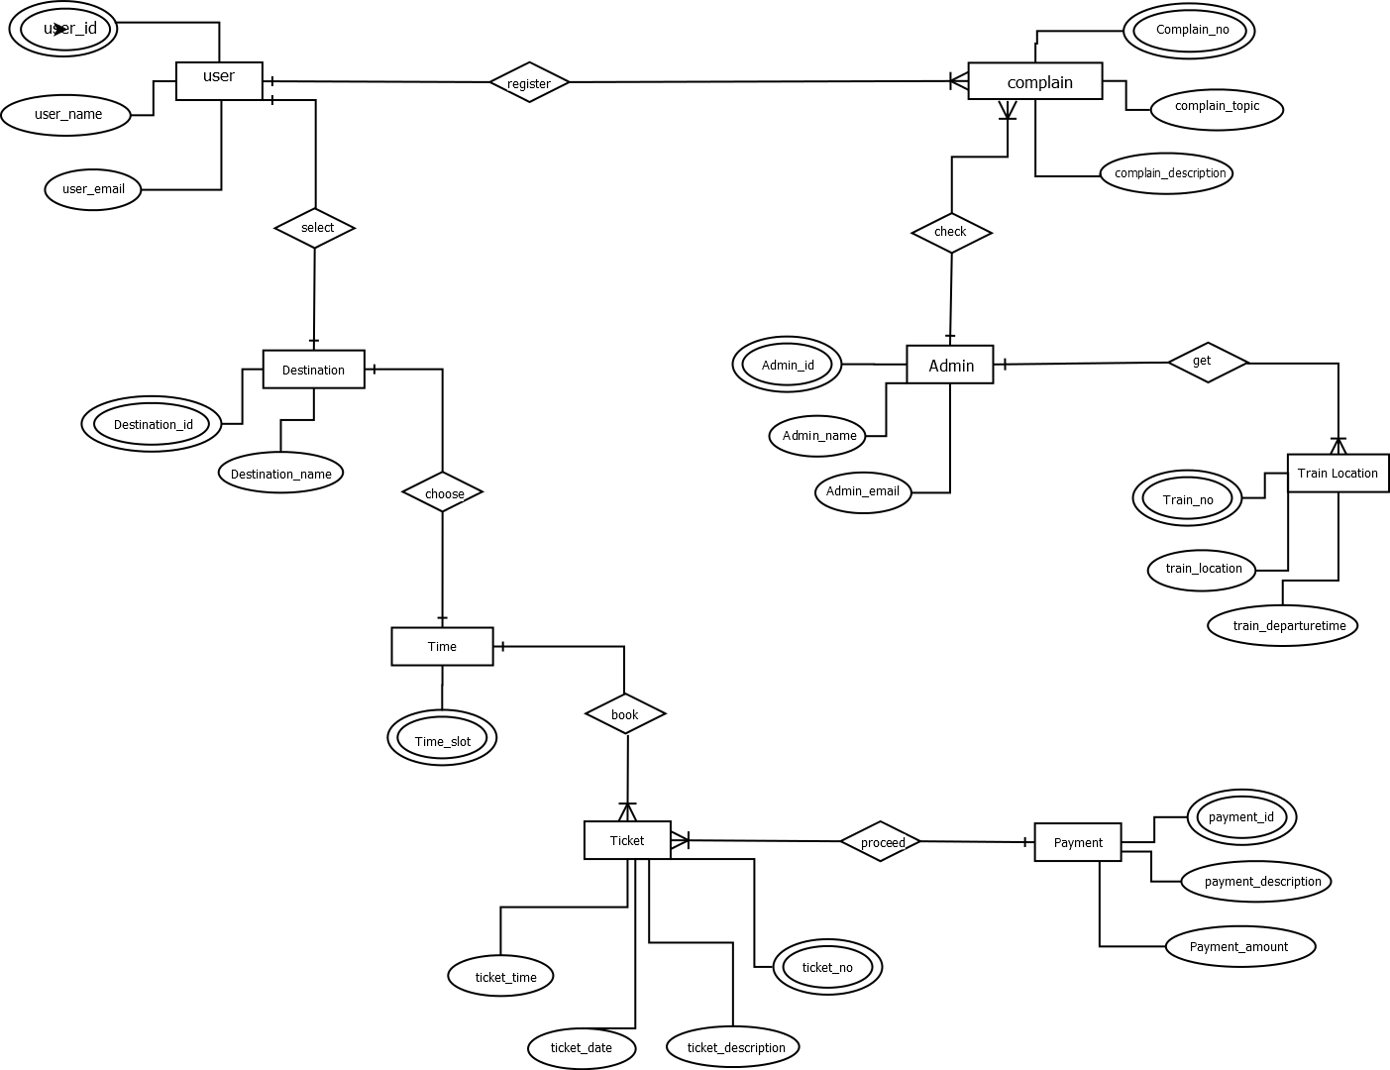

**3.3 Mockup** ***User Dash-board***   
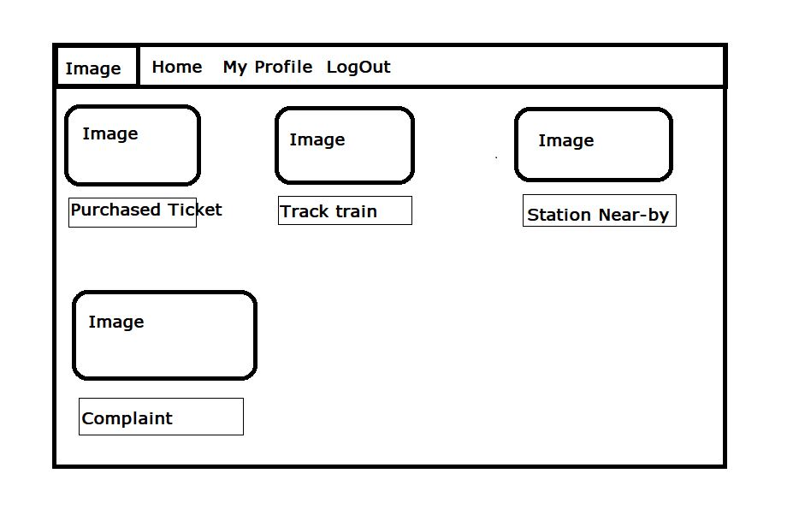

***Admin Dashboard***

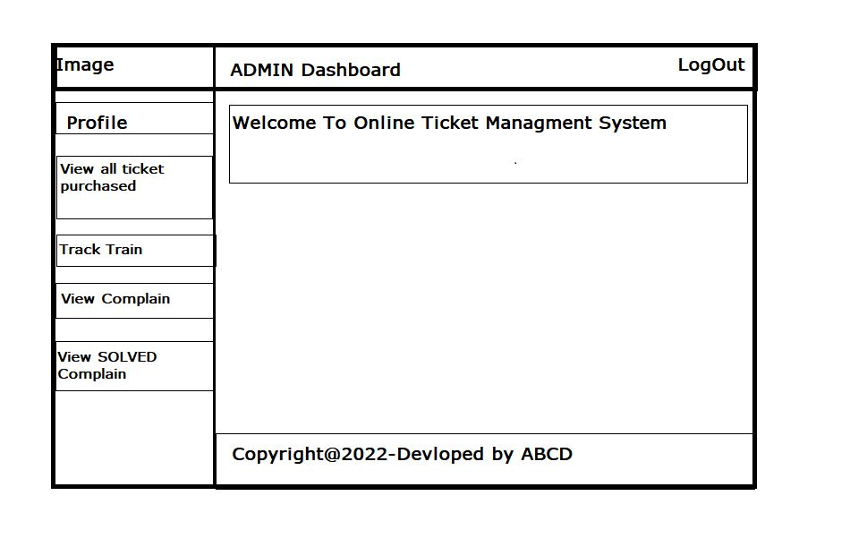

1. **Social Impact of Online Metrorail Ticket Booking System**

A metro rail is a train that is specifically designed to run in metropolitan areas while local trains are designed to connect the distances within the city and its suburbs area. Bangladesh is building Mass Rapid Transit System for the first time in our country. The 20 km Line-6 is an elevated metro rail system connecting Uttara and Motijheel in Dhaka, passing through the busy areas of Pallabhi and Mirpur, with 16 stations and a Maintenance Depot. [1] As a result, we can easily understand that Metrorail has a huge impact on people’s lives as well as the online ticket booking system for Metrorail will be very much helpful and satisfactory for the nation of our country.

Dhaka is the third largest city in the world. With people coming to the capital from all over the country in search of a living, public transport is the only way for many to get from their homes to work, and people wait in line to get on public transport, which is a precious commodity. you have to waste a lot of time. Buses commuting for narrow streets and rickshaws, traffic jams are inevitable, doubling stress and taking more time. become more dependent on online trains. To avoid the hassle of booking tickets at actual stations or long queues, our project helps them in this process. People can easily book their ticket through online and go for their desired location at a certain time without any difficulties. [2]

Establishing an online-based public transport ticket booking system will make it easier for people to travel on public transport, and will eventually reduce congestion as a portion of the population will rely less on private vehicles. help you get rid of it. The whole solution is based on the convenience of the crowd, so it has no business goal, the sole purpose is to make people's lives easier.

This online booking system is available on both mobile his application and open browser, allowing users to access their accounts on both platforms. All user and system information is stored in an internal database, giving you one-click access to information on all train-related inquiries online. [3]

Although our country used an online ticket booking system for intercity travel, there was no platform for ordinary people to travel within urban areas. Our online train ticket booking system is unique and interesting because online trains open up new ways of getting around the city.

Moreover, Online Metrorail Ticket Booking System will increase the cost efficiency and productivity of work. Because, people can buy easily online ticket without any hassle and there will not be any black ticket syndicate. So, the company can earn more money and invest on the further development of the online ticket system technology. [4] After all, it can be said that Online Metrorail Ticket Booking System is going to be an essential part of our lives specially for those people who continuously travel intercity for different purposes. People will be benefitted through this technology and Metrorail will create an economic improvement to our country.

1. **Development Plan with Project Schedule**

***Ghent Chart***

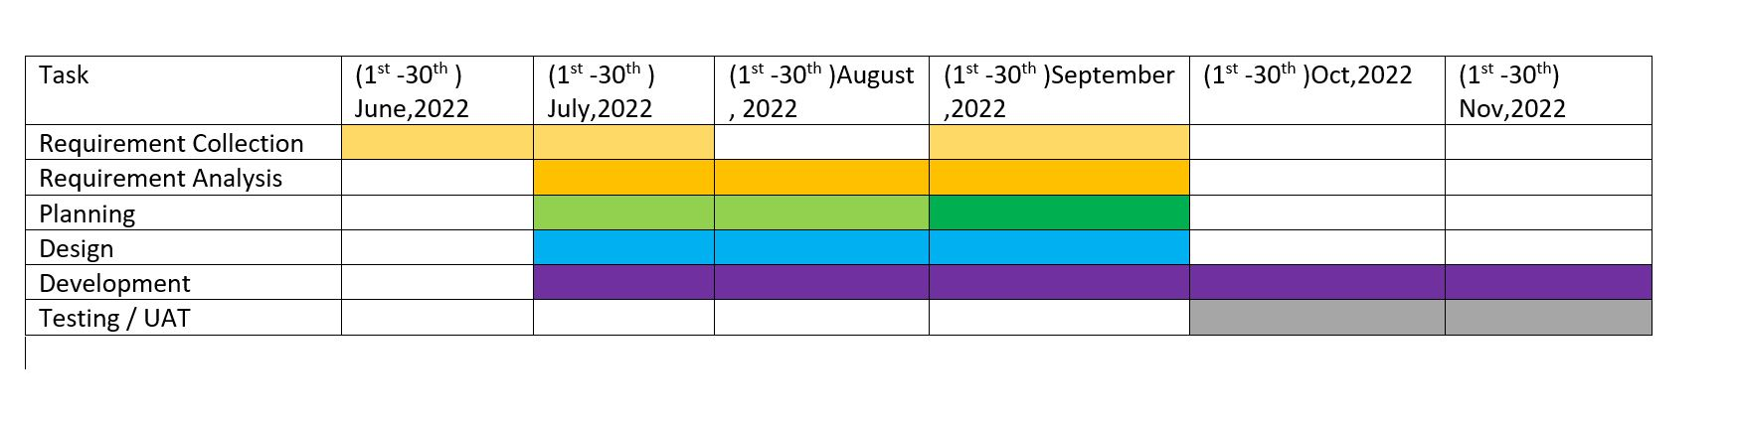

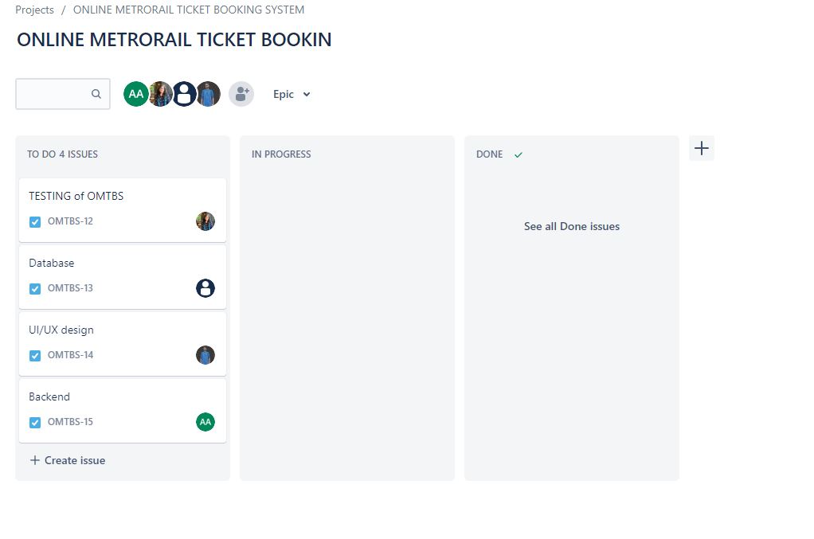

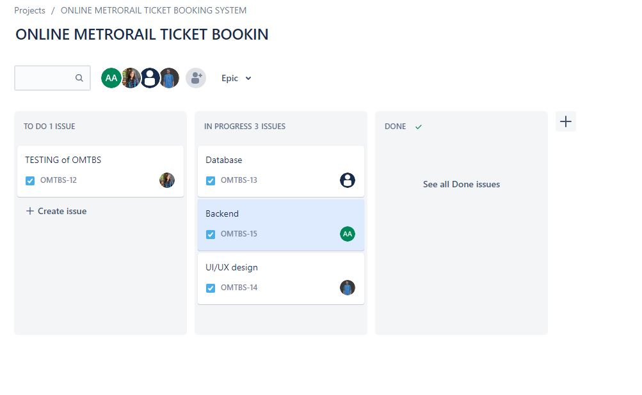

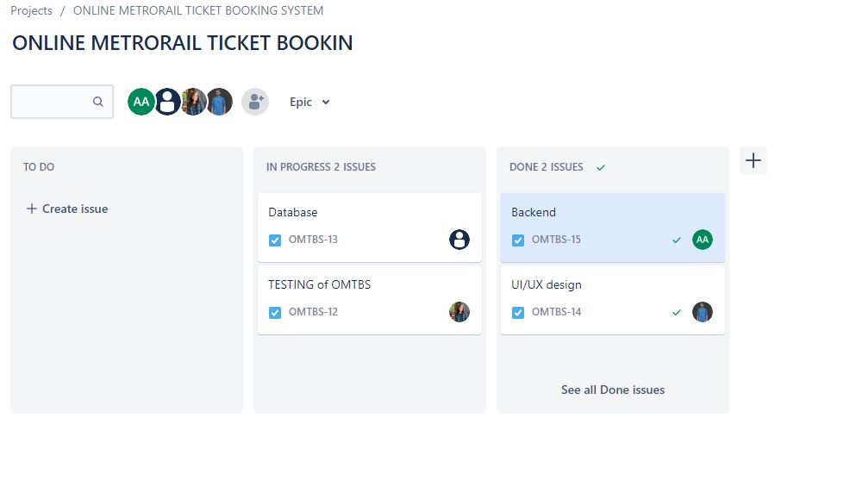

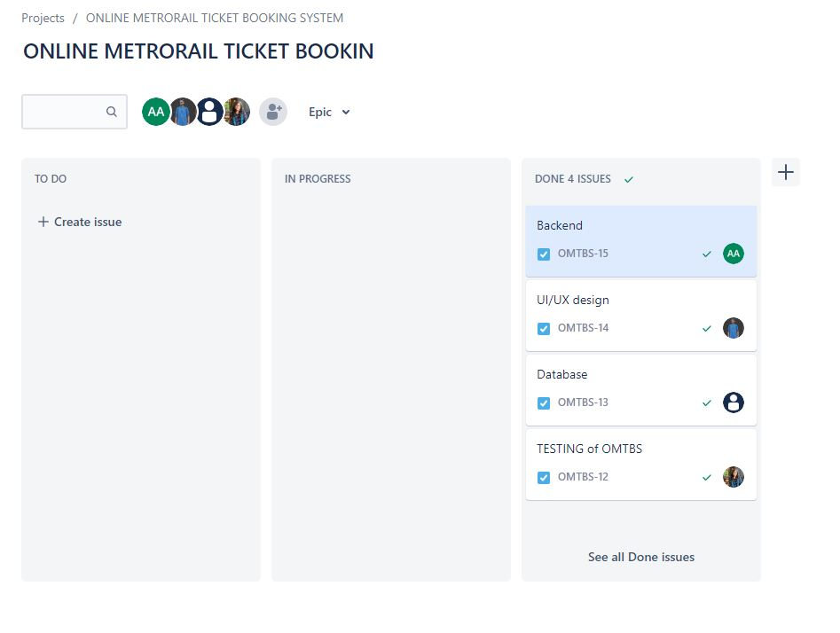

1. **Marketing Plan**

We can run different marketing plans to promote our app to the user. These plans can be short-term, long term and continuous because we need to reach out to a wide number of users so that they can get benefits from our invention. So we have planned 3 ways of the marketing plan so that we can reach out to people who will be our potential customers.

**Short term plan**

* Running Campaign
* Distributing flyers
* Advertising in printed /online news portal

**Long term plan**

* TV advertisement
* Billboard

**Continuous plan**

* Facebook Advertisement
* YouTube advertising

.

1. **Cost and Profit Analysis**

Most common way of public transport system is by Bus, according to BRTA the per K.M is 2.20tk but in reality the cost is much more than that. In metro-rail the cost proposed cost per K.M is 2.40tk. If we apply Online ticket management system in metro-rail, then the company will make a much profit because the minimum salary of the ticket counter representative will be 15thousand tk monthly where by installing this service they have to invest only once to receive its results. To make profit to the company the metro rail will have to earn about 2.33corore that will be achievable by 483000 passengers if they travel daily. but in previous study’s and estimation have shown that between 9am-6pm about 960000 passengers will use metro and minus the ticket counter representative the revenue generation will increases for the company

1. **Reference**

[1] Borthick, A.F., & Kiger, J.E. (2003). Designing audit procedures when evidence is electronic: The case of e-ticket travel revenue. Issues in Accounting Education, 18(3), 275-290.

[2] Chen, S. (2012). The customer satisfaction-loyalty relation in an interactive e-service setting: The mediators. Journal of Retailing & Consumer Services, 19(2), 202-210.

[3] Jakubauskas, G. (2006). Improvement of urban passenger transport ticketing systems by deploying intelligence transport system. Transport, 21(4), 252-259.

[4] Sulaiman, A., Ng, J., & Mohezar, S. (2008). E-ticketing as a new way of buying tickets: Malaysian perceptions. Journal of Social Science, 17(2), 149-157.

[5]. https://businessinspection.com.bd/economical-impacts-of-dhaka-metro-rail-project/