**Content**

**Page No:**

1. Introduction ----------------------------------------------------------------- 2
2. Project Proposal ------------------------------------------------------------------ 2
3. Class Diagram ------------------------------------------------------------------- 3
4. Use Case Diagram ----------------------------------------------------------------- 4
5. Activity Diagram ------------------------------------------------------------------ 5-7
6. User Interface ------------------------------------------------------------------ 8-9
7. Scenario Description -------------------------------------------------------------- 10
8. ER Diagram ------------------------------------------------------------------ 10
9. Normalization ------------------------------------------------------------------ 11
10. Schema Diagram ------------------------------------------------------------------ 12
11. Table Creation ------------------------------------------------------------------ 12-16
12. Data Insertion ------------------------------------------------------------------ 17-20
13. Query Writing(SQL) ---------------------------------------------------------------- 20-25
14. Relational Algebra ---------------------------------------------------------------- 26
15. Conclusion ------------------------------------------------------------------ 26

**Introduction:**

In today's fast-paced world, efficient delivery of products is essential for businesses to grow. Our system aims to provide a seamless experience for everyone involved in the courier process. The primary objective of our Courier Management System is to facilitate the smooth movement of goods from the merchant to the customer, ensuring timely and secure deliveries. With our system in place, merchants can easily place orders for their products, which will then be processed and dispatched through a well-structured workflow.

**Project Proposal:**

Our system will allow merchants to effortlessly place their products, which are then routed to a receiver hub. From there, a dedicated delivery hub takes charge, assigning a delivery person to ensure efficient order fulfillment. With our system, merchants can effortlessly send products to customers, creating a smooth and reliable delivery experience for everyone involved. The journey of a product begins when a merchant initiates an order. The system captures essential information such as Merchant Name, and Merchant Contact. This data allows for effective communication and coordination throughout the delivery process. Once an order is placed, it is assigned a unique Order ID and associated with the order location. The system tracks the order as it moves from the merchant to the receiver hub, where it awaits further processing. At the receiver hub, crucial details such as the receiver's name, Receiver Location, and expected delivery time are recorded. After the order has reached the receiver hub, a dedicated delivery man is assigned to handle the order. The delivery man is responsible for transporting the order from the receiver hub to the customer's location. The delivery location and estimated delivery time are captured to ensure accurate and efficient delivery.

**Class Diagram:**

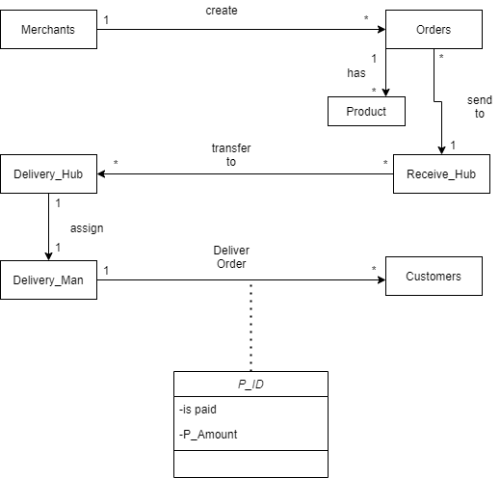

**Use Case Diagram:**

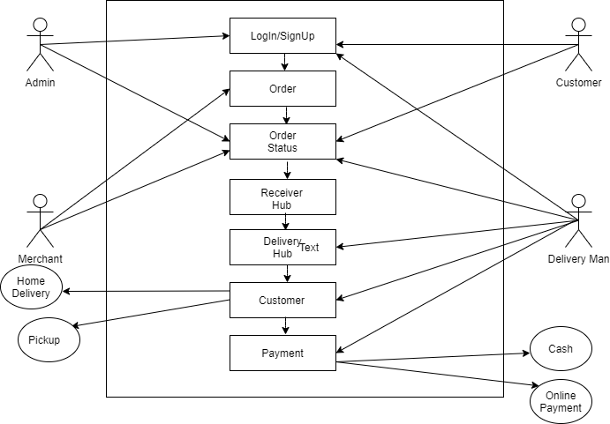

**Activity Diagram:**

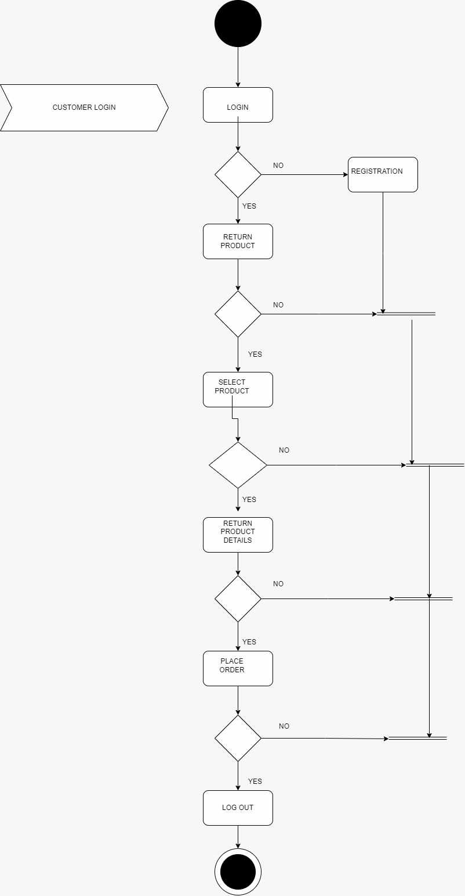

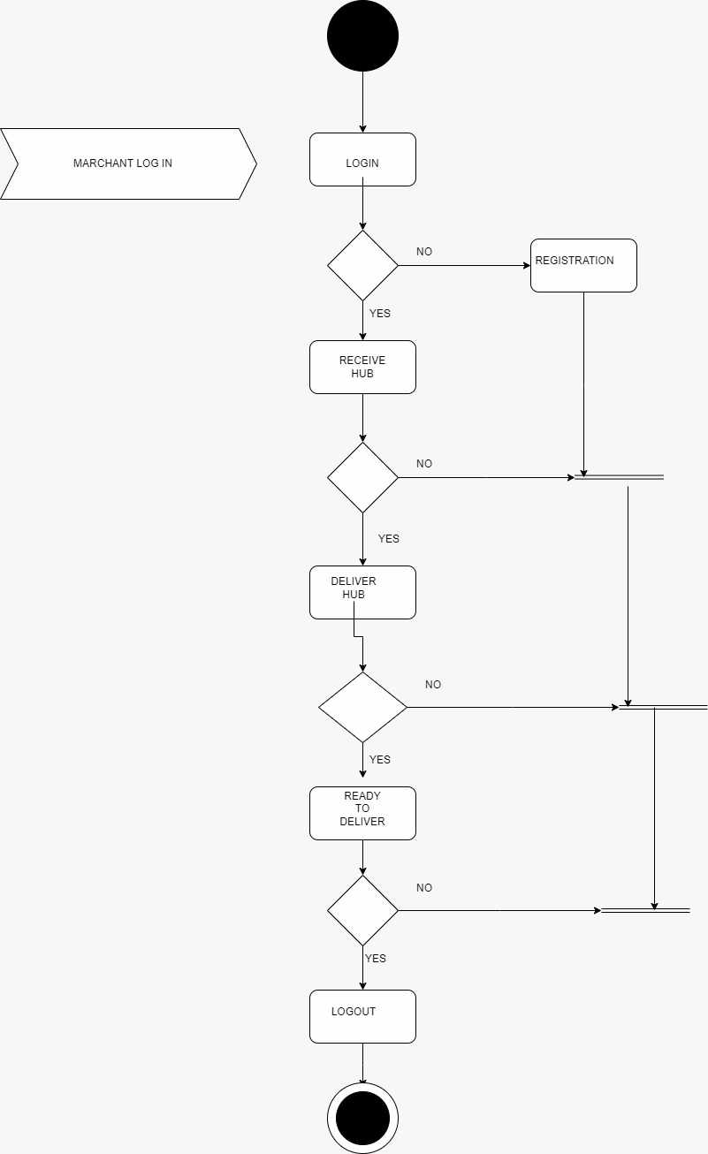

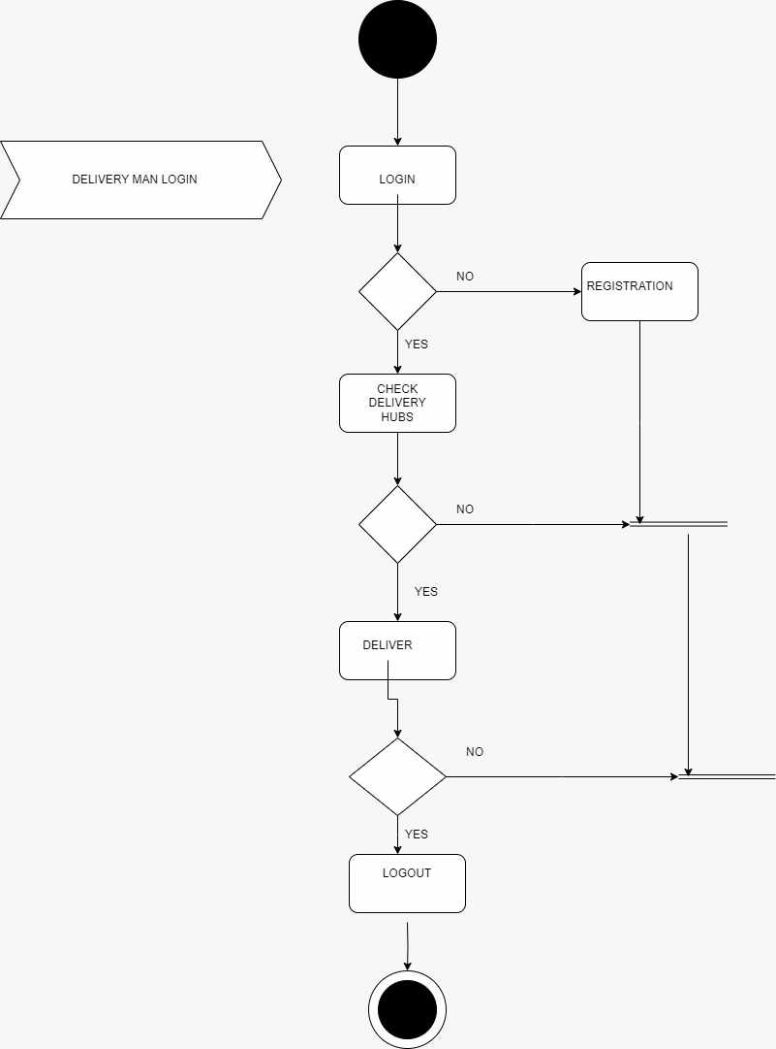

**User-Interface:**

**Login Page**

**

**Order Place Page**

**Track Product Page**

**

**Scenario Description:**

This is a courier service management system. In the data base customer’s details Customer id, customer contact will be stored. Customer will place an order and each of the order should have order id order location, order name. Customer will make payment and the payment id and payment amount will be stored on the data base. Then merchant will create an order receive hub. Marchant also have a unique id, name, contact. Receive hub id, location, time also be stored on the data base. Then transfer that to the delivery hub. Delivery hub have a unique delivery id, location and time. And it will come to deliveryman. Delivery man has a unique id, and contact number.

**ER Diagram:**

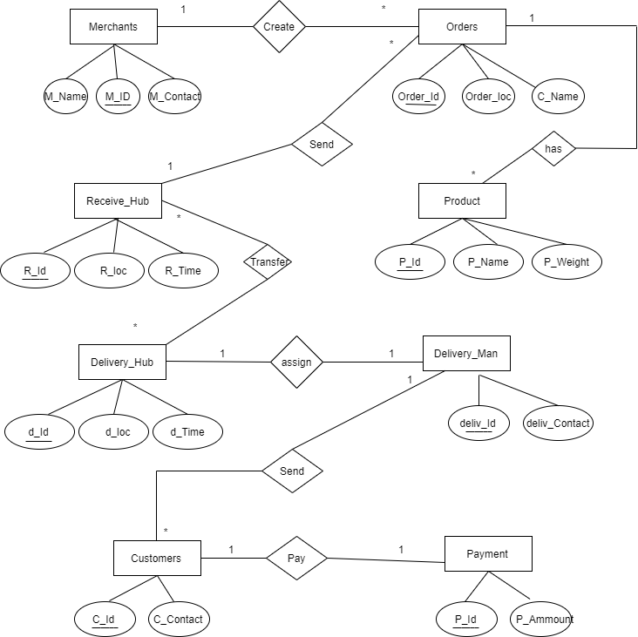

**Normalization:**

**NF**  
**UNF**  
M_ID, M_Name, M_Contact, Order_ID , Order_Loc, C_Name, P_ID , P_Name , P_Weight, C_Name, R_ID , R_Loc, R_time, D_ID , D_Loc, D_Time, Deliv_ID , Deliv_Contact

**Merchants**

1NF:

1: M_ID, M_Name, M_Contact

2: Order_ID , Order_Loc, C_Name

2NF:  
1: M_ID, M_Name, M_Contact

2: Order_ID , Order_Loc, C_Name, M_ID

3NF:  
1: M_ID, M_Name, M_Contact

2: Order_ID , Order_Loc, C_Name, M_ID

**Orders**

1NF:

1: Order_ID , Order_Loc, C_Name

2: P_ID , P_Name , P_Weight

2NF:  
1: Order_ID , Order_Loc, C_Name

2: P_ID , P_Name , P_Weight, Order_ID

3NF:

1: Order_ID , Order_Loc, C_Name

2: P_ID , P_Name , P_Weight, Order_ID

**Receive_HUB**  
1NF:

1: Order_ID , Order_Loc, C_Name

2: R_ID , R_Loc, R_time

2NF:  
1: Order_ID , Order_Loc, C_Name , R_ID

2: R_ID , R_Loc, R_time

3NF:  
1: Order_ID , Order_Loc, C_Name , R_ID

2: R_ID , R_Loc, R_time

**Delivery_Hub**

1NF:

1: R_ID , R_Loc, R_time

2: D_ID , D_Loc, D_Time

2NF:  
1: R_ID , R_Loc, R_time, D_ID

2: D_ID , D_Loc, D_Time

**Schema Diagram:**

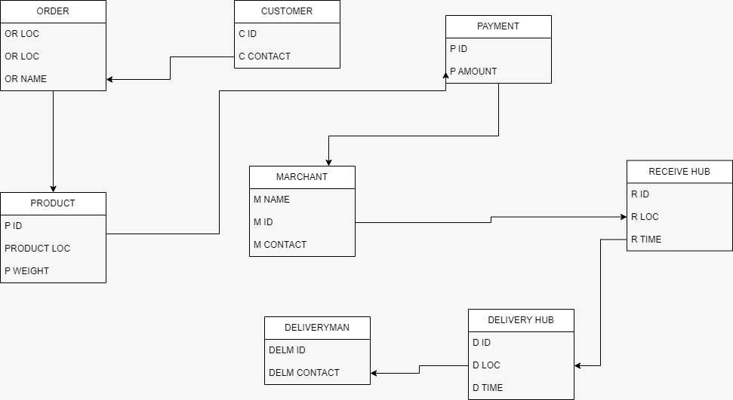

**Table Creation:**

**User Create**

CREATE USER Curriersystem IDENTIFIED BY ashfiqself;

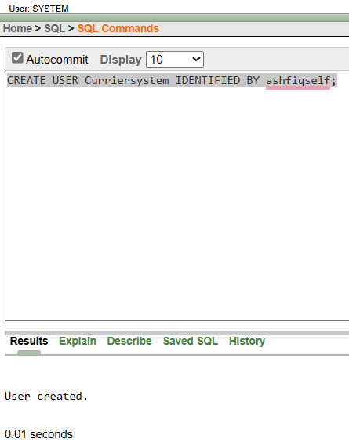

GRANT CREATE SESSION TO Curriersystem;

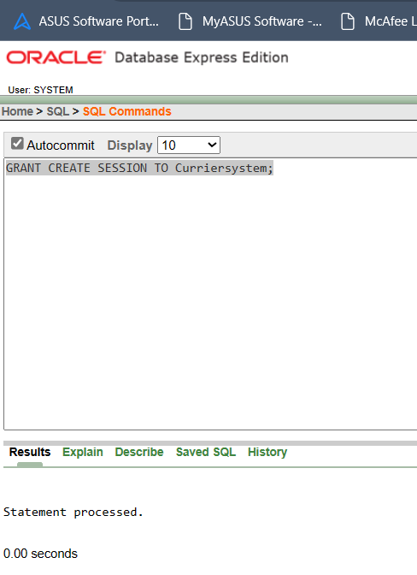

GRANT CREATE TABLE TO Curriersystem;  
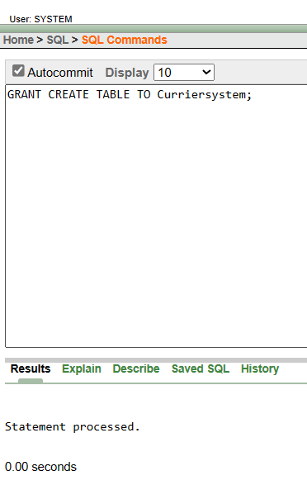

GRANT CREATE VIEW TO Curriersystem;

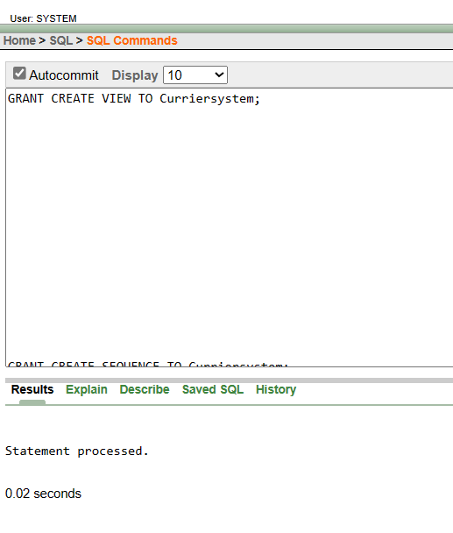

GRANT CREATE SEQUENCE TO Curriersystem;

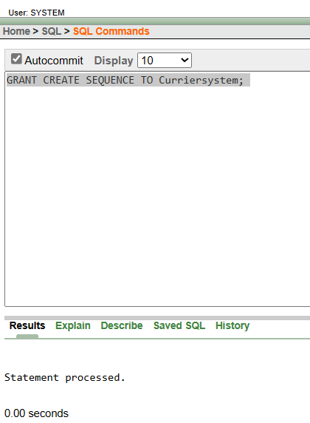

COMMIT;

**Create Marchant’s table**

CREATE TABLE Marchants (

M_ID NUMBER,

M_Name VARCHAR2(255),

M_Contact VARCHAR2(255)

);

DESCRIBE MARCHANTS;

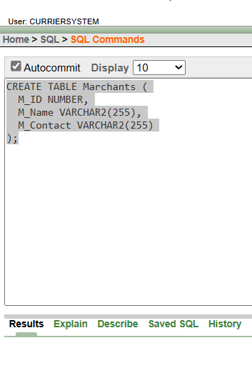

**Order Table Creation**  
CREATE TABLE Orders (

Order_ID NUMBER,

Order_Loc VARCHAR2(255),

C_Name VARCHAR2(255),

M_ID NUMBER

);DESCRIBE ORDERS;

**Product Table Creation**

CREATE TABLE Product (

P_ID NUMBER,

P_Name VARCHAR2(255),

P_Weight NUMBER,

Order_ID NUMBER);

DESCRIBE PRODUCTS;

**Receive_Hub Table Creation**

CREATE TABLE Recieve_Hub (

R_ID NUMBER,

R_Loc VARCHAR2(255),

R_time TIMESTAMP,

D_ID NUMBER);  
DESCRIBE RECEIVE_HUB;

**Delivery_HUB Table Creation**

DELIVARY_HUB TABLE:

CREATE TABLE Delivery_Hub (

D_ID NUMBER,

D_Loc VARCHAR2(255),

D_Time TIMESTAMP,

Deliv_ID NUMBER);

**Delivery_Man Table:**

CREATE TABLE Delivery_Man (

Deliv_ID NUMBER,

Deliv_Contact VARCHAR2(255));

**Customer Table**

CREATE TABLE Customers (

C_ID INT PRIMARY KEY,

C_Contact VARCHAR(50));

**Payment Table**

CREATE TABLE Paymentsys (

P_ID INT PRIMARY KEY,

P_Amount DECIMAL(10, 2),

C_ID INT,

**Data Insertion**

**Data Insertion in Merchants:**  
INSERT INTO Marchants (M_ID, M_Name, M_Contact) VALUES (1, 'Ashfi', '01767333701');

INSERT INTO Marchants (M_ID, M_Name, M_Contact) VALUES (2, 'Muhammed', '01767333733');

INSERT INTO Marchants (M_ID, M_Name, M_Contact) VALUES (3, 'Raiyan', '01867333701');

INSERT INTO Marchants (M_ID, M_Name, M_Contact) VALUES (4, 'Wahid', '01767236789');

INSERT INTO Marchants (M_ID, M_Name, M_Contact) VALUES (5, 'Sajin', '01459861751');

**Data Insert in Orders Table:**  
INSERT INTO Orders (Order_ID, Order_Loc, C_Name, M_ID) VALUES (1, '11/A, Ranoir Kuti, Cumilla', 'Sabuj', 101);

INSERT INTO Orders (Order_ID, Order_Loc, C_Name, M_ID) VALUES (1002, 'F/A, Kuratuli, Dhaka', 'Rafin', 116);

INSERT INTO Orders (Order_ID, Order_Loc, C_Name, M_ID) VALUES (1015, '#12/D, Bashundhara, Dhaka', 'Rafsan', 204);

INSERT INTO Orders (Order_ID, Order_Loc, C_Name, M_ID) VALUES (1111, '702, Asf Taower, 4D,Banani, Dhaka', 'Ahmed', 305);

INSERT INTO Orders (Order_ID, Order_Loc, C_Name, M_ID) VALUES (2221, '#345, 6F, Jakir Tower, Madhya Badda, Dhaka' , 'Faruk', 410);

select * from Orders;

**Product Table Data Insertion:**  
INSERT INTO Product (P_ID, P_Name, P_Weight, Order_ID) VALUES (1, 'Trimer', '1', 1);

INSERT INTO Product (P_ID, P_Name, P_Weight, Order_ID) VALUES (2, 'Makeup Box', '2', 1002);

INSERT INTO Product (P_ID, P_Name, P_Weight, Order_ID) VALUES (3, 'T-Shirt', '0.5', 1015);

INSERT INTO Product (P_ID, P_Name, P_Weight, Order_ID) VALUES (4, 'Mango', '5', 1111);

INSERT INTO Product (P_ID, P_Name, P_Weight, Order_ID) VALUES (5, 'Tool', '10', 2221);

select * from product;

**Receive_Hub Data Insertion:**  
INSERT INTO Recieve_Hub (R_ID, R_Loc, R_time, D_ID) VALUES (101, 'Chittagong', TIMESTAMP '2023-07-13 10:00:00', 1);

INSERT INTO Recieve_Hub (R_ID, R_Loc, R_time, D_ID) VALUES (102, 'Khulna', TIMESTAMP '2023-07-14 12:00:00', 2);

INSERT INTO Recieve_Hub (R_ID, R_Loc, R_time, D_ID) VALUES (103, 'Rajshahi', TIMESTAMP '2023-07-15 14:00:00', 3);

INSERT INTO Recieve_Hub (R_ID, R_Loc, R_time, D_ID) VALUES (104, 'Jessore', TIMESTAMP '2023-07-16 11:00:00', 4);

INSERT INTO Recieve_Hub (R_ID, R_Loc, R_time, D_ID) VALUES (105, 'Rangpur', TIMESTAMP '2023-07-17 1:00:00', 5);

Select * from Recieve_Hub ;

**Delivery_Hub Data Insertion:**  
INSERT INTO Delivery_Hub (D_ID, D_Loc, D_Time, Deliv_ID) VALUES (201, 'Cumilla', TIMESTAMP '2023-07-20 08:00:00', 1);

INSERT INTO Delivery_Hub (D_ID, D_Loc, D_Time, Deliv_ID) VALUES (202, 'Kuratoli, Dhaka', TIMESTAMP '2023-07-21 09:00:00', 2);

INSERT INTO Delivery_Hub (D_ID, D_Loc, D_Time, Deliv_ID) VALUES (203, 'Bashundhara, Dhaka', TIMESTAMP '2023-07-22 10:00:00', 3);

INSERT INTO Delivery_Hub (D_ID, D_Loc, D_Time, Deliv_ID) VALUES (204, 'Banani, Dhaka', TIMESTAMP '2023-07-23 09:00:00', 4);

INSERT INTO Delivery_Hub (D_ID, D_Loc, D_Time, Deliv_ID) VALUES (205, 'Badda, Dhaka', TIMESTAMP '2023-07-24 09:00:00', 5);

Select * from Delivery_Hub;

**Delivery_man Data Insertion:**

INSERT INTO Delivery_man (Deliv_ID, Deliv_Contact) VALUES (10, '1561514515');

INSERT INTO Delivery_man (Deliv_ID, Deliv_Contact) VALUES (20, '4565145455');

INSERT INTO Delivery_man (Deliv_ID, Deliv_Contact) VALUES (30, '2151515154');

INSERT INTO Delivery_man (Deliv_ID, Deliv_Contact) VALUES (40, '8851154596');

INSERT INTO Delivery_man (Deliv_ID, Deliv_Contact) VALUES (50, '4448777774');

select * from Delivery_man ;

**Customer Data Insertion**

INSERT INTO Customers (C_ID, C_Contact)

VALUES (1,'123-456-7890');

INSERT INTO Customers (C_ID, C_Contact)

VALUES (2,'5551545599');

INSERT INTO Customers (C_ID, C_Contact)

VALUES (3,'78789399');

INSERT INTO Customers (C_ID, C_Contact)

VALUES (4,'9541565664');

INSERT INTO Customers (C_ID, C_Contact)

VALUES (5,'89431626621');

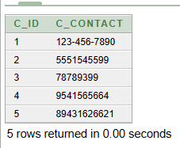

**Payments Data Insertion**

INSERT INTO Paymentsys (P_ID, P_Amount, C_ID) VALUES (1, 100.00, 1);

INSERT INTO Paymentsys (P_ID, P_Amount, C_ID) VALUES (2, 100.00, 2);

INSERT INTO Paymentsys (P_ID, P_Amount, C_ID) VALUES (3, 100.00, 3);

INSERT INTO Paymentsys (P_ID, P_Amount, C_ID) VALUES (4, 100.00, 4);

INSERT INTO Paymentsys (P_ID, P_Amount, C_ID) VALUES (5, 100.00, 5);

**Query Writing**

**SQL**

**-3 single-row function**

**Question 1:** Retrieve the length of the M_Name column for all rows in the Marchants table.

**Answer:**

SELECT M_Name, LENGTH(M_Name) AS Name_Length

FROM Marchants;

**Question 2:** Retrieve the first three characters of the C_Name for all rows in the Orders table.

**Answer:**

SELECT C_Name, SUBSTR(C_Name, 1, 3) AS First_Three_Characters

FROM Orders;

**Question 3:** Retrieve the current date and time.

**Answer:**

SELECT SYSDATE AS Current_Date_Time

FROM DUAL;

**-3 group function**

**Question 1:** Calculate the maximum P_Weight in the Product table.

**Answer:**

SELECT MAX(P_Weight) AS Max_Weight

FROM Product;

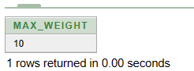

**Question 2:** Count the number of distinct locations in the "Recieve Hub" table.

**Answer:**

SELECT COUNT(DISTINCT R_Loc) AS Distinct_Locations

FROM Receive_Hub;

**Question: 3:** Determine the number of orders placed by each merchant in the Marchants table

**Answer:**

SELECT M_Name, COUNT(*) AS Order_Count

FROM Marchants M

JOIN "Order" O ON M.M_ID = O.M_ID

GROUP BY M_Name;

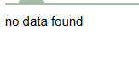

**-3 subquery**

**Question 1:** Retrieve the C_Name and Order_Loc for all orders where the M_ID is not present in the Marchants table.

**Answer:**

SELECT O.C_Name, O.Order_Loc

FROM Orders O

WHERE O.M_ID NOT IN (SELECT M_ID FROM Marchants);

**Question: 2:** Retrieve the M_ID, M_Name, and M_Contact from the 'Marchants' table for the merchant with the highest M_ID."

**Answer:**

SELECT M_ID, M_Name, M_Contact

FROM Marchants

WHERE M_ID = (SELECT MAX(M_ID) FROM Marchants);

**Question: 3:** Retrieve the Order_ID and Order_Loc from the 'Orders' table for orders that have an Order_Loc value present in the 'Customers' table.

**Answer:**

SELECT Order_ID, Order_Loc

FROM Orders

WHERE Order_Loc IN (SELECT DISTINCT Order_Loc FROM Customers);

**-3 joining:  
Inner Joining:**1. Inner Join between Orders and Product:

Answer:

SELECT O.Order_ID, O.Order_Loc, P.P_ID, P.P_Name

FROM Orders O

INNER JOIN Product P ON O.Order_ID = P.Order_ID;

**Left Joining:**

SELECT C.C_ID, C.C_Contact, P.P_ID, P.P_Amount

FROM Customers C

LEFT JOIN Paymentsys P ON C.C_ID = P.C_ID;

**Cross Joining:**

SELECT O.Order_ID, O.Order_Loc, P.P_ID, P.P_Name

FROM Orders O

CROSS JOIN Product P;

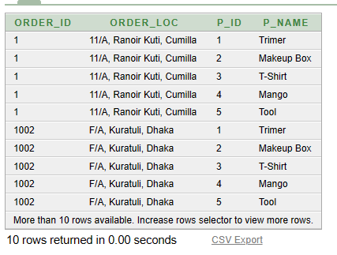

**-3 view**

**Question:1:Create View for Marchant Orders**

**Answer:**

CREATE VIEW MarchantOrders AS

SELECT M.M_ID, M.M_Name, O.Order_ID, O.Order_Loc

FROM Marchants M

INNER JOIN Orders O ON M.M_ID = O.M_ID;

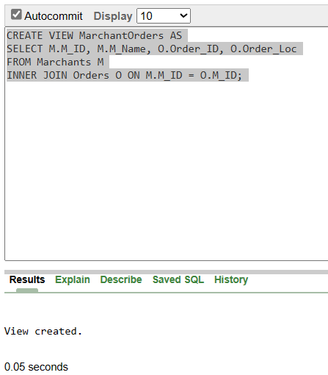

**Question:2: Create view for Product Details:**

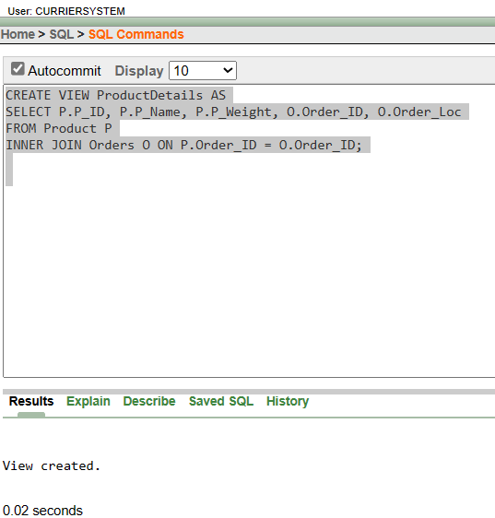

**Question: 3: Create view for Customer Payments:**

CREATE VIEW CustomerPayments AS

SELECT C.C_ID, C.C_Contact, P.P_Amount

FROM Customers C

INNER JOIN Paymentsys P ON C.C_ID = P.C_ID;

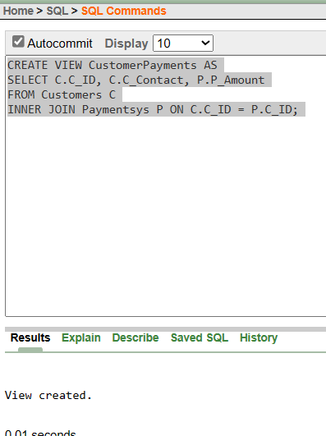

**-3 synonym**

GRANT CREATE SYNONYM TO Curriersystem;

**Question: 1: Create a synonym for the "Marchants" table:**

**Answer:**

CREATE SYNONYM Marchants_Synonym FOR Marchants;

**Question: 2: Create a synonym for the "Orders" table:**

**Answer:**

CREATE SYNONYM Orders_Synonym FOR Orders;

**Question: 3: Create a synonym for the "Customers" table:**

**Answer:**

CREATE SYNONYM Customers_Synonym FOR Customers;

SELECT *

FROM ALL_SYNONYMS

WHERE OWNER = 'CURRIERSYSTEM';

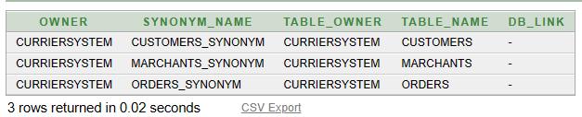

**Relational Algebra:**

**Selection**: Retrieve all orders from the Orders table where the order location is in Dhaka. σ(Order_Loc = 'Dhaka', Orders)

**Projection**: Retrieve the order ID and customer name from the Orders table.

π(Order_ID, C_Name)(Orders)

**Union**: Combine the orders from the Orders table and the receive hubs from the Receive_Hub table.

Orders ⋃ Receive_Hub

**Cartesian Product**: Generate all possible combinations of orders and delivery hubs.

Orders × Delivery_Hub

**Rename**: Change the attribute name "D_Time" to "Delivery_Time" in the Delivery_Hub table. ρ(Delivery_Hub, (D_Time AS Delivery_Time))(Delivery_Hub)

**Conclusion:**

In final term, We plan to add customer to merchant communication system. Customer to delivery man communication system.