Industry – Academia Collaboration Portal

Project Proposal



Supervisor
Sir Ali Irfan

Submitted by

Ashhad Khan
01-134221-109
Muhammad Hammad
01-134221-046

Department of Computer Science,
Bahria University, Islamabad.
[14-10-2024]

Introduction
The Industry-Academia Collaboration Portal is a web-based platform designed to address the increasing industry-academia gap.
The fast-growing IT sector has led to ever-increasing demands for skilled professionals. But there still exists a space between industry and academia to bridge as there is no centralized collaboration platform. Industries cannot seek potential candidates and research partners, while universities cannot show up with a scope for funding exposure in the industry. Therefore, we suggest the Industry-Academia Collaboration Portal, an integrated online portal where students, institutions, and industry professionals can meet and work together for mutual benefit.

Objective
The objective of this project is to develop a web-based centralized platform where industry partners, academic institutions, and students can collaborate effectively. The portal aims to:

- Provide a structured job and internship portal tailored for students and fresh graduates.
- Facilitate industry-academia collaboration for research projects, funding, and consultancy.
- Enable universities to manage and promote workshops, advisory programs, and industry-driven courses.
- Offer an intelligent matching system to connect relevant industry professionals with academic research projects.
- Allow super admins to manage user roles, oversee collaborations, and generate analytics.

Problem Description
- Industries have trouble finding graduates with skills and research participants.
- Academic institutions do not have such arrangements for industry collaboration for research applications or fund sourcing.
- Students have a hard time getting summer internships, jobs, and industry-oriented projects.
- It lacks a centralized platform that connects it efficiently.

The Industry-Academia Collaboration Portal is expected to provide an easy one-stop solution to these issues of communication and opportunity-sharing.

Literature Review
Existing research highlights the gap between academia and industry due to the absence of dedicated networking platforms. Studies indicate that while job platforms like LinkedIn and Rozee.pk cater to employment, they lack structured mechanisms for research collaboration. The proposed portal aims to fill this gap by providing a dedicated space for research projects, industry partnerships, and knowledge sharing, ensuring a more integrated approach to academic and industrial interactions.

Methodology
The project will follow a structured approach:
- Requirement Analysis: Gather stakeholder needs.
- System Design: Design architecture and workflows.
- Development: Build the portal using modern technologies.
- Testing: Identify and fix bugs.
- Deployment: Host the portal on a reliable platform.
- Maintenance: Provide ongoing support.

Project Scope
The scope of this project includes:
- Included:
  - User Registration: A two-step registration process with minimal initial input followed by detailed profile completion.
    - Email verification with activation link within 24 hours.
    - CAPTCHA integration to prevent bot registrations.
    - Mandatory and optional fields based on user type (industry, academia, students).
    - Profile completion with details like CNIC, qualifications, work experience, skills, research projects, and publications.
  - Collaboration Module:
    - Users can post project ideas or collaboration opportunities.
    - Filters based on expertise, target audience, and funding details.
    - Private and public comments for discussions.
    - Notifications sent to target audiences.
  - Job and Internship Postings:
    - Posting of job, internship, and consultancy opportunities.
    - Enforced constraints for visibility based on expertise, experience, and qualifications.
    - Filtering and application mechanisms for users.
    - Initiators can shortlist candidates and manage applications.
  - User Engagement:
    - Email notifications and alerts for new collaborations, jobs, and projects.
    - Discussion forums for interaction.
    - Profile-based recommendations for relevant opportunities.
- Not Included:
  - Financial transactions or payments between users.
  - Automated dispute resolution or legal compliance management.
  - Direct integration with third-party job portals like LinkedIn or Rozee.pk.
  - AI-driven candidate ranking beyond simple filtering mechanisms.

Feasibility Study
- Technical Feasibility: The portal will use HTML, CSS, JavaScript, React.js for Frontend. Node.js for Backend and MySQL for the database ensuring scalability and security.
- Economic Feasibility: Development costs are minimal, requiring only hosting services and APIs.
- Operational Feasibility: The portal will be user-friendly for all stakeholders.

Solution Application Areas
The portal can be used for:
- Job placement for students.
- Research collaborations between industry and academia.
- Organizing workshops and seminars.
- Consultancy opportunities.

Tools/Technology
- Frontend: HTML, CSS, JavaScript (React.js)
- Backend: Node.js (Express.js)
- Database: MySQL
- Server Hosting: On-premises server.
- Version Control: GitHub

Expertise of the Team Members
The team includes final-year students skilled in:
- Web Development.
- Database Management.
- Backend Development
- Project Management.

10. Milestones
Milestone | Duration | Timeline | Description
Requirement Analysis | 1 month | Month 1 | Gather and analyze requirements from stakeholders (industry, academia, students).
System Design | 1 month | Month 2 | Design system architecture, database schema, and workflows.
Front-End Development | 3 months | Months 3-5 | Develop user interfaces using React.js, HTML, CSS, and JavaScript.
Back-End Development | 3 months | Months 6-8 | Build server-side logic using Node.js.
Database Setup and Integration | 1 month | Month 9 | Set up MongoDB database and integrate it with the back end.
Testing and Debugging | 1.5 months | Months 10-11 | Conduct functional, usability, and performance testing. Fix bugs and issues.
Deployment and Final Presentation | 0.5 months | Month 12 | Deploy the portal on on-premises server. Prepare final documentation and demo.
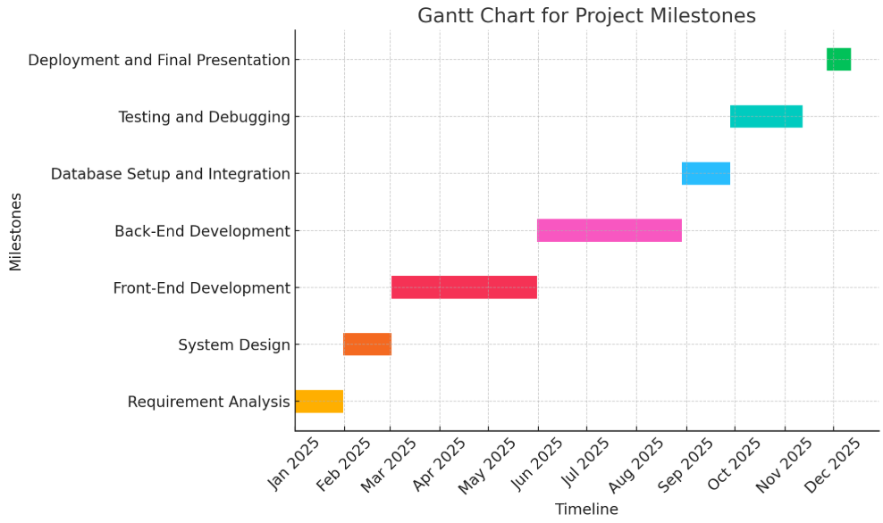

11. References
- https://www.forbes.com/sites/ashleystahl/2021/11/08/the-top-5-growing-career-fields-in-2022/?sh=6e0acd0b46b3
- https://clouddevs.com/freelance-marketplace-statistics/
- https://onlinelibrary.wiley.com/doi/abs/10.1111/j.1468-2370.2007.00225.x
- https://www.sciencedirect.com/science/article/abs/pii/S0956522115000238
- https://academic.oup.com/cjres/article-abstract/1/2/321/413714?redirectedFrom=fulltext

