**PROCEDURE**

STEP 1:

Install pycharm

STEP2:

After Installation you extract the project on “pycharm projects” folder that was created in c directory on users,hp or etc folder and open with pycharm

STEP 3:

After open you face this error now you should install flask package

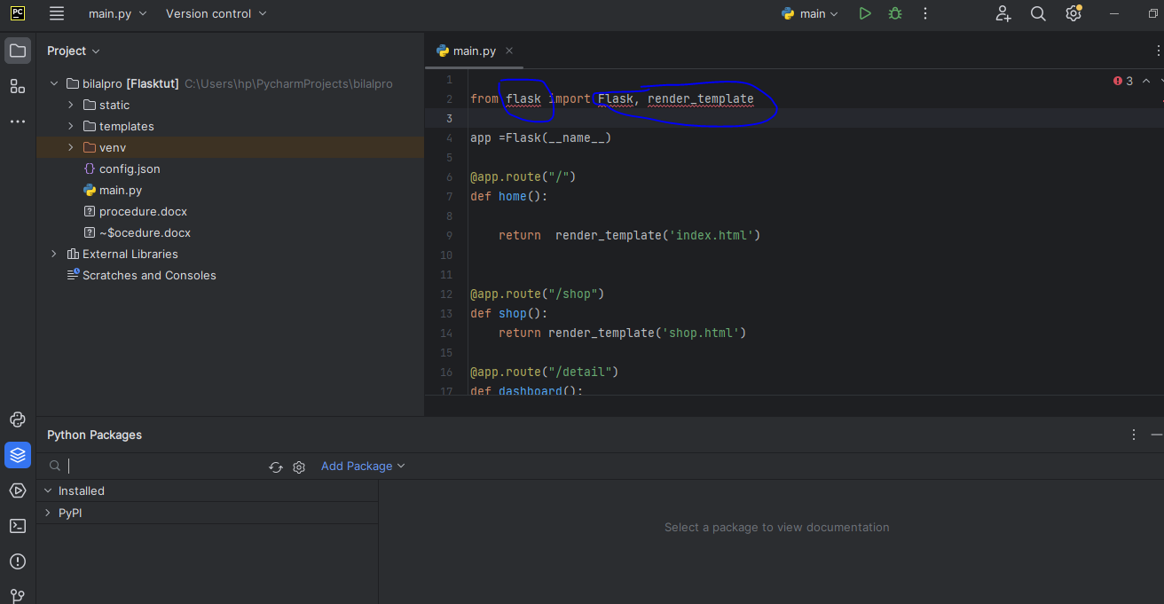

AT the bottom you see install packages

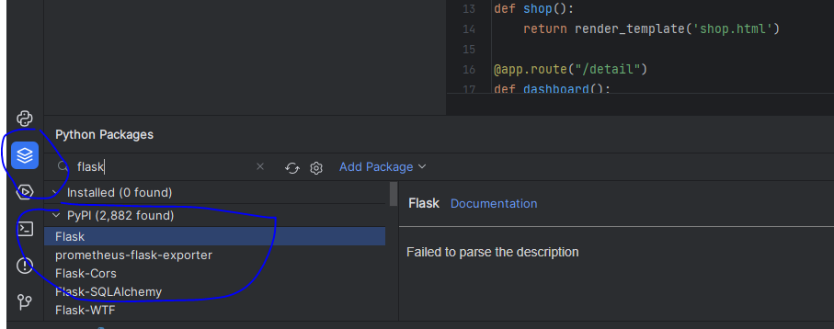

CLICK ON “install package” not add package.

STEP 4:

CLICK ON RUN AND THEN CLICK ON IP

