CS 423
Introduction To Dev-Ops
Assignment # 2

Name: Syed Muhammad Ashhar Shah
Reg No: 2020478
Faculty: B(CS)
Task 1: Selection and deployment on localhost of any simple open-source application.
- Clone the following simple open-source application from GitHub built using ReactJs and NodeJS.
  - ReactNodeTesting app
  - You may also clone any simple open-source application built using any of the following technologies but must discuss with me before proceeding:
    - Frontend: React or Angular
    - Backend: NodeJs, Python, Java, PhP

To clone the repository we will use the command:
- git clone https://github.com/eljamaki01/ReactNodeTesting.git

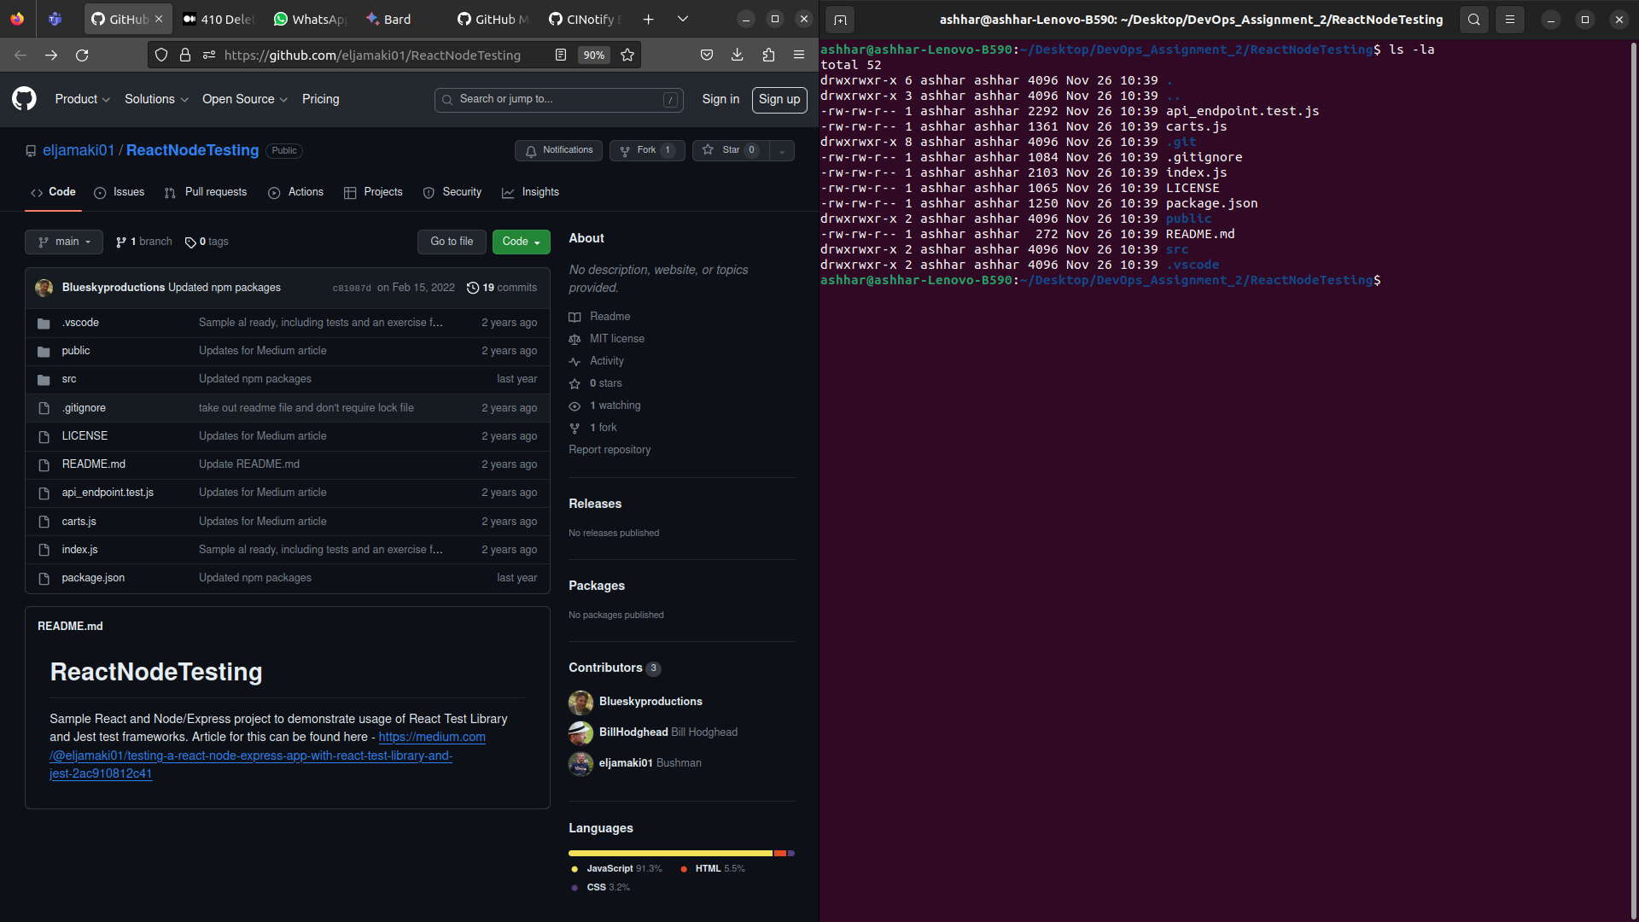
This will clone the git repository onto our local system.

- Clone the following simple open-source application from GitHub built using ReactJs and NodeJS.

To deploy the application on our system we will first install the node dependencies using the command:
- npm install

Once we have installed all the required dependencies we will host our application using the command:
- node index.js

We can also use nodemon via the command:
- npx nodemon index.js

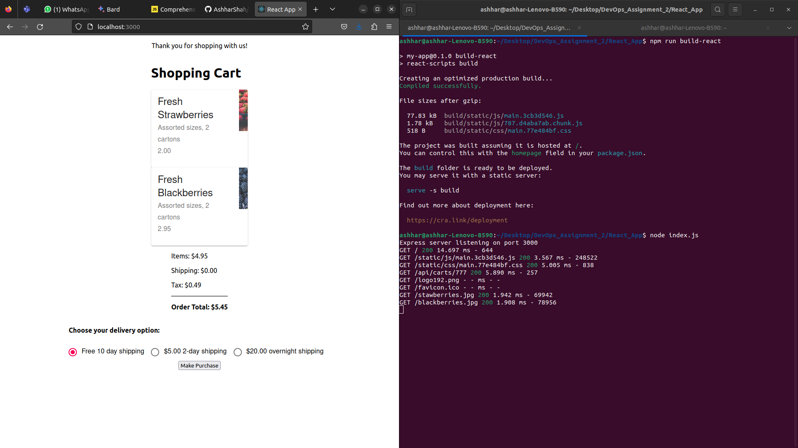

- As you and your team will be making further changes to this application so you must initialize this cloned repository code to your new repository and push it to your GitHub repository. Add a second team member as a collaborator to your GitHub project.

Since I am working on this as a solo project, I will not be adding another collaborator to the repository. I will only add project to my own github repository by creating a repository with the command:
- gh repo create

Then I will push the local repository to the GitHub servers using the commands:
- git add .
- git commit -m “Adding Files”
- git push -u origin master

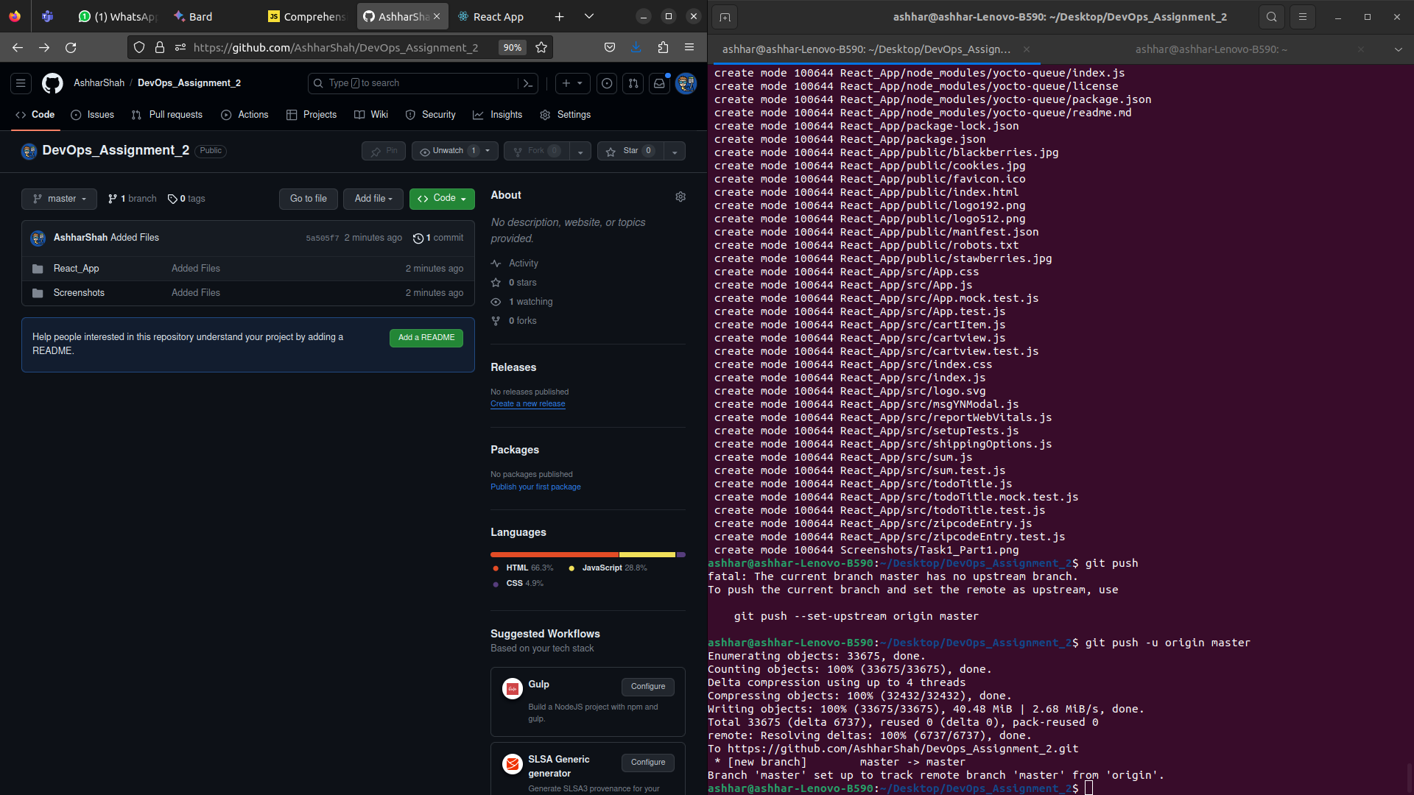

- You must make your repository public and add me as a collaborator to that repository as well.

When we initialize the repository in part 3, we already specify that the repository is going to be public.

Link for verification:
https://github.com/AshharShah/DevOps_Assignment_2

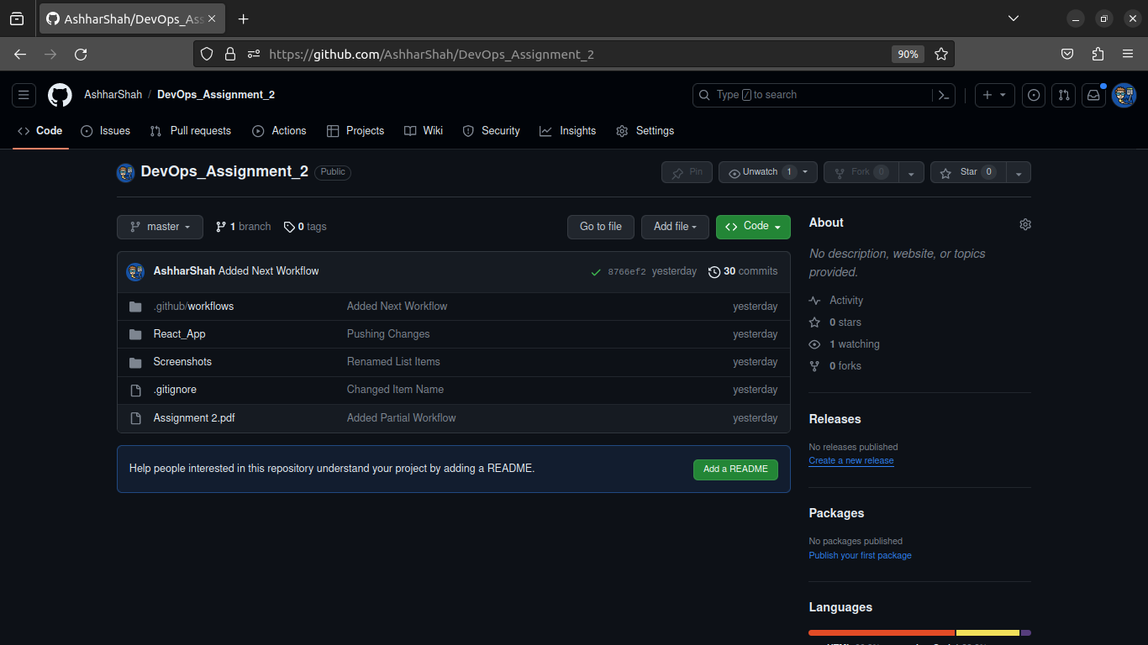

- Update your repository settings such that no collaborator should be able to commit directly to the main branch.

To restrict any developer from pushing directly to the main branch. We will define a branch rule in the repository setting which disables the option to push to the master branch directly without a pull request.

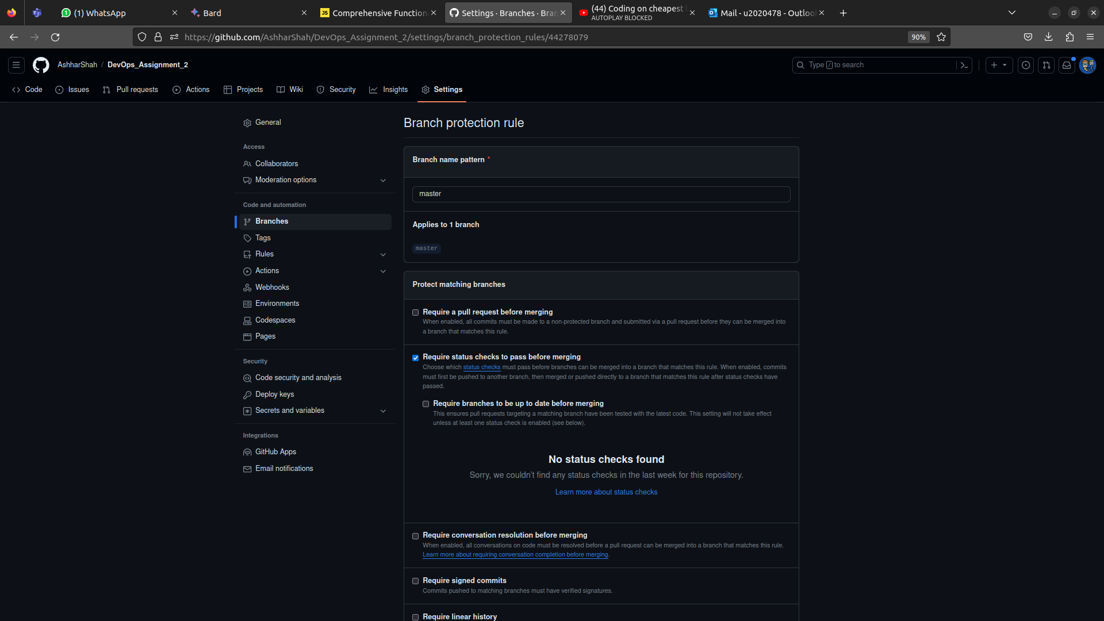

Task 2: Create two EC2 instances on AWS for Testing and Staging environment.

- Give an appropriate name such that it represents environment.

The instances will have the names:
- Testing Server – DevOps
- Staging Server – DevOps

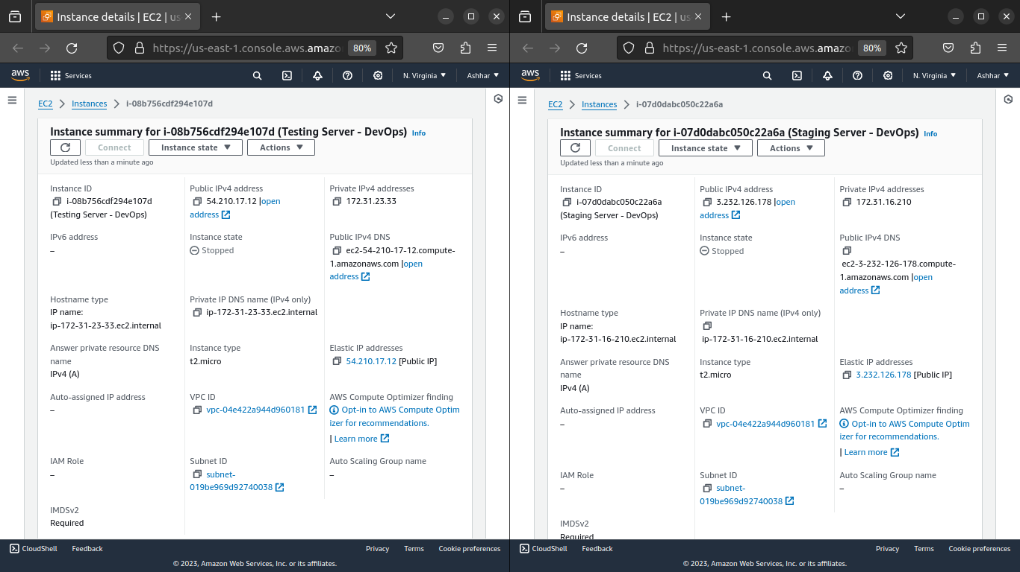

- Each environment Amazon Machine Image (AMI) should be Ubuntu Server 22.04 LTS (HVM)

Both the servers are of t2.micro instances both running the Ubuntu operating system of version 22.04 LTS which can be seen in the screenshot below.

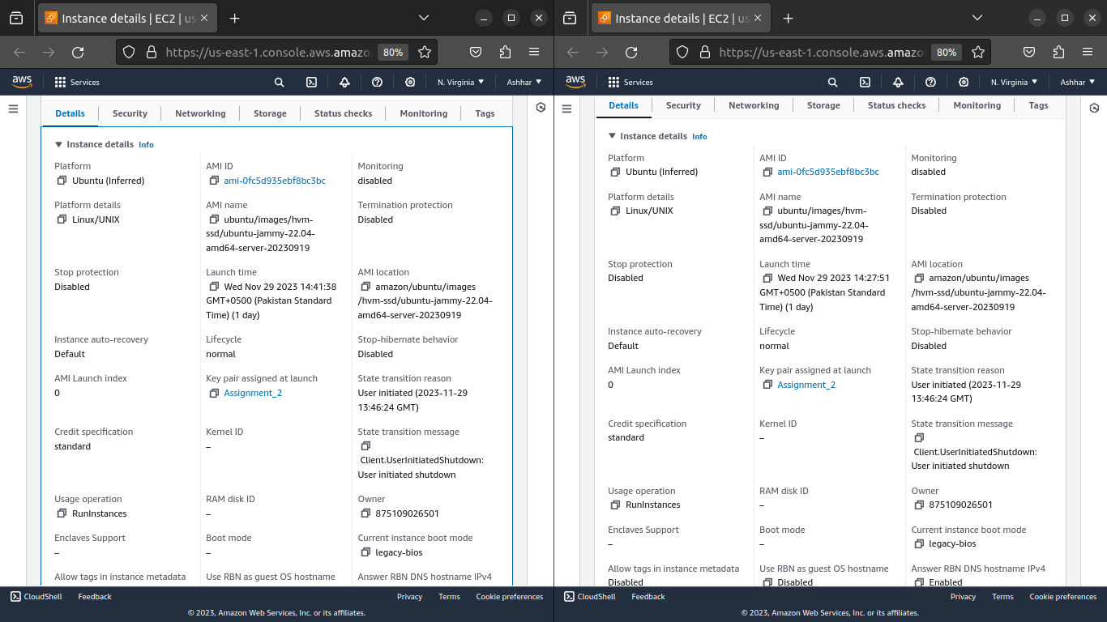

- All instances must share one common security group such that if you add/remove any rule, it should affect all instances.

Both the instances have the same security gourp:
- sg-0b31ee315977fd7c2

The security group has the following rules:
Rule ID Port Protocol Source
a) sgr-0268e78ec9804cf3f 22 TCP 0.0.0.0/0 (SSH)
b) sgr-0558b8e1bb6108e2a 80 TCP 0.0.0.0/0 (HTTP)

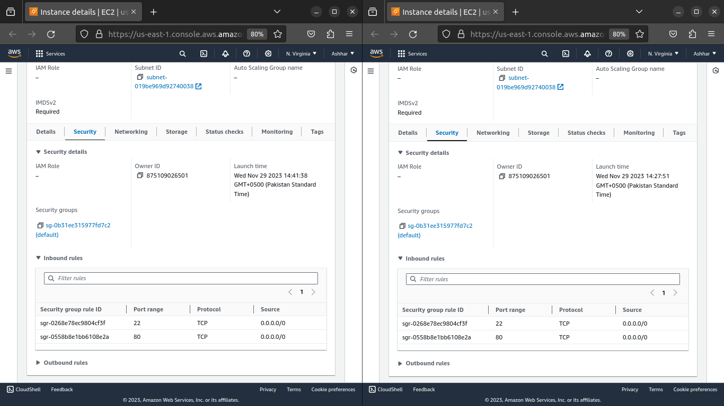

- Configure your environments such that it includes required dependencies for your React and Nodejs project.

To configure our environment we will need to install NodeJs along with Node Package Manager (npm) on our AWS instances.

To do this we will simply SSH into the instances and run the following set of commands:
- sudo apt-get update
- sudo apt-get install -y ca-certificates curl gnupg
- sudo mkdir -p /etc/apt/keyrings
- curl -fsSL https://deb.nodesource.com/gpgkey/nodesource-repo.gpg.key | sudo gpg --dearmor -o /etc/apt/keyrings/nodesource.gpg
- NODE_MAJOR=20
- echo "deb [signed-by=/etc/apt/keyrings/nodesource.gpg] https://deb.nodesource.com/node_$NODE_MAJOR.x nodistro main" | sudo tee /etc/apt/sources.list.d/nodesource.list
- sudo apt-get update
- sudo apt-get install nodejs -y

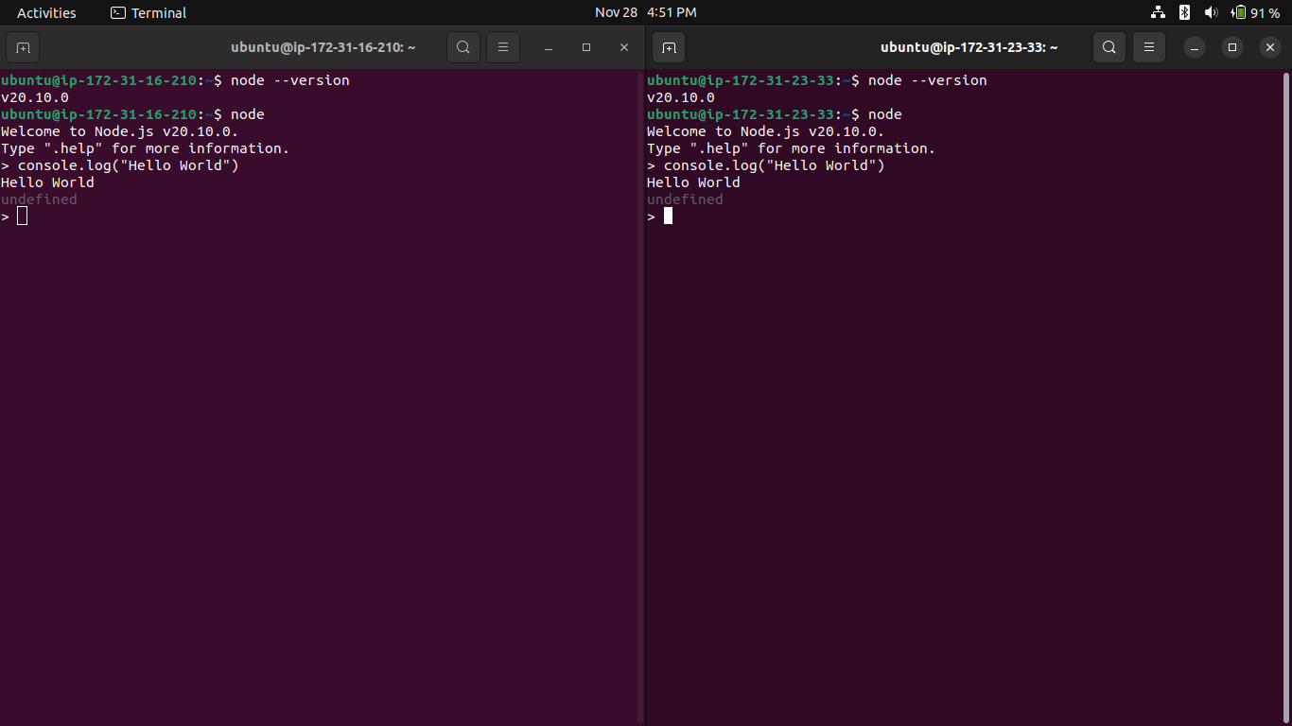

- Add or remove rules in your security group where required.

Since we only want to SSH into the web server and host an application. We will only enable the SHH and HTTP ports in the security group settings.

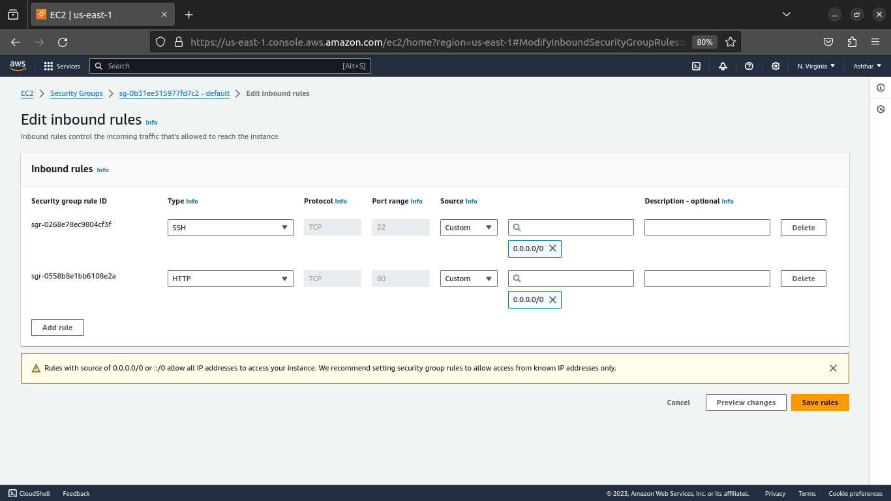

- As you will be working in a group you may create first AWS instance in one account and second in other account.

Since this is a solo project, I will be creating both EC2 instances on the same account which is my personal AWS account.

Also to host the Node/React application I will be using a Nginx HTTP server.

To install nginx on the instances I will use the command:
- sudo apt install nginx

Then I will configure the nginx server to point toward by NodeJs application that runs on the localhost:3000. To do this we will first create a config file in the sites-available folder and link it to the folder sites-enabled. To do this we will use the following commands:
-

