CS 423
Introduction To DevOps
Assignment # 3



Name: Syed Muhammad Ashhar Shah
Reg No: 2020478
Faculty: B(CS)

PROJECT INTRODUCTION

In this project we are going to automate the deployment process in which we have developer’s who are working on developing the application and we have a QA-Engineer who is making sure that there are no bugs or issues in the underlying application.

For the deployment process we will be creating two separate servers, one will be for testing the application (for the QA and the Developers) and the other will be for staging the application (for the Client to view changes).

To automate this the Developers will first modify the code-base to add or remove features as per the requirements of the Client. Once done they will trigger a workflow which will deploy the changes to the testing server which can be viewed by the QA and the developer to see if there are any issues with the code-base and all the features work properly.

If there are no issues, the QA-Engineer will then initiate another workflow which will deploy all the changes to the staging server after which he can prompt the client to view said changes and provide his feedback.

This process will continue when ever there is a new feature being developed on the code-base being modified.

The application for both the servers will be running on containers using docker, the user will be able to access the application with the help of port mapping in which we will map port 3000 of the docker application to the port 3000 of the servers. We will also using Nginx for the server to be able to route the requests to the correct port on the server machine that is the port 3000 for our application that is running the React/Node application.

TASK COMPLETION
Task 1: Remember, in the previous assignment you cloned a simple open-source application from GitHub that was developed using ReactJs and NodeJS.

- As you and your team will be making further changes to this application so you must initialize this cloned repository code to your new repository and push it to your GitHub repository. Add a second team member as a collaborator to your GitHub project.

We will first clone the repository and then initialize an empty repository on our GitHub account on which we will host the current files for the assignment.

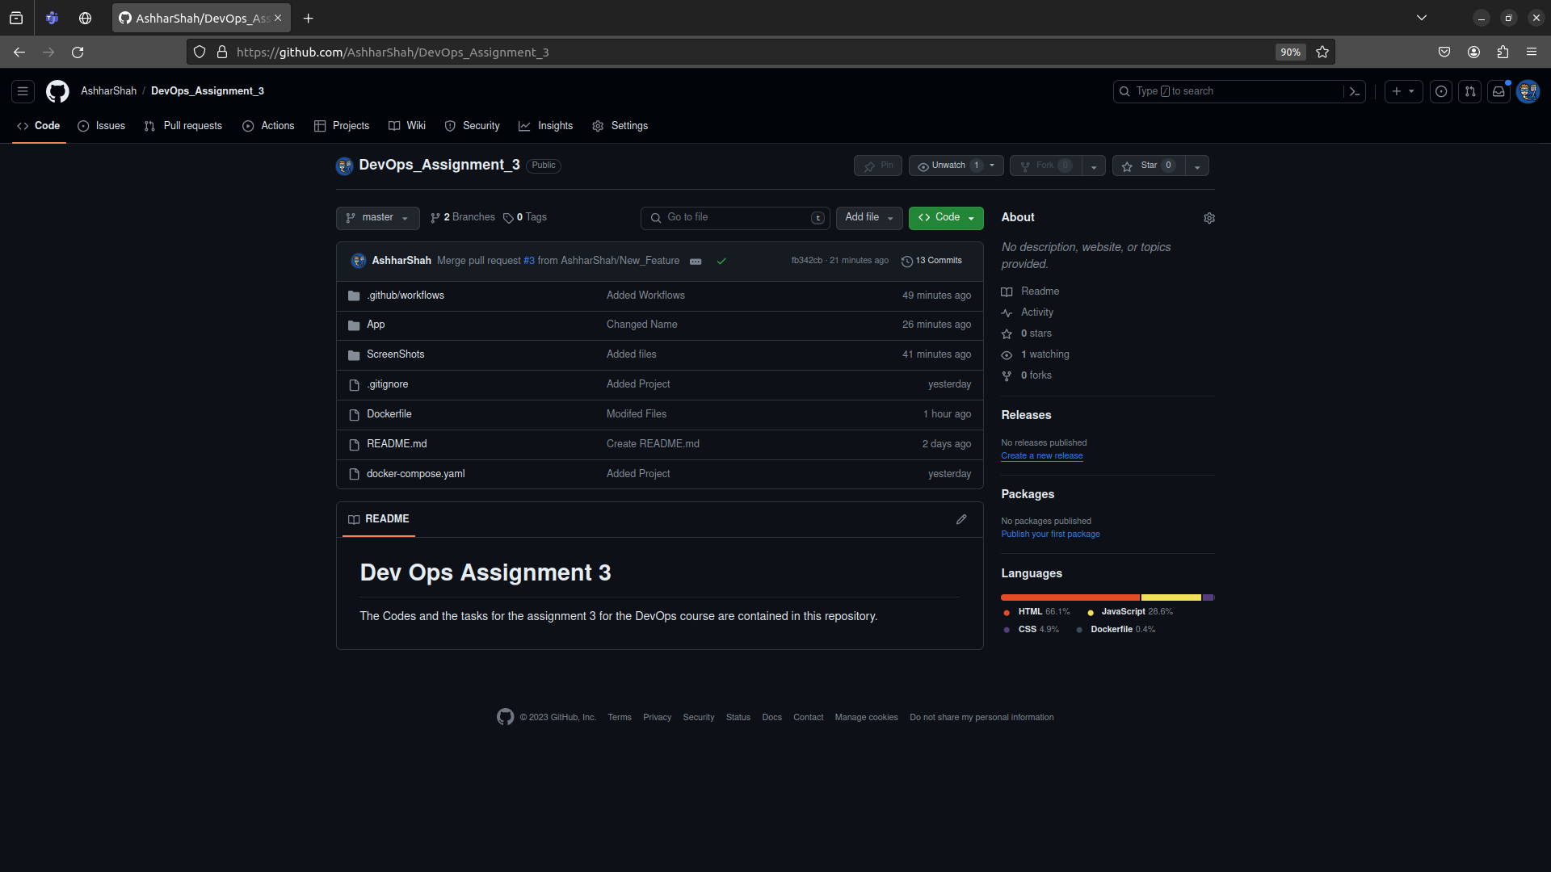

- You must make your repository public and add me as a collaborator to that repository as well.

- Deploy both frontend and backend services on local machine as separate containers named frontend & backend. Create a separate container for the database if it is being used by your application.

Since our application has no database, we do not need to create one. We will only create containers for the backend and the frontend.

First we will need to create a docker image that will be used to host the application. It will consist of the base image “ubuntu” and in the additional layers we will install “NodeJs” and copy the application folder “App” to the current containers.

Below we can see the contents of our Dockerfile which will be used to build the image.

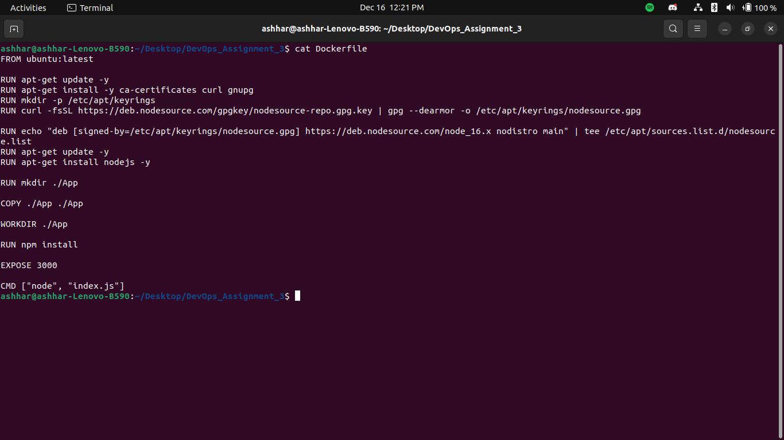
We will also create a compose file named “docker-compose.yaml” which will be used to host and manage the docker containers. Below we can see the contents of the compose file.

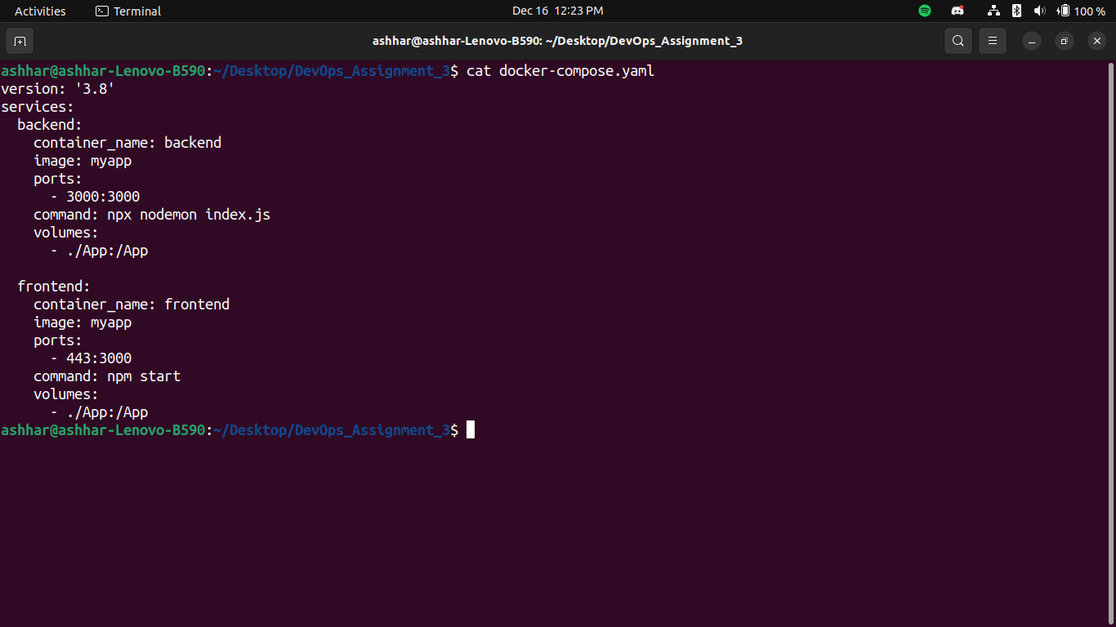
In the compose file we define two services, the frontend and the backend.

The frontend will run the React application using the command “npm start” while the backend will run the Node application using the command “npx nodemon index.js”. In both of the files we will add volumes which will track any changes on the local machine and sync those changes with the container.

If we edit the files inside the App folder on the local machine, the same changes will be reflected inside the App folder that is running on the containers. Hence we can modify the application contents inside the containerized environments.

Task 2: Create or use existing three EC2 instances on AWS for Dev, Testing and Staging environment.

- Please follow instructions from Task 2 of your previous assignment in case you are creating new EC2 instances.

For this task we will create new EC2 instances instead of the ones that we have used for assignment 2. In the screenshot below we can see both the instances.

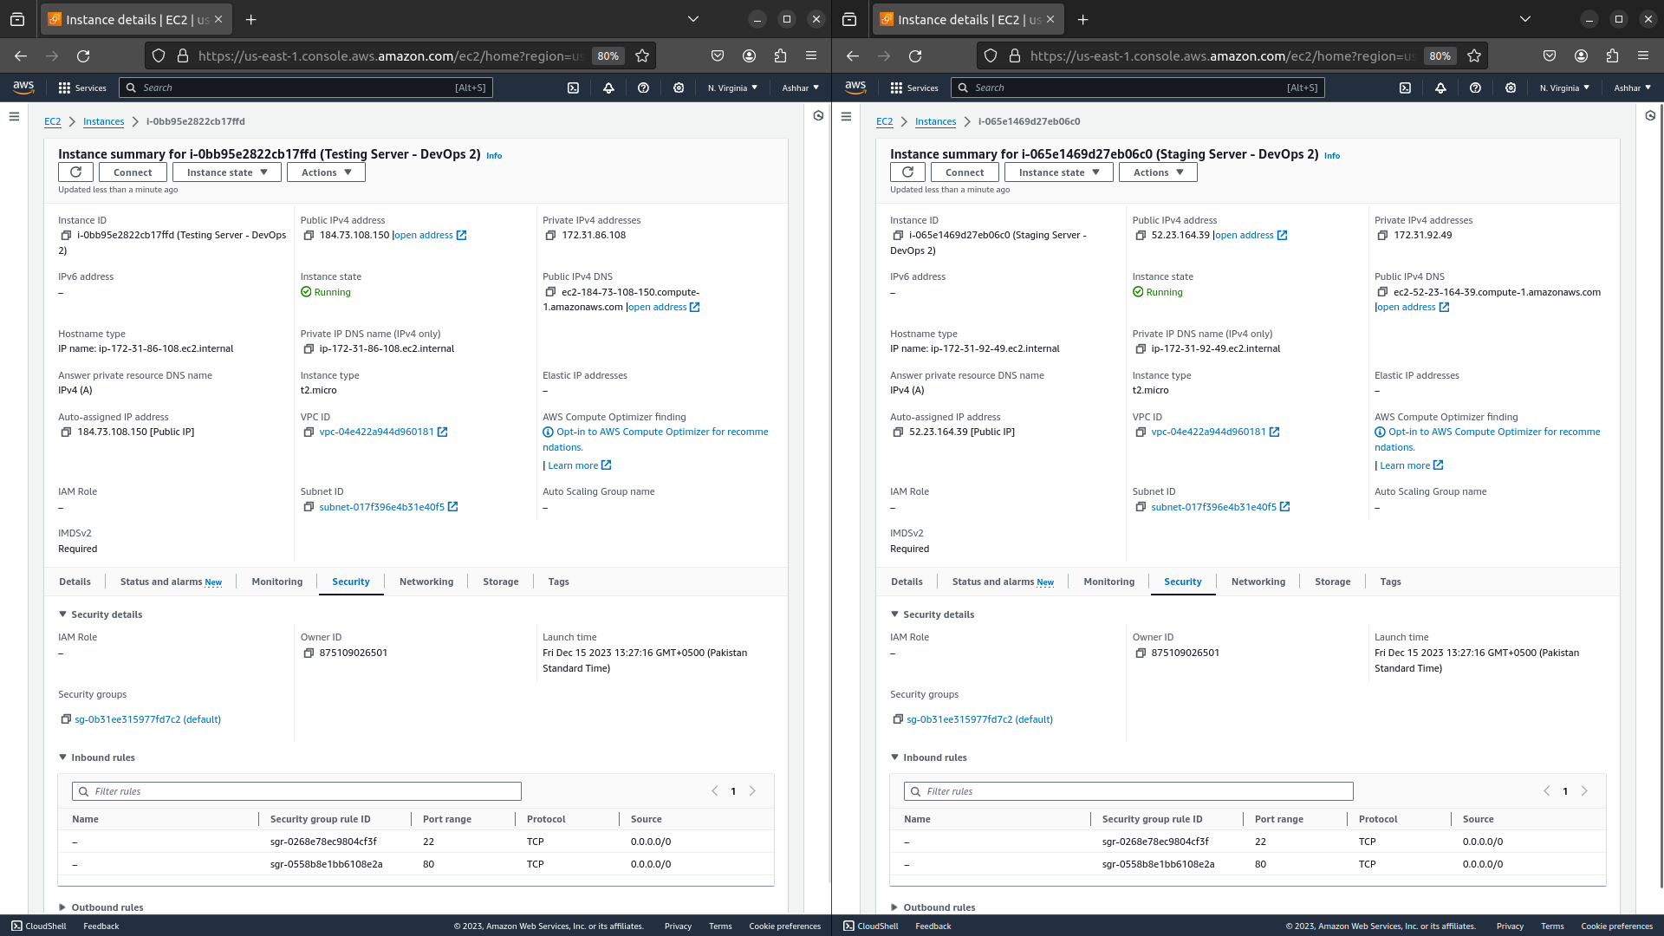
Next step will be to setup dependencies on both the system so that we can run our React/Node application on docker containers on the EC2 instances that we have just created.

In the screenshot below we can see that we can run the application using docker containers on both our EC2 instances which means that we have configured them correctly and have setup all the dependencies.

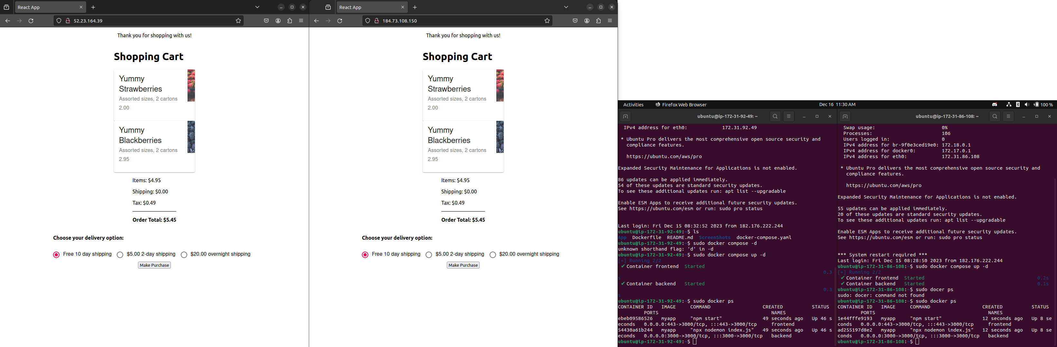
On the left we can see our Testing server and on the Right we can see our Staging server, both running the React application using the compose file that we setup in Part 1 above.

Task 3: Automating application from development to deployment.

- You or your team members will always create features or fix branches from the main branch to add something new or update anything existing in future. Create a pull request, once done with the changes on the feature or fix branch. This pull request must trigger a workflow in your GitHub actions which will deploy changes for QA to test on AWS testing server. There should also be a button on your workflow to trigger this workflow without an pull requests if needed. QA should be able to access the deployed project using the link: http://<Instance_IP>. Your workflow must do the following:

  - Build your project: Compile the source code and build the application or software. This step ensures that the code can be successfully compiled.

To build the project we will simply navigate into the directory and run the command:
- npm run build-react

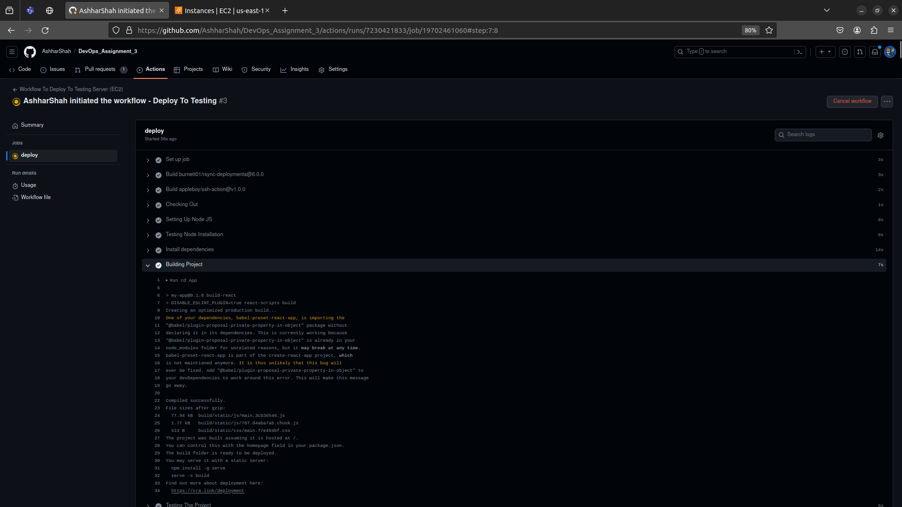

  - Unit Testing: Run unit tests to verify that individual components or functions of the code work as expected. Unit tests are typically fast and focused on specific functionalities. (you must choose a project which has a few unit test cases, or you must create your own).

To run the test cases on our react we will use the following command in the workflow:
- npm run test-react

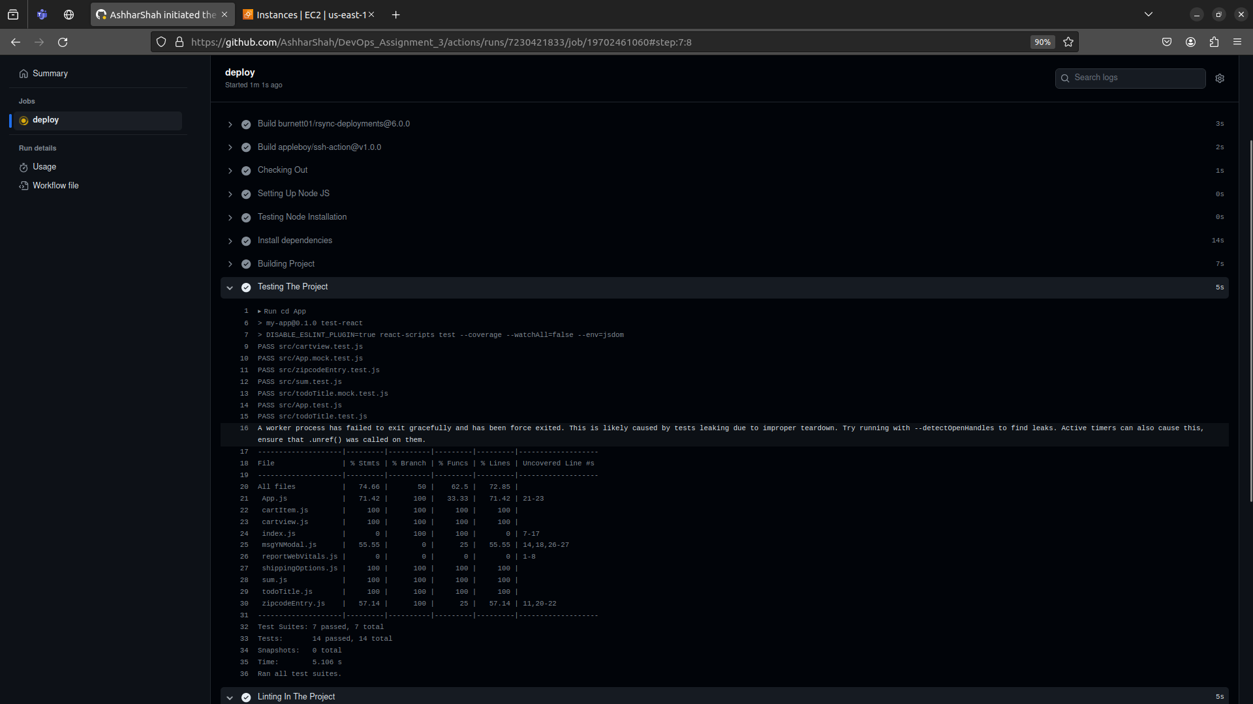

  - Code Analysis/Linting: Perform static code analysis or linting to check for code quality, adherence to coding standards, and potential issues. This step helps maintain a consistent and high-quality code-base.

In the application, there is no linting setup so we will configure eslint in our react application. To do so I have used the following article.

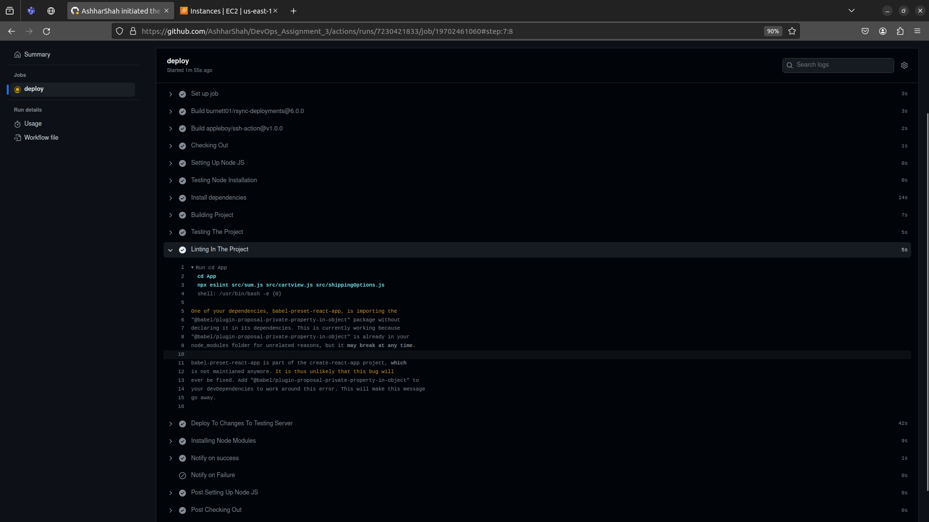

  - Notification: Your workflow must send an email to me and the developer who created a pull request if the workflow fails. Moreover, it must send an email to the QA (to me) if it successfully deploys your change on the instance with all details how the QA can access the deployed app feature for testing.

