From Fragmented Journeys to Unified Experiences:

Investigating Multifunctional Mobile App Design Through a Fitness Case Study

Marwan Ashhuby – 202244071 - John Whelan
Word Count: 16,319

Acknowledgements
The author would like to thank John Whelan for his supervision and guidance throughout this project, and the five participants who generously gave their time to the usability study.

Contents:
1- Introduction
2 - Literature Review
3 - Requirements
4 - Design
5 - Implementation and Testing
6 - Evaluation
7 - Conclusion
Reference List

Abstract
A fundamental issue for gym-goers has not been addressed by the widespread use of mobile fitness apps: the resources available to assist a training session are still dispersed among several single-purpose apps, each of which handles a single aspect of a workflow that is, in reality, a single cohesive activity. Using the fitness industry as a controlled case study, this project explores whether unified, multipurpose mobile application design might lessen the cognitive load and workflow fragmentation imposed by this fragmented toolchain.
OneRep, a cross-platform fitness tracking app, was created and deployed using Flutter as the main research artifact. Workout logging, exercise library management, an integrated rest timer, personal best detection, progress visualization, a gamification layer with badges, streaks, and population-relative strength benchmarking, and Supabase-backed cloud synchronization are all combined into one offline-first interface. A survey of the literature, including Sweller's Cognitive Load Theory, Norman's Action Cycle, Nielsen's usability criteria, and well-established gamification frameworks, as well as needs from a domain expert interview and stakeholder consultation, served as the basis for the design.
Four complementary methodologies were used for the evaluation. In a baseline session, a structured autoethnographic comparison between OneRep and the developer's previous fragmented toolchain revealed 23 application switches and 4 minutes 27 seconds of inter-application navigation time, while the corresponding OneRep session had zero switches and zero navigation time. Before participant testing, a heuristic review found 12 usability problems, two of which were categorized as severity-4 and fixed. A five-person usability study that combined in-person think-aloud sessions with seven days of realistic usage yielded a mean System Usability Scale score of 80.0, higher than the industry average of 68, and a 100% task completion rate. Four topics emerged from a thematic analysis of qualitative data: smooth session initiation, workout navigation as a recurring usability obstacle, and gamification generating quantifiable. Thematic analysis of qualitative data identified four themes: frictionless session initiation, exercise navigation as a consistent usability barrier, gamification producing measurable behavioural change, and freestyle sessions resolving the fragmentation problem for users with variable training schedules.
The evidence supports the conclusion that unified multifunctional design, when executed with structural coherence and journey-oriented intent, measurably reduces the extraneous cognitive load imposed by fragmented tool use in the fitness domain. The primary limitation of this finding is the scale of the study; further investigation with a larger participant cohort is identified as the most important direction for future work.

1- Introduction

1.1 Background to the Project
Tracking physical activity has grown in popularity among gym patrons of all skill levels. A key component of successful strength and fitness development is the capacity to record workouts, track increasing overload, and evaluate performance over time (Kraemer and Ratamess, 2004). Almost many gym patrons carry a smartphone, which makes it an obvious platform for this activity. However, a large percentage of frequent gym-goers still rely on disjointed, improvised solutions to manage their training, despite the abundance of fitness programs available on both major mobile platforms. This issue is what drives the work detailed in this paper.
The current fitness application landscape is characterised by two dominant failure modes. The first is excessive specialisation. Applications such as Strava are designed around a single activity domain — in Strava's case, GPS-tracked endurance exercise such as running. A user who both runs outdoors and trains with weights in a gym cannot consolidate their activity within a single coherent tool. Similarly, gym-chain companion applications such as the PureGym app are tightly coupled to membership and physical attendance at a specific facility, rendering them non-functional during home workouts or visits to alternative venues. The second failure mode is monetisation through restriction. Several applications offering substantive tracking functionality — including population-relative strength benchmarking, these features behind aggressive subscription paywalls, effectively excluding cost-sensitive users from meaningful engagement with their own training data.
Due to these restrictions, a lot of users, including the main developer of this project, have gradually given up on specially designed fitness apps in favor of homemade substitutes, such as physical training journals and combinations of native smartphone apps like the Notes and Clock apps. A systemic failing of the present fitness application ecosystem is revealed by this trajectory, which is detailed in Section 3.2.1. Lack of software is not the issue. There is not enough software that is free, offline-capable, activity-agnostic, and cohesive enough to sustain a whole workout without asking the user to exit the program.
This project addresses that gap directly.

1.2 Professional, Social, Legal and Ethical Considerations
The project's design choices were influenced by a number of external issues raised by OneRep's development and assessment. According to the UK General Data Protection Regulation (UK GDPR), the application's storage of personal fitness data, such as workout history, body measurements, and performance records, is considered personal data. Supabase's Row Level Security, which imposes per-user data isolation at the database level and guarantees that authenticated users may only access their own records, was used to remedy this. The service role key, which circumvents row-level security, is completely removed from the client program, and authentication credentials are injected during compilation and are never hardcoded in the source.
Five people participated in the usability study. The study supervisor gave ethical approval in accordance with the low-risk research criteria of the University of Hull. Prior to participating, each participant gave their informed digital consent; they were anonymized as P1–P5 throughout the report; and they were made aware of their right to withdraw at any moment without incurring any fees.
From a business standpoint, OneRep was created as a free app with no in-app purchases or ads. This was a conscious reaction to the subscription-based revenue structures that were noted in Chapter 1 as a deterrent to adoption. The developer plans to seek publication after the academic submission, and the program is architecturally ready for release on the Google Play Store and Apple App Store. The application's value proposition is accessibility rather than profitability, and no revenue model is envisioned.

1.3 Research Question, Aims and Objectives
The central research question motivating this project is as follows:
Does a unified, multifunctional mobile application design reduce cognitive load and improve user experience for gym-goers, compared to the fragmented use of multiple single-purpose tools?
Through the design, implementation, and user evaluation of a fitness tracking application that serves as a controlled case study, the project aims to explore multifunctional mobile application design principles.
The following objectives were defined at the outset of the project:
O1. To conduct a review of existing literature in the areas of human-computer interaction, cognitive load theory, mobile application design, and gamification, identifying the theoretical basis for unified interface design. (Chapter 2)
O2. To gather requirements from domain stakeholders — including a qualified personal trainer and regular gym-goers — and derive a formal set of functional and non-functional requirements for a multifunctional fitness application. (Chapter 3)
O3. To create and deploy OneRep, a fully featured, offline-first fitness program that includes gamification mechanisms, cloud backup, workout logging, exercise library management, rest timer functionality, and progress visualization. (Chapters 4 and 5)
O4. To evaluate the developed application through a structured usability study with 5–8 participants drawn from the target user population, using the System Usability Scale as the primary quantitative instrument supplemented by qualitative think-aloud observations. (Chapter 6)
O5. to determine whether the usability study's results confirm or refute the theory that unified multipurpose design lessens cognitive burden in comparison to fragmented tool usage. (Chapter 7)
O6. To reflect critically on the development process, methodology, and project management decisions, identifying lessons applicable to future work. (Chapter 7)

1.4 Report Structure
The rest of this report is structured as follows. The literature review, which covers pertinent research in HCI, cognitive load theory, super-app design approaches, and gamification, is presented in Chapter 2. With the help of user path maps and an autoethnographic baseline study, Chapter 3 outlines the requirements gathering procedure and determines the functional and non-functional requirements for OneRep. The system design, including software architecture, database design, user interface design, and gamification design, is presented in Chapter 4. The system's implementation is covered in Chapter 5, along with the testing methodology and findings. The usability evaluation, which combines heuristic inspection, realistic usage, think-aloud sessions, and System Usability Scale measurement, is presented in Chapter 6. In Chapter 7, conclusions are drawn, the study question and objectives are reviewed, and future work directions are identified.

2 - Literature Review

2.1 Introduction to the Literature Review
This literature review adopts a journey-oriented approach, synthesising research on human-computer interaction, cognitive load, mobile usability, and service design to examine how fragmented digital ecosystems affect user experience and how multifunctional platforms attempt to resolve these issues. Fitness applications serve as the primary example domain throughout.

2.2 Evolution of Human–Computer Interaction
The discipline of human–computer interaction has historically evaluated usability at the level of the individual interface. Early computing systems relied on command-line interfaces requiring specialised technical knowledge, imposing high cognitive demands that restricted access to expert users (Myers, 1996). This burden was lessened with the advent of graphical user interfaces in the 1980s, which allowed non-specialist audiences to interact with computer systems for the first time by substituting visual metaphors such as windows, icons, menus, and direct interaction for command syntax (Shneiderman et al., 2017).
The fundamental usability frameworks that are still essential to HCI practice were created as a result of this shift. Nielsen's (1994) ten usability heuristics, which include consistency and standards, visibility of system state, and recognition rather than recollection, provide a methodical way to look for issues at the interface level. Through two analytical constructs, Norman's (2013) Action Cycle formalized the relationship between user intention and system response: the gulf of evaluation, which represents the gap between system output and the user's capacity to interpret it, and the gulf of execution, which represents the gap between a user's goal and the actions necessary to achieve it. Both frameworks were developed in the context of single-application, single-device interaction, and both are deployed directly in this project: Nielsen’s heuristics inform the evaluation in Chapter 6, and Norman’s Action Cycle informs the interaction design in Chapter 4.
But the computing environment that gave rise to these frameworks is no longer representative of how people engage with technology. Real-world objectives are no longer achieved by users using a single application. Tasks are divided among several apps in modern mobile usage, each having a unique navigation structure and interaction style. Because of this change, interface-level usability—the area where Norman's Action Cycle and Nielsen's heuristics function—is now required but insufficient. Continuity, direction, and cognitive efficiency throughout a workflow—rather than just on a single screen—are the usability issues that matter in a multi-application setting.
This observation motivates the analytical approach adopted in this project: applying established single-interface frameworks within a unified application designed to consolidate what would otherwise be a fragmented, multi-application workflow.

2.3 Interaction Styles and Mobile Constraints
Constraints brought forth by the transition from desktop to mobile computing drastically changed the requirements for interface design and assessment. Long-term focus, a sizable screen, and accurate mouse and keyboard input are all necessary for desktop interaction. None of these are provided via mobile interaction. Users interact with smartphones in brief, interrupted spurts. Oulasvirta et al. (2005) discovered that mobile interactions take place in episodes that average around four seconds, often interspersed with speech, physical activity, or environmental awareness. This discovery directly affects the project's application domain: a gym-goer uses their phone in between sets when physically exhausted, frequently using just one hand, and expecting the interaction to be finished in a matter of seconds.
Touch-based input — tapping, swiping, pinching — is the dominant mobile modality and introduces its own constraints. Small screen dimensions limit the amount of information that can be presented simultaneously, requiring designers to prioritise content through progressive disclosure, shallow navigation hierarchies, and minimal visual complexity (Norman, 2013). These principles are not merely best practice; they are structural necessities imposed by the physical medium. An interface that demands extensive scrolling, deep navigation, or sustained visual attention will fail in a mobile context not because it is poorly designed in the abstract, but because it is incompatible with how the device is actually used.
When a user's workflow involves several programs, these limitations become more severe. Oulasvirta et al. (2005) noted that each application switch during a mobile interaction resets the user's visual context, necessitates reorientation to a different navigation structure, and takes up some of the already constrained attention window. The expense of even one pointless program switch is significant in a gym setting where interaction windows are limited by rest intervals of sixty to one hundred and eighty seconds. The accumulation of these expenses throughout fragmented digital trips is examined in the following section.

2.4 Fragmented Digital Journeys and Service Design
The entire series of interactions a user has with one or more systems in order to achieve a goal is referred to as a user journey. Because user experiences were thought to take place within a single program in traditional HCI, usability could be evaluated at the interface level (Stickdorn and Schneider, 2012). This idea has been refuted by modern mobile usage. A single real-world goal is frequently divided among several applications by users. For everyday tasks like communication, trip planning, and fitness tracking, this distribution—also known as a fragmented digital journey—is the default state.
Fragmented journeys impose measurable cognitive costs. González and Mark (2004) demonstrated that task switching requires users to reorient themselves, reconstruct previous context, and re-establish situational awareness — operations that consume attentional resources and increase error rates. In mobile environments, these costs are amplified by the constraints identified in Section 2.3: small displays offer limited visual context for re-orientation, and the brief interaction windows documented by Oulasvirta et al. (2005) leave minimal time for recovery from a context switch. The result is that each application transition during a mobile workflow consumes a disproportionate share of the user’s available cognitive capacity.
Additionally, fragmentation weakens task continuity by making memory more important than recognition. Instead of being guided by a consistent interface, users must remember where particular tools and data are located when functionality is spread over multiple programs. This breaks the sense of flow that is necessary for continuous engagement and goes against one of Nielsen's (1994) main heuristics, which is recognition rather than recall (Norman, 2013).
Service design theory provides a framework for understanding this class of problem. Polaine, Løvlie, and Reason (2013) argue that meaningful user experience arises not from individual touchpoints but from the coherence of the connections between them. Journey mapping, a technique for visualising the emotional, cognitive, and temporal dimensions of a user’s path through a service, has been proposed as a diagnostic tool for identifying precisely these inter-application friction points (Stickdorn and Schneider, 2012). This project employs journey mapping in Chapter 3 to compare a fragmented gym session workflow against the equivalent workflow within OneRep.
Digital journeys that are fragmented are a structural design issue that calls for a structural solution rather than a collection of discrete usability flaws. This project's solution, which combines related features into a single, cohesive application, fits within a larger trend toward superapps and multipurpose platforms, which are discussed in the section that follows.

2.5 Multifunctional Platforms and Superapps
The fragmentation problem described in Section 2.4 has produced a counter-movement in platform design: the multifunctional application, or “superapp,” which consolidates related services into a single persistent environment. The architectural premise is that centralising functionality within one application preserves stable mental models, eliminates inter-application context switching, and enables end-to-end user journeys that fragmented ecosystems cannot support (Polaine, Løvlie, and Reason, 2013).
A better user experience is not, however, assured by integration alone. The precise cognitive overload that a multifunctional platform aims to prevent could be introduced if it accumulates features without structural coherence. According to Norman (2013), usability issues at scale usually result from how systems arrange and display capabilities rather than from the capabilities themselves. Therefore, the main design problem for any multipurpose platform is not how many features it has, but rather how well those elements are incorporated into logical user experiences. This contrast is demonstrated by two case studies, one successful and one unsuccessful.
From its beginnings as a messaging software, WeChat has grown into an integrated ecosystem that facilitates social networking, payments, communication, and third-party services all through a single interface. Its architecture allows for end-to-end user journeys without platform exits and maintains consistent interaction patterns across services, prioritizing recognition over memory (Norman, 2013). Crucially, rather than being presented all at once, services are contextually revealed in response to user intent; this pattern is similar with the brief interaction bursts reported by Oulasvirta et al. (2005). Appendix K provides a thorough cognitive walkthrough of WeChat's integration model.
By contrast, Meta's ecosystem — spanning Facebook, Instagram, WhatsApp, and Messenger — distributes comparable functionality across architecturally and experientially separate applications. Each application maintains its own navigation logic and interaction patterns, imposing precisely the context-switching costs identified by González and Mark (2004). The full comparative analysis is presented in Appendix K
The argument that drives this project is crystallized by the differences between these cases: integrating functionality within one application is not the same as aggregating functionality across numerous applications. A multifunctional ecosystem may worsen fragmentation rather than alleviate it in the absence of intentional system-level coherence and journey-oriented design. This idea is immediately applicable to the fitness industry: a gym-goer who uses different apps for measuring progress, recording workouts, and timing rests is dealing with Meta's issue on a smaller scale. WeChat's concept of unified, journey-coherent functionality within a single permanent environment is what OneRep is intended to apply to that particular use case.

2.6 Cognitive Load, Learnability, and the Wundt Curve
Cognitive load — the mental effort required to process information, make decisions, and execute actions within an interface — is the primary theoretical construct through which this project evaluates fragmented versus unified design. Sweller’s Cognitive Load Theory (Sweller, 1988) distinguishes three components: intrinsic load, determined by the inherent complexity of the task; extraneous load, imposed by the design of the instructional or interaction environment; and germane load, representing the cognitive effort devoted to constructing useful mental models. In the context of mobile application design, extraneous load is the component most directly under the designer’s control, and it is the component most directly increased by fragmented tool use.
Over time, learnability and cognitive load interact. However, users must develop and maintain distinct mental models for each program when the same workflow is dispersed across several. Even in cases when individual programs are individually learnable, this fragmentation jeopardizes system-level learnability.
The inverted-U relationship between stimulation and performance, known as the Wundt curve (Berlyne, 1960), offers a helpful framework for the design risk present in multifunctional applications. Too-complex systems overwhelm users and impair performance, while too-simple systems are unable to maintain engagement. A crucial place on this curve is occupied by a single application that combines several tools. The program minimizes unnecessary load by avoiding context switching while staying within the ideal stimulation range if integration is carried out with structural coherence, which includes consistent navigation, progressive disclosure, and contextually appropriate feature surfacing. The program runs the danger of feature overload if integration is done incorrectly, pushing users toward the high-complexity end of the curve where performance and satisfaction deteriorate. In Chapter 6, this trade-off is assessed empirically.

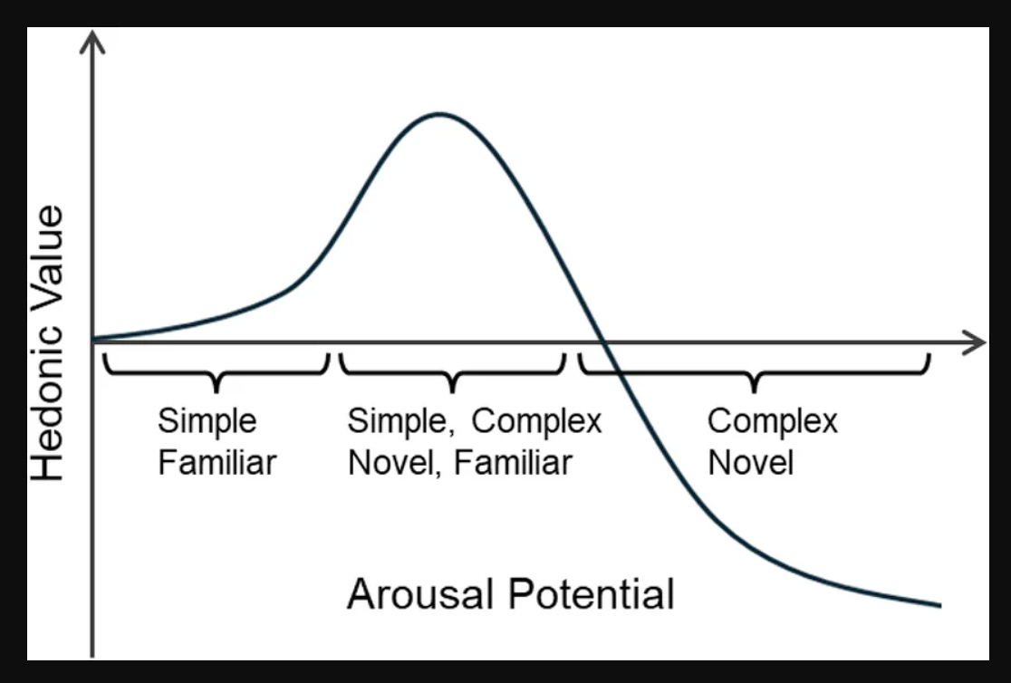

Figure 2.1 — The Wundt curve applied to multifunctional application design. The x-axis represents interface complexity; the y-axis represents user satisfaction and performance. OneRep's design target occupies the optimal range between understimulation and feature overload.

2.7 The Fitness Domain: Context and Fragmentation
It is necessary to establish what a typical gym session involves and what data a user needs to record
Resistance training sessions in the gym have a generally standard format. To prepare the body for increased loads, the session usually starts with a warm-up phase that includes mobility exercises and mild aerobic activity. The exercises that make up the majority of the workout are done for a predetermined number of sets. A set is a continuous series of repetitions of a particular exercise, such as 10 barbell bench press repetitions. There is a rest period after each set. For lighter, higher-repetition activity, rest intervals usually last sixty seconds; for maximal strength efforts, they may last three minutes or longer (Schoenfeld, 2010).
The data a gym-goer needs to record must be captured in real time, during the session itself, rather than recalled afterwards. For each set performed, the user must log the exercise name, the weight lifted, and the number of repetitions completed. Over time, this data constitutes a longitudinal record of performance. The fundamental principle underpinning progressive resistance training — progressive overload — requires that training stimulus increase incrementally over time, whether through additional weight, additional repetitions, or reduced rest (Kraemer and Ratamess, 2004). Without an accurate historical record, a user cannot reliably determine whether they are progressing, stagnating, or regressing.
A workout split, which is an organized schedule that divides different muscle groups or movement patterns throughout different days of the week, is how many gym patrons arrange their training. One popular example is the Push/Pull/Legs split, where a specific training day is allotted for pushing, pulling, and leg workouts. A workout routine is made up of the particular exercises that are assigned to each day as well as their goal sets, repetitions, and weights. A natural gamification hook is the personal record (PR), which is the maximum weight lifted for a particular exercise at a specific repetition count (Section 2.8).
The fragmentation problem can be precisely stated once this domain context has been established. An especially clear example of the fragmentation problem mentioned above can be seen in the fitness domain. In order to make loading decisions during a typical gym session, a user must examine a training plan, record sets with weight and repetition data, time rest intervals between sets, and review past results. None of these duties are supported by a single interface in any widely accessible free program. As a result, users put together ad hoc toolchains, such as an application for tracking workouts, the native clock for timing rests, a notes application for session plans, and possibly a different reference tool for exercise technique. Each of these toolchains focuses on one aspect of the workflow while ignoring the others.
The situational context of the gym amplifies the cognitive costs of this fragmentation. Users interact with their devices during rest periods of sixty to one hundred and eighty seconds, under physical fatigue, frequently with one hand. These are precisely the conditions under which Oulasvirta et al.’s (2005) four-second interaction bursts apply most acutely. Each application switch during a rest period consumes a portion of the limited interaction window and forces the user to re-establish context in a new interface — costs that, over the course of a sixty-to-ninety-minute session involving twenty or more sets, accumulate into a substantial and unnecessary cognitive burden.
The fitness workflow also has a property that makes it particularly amenable to unification: it is a single coherent activity distributed across tools for accidental rather than essential reasons. A gym-goer does not want to use three applications; they use three applications because no single free tool serves the complete workflow. The opportunity, therefore, is not to invent new functionality but to consolidate existing functionality into a single, journey-coherent environment — which is the design objective of OneRep.

2.8 Gamification in Mobile Applications
Since Deterding et al. (2011) fully defined the notion, gamification—the application of game design features to non-gaming contexts—has garnered significant scholarly and commercial interest. Gamification in mobile software has developed from a novel approach to a proven design strategy for maintaining user engagement, reinforcing habitual behavior, and offering motivational scaffolding in areas where intrinsic motivation is not enough to sustain consistent participation (Hamari, Koivisto, and Sarsa, 2014).
Fitness represents one of the most natural application domains for gamification. The challenges that cause users to abandon exercise programmes — lack of immediate reward, difficulty perceiving incremental progress, and the absence of social accountability — map directly onto the problems that game mechanics are designed to solve. A user who cannot feel themselves getting stronger on a week-to-week basis is a user who stops training. Gamification addresses this by making invisible progress visible, and by attaching extrinsic reward structures to behaviour that would otherwise yield only deferred, biological feedback.

2.8.1 Streak Mechanics and Habit Formation
One of the most popular gamification techniques in consumer mobile applications is the streak, which counts the number of days or sessions in which a specific behavior has been carried out. Research on habit formation serves as its theoretical foundation: According to Lally et al. (2010), regular repetition in stable environments fosters behavioral automaticity, and breaking a streak creates a psychologically noticeable penalty that encourages persistence. According to Shortt et al. (2023), one of the main factors influencing daily active user retention is Duolingo's streak system, which is the standard commercial implementation. A user who has maintained a seven-day or thirty-day training streak has a tangible, loss-aversive motive to attend their next session in a fitness environment, where the streak mechanic maps into training frequency. The application of streak mechanics to fitness tracking is explored through the design of OneRep in Chapter 4.

2.8.2 Personal Records and Mastery Feedback
The personal record — the maximum weight lifted for a given exercise at a given repetition count, commonly abbreviated as PR or PB — occupies a unique position in fitness gamification in that it is not an artificial construct imposed by the application, but a genuine measure of physical capability. Its gamification value derives from what Csikszentmihalyi (1990) termed the flow state: the condition of optimal engagement produced when challenge and skill are in equilibrium. Progressive resistance training is structurally aligned with flow: each incremental increase in weight represents a new challenge threshold, and the detection and celebration of a new personal record provides the immediate positive feedback that sustains engagement through the longer plateaus between measurable breakthroughs. Applications such as Strava implement analogous mechanics through segment records for running and cycling. The implementation of automatic PR detection within OneRep is described in Chapter 4.

2.8.3 Badges and Achievement Systems
Badge and achievement systems extend the reward schedule beyond the single-session PR by introducing a taxonomy of milestones distributed across a user's longitudinal engagement with the application. By guaranteeing that the next achievable milestone is always within reach, well-designed badge systems establish a permanent motivating foreground. This is based on variable ratio reinforcement schedules, which Skinner (1938) identified as the most resistant to extinction among reinforcement patterns. A complementary theory is offered by Fogg's Behavior Model (Fogg, 2009), which states that behavior results from the simultaneous convergence of motivation, ability, and a trigger. When a threshold is reached, badges operate as triggers, transforming latent drive into tangible action. Crucially, goal gradient theory (Hull, 1932), which states that effort increases as a goal approaches fulfillment, is used in the display of locked, unearned badges alongside earned ones, a nearly uniform pattern in commercial implementations like Xbox Achievements and Apple Fitness Awards. The design of OneRep's badge system, informed by these principles, is presented in Chapter 4.

2.8.4 Social Comparison and Population Benchmarking
Social comparison, or how a person's performance is positioned in relation to a reference population, is a fourth class of gamification mechanic that is pertinent to fitness apps. According to Festinger's (1954) social comparison theory, people assess their own skills and viewpoints by comparing them to others. When the gap is seen as manageable, upward comparison—that is, comparing oneself to someone who is performing better—can serve as a motivating stimulus. Population-relative strength benchmarking, which expresses a user's own record for a particular lift as a percentile rank within a reference dataset, is how fitness software implements this mechanism. By releasing percentile lookup tables from big aggregated datasets of self-reported lifting performance, stratified by bodyweight, sex, and activity, Strengthlevel.com has operationalized this idea at scale. These tables allow an application to present a contextually meaningful statement — for example, that a given bench press performance exceeds that of approximately seventy percent of the reference population — without requiring real-time network access or proprietary data collection. The application of this mechanic within OneRep, using publicly available strength standards from Strengthlevel.com, is described in Chapter 4.

2.8.5 Gamification in the Context of This Project
OneRep does not use the aforementioned gamification techniques as ornamental additions to a functioning core. They are positioned to directly address the fragmentation issue mentioned in Section 1.1. The longitudinal data continuity that enables population benchmarking, PR detection, and streak monitoring is lost when a user manages their training across several disconnected platforms. In a precise sense, these characteristics are only possible in a single program that keeps a comprehensive, persistent log of each session. Because it embodies the value proposition of the unified design approach that this project explores in tangible functional terms, the gamification layer serves as both a user retention mechanism and a case for consolidation.
OneRep was evaluated using the theoretical underpinnings and design antecedents outlined in this chapter. Through the documentation of the stakeholder engagement process and the derivation of the functional and non-functional specification for the application, Chapter 3 converts these theoretical concerns into particular requirements.

2.9 Literature Review Summary and Research Gap
The project's theoretical underpinnings have been established by this review of the literature, which covers the evolution of HCI (Section 2.2), mobile interaction constraints (Section 2.3), fragmented digital journeys (Section 2.4), multifunctional platform models (Section 2.5), cognitive load theory (Section 2.6), the fitness domain (Section 2.7), and gamification (Section 2.8).
A gap exists in the literature at the intersection of these threads. Research on superapps and multifunctional platforms has focused predominantly on large-scale ecosystems, cultural adoption factors, and platform economics rather than on the immediate user experience of integrated design. Applied research on fragmentation in routine, domain-specific mobile contexts — where users interact frequently, briefly, and under physical constraint — is largely absent. The fitness domain, despite being a clear example of fragmented tool use among a large and active user population, has received no empirical investigation of whether multifunctional design can measurably reduce cognitive load and improve journey continuity.
That void is filled by this initiative. Through the development, implementation, and assessment of OneRep, a multifunctional fitness application, the project offers empirical evidence regarding whether unified mobile design lessens the unnecessary cognitive load imposed by fragmented tool use and whether integration can be accomplished without going beyond the Wundt curve's optimal complexity range.

3 - Requirements

3.1 Requirements Gathering Methodology
The requirements for OneRep were derived through three complementary sources: the personal experience of the developer as an active gym-goer and primary user of the system; a semi-structured interview with a qualified personal trainer serving as a domain expert; and informal consultations with a small cohort of gym-goers drawn from the developer's immediate social network.
Chapter 6 discusses this approach's drawbacks, which include informal peer consultations and a single expert interview. However, the requirements outlined in this chapter have an adequate evidentiary foundation thanks to the triangulation of three independent sources.

3.2 Personal Experience and User Journey

3.2.1 The Developer's Journey
The developer's experience as a frequent gym patron serves as the inspiration for this project. It was discovered that dedicated fitness apps were either overly specialized, linking features to particular kinds of exercises or gym memberships, or commercially designed in a way that concealed essential features behind subscription paywalls.
This experience led to the crucial realization that the gym session itself is a cohesive, time-bound workflow with distinct, predictable data requirements. The failure of current tools is a failure to support that workflow as a cohesive whole rather than a failure of specific features in isolation. It should not be necessary for a user in the middle of a set to switch between three programs in order to record a repetition, initiate a rest timer, and review the results from their prior session. This has a cognitive cost that is felt on every working set of every session, thus it is not theoretical.

3.3 Personal Trainer Interview

3.3.1 Interview Overview
On March 20, 2026, a trained personal trainer with four years of experience conducted a semi-structured audio call interview. This report refers to the interviewee, who asked to remain anonymous, as PT-1. The audio recording of the about 28-minute interview was verbatim transcribed. Appendix A has the whole transcript.
PT-1 specialises in rehabilitation and physical therapy, working with a client base ranging from older adults in recovery to amateur athletes returning from injury, as well as general population clients seeking improved fitness. This breadth of client experience — spanning beginners through to competitive athletes — lends particular weight to observations about what gym-goers of varying experience levels need from a tracking tool. PT-1 has personal experience of multiple professional training platforms (Everfit, Trainerize, MyPTHub) as well as consumer fitness applications.

3.3.2 Key Findings
On workout logging: PT-1 identified workout logging as the single non-negotiable feature: "Forgetting just one number can halt your progress especially if your memory is as bad as mine. Really workout logging is THE feature of weightlifting apps, if you don't have it then there is little point in pressing the download button. Machines don't forget" (PT-1, personal communication, 20 March 2026).
On the integrated rest timer: PT-1 characterised the integrated rest timer as "the number one feature 90% of gym apps are missing" (PT-1, personal communication, 20 March 2026).
On progress visualisation: PT-1 emphasised progress charts as a primary motivator: "99% of my clients get their motivation from seeing progress" (PT-1, personal communication, 20 March 2026).
On cross-device data persistence: PT-1 validated the cloud backup requirement: "Seeing the progress chart and everything you accomplished is such a great feeling, I wouldn't want to lose all that data just because I'm switching phones" (PT-1, personal communication, 20 March 2026).
On gamification: PT-1 offered the most distinctive insight of the interview on this topic, drawing an explicit analogy between the gym and a video game: "A PR is just a high score" (PT-1, personal communication, 20 March 2026). Gamification mechanics — streaks, badges, achievement milestones — were characterised as a scalable implementation of this motivational function: "My job is encouragement, its keeping people motivated long enough where habit overtakes motivation, and they are now in the gym a few times a week because its Tuesday and Tuesday is push day" (PT-1, personal communication, 20 March 2026).
On the free-to-use requirement: PT-1 endorsed the free-to-use model: "If you're going to make an app for the average weightlifter it really needs to be free with no ads" (PT-1, personal communication, 20 March 2026).
On simplicity: PT-1 observed that the current application landscape is disproportionately oriented towards beginners, with features and interface complexity that intermediate and advanced users find irrelevant or counterproductive.

3.3.3 Contradictions and Surprises
PT-1's skepticism about AI-assisted features in fitness apps, which he described as a distraction rather than a true value-add for the majority of users, was the most noteworthy surprise component. This finding supports the design choice to concentrate on a dependable, quick, and frictionless core experience rather than incorporating AI elements into OneRep.

3.4 Gym-Goer Feedback
A number of gym patrons selected from the developer's social network, covering a range of training experience from roughly one to eight years, participated in informal video discussions.
The main topics that emerged from these discussions aligned with those found in the PT interview and personal experience. Participants supported the idea of a single, free tracking application and acknowledged that they were familiar with the fragmentation issue, which is the use of many applications during a single session. The majority of participants described their present tracking system as competent but flawed, with cost, complexity, or feature deficiencies being the main reasons for dissatisfaction. No participant reported having a very favourable experience with their current monitoring solution.
Their value lies in corroboration: the problems identified through personal experience and expert interview are recognisable across the target user population.

3.5 User Journey Maps
Two user journey maps were constructed: one representing a gym session conducted using a fragmented combination of tools, and one representing the equivalent session within OneRep. These maps are presented in Figures 3.1 and 3.2 respectively.
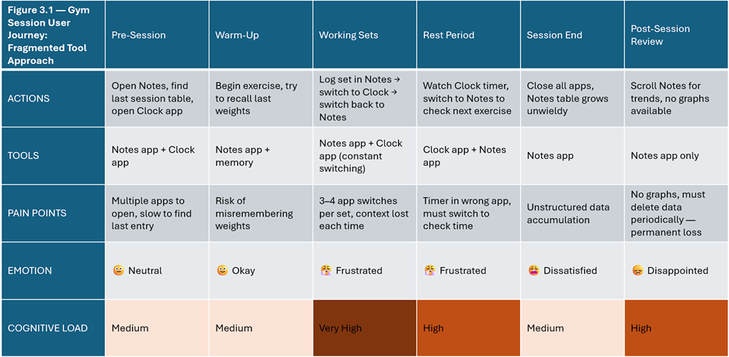

Figure 3.1 — Fragmented tool journey map: touchpoints, tools used, cognitive load, emotional state across a gym session.

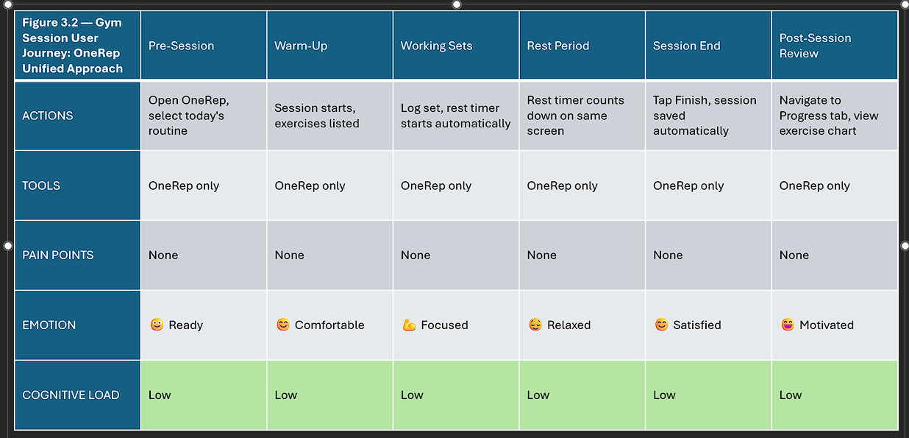

Figure 3.2 — OneRep unified journey map: same session, single application.

The application switching between a workout log, a rest timer, and a reference tool at each predetermined boundary, the loss of session context during each switch, the manual transcription of data into poorly structured formats, and the irreversible loss of historical data when accumulated records become unmanageable are all identified as pain points by the fragmented journey map. The unified trip map shows how consolidating the workflow into a single application that maintains a persistent state during the session eliminates each of these friction spots.

3.6 Autoethnographic Baseline Study
To establish a quantitative baseline against which OneRep's impact on workflow fragmentation could be assessed, a structured autoethnographic observation was conducted by the developer across two gym sessions: one using the fragmented tool combination that motivated this project, and one using OneRep following the completion of the application.
Autoethnography — the systematic, self-reflective study of one's own practice — is an established qualitative research method in HCI and service design contexts (Ellis, Adams and Bochner, 2011). Its application here is constrained to a single-participant observational study and is treated as illustrative rather than generalisable evidence.
The developer's well-established fragmented toolchain—the native Notes application for workout recording, the native Clock application for rest time, and memory for exercise reference—was used for the baseline session. The number of application switches, the total amount of time spent switching between applications, the number of cognitive reorientation events—defined as any instance in which the user must re-establish context following an application switch—and the duration of the session were all measured. At the same gym, the replication session was carried out using OneRep under similar circumstances.
The results are presented in Table 3.1.

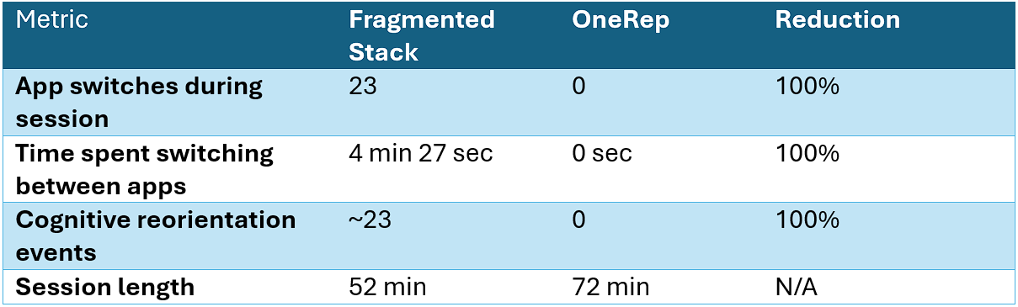

Table 3.1 — Autoethnographic comparison: fragmented stack versus OneRep.

During the OneRep session, no application switches occurred within the workout window. Rest timer notifications returned the researcher's attention to the application automatically between sets.
The session length difference — 52 minutes versus 72 minutes — reflects natural variation in training volume between two distinct sessions rather than a systematic effect of the tool used. It does not confound the switch and reorientation results, which are zero regardless of session length.
These results should be interpreted as indicative rather than conclusive, given the single-participant design. They are presented alongside the five-participant usability study in Chapter 6 as complementary evidence.

3.7 Functional Requirements
The three sources mentioned above provided the functional requirements listed below. The MoSCoW technique (Must Have, Should Have, Could Have, Will not Have for this release) is used to assign requirements a priority ranking along with a unique identification, a description, and the source from which they originated.

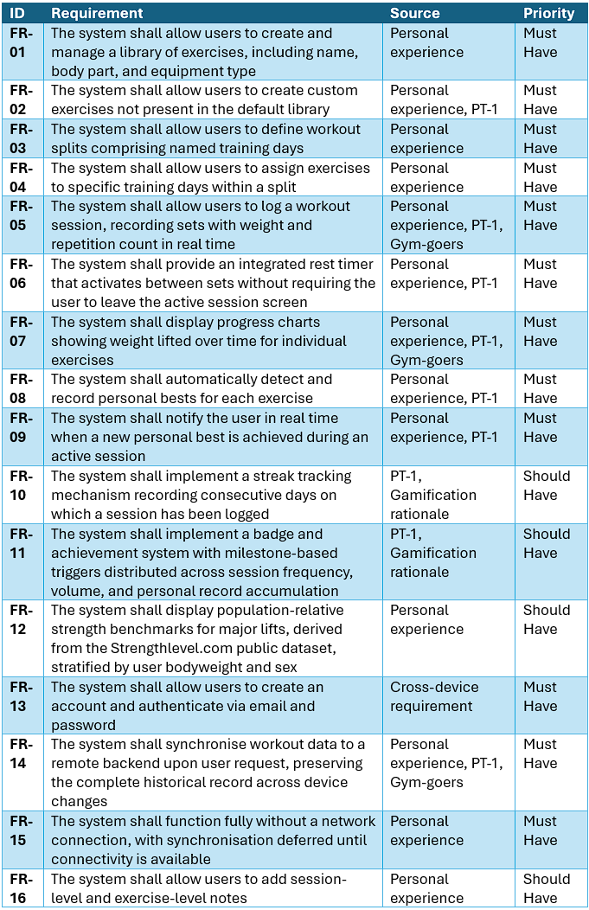
Table 3.2 — Functional requirements.

3.8 Non-Functional Requirements
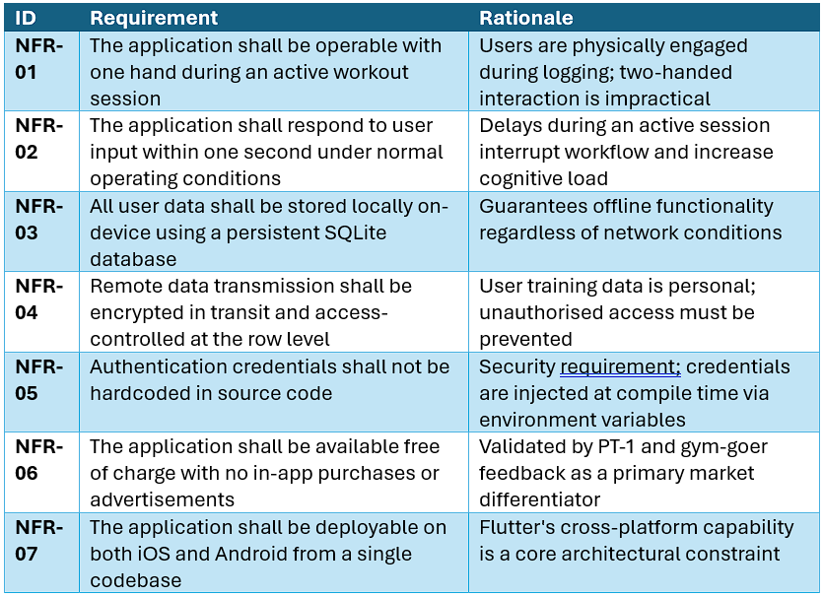

Table 3.3 — Non-functional requirements

3.9 Design Constraints
The application's architecture was conceived as a five-layer stack (presentation, state management, local data, synchronisation, and remote services) prior to technology selection. An abstract representation is presented in Figure 3.3.
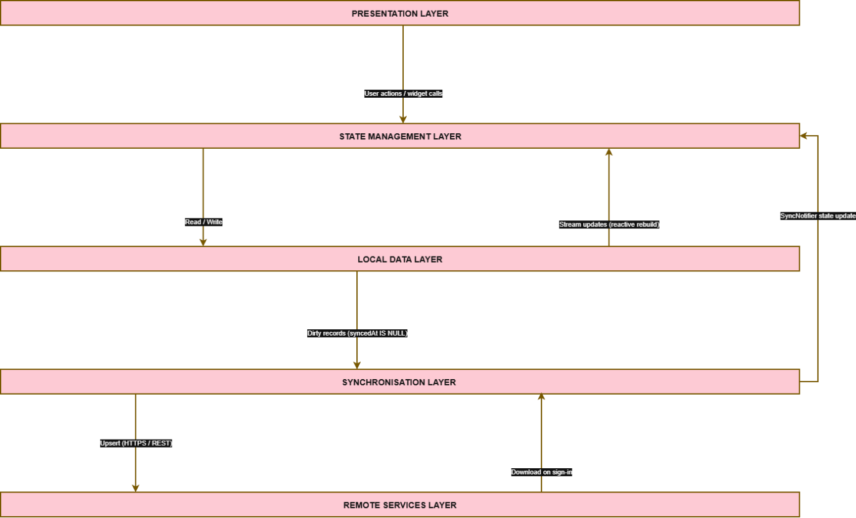

Figure 3.3 — Abstract architecture stack.

The following constraints were established at the outset of the project and shaped all subsequent design and implementation decisions:
The development platforms used were Flutter and Dart, allowing a single codebase to target both iOS and Android. Flutter is particularly well-suited to a single-developer project that needs both development velocity and production-grade output because of its hybrid compilation model, which combines Just-In-Time (JIT) compilation during development, enabling sub-second hot reload for rapid iteration, and Ahead-Of-Time (AOT) compilation for release builds, producing native ARM code with predictable performance (Flutter, 2026).
Offline-first architecture was mandated by the practical reality of gym environments, which frequently offer poor or absent network connectivity. The application must be fully functional without any network dependency; cloud synchronisation is an enhancement, not a prerequisite.
The recognized failure mode of the current application environment immediately drove the establishment of no subscription model and no adverts as hard constraints from the beginning.
Supabase was selected as the remote backend for authentication and cloud synchronisation, providing a managed PostgreSQL database with row-level security and a Flutter-compatible SDK.
The project moves on to the design stage once the restrictions and requirements have been established. The system architecture, database schema, user interface design, and gamification design that convert the previously defined requirements into a particular technical specification are presented in Chapter 4.

4 - Design

4.1 Development Methodology
The development of OneRep was conducted using a hybrid methodology combining structured Waterfall planning with iterative Agile development practices. This approach was adopted deliberately in response to the constraints of an academically supervised project with a fixed submission deadline.
A separate requirements gathering phase came before system design, which came before implementation, which came before evaluation, according to the high-level project lifecycle's Waterfall structure. The planning visibility needed for academic supervision was made possible by this sequential framework. Nonetheless, work continued in distinct feature-focused sprints that are typical of Agile methodology during the implementation phase. Every sprint resulted in a testable, deployable increment of the application, and feedback from informal user consultations and supervisor meetings was integrated in between sprints. This led to a number of mid-development requirement additions, most notably the gamification layer and multiple exercise metric types (weightReps, bodyweightReps, timeOnly, distanceTime), neither of which were included in the original design.
This hybrid approach is reflected in the Git branching method used throughout the project. Every major development increment resulted in the creation of feature branches, with work taking place on a protected main branch that could only be accessed through pull requests. This procedure created a commit history that functions as an auditable record of development progress and imposed code review discipline even inside a single-developer project.
The choice of methodology is acknowledged to carry limitations. The fixed deadline introduced scope pressure during the final sprints, resulting in some planned improvements — most notably alphabetical sorting and search functionality for the exercise library — being deferred to future work rather than completed within the project timeline.

4.2 System Architecture
OneRep is structured across five distinct architectural layers, each with clearly defined responsibilities. The architecture is illustrated in Figure 4.1.

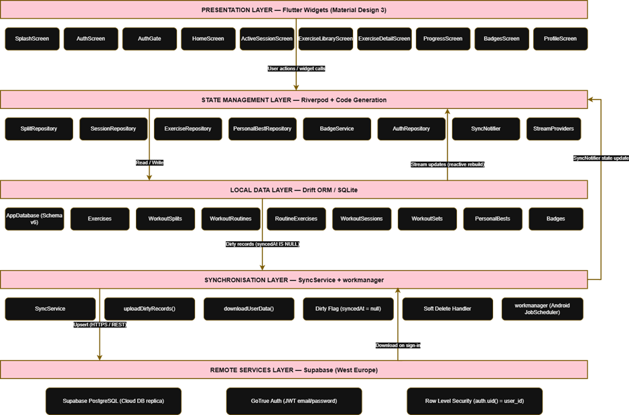

Figure 4.1 – System architecture diagram.

Presentation Layer. The user interface is implemented entirely in Flutter using Material Design 3 (Google, 2026), with a custom deep burgundy and gold colour scheme. All screens are implemented as Flutter widgets — either stateless or stateful — and interact with the application state exclusively through Riverpod providers. No business logic resides in the presentation layer.
State Management Layer. All application state is managed via Riverpod using code generation through the @riverpod annotation. Repository classes function as the primary state containers, exposing reactive streams derived from the local database.
Local Data Layer. All persistent data is stored in a Drift-managed SQLite database on the device. This layer is the single source of truth; all reads and writes are directed here regardless of network state. The database is initialised on first launch with a seed of 40 default exercises.
Synchronisation Layer. A dedicated SyncService class manages the propagation of locally modified records to the remote backend. Synchronisation is upload-only during normal operation; download occurs exclusively at sign-in as a restoration mechanism. The synchronisation layer is intentionally decoupled from Flutter's widget lifecycle, enabling it to operate in a background isolate via the workmanager package.
Remote Services Layer. Supabase provides three services to the application: a managed PostgreSQL database serving as the cloud replica of local data, GoTrue authentication handling JWT-based email and password credentials, and Row Level Security policies enforcing per-user data isolation at the database level.
The following is how data moves from user interaction to remote backup. A Riverpod repository method is triggered by a user action. This method uploads the modification to the local Drift database and sets the syncedAt column of the affected record to null, marking it as unclean. Every observing widget rebuilds using the updated data when Drift emits a stream update. SyncService queries all dirty records and upserts them to Supabase at the subsequent sync trigger, which could be a scheduled background task, an application foreground event, or a manual tap.
The offline-first guarantee is enforced architecturally: the Supabase client is never invoked during normal read or write operations. The UI never awaits a network response to display data.

4.3 Database Design
The OneRep database schema is at version 6, having undergone six iterative migrations during development. The schema comprises eight tables organised around a five-level workout hierarchy, supplemented by tables for gamification data and a badges system. The complete entity-relationship diagram is presented in Figure 4.2.

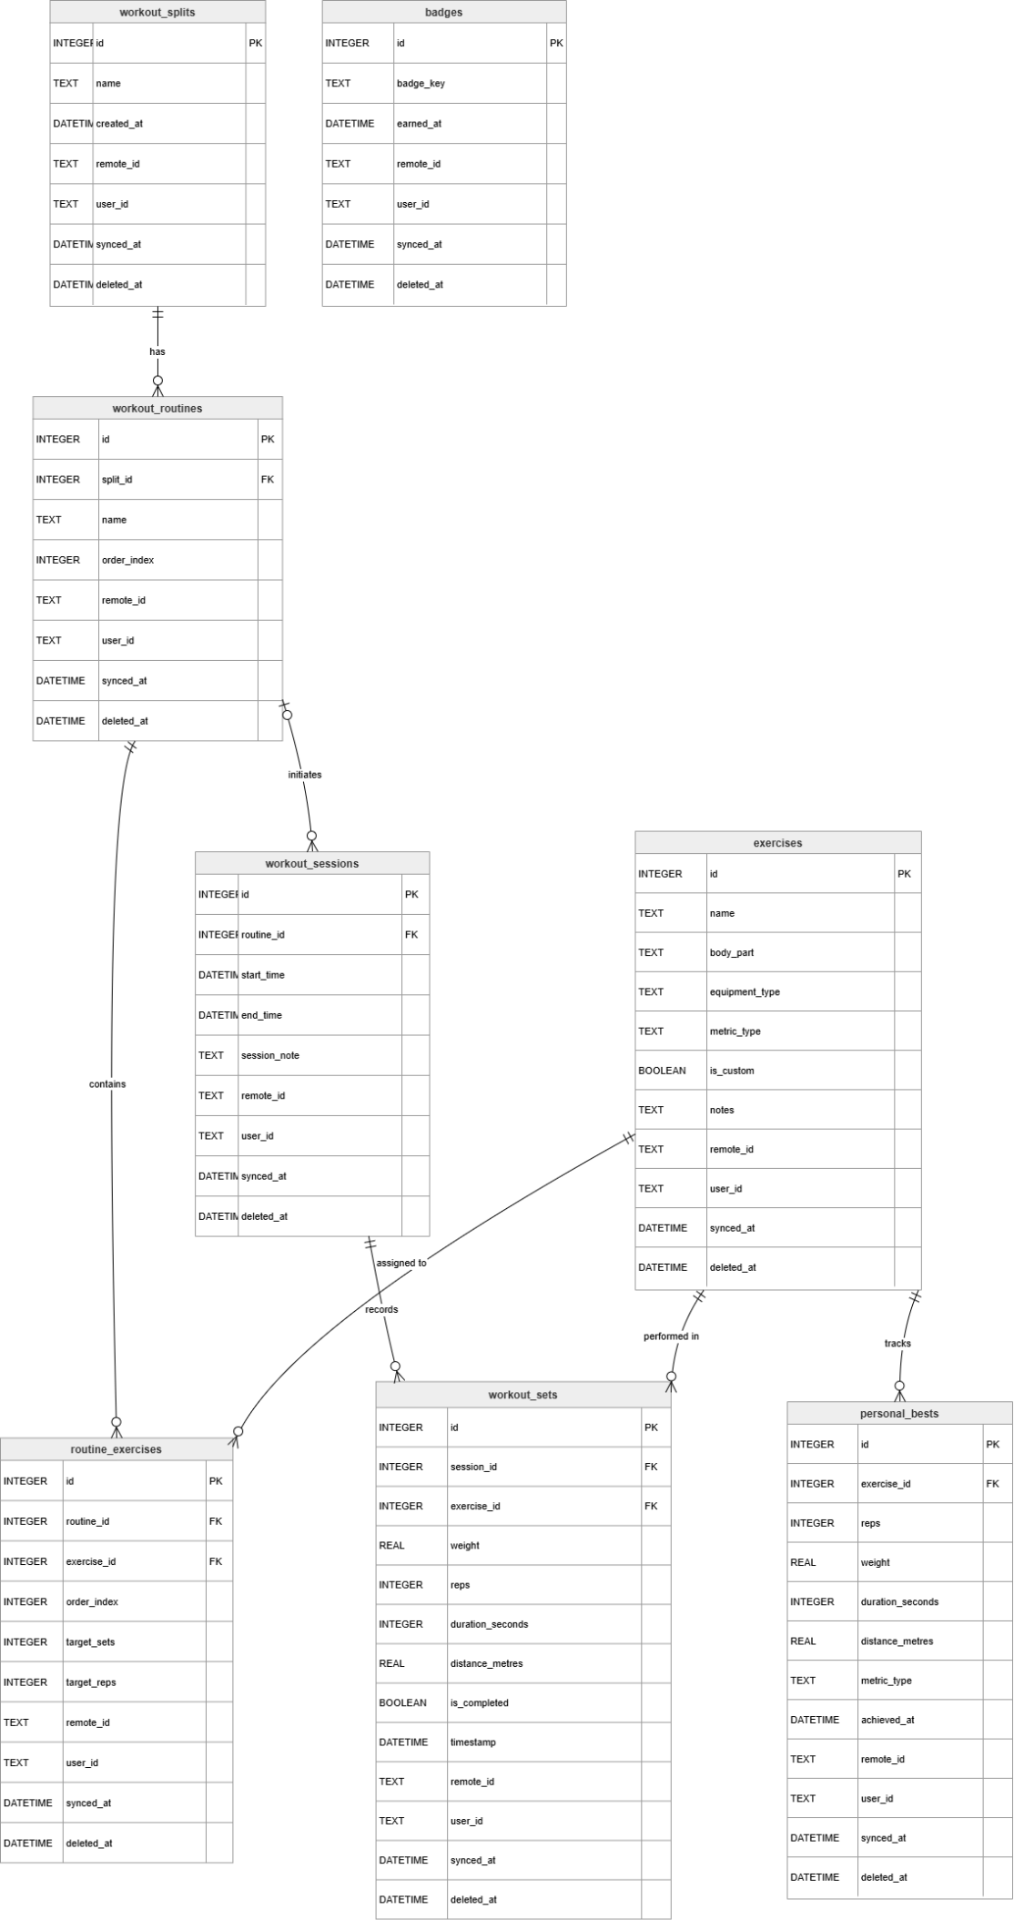
Figure 4.2 — Entity-relationship diagram.

4.3.1 The Workout Hierarchy
The core data model represents the conceptual structure of resistance training as a five-level hierarchy:
Exercises serve as the user's fundamental movement dictionary. Every exercise record has a name, body part, type of equipment, metric type that describes the performance data recorded for that exercise, a flag that indicates whether the exercise was produced by the user or the system, and optional annotations. Four values are supported by the metric type field: timeOnly (duration), distanceTime (distance and time), bodyweightReps (repetition count only), and weightReps (weight and repetition count).
WorkoutSplits represent a training programme — a named collection of training days. A typical example is a Push/Pull/Legs split or an Upper/Lower split.
WorkoutRoutines represent individual training days within a split. A Push/Pull/Legs split, for instance, contains three routines: Push Day, Pull Day, and Legs Day.
RoutineExercises is a junction table linking exercises to routines, supporting ordered exercise lists with optional target set and repetition counts. This table allows the same exercise to appear in multiple routines across different splits.
WorkoutSessions represent individual gym visits. A session is optionally linked to a routine — sessions without a routine link are classified as freestyle sessions, enabling ad-hoc workouts that fall outside a planned programme. Sessions carry start and end timestamps; an absent end timestamp indicates a session in progress and excludes the record from synchronisation.
WorkoutSets are the atomic unit of training data — a single logged performance: the exercise performed, the weight used, the repetitions completed, and any applicable duration or distance values. Every set is associated with a session and an exercise.

4.3.2 Gamification Tables
Every exercise's current performance record for every measure category is stored in PersonalBests. The upsert target is a composite unique constraint on (exerciseId, metricType), which guarantees that each exercise keeps exactly one PR record for each metric category. It is possible to visualize past PR progression over time using the achieved_at timestamp.
Badges stores the state of all achievement badges. All badge rows are pre-seeded at database creation with earnedAt set to null, representing a locked state. Earning a badge writes the current timestamp to earnedAt. The badge_key column acts as a stable identifier for each badge definition.

4.3.3 Sync Column Design
To support the synchronization architecture, each of the eight tables has four extra columns: deletedAt (a soft delete marker that permits remote propagation of deletions), userId (the authenticated user's Supabase UUID, stamped at sync time), syncedAt (null indicates a dirty record requiring upload), and remoteId (a UUID bridge between the local integer primary key and the Supabase row identifier). Section 4.5 discusses the dual-key approach, which uses UUIDs remotely and integer primary keys locally.

4.4 User Interface Design

4.4.1 Design Principles
Two well-known HCI frameworks that were presented in Chapter 2 served as the basis for the design of the OneRep interface. The macro-level structural choices were influenced by Nielsen's ten usability heuristics: error prevention is addressed by soft deletion with implicit undo via swipe gestures rather than destructive confirmation dialogs; consistency and standards are upheld through Material Design 3 conventions; and visibility of system status is maintained through real-time set logging and persistent sync state indicators. The micro-level interaction design was motivated by Norman's Action Cycle, which guarantees that the distance between a user's objective—logging a set—and the actual actions necessary to accomplish it is minimized at each stage.
NFR-01 (one-handed operability) further constrains all interface decisions to large tap targets, bottom-anchored controls, and minimal navigation depth.

4.4.2 Navigation Structure
Splits, Exercises, Progress, and Badges are the four tabs that make up the program shell, which is a bottom navigation bar. An IndexedStack, which renders all four tab screens concurrently and maintains their widget state during tab transitions, is used to construct the tab bar. The latency and visual disturbance associated with reconstructing screens after each tab change are eliminated by this design choice.
One-tap access to an impromptu exercise session without navigating through the split and routine hierarchy is made possible by a full-width freestyle session banner that is permanently displayed above the bottom navigation bar on the home screen.
The OneRep wordmark, a profile symbol, a manual sync trigger, and a sign-out control are the four persistent buttons seen in the application bar.

4.4.3 Screen Map
The complete screen hierarchy is illustrated in Figure 4.3.
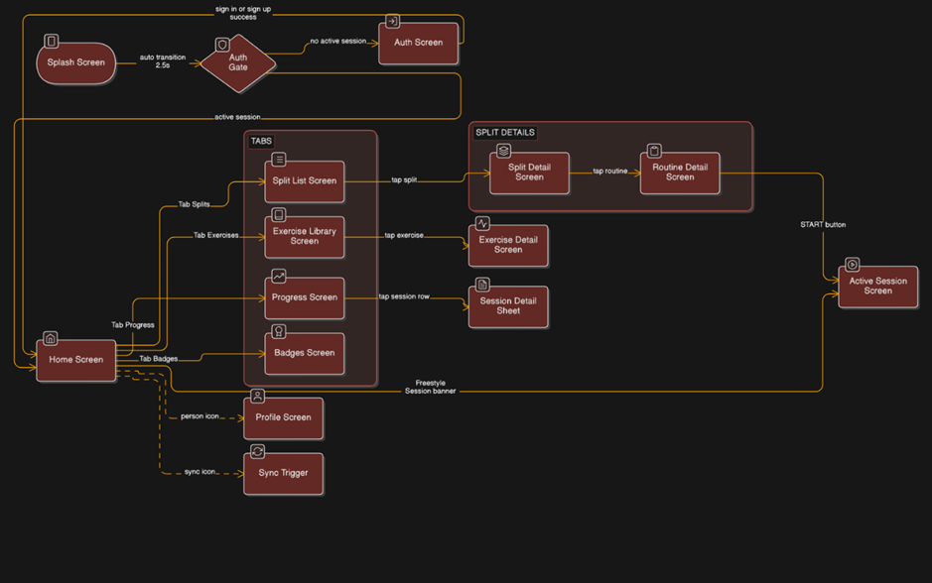

Figure 4.3 – Screen navigation flow.

During an active gym session, the main user journey goes like this: SplitListScreen → SplitDetailScreen → RoutineDetailScreen → ActiveSessionScreen. The ActiveSessionScreen received the most design attention and is the application's most interactive screen. Set logging controls display weight and repetitions fields for weightReps exercises, a reps-only field for bodyweight exercises, duration inputs for timed exercises, and distance and time fields for cardio activities. These controls dynamically adjust to the metric type of the selected exercise. When a new personal best is identified, a gold animated PR banner appears instantly, offering the real-time motivational feedback covered in Section 2.9.

4.4.4 Visual Design
The application adopts a deep burgundy primary colour with gold accents, a palette chosen to convey premium quality whilst differentiating the application from the blue-dominant aesthetic of the mainstream fitness app market. The gold accent colour is applied consistently to performance indicators, PR banners, earned badges, and active state indicators, creating a visual language in which gold signifies achievement — a deliberate gamification design choice.
Early interface wireframes were produced in Figma prior to implementation to establish the navigation hierarchy, screen layout, and interaction flow before committing to code. Representative wireframes are presented in Appendix J.

4.5 Key Design Decisions

4.5.1 Local Storage: Drift over Alternatives
Because the workout data model is essentially relational, Drift was chosen as the local data layer above the other options. JOIN procedures across many tables are needed to compute attendance streaks, calculate personal bests, and query all sets for a given exercise across all sessions. These searches cannot be expressed natively by document stores like Hive and Isar or key-value stores like SharedPreferences. Drift offers all the features needed by the application's data model, including a fully type-safe SQL layer with compile-time query verification, reactive stream support via Dart's Stream API, and a schema migration system.

4.5.2 State Management: Riverpod over Alternatives
As opposed to BLoC, Provider, and GetX, Riverpod with code generation was chosen. Because BLoC adds boilerplate overhead to a single-developer project with frequent iteration cycles, it was rejected. Because GetX combined state management and navigation, making testing more difficult, it was rejected. Compile-time safety is lacking in Riverpod's predecessor, Provider. Riverpod's @riverpod annotation offers automatic dependency tracking, doing away with the need for manual provider registration, and smoothly connects with Drift's reactive streams through StreamProvider.

4.5.3 Dual-Key Design: Integer Local PKs and UUID Remote Keys
Local records use SQLite autoincrement integer primary keys for performance — integer comparisons and joins are faster than string comparisons on UUID values. However, integer primary keys are not globally unique: two devices creating records offline would generate conflicting IDs. UUID v4 is used as the remote identifier, generated client-side without a server round-trip, ensuring global uniqueness from the point of creation. The remoteId column is null until first sync, at which point it is stamped and used as the stable Supabase row identifier for all subsequent upserts. This design isolates the synchronisation concern entirely from the local data model.

4.5.4 Upload-Only Sync
Conflict resolution complexity introduced by bidirectional synchronization is out of proportion to the use case of the application. OneRep does not support collaboration scenarios; it is intended to be a single-user, single-device program. Conflict resolution is completely removed by designating the local database as the only source of truth and limiting Supabase to a backup and restoration role. The user's data is restored to a fresh or reset device only during the sign-in process.

4.5.5 Soft Deletes
Hard deletes cannot be propagated to a remote database if the device is offline when the deletion occurs. A record deleted locally leaves no artefact that can inform the sync service of the required remote operation. Soft deletes solve this by writing a deletedAt timestamp to the record, which the sync service can upload to Supabase. After successful remote propagation, the local record is hard-deleted. All database queries filter on deletedAt IS NULL, rendering soft-deleted records invisible to the UI without any additional application-layer logic.

4.5.6 Supabase over Alternatives
Document stores without native support for relational queries are Firebase Realtime Database and Firestore. With JOINs across sessions, sets, workouts, and personal bests, the workout data model is essentially a relational problem that document storage awkwardly handle by either denormalization or several round-trip queries. With a generous free tier and a Flutter SDK, Supabase offers a managed PostgreSQL instance with a REST API, GoTrue authentication, and Row Level Security. Due to operational overhead that was outside the project's scope, a self-hosted PostgreSQL instance was turned down.

4.6 Gamification Design
The gamification system was designed as a coherent layer atop the core tracking functionality, implementing the four mechanics identified in the literature review: personal best detection, streak tracking, badge achievements, and the groundwork for future population percentile benchmarking.

4.6.1 Personal Best Detection
Following each set's logging, PR detection is initiated synchronously. The detection method applies the proper comparator based on the exercise's metric type: for weightReps exercises use weight as the main comparator and repetition count as a tiebreaker; bodyweight exercises use repetition count as the only comparator; and timeOnly longer-duration workouts are considered new PRs; for distance-time exercises, the performance metric is a faster time for a given distance. Strength training theory prioritizes load progression, which is reflected in the choice to use weight as the main comparator for weighted workouts.
The user is immediately presented with the outcome of PR detection in the active session screen through a gold animated banner, providing the real-time positive feedback that was noted in Section 2.9 as being essential to the gamification loop. The application of Fogg's convergence of desire, ability, and trigger is this immediacy—feedback at the time of accomplishment rather than after a session (Fogg, 2009).

4.6.2 Streak Tracking
The streak is calculated as the number of consecutive calendar weeks in which at least one session was completed. The weekly granularity — rather than daily — was chosen to accommodate the reality of resistance training programmes, in which rest days are physiologically necessary and a strict daily streak would penalise users following evidence-based training frequencies. The calculation works backwards from the current week, terminating at the first week with no sessions. The current week is permitted to be incomplete without breaking the streak.

4.6.3 Badge and Achievement System
Eight badges are defined, spanning four categories of engagement: session completion (first_workout), volume accumulation (sets_50, sets_500), personal record achievement (first_pr, pr_10), consistency (streak_7_day, streak_30_day), and feature engagement (first_custom_exercise). All badge rows are pre-seeded at database initialisation in a locked state, implementing the goal gradient effect described in Section 2.9: unearned badges are visible and described, creating concrete proximal goals that motivate continued engagement. Badge evaluation is performed after every set and every session completion via the BadgeService, which checks each trigger condition against the current database state.

4.6.4 Population Percentile Benchmarking
The population percentile benchmarking feature displays a user’s personal best for major lifts as a percentile rank within the Strengthlevel.com reference dataset, stratified by bodyweight and sex. Implementation details are presented in Section 5.4.4.
The architectural and interaction foundations of OneRep are established by the design choices detailed in this chapter. Chapter 5 explains how these designs were implemented in code, details the major technical difficulties that arose during implementation, and provides the automated test suite that confirms the accuracy of the core data layer.

5 - Implementation and Testing

5.1 Implementation Overview
OneRep was implemented as a cross-platform Flutter application targeting Android and iOS from a single Dart codebase. Table 5.1 summarises the complete dependency stack.
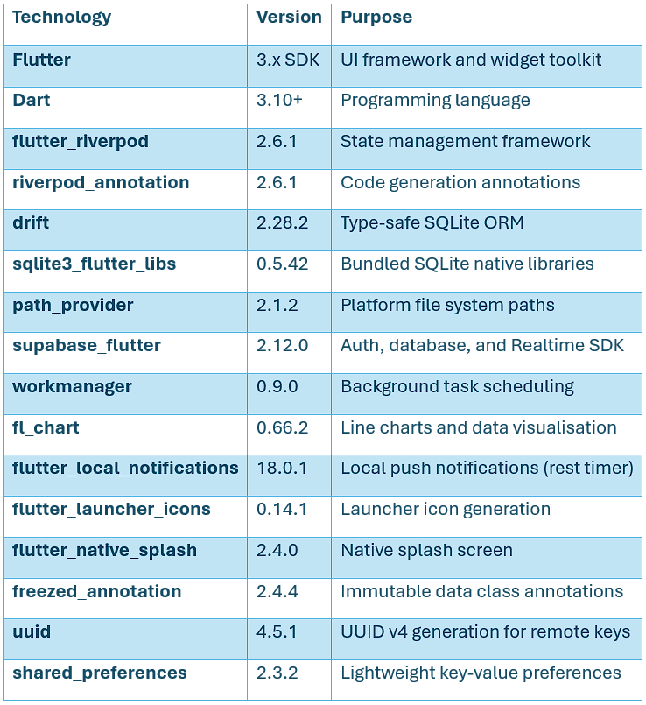

Table 5.1 — OneRep technology stack.

5.2 Core Feature Implementation

5.2.1 Exercise Library
The exercise library is implemented around the exercises table, pre-seeded with 40 default exercises spanning the major muscle groups and movement patterns. Each exercise carries a metricType field that governs how performance data is captured for that exercise across the application.

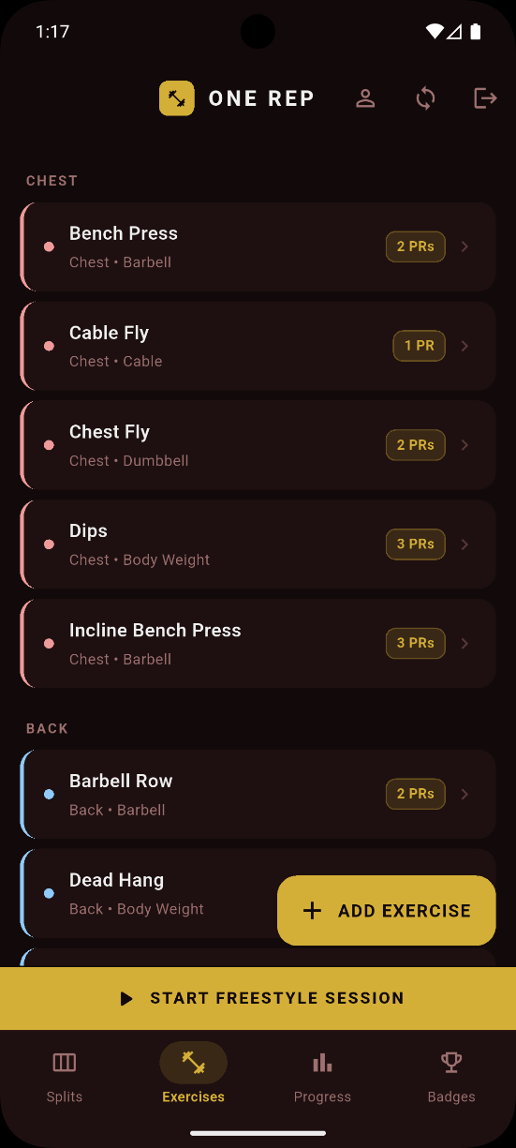

Figure 5.1 — ExerciseLibraryScreen displaying exercises grouped by body part with colour-coded category chips. The floating action button provides access to custom exercise creation.

Users may add custom exercises via a creation dialog specifying name, body part, equipment type, and metric type. Custom exercises are marked for cloud synchronization with isCustom = true. In order to prevent redundant network traffic and possible conflicts on the unique name constraint, default exercises are not included in the sync surface because they are seeded identically on each installation.

5.2.2 Workout Structure
The five-level workout hierarchy described in Section 4.3 is implemented across five Drift tables with foreign key constraints enforced at the database level via SQLite's PRAGMA foreign_keys = ON.
The freestyle session entry point is surfaced permanently via the full-width banner on the HomeScreen, accessible with a single tap at any point during the application's use.
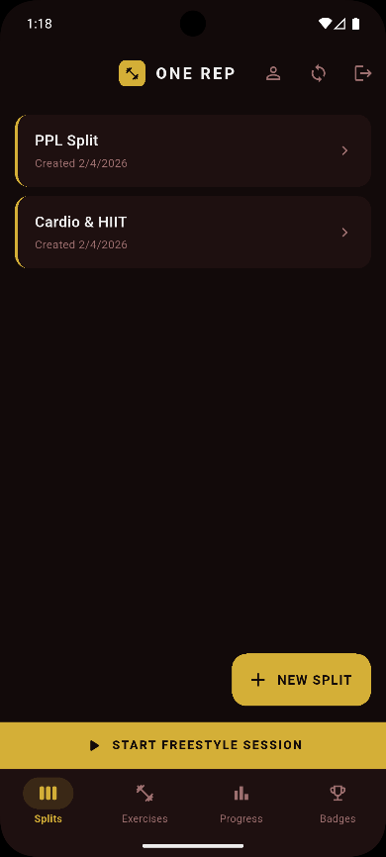
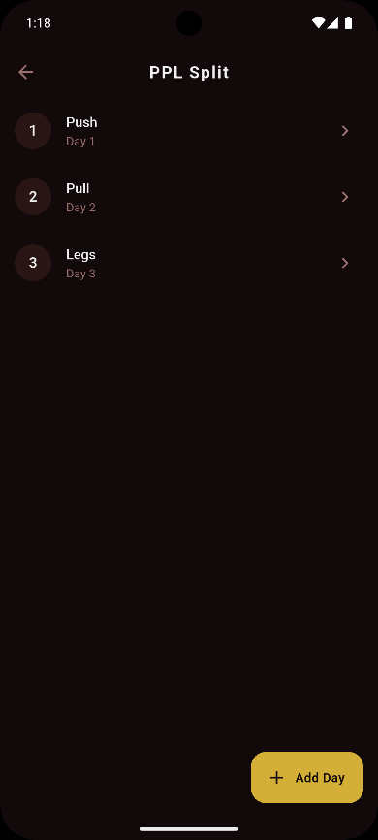

Figure 5.2.1 (left) – SplitListScreen showing all splits user has created.

Figure 5.2.1 (right) - SplitDetailScreen showing routines within a training split.

5.2.3 Active Session Logging
The ActiveSessionScreen is the most interaction-intensive surface in the application and received the greatest implementation effort. Set logging controls adapt to the selected exercise's metricType, as described in Section 4.4.3.
When a set is logged, the SessionRepository.logSet() method instantly calls PersonalBestRepository and writes the set to the local database.checkAndSavePr(). LogSet() provides a non-null PrResult with the exercise name and performance values if a new personal best is found. When a non-null PrResult is received, the ActiveSessionScreen shows a gold animated banner, providing instantaneous motivational feedback at the point of accomplishment.
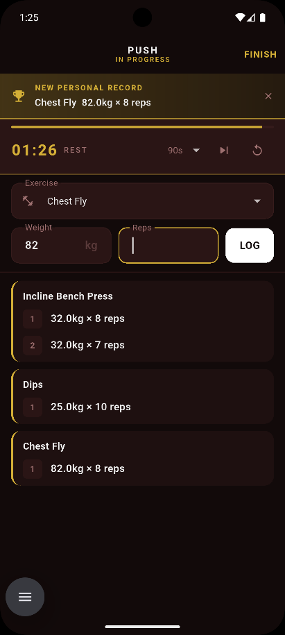

Figure 5.3 — ActiveSessionScreen during an active session showing logged sets grouped by exercise. The gold PR banner is displayed when a new personal best is detected.

5.2.4 Rest Timer
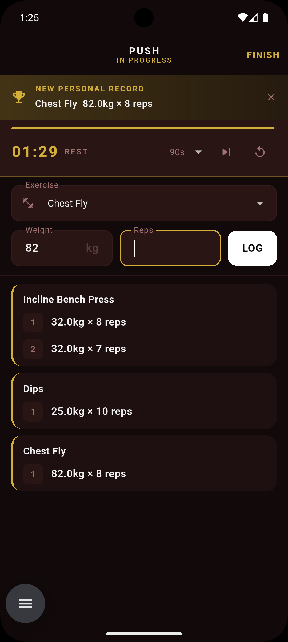
The integrated rest timer is implemented using flutter_local_notifications to deliver a local push notification when the countdown expires, ensuring the alert fires even if the user has briefly navigated away from the active session screen. The timer is initiated automatically upon set logging, removing the need for a manual start action between sets. The countdown is displayed persistently within the ActiveSessionScreen, maintaining visibility of remaining rest time without requiring the user to navigate to a separate screen or application.

Figure 5.4.1 — ActiveSessionScreen displaying the integrated rest timer countdown between sets. The timer initiates automatically upon set logging without user intervention. Three options are available; Select duration (90s default), end timer and restart timer.
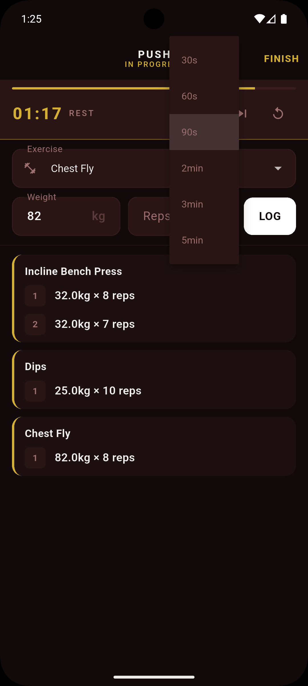

Figure 5.4.2 – Clicking the dropdown allows users to select a timer duration.

5.2.5 Progress Visualisation
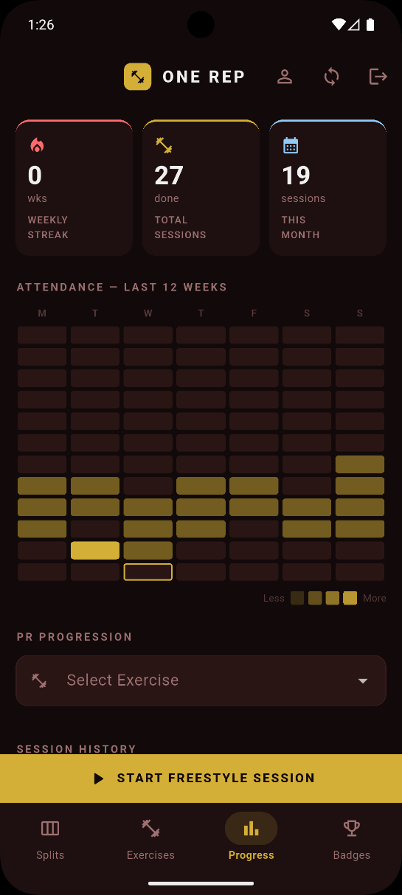
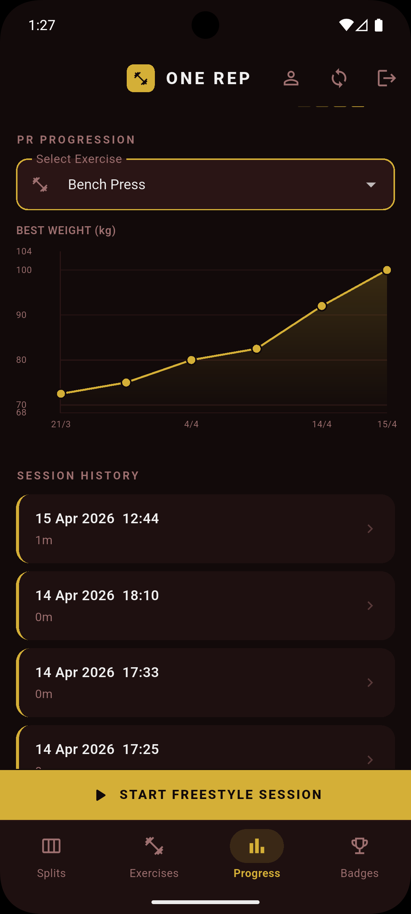
Three different data visualizations are available on the ProgressScreen. The current weekly streak count, the overall number of sessions completed, and the number of sessions logged in the current calendar month are all shown on stat cards at the top of the screen. A visual concept taken from code contribution graphs that software professionals are familiar with, an attendance heatmap shows 12 weeks of session activity aligned to Monday, with gold squares of different opacity indicating session frequency each day. The primary analytical tool is a PR progression line chart implemented using fl_chart, displaying the user's best performance over time for a selected exercise.

Figure 5.5 — ProgressScreen showing the weekly streak stat card, twelve-week attendance heatmap aligned to Monday.

Figure 5.5.2 (right) - Shows PR progression line chart for a selected exercise and session history.

5.3 Synchronisation Implementation

5.3.1 Schema Migration History
The Drift database schema reached version 6 during development, reflecting six iterative migration steps as requirements evolved. Key migrations included: the addition of the metricType column to the exercises table and the duration and distance columns to workout_sets (v2 → v3); the introduction of sync columns across all five core tables (v3 → v4); and the addition of the personal_bests and badges tables (v5 → v6). Each migration was implemented using explicit ALTER TABLE ADD COLUMN statements within Drift's onUpgrade callback, as Drift's migration DSL does not support all column constraint types and raw SQL was required for several additions.

5.3.2 Dirty Flag Mechanism
Using the syncedAt column found on each of the eight syncable tables, the synchronization mechanism is based on a dirty flag pattern. A record marked as dirty—modified locally but not yet reflected in Supabase—has a null syncedAt value. In the repository layer, syncedAt is set to null for each insert and update operation. SyncService clears the dirty flag by stamping syncedAt with the current timestamp after a successful upload to Supabase. From the UI's point of view, this technique is completely passive: the sync layer reads the dirty queue independently, and the application writes to the local database without any restrictions.

5.3.3 SyncService
SyncService is implemented as a plain Dart class — deliberately free of Flutter bindings — instantiated with an AppDatabase reference and a SupabaseClient reference. This enables operation in a workmanager background isolate. The service exposes two public methods.
uploadDirtyRecords() iterates through all syncable tables in foreign key dependency order: WorkoutSplits → WorkoutRoutines → RoutineExercises → WorkoutSessions → WorkoutSets → PersonalBests → Badges → CustomExercises. This ordering is mandatory; PostgreSQL enforces foreign key constraints. Each table's sync runs within an independent try-catch block, collecting errors in a SyncResult.errors list rather than aborting the entire operation on a single failure.
downloadUserData() is invoked on sign-in and fetches all rows belonging to the authenticated user from Supabase, inserting or updating them into the local database using insertOnConflictUpdate keyed on the record's remoteId. This is the sole mechanism by which data flows from Supabase to the local database, implementing the download-on-restore pattern described in Section 4.5.

5.3.4 Soft Delete Implementation
Soft deletes are used for all deletion procedures in OneRep. The repository writes deletedAt = DateTime.now() and syncedAt = null to the local record within a database transaction when a user deletes a record, such as by swiping a split card. To preserve referential consistency, children are soft-deleted before parents within the same transaction. Without the need for application-layer deletion logic, all stream queries in the repository layer filter on deletedAt IS NULL, rendering the soft-deleted record instantly invisible to the user interface. SyncService finds the dirty record on the subsequent sync cycle, upserts the populated deleted_at value to Supabase, and, upon a verified upload, hard-deletes the local record. In order to prevent previously erased entries from ever being restored upon sign-in, the Supabase download query filters on deleted_at IS NULL.

5.3.5 Authentication Implementation
Authentication is handled by Supabase GoTrue via the AuthRepository, which wraps the signIn, signUp, and signOut methods and catches AuthException, rethrowing sanitised user-facing messages. The application's routing is driven by a StreamProvider watching Supabase's onAuthStateChange stream, consumed by AuthGate at the application root. When the stream emits an event with a non-null session, AuthGate renders HomeScreen; when the session is null, AuthScreen is rendered. This pattern reacts to all authentication events without requiring explicit navigation calls.
On successful sign-in, downloadUserData() restores the user's data from Supabase. On sign-out, clearLocalData() wipes all user-owned rows before the session is cleared.
Row Level Security on all Supabase tables is configured with the policy auth.uid() = user_id. Every row uploaded to Supabase includes the authenticated user's UUID in the user_id column. This policy ensures that a user can only read and write their own rows, even if the application's anon key — which is embedded in the compiled client binary — were to be extracted. The service role key, which bypasses RLS, is never included in the client application.

5.3.6 Background Synchronisation
Background synchronisation is implemented via the workmanager package, which uses Android's JobScheduler to schedule a periodic task with a seven-day interval and a network connectivity constraint. The background callback dispatcher is a top-level Dart function annotated with @pragma('vm:entry-point') to prevent tree-shaking by the Dart compiler. The dispatcher initialises Supabase and AppDatabase independently — without Flutter bindings — and calls uploadDirtyRecords(), returning true on success or false to request a workmanager retry. On iOS, background execution is subject to significant operating system throttling and cannot be guaranteed to execute reliably at the scheduled interval. The manual sync trigger in the application bar is the primary and reliable sync mechanism for iOS users; the background sync provides a secondary best-effort layer.

5.4 Gamification Implementation

5.4.1 Personal Best Detection
PR detection is triggered synchronously within SessionRepository.logSet() after every set is persisted to the local database. The comparator logic per metric type is described in Section 4.6.1.
When a PR is found, an upsert with a conflict target on (exerciseId, metricType) is used to update the personal_bests table, guaranteeing that each exercise has exactly one PR entry for each metric type. The calling repository receives a PrResult object from the method and propagates it to the ActiveSessionScreen for instant display.

5.4.2 Streak Calculation
The weekly streak is calculated by getWeeklyStreakProvider in session_repository.dart. The algorithm iterates backwards through 7-day windows aligned to Monday. The streak counter increments for each consecutive week containing at least one session and terminates at the first week with no sessions. The current week is treated as incomplete and does not break the streak if no sessions have yet been logged within it. This weekly granularity, rather than a daily streak, was chosen deliberately to reflect the physiological reality of resistance training: rest days are not failures but necessary components of an effective programme.

5.4.3 Badge System
All eight badge rows are pre-seeded into the badges table at database creation with earnedAt = null. BadgeService.evaluateAll() is called after every set log and every session completion. The method evaluates each of the eight badge triggers in sequence against the current database state: session count for first_workout, total set count for sets_50 and sets_500, the totalPrCount parameter for first_pr and pr_10, a streak calculation for streak_7_day and streak_30_day, and a query for custom exercises for first_custom_exercise. Badge award is idempotent — if earnedAt is already non-null, the trigger check is skipped without writing to the database. BadgesScreen watches the badges table via a StreamProvider and rebuilds automatically when any badge is earned.

5.4.4 Population Percentile Benchmarking
Strength standards data sourced from Strengthlevel.com (accessed March 2026, non-commercial educational use, attribution present in both source code and UI) is stored as compile-time Dart constants in strength_standards_data.dart. Six major compound exercises are supported.
The calculatePercentile() function finds the closest bracket, compares the user's best lift to the five threshold values, then clamps the user's bodyweight to the table's minimum and maximum bracket. Linear interpolation yields a smooth integer percentile outcome when the lift is between two thresholds. A conservative decision that understates rather than overstates the user's relative strength is made by comparing the optimal lift straight to 1RM standards without conversion. ExerciseDetailScreen shows the outcome as a "Top N!" indicator, a label chip, and a progress bar colored by achievement level. Beneath the widget is a credit from Strengthlevel.com. When bodyweight or sex are not input, a nudge card promotes profile completion, and the widget is completely hidden for exercises without standards data.

5.5 Production Challenges
The development of OneRep encountered several significant technical challenges. Their documentation here serves the dual purpose of academic reflection and practical guidance for future developers encountering analogous problems.
Schema migration complexity. One ongoing problem with Drift's versioned migration method was managing a changing database structure. Because Drift's migration DSL does not support some column constraint types, retroactive column addition—most notably the sync columns introduced across five tables at once—required explicit ALTER TABLE ADD COLUMN instructions in raw SQL. This experience taught us that schema design should be finished as soon as possible before implementation starts.
Riverpod generated file conflicts during branch merges. The .g.dart files produced by Riverpod's code generator were committed to version control in the early stages of the project. When feature branches were subsequently merged, the generated files — having been independently regenerated on each branch — produced conflicting diffs that automated merge strategies could not resolve cleanly. Resolution required manual conflict resolution followed by a full build_runner regeneration. The corrective action taken was to add all .g.dart files to .gitignore, treating them as build artefacts rather than source files.
Companion class Value wrapper semantics. Because Drift's Companion classes differentiate between explicitly set and absent fields, adding default values to the weight and reps columns in schema v6 resulted in type errors in all test code utilizing WorkoutSetsCompanion.insert(). It was necessary to update 71 test cases to employ explicit Value() wrappers.
DateTime timezone mismatch in the attendance heatmap. The attendance heatmap displayed incorrect data for downloaded sessions due to three compounding issues: grid misalignment to Monday, a non-reactive provider (ref.read instead of ref.watch), and UTC timestamp parsing shifting session dates. Resolution required correcting the weekday arithmetic, converting to a StreamProvider, and introducing a _parseLocal() helper
Android adaptive icon rendering. On Android 8+, adaptive icon rendering caused the app icon to appear with an unwanted white background. Resolution necessitated using flutter_launcher_icons to split the icon into an explicit background color and a foreground silhouette.
Hero tag conflicts in IndexedStack. A Flutter assertion issue reporting numerous Hero widgets having the same tag within a subtree was caused by navigating between screens. All four tab screens, including their FloatingActionButtons, which employ a common default Hero tag for transition animations, are rendered concurrently by the IndexedStack. Assigning distinct heroTag values to each FAB—"split_fab" for SplitListScreen and "exercise_fab" for ExerciseLibraryScreen—was the solution.
Git merge conflicts from generated file tracking. Repeated merge conflicts in generated files and independently modified source files required temporary disabling of branch protection to allow force-push after manual resolution. The corrective action was to establish a policy of short-lived feature branches merged frequently to minimise divergence, and to ensure generated files were excluded from version control going forward.

5.6 Testing

5.6.1 Test Strategy
The testing strategy for OneRep distinguishes between three categories of verification: automated unit tests covering the data layer, manual testing covering the UI layer, and structured usability evaluation covering the user experience layer (detailed in Chapter 6).
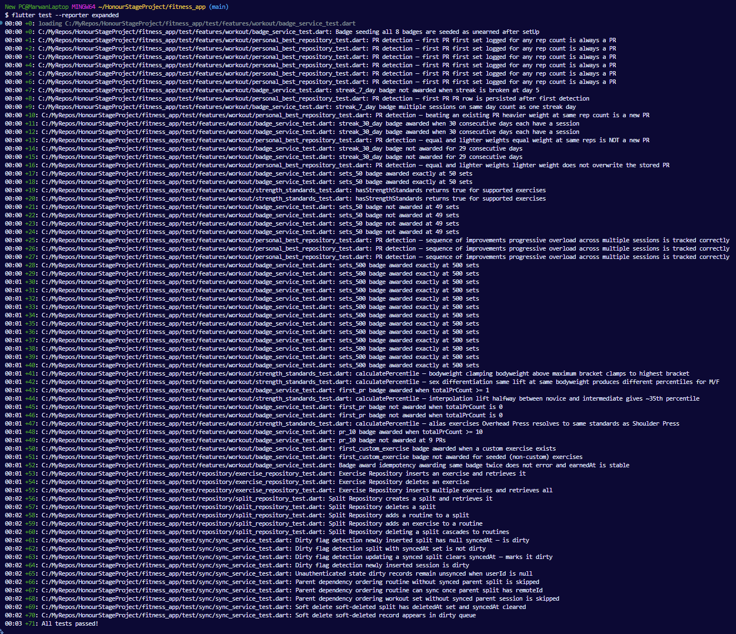
Automated tests target the repository and service classes using in-memory SQLite databases instantiated via Drift's NativeDatabase.memory(). Because repository logic—PR detection, streak computation, badge triggering, schema accuracy, and sync readiness—is deterministic and completely testable without requiring a user interface or network, this barrier was selected. The excessive setup complexity for a single-developer project under iteration prevented the creation of widget tests. via design, Supabase network calls are not included in automated testing; instead, the HTTP layer is verified via manual device sync testing.

Figure 5.6 — Terminal output of flutter test --reporter expanded confirming all 71 tests passing across five test files.

5.6.2 Test Suite
The test suite comprises 71 test executions across five test files, corresponding to approximately 40 distinct test cases. The higher execution count reflects parametrised tests — single test definitions executed across multiple input values to verify boundary conditions efficiently.
Exercise CRUD operations, split hierarchy and cascade deletion, badge trigger verification and idempotency, percentile calculation with interpolation and clamping, PR detection across all metric types and boundary conditions, and sync readiness logic including dirty flags, parent dependency skipping, and soft delete propagation are all covered by the suite. Appendix N has complete test descriptions.

5.6.3 Requirement Traceability
Table 5.2 maps the test groups to the functional requirements defined in Chapter 3.
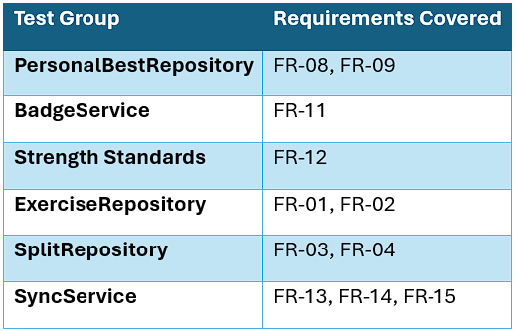

Table 5.2 — Requirement traceability matrix.

FR-05, FR-06, FR-07, FR-10, and FR-16 are validated through manual testing and the usability study (Chapter 6), as their correctness depends on UI behaviour.
The automated test suite confirms the correctness of the data layer; the question that remains is whether the application, as experienced by real users, fulfils its design objectives. Chapter 6 presents a structured usability evaluation combining heuristic inspection, naturalistic usage, think-aloud sessions, and the System Usability Scale to assess OneRep against both objective usability standards and the subjective experience of its target user population.

6 - Evaluation

6.1 Evaluation Strategy
OneRep was evaluated at four stages using a combination of inspection-based and user-centred techniques to compare the application to both real-world user experience and objective usability requirements. The stepwise approach was intended to guarantee that the application was robust and testable prior to participant interaction, and that participant input was based on actual usage rather than just initial impressions.
Nielsen's (1994) eight heuristics were used for a heuristic evaluation in phase 1. A seven-day period of naturalistic usage comprised Phase 2. Five work situations were used in structured think-aloud sessions during phase three. Phase 4 consisted of a post-session survey that included both qualitative and SUS questions.
The distinction made in the testing and evaluation literature between software functionality and user satisfaction is reflected in this multi-method architecture (Robinson, 2025). The think-aloud sessions and SUS directly involve users to address the latter, while the heuristic evaluation uses expert inspection to solve the former. Because participants supplied real training data to the think-aloud sessions, the seven-day naturalistic period adds ecological validity.

6.2 Phase 1 — Heuristic Evaluation
A heuristic evaluation was conducted by the researcher against Nielsen's (1994) ten usability heuristics prior to participant testing. The evaluation identified 12 violations across the application, ranging from cosmetic issues to two severity-4 findings classified as usability catastrophes requiring resolution before participant testing could safely proceed.
The complete violation table is presented in Table 6.1.

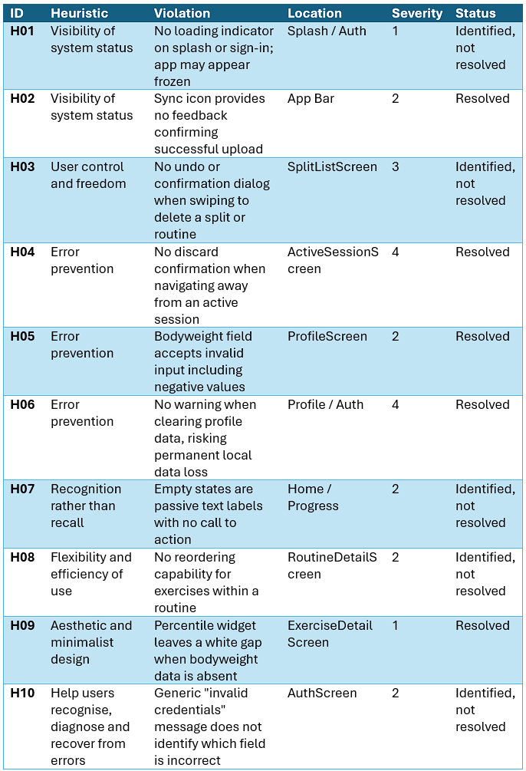
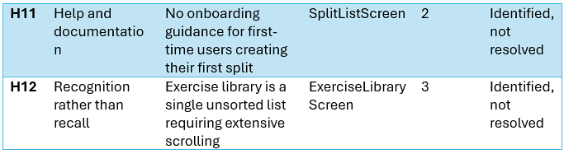

Table 6.1 — Heuristic evaluation violations (baseline, prior to participant testing)

The two severity-4 violations were resolved before participant testing commenced. The two severity-4 violations (H04 and H06) were resolved through confirmation dialogs before participant testing commenced.
H12 (unsorted exercise library) was not resolved within the project timeline. Its predicted impact on participants was confirmed in the subsequent usability study (Section 6.5).

6.3 Phase 2 — Naturalistic Usage Period
All five participants installed OneRep on their personal Android handsets and utilized the app during their actual gym sessions over a seven-day period after the heuristic evaluation and the resolution of severity-4 violations. Participants were told to use the app throughout their regular workouts and record any instances of positive surprise or bewilderment.
On Day 3, a quick check-in survey was conducted using a Google Form to get initial thoughts. Four out of the five participants said they used the app every time they went to the gym, and all five said they used it at least occasionally. At the halfway point of Day 3, the average rating for ease of use was 4.2 out of 5.
The Day 3 responses revealed a number of themes that were later verified in the think-aloud sessions. P1 commended the haptic alert and automatic rest timer for preventing excessive rest in between sets. H12 from the heuristic evaluation was supported by P2's observation of friction when perusing the exercise list. A feature gap that was continually raised across all subsequent data collection rounds was P3's desire for auto-population of prior session data. P4 stated that they were motivated to pursue the 30-day badge after obtaining the 7-day streak badge naturally. P5 said it was challenging to browse the workout page.
The naturalistic period ensured that participants arrived at think-aloud sessions with genuine training data and first-hand opinions.

6.4 Participants
Five participants were recruited from the researcher's social network, all of whom were regular gym-goers with active training programmes at the time of the study. Participant demographics are summarised in Table 6.2.
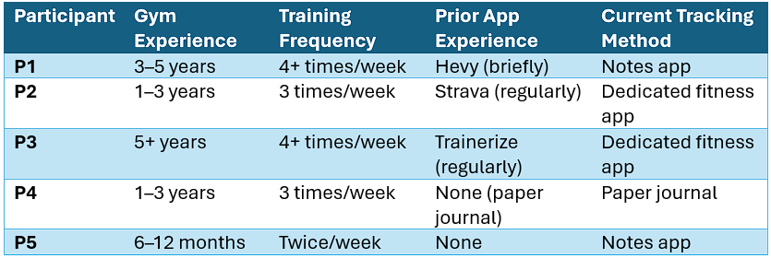

Table 6.2 — Participant demographics.

The sample spans the full target user population identified in Chapter 3: a novice with no prior app experience (P5), intermediate users transitioning from paper and Notes-based tracking (P1, P4), and experienced lifters with established app workflows (P2, P3). The sample provides a reasonable basis for assessing the application across experience levels.
Before the study started, all five participants gave their informed consent using a Google Form that included a digital consent agreement and the complete participant information page. Throughout this report, all participants are identified by their pseudonyms (P1–P5). No analysis or supplement contains any personally identifiable information.

6.5 Phase 3 — Think-Aloud Sessions
Think-aloud sessions were conducted in person with all five participants following the seven-day naturalistic usage period. Each session lasted between 20 and 35 minutes. Participants were asked to narrate their actions, intentions, and reactions as they completed five task scenarios. The researcher observed and recorded hesitations, errors, navigational choices, and verbal comments without intervention. Task completion and approximate task durations were recorded for each participant.

6.5.1 Task Completion Results
All five participants completed all five tasks successfully, yielding a 100% task completion rate. Task durations are summarised in Table 6.3.
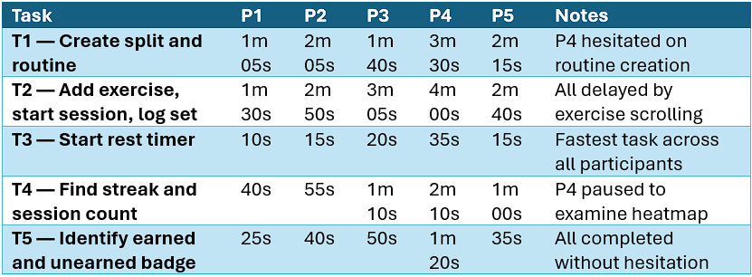

Table 6.3 — Task completion times by participant.

Task 3 (rest timer initiation) was the fastest task across all participants, with a mean completion time of approximately 19 seconds. This result is particularly significant given that the rest timer was identified in the requirements gathering phase as critically absent from the majority of free fitness applications (PT-1, personal communication, 20 March 2026) — its zero-friction discoverability suggests the implementation successfully addresses this gap.
Task 2 (exercise logging) was the slowest task across all participants. The primary cause in every case was navigation through the unsorted exercise library. P2 remarked:"still scrolling... wow, this is a long list." P3 completed the task but was visibly slowed by the absence of auto-populated previous session data, noting: "wait, it doesn't show me what I did last time? I have to remember my weight? That's a bit of a let-down." The convergence of all five participants on this single friction point constitutes the study's most consistent and actionable finding.

6.5.2 Observational Findings
P1 navigated the application with high confidence throughout, exhibiting no visible learning curve. Their spontaneous reaction to the rest timer — "Oh! It just started. I didn't even have to look for it. That's actually great because I usually just guess" — was the most direct unprompted validation of FR-06 produced during the study.
P2 demonstrated the clearest instance of the exercise navigation problem. P2 demonstrated the clearest instance of the exercise navigation problem during T2. Their post-task comments consistently returned to social comparison features — a desire to see friend leaderboards for personal bests — aligning with the social comparison mechanics discussed in Section 2.8.4.
P3, the most experienced participant and the only regular user of a professional training platform (Trainerize), provided the most technically critical feedback. During the think-aloud, the Day 3 check-in, and the post-session questionnaire, their main concern—the lack of auto-populated prior session data—was brought up. This was the most frequently mentioned individual feature gap during all stages of data collection. Despite this, P3 praised freestyle sessions emphatically, describing them as "so so so helpful" and explaining that the feature resolved a genuine workflow problem: the inability to log an unplanned session without losing the continuity of progress dataThe most direct user-articulated validation of the fragmentation argument comes from this participant's experience, which they described as a before-and-after comparison where OneRep's unified approach solved an issue that their prior tool combination was unable to.
P4, transitioning from a paper journal, demonstrated the application's accessibility to users with no prior digital tracking experience. Their hesitation during T1 — pausing to locate the routine creation entry point — was the only navigational error observed that was attributable to interface discoverability rather than the exercise list. P4 showed the most pronounced reactions to gamification elements, with the First Workout badge received with evident satisfaction. The participant's journey from paper journal to real app interaction in just seven days is a good measure of how accessible the onboarding process is.
P5, the least experienced participant with no prior fitness app usage, completed all tasks with confidence and produced the most emotionally resonant qualitative statement of the study: "Seeing my streak grow is the only reason I went to the gym on Tuesday." The streak mechanism, which creates a loss-aversive motive that overcomes the friction of attending training, is a gamification mechanism that Lally et al. (2010) describe. This sentence directly instantiates this process.

6.6 Phase 4 — SUS Results and Quantitative Analysis

6.6.1 SUS Scores
The standard scoring procedure (Brooke, 1996) was used to calculate SUS scores from post-session questionnaire responses. For odd-numbered items, the participant's score was subtracted by one, and for even-numbered items, it was subtracted by five. The results were then summed and multiplied by 2.5 to yield a score out of 100.

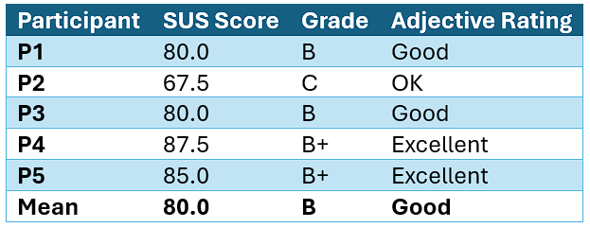

Table 6.4 — SUS scores by participant.

The mean SUS score of 80.0 exceeds the widely cited industry average of 68 (Bangor, Kortum and Miller, 2008), placing OneRep in the "Good" band and approaching the "Excellent" threshold of 85. Four of five participants scored above the industry average.
P2's score of 67.5 — the single below-average result — is interpretable in context. P2 was the only participant who scored the consistency item (Q6: "I thought there was too much inconsistency in this app") at 4, indicating agreement with the negative statement. The exercise navigation issue (H12) is the primary driver of P2's lower score — a localised, addressable problem rather than a general quality failure.

6.6.2 Item-Level Analysis
Every participant's individual SUS item analysis shows a recurring pattern. All five participants gave item 4 ("I think that I would need the support of a technical person to use this app") a score of 1, indicating unanimous strong disagreement. This suggests that the application is viewed as independently learnable across the entire experience range, including P5, who had never used a fitness app before. Four out of five users scored 4 or 5 on item 5 ("I found the various functions in this app were well integrated"), which directly supports the unified design hypothesis: participants thought the application's features were cohesive rather than dispersed.

6.7 Qualitative Analysis
Qualitative data was gathered from three sources: the Day 3 check-in form, post-task verbal responses during think-aloud sessions, and open-ended post-session questionnaire items. Thematic analysis was conducted following the six-phase procedure described by Braun and Clarke (2006): familiarisation with data, initial code generation, theme identification, theme review, theme definition, and report production. Four themes were identified.

Theme 1 — Frictionless Session Initiation
During several stages of data collecting, session initiation speed was found to be a major benefit. P2 defined the session start flow as "tap, tap, go"—a phrase that encapsulates the unified navigation path's low cognitive burden. In contrast to their previous paper-based approach, P4 reported that logging felt "actually much faster than writing it in my book," while P1 regarded the overall experience as "very natural." These answers all agree on the main thesis of this dissertation, which is that by removing the context-switching that comes with using fragmented tools, a unified application lowers the cognitive load of the gym session workflow.
Theme 2 — Exercise Navigation as a Consistent Usability Barrier
Four of five participants identified the exercise library as the primary source of friction in their experience of OneRep. This finding corroborates the severity-3 heuristic violation H12 identified in Phase 1, which was not resolved before testing. The convergence of the heuristic evaluation prediction and independent user reports constitutes a validated finding — the heuristic method correctly identified a real user problem. P2's think-aloud produced the clearest articulation of the issue: the participant scrolled for an extended period, audibly expressing frustration. P4 proposed a specific solution — alphabetical sorting — which is consistent with the standard information architecture pattern for exercise libraries in the existing market (e.g. Hevy, Strong). P5 described the exercise page as "a bit of a chore." The evaluation's most practical conclusion and the most obvious priority for the upcoming development iteration are represented by this theme.
Theme 3 — Gamification Producing Measurable Behavioural Change
The gamification layer produced the strongest qualitative evidence of any feature area. P5's statement that the streak mechanic was "the only reason I went to the gym on Tuesday" is a causally stated behavioural outcome attributable directly to the application's design. This result is in line with the studies on habit formation covered in Section 2.8.1. P4 demonstrated motivation to pursue the 30-day badge after the study ended and won the 7-day streak badge naturally during the naturalistic usage period, demonstrating that the accomplishment system was successful in creating a proximal goal beyond the study period. Badges and PR tracking were mentioned by P1 as their two favorite features. Widespread appeal is suggested by the consistency among individuals with different levels of experience.
Theme 4 — Freestyle Sessions Resolving the Fragmentation Problem
P3's responses across all data collection phases consistently highlighted freestyle sessions as the application's most significant contribution to their workflow. As a highly experienced user of a professional training platform (Trainerize), P3 represents the most credible evaluator of feature quality in the participant cohort. Their description of freestyle sessions as resolving a genuine problem — the inability to log unplanned workouts without losing progress continuity — is a direct user-articulated instantiation of the dissertation's central argument. Their pre-OneRep workflow for unstructured sessions involved the Notes application, which does not carry forward PRs, progress data, or historical context. This continuation is automatic thanks to OneRep's unified data model. In the evaluation data, this participant's experience offers the clearest before-and-after comparison.

6.8 Requirements Evaluation
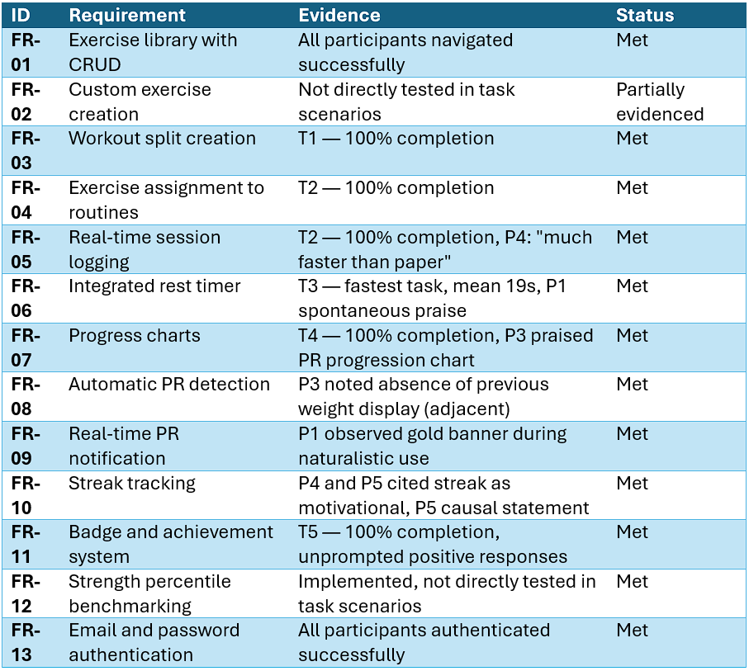
Table 6.5 assesses each functional requirement defined in Chapter 3 against the evaluation evidence.

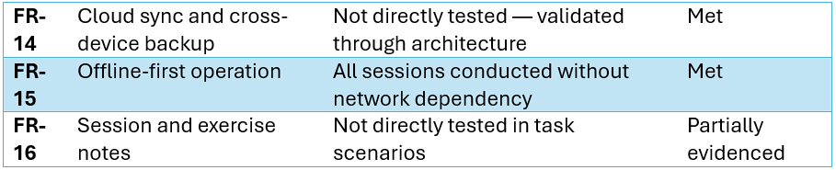
Table 6.5 — Requirements evaluation against study evidence.

NFR-01 (one-handed operability) and NFR-02 (sub-one-second response) were implicitly validated — no participant required two-handed input or experienced perceptible delay.
OneRep appears to be in the ideal stimulation range when viewed through the Wundt curve (Section 2.6): gamification responses show adequate interest, but SUS Item 4 scores show no user overwhelm. A localized complexity spike that can be resolved using common information architecture patterns is represented by the exercise navigation barrier.

6.9 Limitations
It is important to recognize a few of this evaluation's shortcomings. Nielsen and Landauer (1993) showed that five evaluators detect about 85% of usability difficulties, so the participant sample of five is adequate for finding most usability problems, but it is insufficient for statistical generalization. The qualitative themes and the SUS mean of 80.0 are suggestive rather than definitive.
Convenience sampling introduces potential bias: all participants were recruited from the researcher's social network and had pre-existing familiarity with the researcher. Participants may have moderated negative feedback to avoid causing offence, a form of social desirability bias (Hawthorne effect).
Although ecologically sound, the seven-day naturalistic usage time is insufficient to evaluate gamification effects' persistence or long-term memory. It is impossible to infer from this data whether the streak motivation seen in P5 continues after the study time.
Finally, the exercise navigation problem (H12, Theme 2) was a known, unresolved issue at the time of testing. P2’s below-average SUS score may have been higher had this issue been resolved before testing.
Despite these limitations, the evaluation provides a coherent body of quantitative and qualitative evidence against which the research question can be assessed. Chapter 7 draws together the findings from all preceding chapters, revisits the research question and objectives, and identifies directions for future development.

7 - Conclusion

7.1 Summary of Work
The purpose of this experiment was to determine whether a unified, multifunctional mobile application design would lessen cognitive burden and enhance gym-goers' user experience. OneRep, a cross-platform fitness app, was created, put into use in Flutter, and assessed using a four-phase usability research. A survey of the literature that drew on gamification frameworks, Norman's Action Cycle, and Cognitive Load Theory established the theoretical foundation. A domain expert interview, peer consultations, and the developer's documented experience were used to determine the requirements. A 12-violation heuristic evaluation and 71 automated tests were used to verify the application, which combines workout logging, exercise library management, rest timing, progress visualization, gamification, and cloud synchronization into a single offline-first interface. Two severity-4 violations were fixed prior to participant testing.

7.2 Research Question Revisited
The central research question was: does a unified, multifunctional mobile application design reduce cognitive load and improve user experience for gym-goers, compared to the fragmented use of multiple single-purpose tools?
The evidence gathered in this project supports an affirmative answer, with appropriate qualification for the scale of the study.
Participants who had previously used fragmented toolchains and provided clear comparison descriptions of their OneRep experience provide the most direct proof. P2 described the session start flow as "tap, tap, go" after switching from Strava to a specialized fitness app. This unprompted articulation of less navigational overhead immediately maps onto the reduction in unnecessary cognitive load predicted by Sweller's (1988) approach. P4, who had never used a fitness app before, reported that logging seemed "actually much faster than writing it in my book" and finished all five task scenarios in a single session. In the study's most detailed before-and-after comparison, P3 found that freestyle sessions solved a workflow continuity issue that their prior tool combination was unable to.
Quantitatively, the mean System Usability Scale score of 80.0 places OneRep in the "Good" band above the industry average of 68 (Bangor, Kortum and Miller, 2008). SUS Item 4 — "I think that I would need the support of a technical person to use this app" — received a score of 1 from all five participants, indicating unanimous perception of independent learnability across the full experience range. SUS Item 5 — "I found the various functions in this app were well integrated" — received scores of 4 or 5 from four of five participants, directly supporting the unified design hypothesis at the level of perceived coherence.
The gamification evidence is the most behaviourally significant finding of the study. The gamification evidence (Section 6.7, Theme 3) is the most behaviourally significant finding — P5's causally stated gym attendance attributable to the streak mechanic is achievable only within a unified application maintaining persistent session data.
It is important to interpret these results in light of their limitations. For statistical generalization, a convenience sample of five people drawn from the developer's social network is insufficient. Rather than providing definitive evidence, the SUS mean of 80.0 and the qualitative themes show a distinct tendency. Although it offers ecological validity not found in task-based assessments, the seven-day naturalistic usage time is insufficient to evaluate long-term recall or the durability of gamification benefits. Although P3's critical responses and P2's below-average SUS score indicate that participants were willing to disclose real unhappiness when it existed, social desirability bias cannot be ruled out.
The data consistently leads in one way within these limitations. Each participant finished all of the tasks. Instead of being a structural aspect of the unified design approach, the one persistent usability issue—exercise library navigation—was a localized, specific, and fixable flaw. The conclusion that unified multifunctional design lessens the unnecessary cognitive load imposed by fragmented tool use in the fitness domain when implemented with structural coherence and journey-oriented intent is supported by the majority of the available data.

7.3 Objectives Review
O1 — Literature review: Completed. Chapter 2 surveyed HCI evolution, mobile constraints, fragmented journeys, multifunctional platforms, cognitive load theory, and gamification.
O2 — Requirements gathering: Completed. Chapter 3 produced sixteen functional and seven non-functional requirements. Fourteen of sixteen were assessed as Met; two were partially evidenced.
O3 — Design and implementation: Completed. Chapters 4 and 5 documented the system architecture, database schema, UI design, gamification design, and full implementation with 71 automated tests.
O4 — Usability evaluation: Completed. A four-phase evaluation with five participants produced a 100% task completion rate and a mean SUS score of 80.0.
O5 — Assessment of hypothesis: Completed in Section 7.2. The evidence supports the hypothesis with appropriate qualification for sample size.
O6 — Process reflection: Completed in Section 7.4. The hybrid methodology, its strengths, and its limitations are critically evaluated.

7.4 Reflection on Process
Although suitable, the hybrid Waterfall-Agile technique used for this project has flaws. The Waterfall framework, which consists of requirements, design, implementation, and assessment, offered the structural discipline required for a project with a set deadline under academic supervision. Feature branches, iterative sprints, and mid-development requirement additions are examples of Agile components that offer the flexibility required for developing software whose requirements are partially uncovered during the building process. During the last development sprint, when the gamification layer, the Supabase synchronization architecture, and the strength standards feature were all actively developed at the same time, the conflict between these two strategies was most noticeable. The migration difficulty described in Section 5.5 may have been decreased with more rigorous sprint planning and earlier schema finalization.
Weekly supervisor meetings with John Whelan were conducted throughout the project and attended consistently. Supervisor guidance was particularly valuable during the early stages when the project scope and research question were not yet concrete, and during the evaluation design phase when the multi-method approach was refined. A Gantt chart documenting the project timeline is presented in Appendix P.
The most important process choice made during the evaluation phase was to hold a seven-day realistic usage period prior to the think-aloud sessions. Compared to participants in solely task-based experiments, those who had used the program during actual exercises for a week provided feedback that was qualitatively richer. A first-contact session would not have shown the most important qualitative findings.
The researcher's heuristic evaluation, which was carried out before participant testing, achieved its goal: two severity-4 violations were found and fixed before individuals used the application. Four out of five participants validated the forecast that H12 (unsorted exercise library) would appear in participant testing, confirming the predictive efficacy of the approach even when it was used by a developer assessing their own work.
The principal process limitation is the scale of the usability study. A follow-up with fifteen to twenty participants would produce more generalisable results.

7.5 Future Work
The evaluation and development process identified several directions for future work, ordered here by priority.
Exercise library navigation. The most consistently reported usability failure across both the heuristic evaluation and the participant study is the absence of alphabetical sorting, search functionality, and category filtering in the exercise library. This is the highest-priority improvement for the next development iteration. The main cause of P2's below-average SUS score and the slowest task time seen among all participants will be immediately addressed by its resolution. Drift's natural support for ORDER BY and WHERE filtering makes the implementation simple, and no schema modifications would be necessary.
Auto-populate previous session data. P3's most consistent feedback across all three data collection phases was the absence of auto-populated weight and repetition values from the previous session when logging a new set. This feature is standard in more established applications such as Hevy and Strong, and its absence was the primary reason the most experienced participant in the cohort rated the application slightly below their prior tool. For each exercise, implementation would necessitate a query to the most recent session that was finished, displaying the most recent recorded values as default inputs when a new set is started.
Social comparison and leaderboard features. P2's request for friend leaderboards, and their interest in sharing the attendance heatmap, indicate strong appetite for social features among competitive users. The fundamental data model for social comparison is provided by OneRep's population percentile benchmarking tool. The social comparison mechanics covered in Section 2.8.4 could be immediately implemented in a future extension that enables users to post personal bests, compare lifts with connected friends, or take part in opt-in leaderboards for particular exercises.
Customisation and personalisation. P4 and P5 both requested UI customisation — alternative colour themes, home screen widgets, and personalised dashboards. These features would boost perceived ownership of the application, which gamification research finds correlates with persistent engagement, without changing the essential functionality (Deterding et al., 2011).
Long-term retention study. The seven-day study window is insufficient to assess whether the gamification effects observed persist over weeks and months. The evidence base required to assess the longevity of the motivational mechanics and the long-term effects of unified design on training consistency would be provided by a longitudinal study that followed a larger participant cohort for at least four weeks.
App Store and Google Play publication. OneRep was developed as an academic case study but is architecturally complete for public release. The application's cross-platform, offline-first, and free features directly address the market's failure modes noted in Chapter 1. Additionally, publication would facilitate large-scale passive data collecting, supplying the population-level dataset required to bolster the strength percentile benchmarking feature using actual lifting data given by users rather than standards from outside sources.

7.6 Closing Statement
This research started with a straightforward observation: the gym-goers' equipment in 2026 fail them due to their collective fragmentation rather than any individual shortcomings. The workout is a logical, time-bound process. The instruments that support it are not. The purpose of OneRep was to determine whether that gap could be closed, and the data obtained for this project—from the literature review to P5's Tuesday workout—indicates that it can.
Four qualitative themes that agree on the need of unified design, a mean SUS score of 80.0, and a 100% job completion rate do not provide scientific proof. According to the discipline's terminology, they represent a promising outcome that warrants further extensive research. This project's contribution is to show that a single free application created by a single developer over the course of an academic year can produce a measurably better gym session experience than the disjointed combination of tools it replaces. It also provides the theoretical, empirical, and technical foundation from which that demonstration can be expanded.

Reference List
Bangor, A., Kortum, P.T. and Miller, J.T. (2008) ‘An empirical evaluation of the System Usability Scale’, International Journal of Human–Computer Interaction, 24(6), pp. 574–594.
Berlyne, D.E. (1960) Conflict, Arousal, and Curiosity. New York: McGraw-Hill.
Braun, V. and Clarke, V. (2006) ‘Using thematic analysis in psychology’, Qualitative Research in Psychology, 3(2), pp. 77–101.
Brooke, J. (1996) ‘SUS: A quick and dirty usability scale’, in Jordan, P.W., Thomas, B., Weerdmeester, B.A. and McClelland, A.L. (eds.) Usability Evaluation in Industry. London: Taylor and Francis, pp. 189–194.
Bubeck, S. et al. (2023) ‘Sparks of artificial general intelligence: Early experiments with GPT-4’, arXiv preprint arXiv:2303.12712.
Csikszentmihalyi, M. (1990) Flow: The Psychology of Optimal Experience. New York: Harper and Row.
Deterding, S., Dixon, D., Khaled, R. and Nacke, L. (2011) ‘From game design elements to gamefulness: Defining gamification’, Proceedings of the 15th International Academic MindTrek Conference, Tampere, Finland, September 2011, pp. 9–15.
Ellis, C., Adams, T.E. and Bochner, A.P. (2011) 'Autoethnography: An overview', Historical Social Research, 36(4), pp. 273–290.
Festinger, L. (1954) ‘A theory of social comparison processes’, Human Relations, 7(2), pp. 117–140.
Fogg, B.J. (2009) ‘A behavior model for persuasive design’, Proceedings of the 4th International Conference on Persuasive Technology, Claremont, California, April 2009, Article 40.
Flutter (2026) Flutter architectural overview. Available at: https://docs.flutter.dev/resources/architectural-overview (Accessed: April 2026).
Google (2026) Material Design 3. Available at: https://m3.material.io (Accessed: April 2026).
González, V.M. and Mark, G. (2004) ‘“Constant, constant, multi-tasking craziness”: Managing multiple working spheres’, Proceedings of the SIGCHI Conference on Human Factors in Computing Systems (CHI ’04), Vienna, Austria. New York: ACM, pp. 113–120.
Hamari, J., Koivisto, J. and Sarsa, H. (2014) ‘Does gamification work? A literature review of empirical studies on gamification’, Proceedings of the 47th Hawaii International Conference on System Sciences, Hawaii, January 2014, pp. 3025–3034.
Hoy, M.B. (2018) ‘Alexa, Siri, Cortana, and more: An introduction to voice assistants’, Computer, 51(1), pp. 72–75.
Hull, C.L. (1932) ‘The goal-gradient hypothesis and maze learning’, Psychological Review, 39(1), pp. 25–43.
Kraemer, W.J. and Ratamess, N.A. (2004) 'Fundamentals of resistance training: progression and exercise prescription', Medicine and Science in Sports and Exercise, 36(4), pp. 674–688.
Lally, P., van Jaarsveld, C.H.M., Potts, H.W.W. and Wardle, J. (2010) ‘How are habits formed: Modelling habit formation in the real world’, European Journal of Social Psychology, 40(6), pp. 998–1009.
Myers, B.A. (1996) ‘A brief history of human-computer interaction technology’, Interactions, 5(2), pp. 44–54.
Nielsen, J. (1994) Usability Engineering. San Francisco: Morgan Kaufmann.
Nielsen, J. and Landauer, T.K. (1993) ‘A mathematical model of the finding of usability problems’, Proceedings of the INTERACT ’93 and CHI ’93 Conference on Human Factors in Computing Systems, Amsterdam, April 1993, pp. 206–213.
Norman, D.A. (2013) The Design of Everyday Things. Revised and expanded edition. New York: Basic Books.
Oulasvirta, A., Tamminen, S., Roto, V. and Kuorelahti, J. (2005) ‘Interaction in 4-second bursts: The fragmented nature of attentional resources in mobile HCI’, Proceedings of the SIGCHI Conference on Human Factors in Computing Systems (CHI ’05), Portland, OR, USA. New York: ACM, pp. 919–928.
Polaine, A., Løvlie, L. and Reason, B. (2013) Service Design: From Insight to Implementation. Brooklyn, NY: Rosenfeld Media.
Porcheron, M., Fischer, J.E., Reeves, S. and Sharples, S. (2018) ‘Voice interfaces in everyday life’, Proceedings of the SIGCHI Conference on Human Factors in Computing Systems (CHI ’18). New York: ACM.
Robinson, P.A. (2025) Testing and Evaluation. 600091 Honours Stage Project lecture slides. University of Hull.
Schoenfeld, B.J. (2010) ‘The mechanisms of muscle hypertrophy and their application to resistance training’, Journal of Strength and Conditioning Research, 24(10), pp. 2857–2872.
Shneiderman, B., Plaisant, C., Cohen, M., Jacobs, S., Elmqvist, N. and Diakopoulos, N. (2017) Designing the User Interface: Strategies for Effective Human–Computer Interaction. 6th edn. Boston, MA: Pearson.
Shortt, M., Tilak, S., Kuznetcova, I., Martini, B. and Akinkuolie, B. (2023) ‘Gamification in mobile-assisted language learning: A systematic review of Duolingo literature from public release of 2012 to early 2020’, Computer Assisted Language Learning, 36(3), pp. 517–554.
Skinner, B.F. (1938) The Behavior of Organisms: An Experimental Analysis. New York: Appleton-Century-Crofts.
Stickdorn, M. and Schneider, J. (2012) This Is Service Design Thinking: Basics, Tools, Cases. Hoboken, NJ: John Wiley & Sons.
Sweller, J. (1988) ‘Cognitive load during problem solving: Effects on learning’, Cognitive Science, 12(2), pp. 257–285.
Strengthlevel.com (2026) Strength Standards. Available at: https://strengthlevel.com/strength-standards (Accessed: March 2026).

