From Fragmented Journeys to Unified Experiences:

Investigating Multifunctional Mobile App Design Through a Fitness Case Study

Marwan Ashhuby – 202244071 - John Whelan
Word Count:

Contents:
1- Introduction
2 - Literature Review
3 - Requirements
4 - Design
5 - Implementation and Testing
6 - Evaluation
7 - Conclusion
Reference List

Abstract
The proliferation of mobile fitness applications has not resolved a fundamental problem for gym-goers: the tools available to support a training session remain fragmented across multiple single-purpose applications, each addressing one component of a workflow that is, in practice, a single coherent activity. This project investigates whether unified, multifunctional mobile application design can reduce the cognitive load and workflow fragmentation imposed by this fragmented toolchain, using the fitness domain as a controlled case study.
A cross-platform fitness tracking application — OneRep — was designed and implemented in Flutter as the primary research artefact. The application consolidates workout logging, exercise library management, an integrated rest timer, personal best detection, progress visualisation, a gamification layer comprising streaks, badges, and population-relative strength benchmarking, and Supabase-backed cloud synchronisation within a single offline-first interface. The design was informed by a literature review spanning Sweller's Cognitive Load Theory, Norman's Action Cycle, Nielsen's usability heuristics, and established gamification frameworks, and by requirements derived from a domain expert interview and stakeholder consultation.
Evaluation was conducted through four complementary methods. A structured autoethnographic comparison between the developer's prior fragmented toolchain and OneRep recorded 23 application switches and 4 minutes 27 seconds of inter-application navigation time during a baseline session, compared to zero switches and zero navigation time during the equivalent OneRep session. A heuristic evaluation identified 12 usability violations prior to participant testing, two of which were classified as severity-4 and resolved. A five-participant usability study combining seven days of naturalistic usage with in-person think-aloud sessions produced a 100% task completion rate and a mean System Usability Scale score of 80.0, exceeding the industry average of 68. Thematic analysis of qualitative data identified four themes: frictionless session initiation, exercise navigation as a consistent usability barrier, gamification producing measurable behavioural change, and freestyle sessions resolving the fragmentation problem for users with variable training schedules.
The evidence supports the conclusion that unified multifunctional design, when executed with structural coherence and journey-oriented intent, measurably reduces the extraneous cognitive load imposed by fragmented tool use in the fitness domain. The primary limitation of this finding is the scale of the study; further investigation with a larger participant cohort is identified as the most important direction for future work.

1- Introduction

1.1 Background to the Project
Physical exercise tracking has become an increasingly common practice among gym-goers of all experience levels. The ability to log workout sessions, monitor progressive overload, and reflect on performance over time is widely regarded as a cornerstone of effective strength and fitness development (Kraemer and Ratamess, 2004). The smartphone, carried by virtually every gym attendee, represents an obvious platform for this activity. Yet despite the proliferation of fitness applications available on both major mobile platforms, a significant proportion of regular gym-goers continue to rely on fragmented, makeshift solutions to manage their training — a problem that motivates the work presented in this report.
The current fitness application landscape is characterised by two dominant failure modes. The first is excessive specialisation. Applications such as Strava are designed around a single activity domain — in Strava's case, GPS-tracked endurance exercise such as running. A user who both runs outdoors and trains with weights in a gym cannot consolidate their activity within a single coherent tool. Similarly, gym-chain companion applications such as the PureGym app are tightly coupled to membership and physical attendance at a specific facility, rendering them non-functional during home workouts or visits to alternative venues. The second failure mode is monetisation through restriction. Several applications offering substantive tracking functionality — including population-relative strength benchmarking, these features behind aggressive subscription paywalls, effectively excluding cost-sensitive users from meaningful engagement with their own training data.
Faced with these limitations, many users — including the primary developer of this project — have progressively abandoned purpose-built fitness applications in favour of improvised alternatives: physical training journals, followed by combinations of native smartphone utilities such as the Notes and Clock applications. This progression, documented in detail in Section 3.2.1, reveals a systemic failure of the current fitness application landscape. The problem is not a lack of available software. It is a lack of software that is simultaneously free, offline-capable, activity-agnostic, and sufficiently unified to support an entire gym session without requiring the user to leave the application.
This project addresses that gap directly.

1.2 Research Question, Aims and Objectives
The central research question motivating this project is as follows:
Does a unified, multifunctional mobile application design reduce cognitive load and improve user experience for gym-goers, compared to the fragmented use of multiple single-purpose tools?
The aim of the project is to investigate multifunctional mobile application design principles through the design, development, and user evaluation of a fitness tracking application serving as a controlled case study.
The following objectives were defined at the outset of the project:
O1. To conduct a review of existing literature in the areas of human-computer interaction, cognitive load theory, mobile application design, and gamification, identifying the theoretical basis for unified interface design. (Chapter 2)
O2. To gather requirements from domain stakeholders — including a qualified personal trainer and regular gym-goers — and derive a formal set of functional and non-functional requirements for a multifunctional fitness application. (Chapter 3)
O3. To design and implement a fully functional, offline-first fitness application — OneRep — incorporating workout logging, exercise library management, rest timer functionality, progress visualisation, gamification mechanics, and cloud backup. (Chapters 4 and 5)
O4. To evaluate the developed application through a structured usability study with 5–8 participants drawn from the target user population, using the System Usability Scale as the primary quantitative instrument supplemented by qualitative think-aloud observations. (Chapter 6)
O5. To assess the extent to which the findings of the usability study support or challenge the hypothesis that unified multifunctional design reduces cognitive load relative to fragmented tool usage. (Chapter 7)
O6. To reflect critically on the development process, methodology, and project management decisions, identifying lessons applicable to future work. (Chapter 7)

1.3 Report Structure
The remainder of this report is organised as follows. Chapter 2 presents the literature review, surveying relevant work in HCI, cognitive load theory, super-app design models, and gamification. Chapter 3 documents the requirements gathering process and derives the functional and non-functional requirements for OneRep, supported by user journey maps and an autoethnographic baseline study. Chapter 4 presents the design of the system, covering software architecture, database design, user interface design, and gamification design. Chapter 5 describes the implementation of the system and documents the testing strategy and results. Chapter 6 presents the usability evaluation, combining heuristic inspection, naturalistic usage, think-aloud sessions, and System Usability Scale measurement. Chapter 7 draws conclusions, revisits the research question and objectives, and identifies directions for future work.

2 - Literature Review

2.1 Introduction to the Literature Review
This literature review adopts a journey-oriented approach, synthesising research on human-computer interaction, cognitive load, mobile usability, and service design to examine how fragmented digital ecosystems affect user experience and how multifunctional platforms attempt to resolve these issues. Fitness applications serve as the primary example domain throughout.

2.2 Evolution of Human–Computer Interaction
The discipline of human–computer interaction has historically evaluated usability at the level of the individual interface. Early computing systems relied on command-line interfaces requiring specialised technical knowledge, imposing high cognitive demands that restricted access to expert users (Myers, 1996). The introduction of graphical user interfaces in the 1980s reduced this burden by replacing command syntax with visual metaphors — windows, icons, menus, and direct manipulation — enabling non-specialist populations to interact with computing systems for the first time (Shneiderman et al., 2017).
This transition produced the foundational usability frameworks that remain central to HCI practice. Nielsen’s (1994) ten usability heuristics — including visibility of system status, consistency and standards, and recognition rather than recall — provided a systematic inspection method for identifying interface-level problems. Norman’s (2013) Action Cycle formalised the relationship between user intention and system response through two analytical constructs: the gulf of execution, representing the distance between a user’s goal and the actions required to achieve it, and the gulf of evaluation, representing the distance between system output and the user’s ability to interpret it. Both frameworks were developed in the context of single-application, single-device interaction, and both are deployed directly in this project: Nielsen’s heuristics inform the evaluation in Chapter 6, and Norman’s Action Cycle informs the interaction design in Chapter 4.
However, the computing landscape in which these frameworks originated no longer reflects how users interact with technology. Users no longer accomplish real-world goals within a single application. Modern mobile usage distributes tasks across multiple applications, each with its own interaction model and navigation structure. This shift means that interface-level usability — the domain in which Nielsen’s heuristics and Norman’s Action Cycle operate — is necessary but no longer sufficient. The usability questions that matter in a multi-application context concern continuity, orientation, and cognitive efficiency across an entire workflow, not merely within a single screen.
This observation motivates the analytical approach adopted in this project: applying established single-interface frameworks within a unified application designed to consolidate what would otherwise be a fragmented, multi-application workflow.

2.3 Interaction Styles and Mobile Constraints
The shift from desktop to mobile computing introduced constraints that fundamentally alter how interfaces must be designed and evaluated. Desktop interaction assumes sustained attention, a large display surface, and precise input via mouse and keyboard. Mobile interaction offers none of these. Users engage with smartphones in short, interrupted bursts — Oulasvirta et al. (2005) found that mobile interactions occur in episodes averaging approximately four seconds, frequently interleaved with physical activity, conversation, or environmental awareness. This finding has direct implications for the application domain of this project: a gym-goer mid-session interacts with their phone between sets, under physical fatigue, often with one hand, and with an expectation that the interaction will be complete within seconds.
Touch-based input — tapping, swiping, pinching — is the dominant mobile modality and introduces its own constraints. Small screen dimensions limit the amount of information that can be presented simultaneously, requiring designers to prioritise content through progressive disclosure, shallow navigation hierarchies, and minimal visual complexity (Norman, 2013). These principles are not merely best practice; they are structural necessities imposed by the physical medium. An interface that demands extensive scrolling, deep navigation, or sustained visual attention will fail in a mobile context not because it is poorly designed in the abstract, but because it is incompatible with how the device is actually used.
These constraints compound when a user’s workflow spans multiple applications. Each application switch during a mobile interaction resets the user’s visual context, requires re-orientation to a different navigation structure, and consumes a portion of the already-limited attention window identified by Oulasvirta et al. (2005). In a gym environment, where interaction windows are constrained by rest periods of sixty to one hundred and eighty seconds, the cost of even a single unnecessary application switch is non-trivial. The following section examines how these costs accumulate across fragmented digital journeys.

2.4 Fragmented Digital Journeys and Service Design
A user journey describes the complete sequence of interactions a user undertakes across one or more systems to accomplish a goal. In traditional HCI, user journeys were assumed to occur within a single application, and usability could therefore be assessed at the interface level (Stickdorn and Schneider, 2012). Modern mobile usage has invalidated this assumption. Users routinely distribute a single real-world objective across multiple applications. This distribution — termed a fragmented digital journey — is the default condition for routine activities including communication, travel planning, and fitness tracking.
Fragmented journeys impose measurable cognitive costs. González and Mark (2004) demonstrated that task switching requires users to reorient themselves, reconstruct previous context, and re-establish situational awareness — operations that consume attentional resources and increase error rates. In mobile environments, these costs are amplified by the constraints identified in Section 2.3: small displays offer limited visual context for re-orientation, and the brief interaction windows documented by Oulasvirta et al. (2005) leave minimal time for recovery from a context switch. The result is that each application transition during a mobile workflow consumes a disproportionate share of the user’s available cognitive capacity.
Fragmentation also degrades task continuity by forcing reliance on recall rather than recognition. When functionality is distributed across separate applications, users must remember where specific tools and data reside rather than being guided by a consistent interface. This violates one of Nielsen’s (1994) core heuristics — recognition rather than recall — and disrupts the sense of flow that sustained engagement requires (Norman, 2013).
Service design theory provides a framework for understanding this class of problem. Polaine, Løvlie, and Reason (2013) argue that meaningful user experience arises not from individual touchpoints but from the coherence of the connections between them. Journey mapping, a technique for visualising the emotional, cognitive, and temporal dimensions of a user’s path through a service, has been proposed as a diagnostic tool for identifying precisely these inter-application friction points (Stickdorn and Schneider, 2012). This project employs journey mapping in Chapter 3 to compare a fragmented gym session workflow against the equivalent workflow within OneRep.
Fragmented digital journeys are not a collection of isolated usability defects but a structural design problem requiring a structural response. The response examined in this project — the consolidation of related functionality into a single, unified application — is situated within a broader trend toward multifunctional platforms and superapps, which are examined in the following section.

2.5 Multifunctional Platforms and Superapps
The fragmentation problem described in Section 2.4 has produced a counter-movement in platform design: the multifunctional application, or “superapp,” which consolidates related services into a single persistent environment. The architectural premise is that centralising functionality within one application preserves stable mental models, eliminates inter-application context switching, and enables end-to-end user journeys that fragmented ecosystems cannot support (Polaine, Løvlie, and Reason, 2013).
However, integration alone does not guarantee a superior user experience. A multifunctional platform that accumulates features without structural coherence risks introducing the very cognitive overload it seeks to eliminate. Norman (2013) observes that usability failures at scale typically arise from how systems organise and reveal capabilities, not from the capabilities themselves. The central design challenge for any multifunctional platform is therefore not how many features it offers, but how effectively those features are integrated into coherent user journeys. Two case studies — one successful, one unsuccessful — illustrate this distinction.
WeChat, originating as a messaging application, has expanded into an integrated ecosystem supporting communication, payments, social networking, and third-party services within a single interface. Its design preserves consistent interaction patterns across services, favouring recognition over recall (Norman, 2013) and enabling end-to-end user journeys without platform exits. Critically, services are surfaced contextually in response to user intent rather than presented simultaneously, a pattern consistent with the brief interaction bursts described by Oulasvirta et al. (2005). A detailed cognitive walkthrough of WeChat's integration model is presented in Appendix K.
By contrast, Meta's ecosystem — spanning Facebook, Instagram, WhatsApp, and Messenger — distributes comparable functionality across architecturally and experientially separate applications. Each application maintains its own navigation logic and interaction patterns, imposing precisely the context-switching costs identified by González and Mark (2004). The full comparative analysis is presented in Appendix K
The distinction between these cases crystallises the argument that motivates this project: aggregation of functionality across multiple applications is not equivalent to integration of functionality within one. Without deliberate system-level coherence and journey-oriented design, a multifunctional ecosystem may exacerbate fragmentation rather than resolve it. This principle applies directly to the fitness domain: a gym-goer using separate applications for workout logging, rest timing, and progress tracking is experiencing Meta's problem at a smaller scale. OneRep is designed to apply WeChat's principle — unified, journey-coherent functionality within a single persistent environment — to that specific use case.

2.6 Cognitive Load, Learnability, and the Wundt Curve
Cognitive load — the mental effort required to process information, make decisions, and execute actions within an interface — is the primary theoretical construct through which this project evaluates fragmented versus unified design. Sweller’s Cognitive Load Theory (Sweller, 1988) distinguishes three components: intrinsic load, determined by the inherent complexity of the task; extraneous load, imposed by the design of the instructional or interaction environment; and germane load, representing the cognitive effort devoted to constructing useful mental models. In the context of mobile application design, extraneous load is the component most directly under the designer’s control, and it is the component most directly increased by fragmented tool use.
Learnability interacts with cognitive load over time. When the same workflow is distributed across multiple applications, however, users must acquire and maintain separate mental models for each. This fragmentation compromises learnability at the system level even when individual applications are independently learnable.
The Wundt curve (Berlyne, 1960) — the inverted-U relationship between stimulation and performance — provides a useful frame for the design risk inherent in multifunctional applications. Systems that are too simple fail to sustain engagement; systems that are too complex overwhelm the user and degrade performance. A unified application that consolidates multiple tools occupies a critical position on this curve. If integration is executed with structural coherence — consistent navigation, progressive disclosure, and contextually appropriate feature surfacing — the application reduces extraneous load by eliminating context switching whilst remaining within the optimal stimulation range. If integration is poorly executed, the application risks feature overload, pushing users toward the high-complexity end of the curve where performance and satisfaction decline. This trade-off is evaluated empirically in Chapter 6.

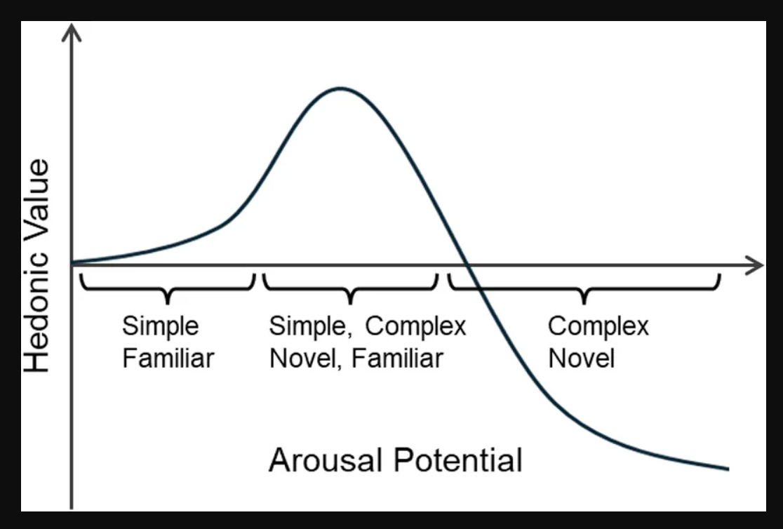

Figure 2.1 — The Wundt curve applied to multifunctional application design. The x-axis represents interface complexity; the y-axis represents user satisfaction and performance. OneRep's design target occupies the optimal range between understimulation and feature overload.

2.7 The Fitness Domain: Context and Fragmentation
It is necessary to establish what a typical gym session involves and what data a user needs to record
A gym session centred on resistance training follows a broadly consistent structure. The session begins with a warm-up phase, typically consisting of light cardiovascular activity and mobility work to prepare the body for heavier loading. The main body of the session consists of a series of exercises, each performed for a defined number of sets. A set is a continuous sequence of repetitions of a given movement — for example, ten repetitions of a barbell bench press. Each set is followed by a rest period. Rest periods typically range from sixty seconds for lighter, higher-repetition work to three or more minutes for maximal strength efforts (Schoenfeld, 2010).
The data a gym-goer needs to record must be captured in real time, during the session itself, rather than recalled afterwards. For each set performed, the user must log the exercise name, the weight lifted, and the number of repetitions completed. Over time, this data constitutes a longitudinal record of performance. The fundamental principle underpinning progressive resistance training — progressive overload — requires that training stimulus increase incrementally over time, whether through additional weight, additional repetitions, or reduced rest (Kraemer and Ratamess, 2004). Without an accurate historical record, a user cannot reliably determine whether they are progressing, stagnating, or regressing.
Many gym-goers organise their training according to a workout split: a structured plan that distributes different muscle groups or movement patterns across different days of the week. A common example is the Push/Pull/Legs split, in which pushing movements, pulling movements, and leg exercises are each assigned a dedicated training day. The specific exercises assigned to each day, along with their target sets, repetitions, and weights, constitute a workout routine. The personal record (PR) — the maximum weight lifted for a given exercise at a given repetition count — serves as a natural gamification hook (Section 2.8)
With this domain context established, the fragmentation problem can be stated precisely. The fitness domain offers a particularly well-defined instance of the fragmentation problem described above. A typical gym session requires a user to consult a workout plan, log sets with weight and repetition data, time rest periods between sets, and review historical performance to inform loading decisions. No widely available free application supports all of these tasks within a single interface. Users therefore assemble ad-hoc toolchains — a workout logging application, the native clock for rest timing, a notes application for session plans, and potentially a separate reference tool for exercise technique — each of which addresses one component of the workflow whilst leaving the others unsupported.
The situational context of the gym amplifies the cognitive costs of this fragmentation. Users interact with their devices during rest periods of sixty to one hundred and eighty seconds, under physical fatigue, frequently with one hand. These are precisely the conditions under which Oulasvirta et al.’s (2005) four-second interaction bursts apply most acutely. Each application switch during a rest period consumes a portion of the limited interaction window and forces the user to re-establish context in a new interface — costs that, over the course of a sixty-to-ninety-minute session involving twenty or more sets, accumulate into a substantial and unnecessary cognitive burden.
The fitness workflow also has a property that makes it particularly amenable to unification: it is a single coherent activity distributed across tools for accidental rather than essential reasons. A gym-goer does not want to use three applications; they use three applications because no single free tool serves the complete workflow. The opportunity, therefore, is not to invent new functionality but to consolidate existing functionality into a single, journey-coherent environment — which is the design objective of OneRep.

2.8 Gamification in Mobile Applications
The application of game design elements to non-game contexts — a practice termed gamification — has attracted substantial academic and commercial interest since the concept was formally defined by Deterding et al. (2011). In the context of mobile software, gamification has evolved from a novelty into a well-evidenced design strategy for sustaining user engagement, reinforcing habitual behaviour, and providing motivational scaffolding in domains where intrinsic motivation alone is insufficient to maintain consistent participation (Hamari, Koivisto and Sarsa, 2014).
Fitness represents one of the most natural application domains for gamification. The challenges that cause users to abandon exercise programmes — lack of immediate reward, difficulty perceiving incremental progress, and the absence of social accountability — map directly onto the problems that game mechanics are designed to solve. A user who cannot feel themselves getting stronger on a week-to-week basis is a user who stops training. Gamification addresses this by making invisible progress visible, and by attaching extrinsic reward structures to behaviour that would otherwise yield only deferred, biological feedback.

2.8.1 Streak Mechanics and Habit Formation
The streak — a count of consecutive days or sessions in which a target behaviour has been performed — is among the most widely deployed gamification mechanics in consumer mobile applications. Its theoretical basis lies in habit formation research: Lally et al. (2010) demonstrated that behavioural automaticity develops through consistent repetition in stable contexts, and that disruption of a streak introduces a psychologically salient cost that motivates continuance. Duolingo's streak system is the canonical commercial implementation, credited as a primary driver of daily active user retention (Shortt et al., 2023). In a fitness context, the streak mechanic maps onto training frequency — a user who has maintained a seven-day or thirty-day training streak has a concrete, loss-aversive reason to attend their next session. The application of streak mechanics to fitness tracking is explored through the design of OneRep in Chapter 4.

2.8.2 Personal Records and Mastery Feedback
The personal record — the maximum weight lifted for a given exercise at a given repetition count, commonly abbreviated as PR or PB — occupies a unique position in fitness gamification in that it is not an artificial construct imposed by the application, but a genuine measure of physical capability. Its gamification value derives from what Csikszentmihalyi (1990) termed the flow state: the condition of optimal engagement produced when challenge and skill are in equilibrium. Progressive resistance training is structurally aligned with flow: each incremental increase in weight represents a new challenge threshold, and the detection and celebration of a new personal record provides the immediate positive feedback that sustains engagement through the longer plateaus between measurable breakthroughs. Applications such as Strava implement analogous mechanics through segment records for running and cycling. The implementation of automatic PR detection within OneRep is described in Chapter 4.

2.8.3 Badges and Achievement Systems
Badge and achievement systems extend the reward schedule beyond the single-session PR by introducing a taxonomy of milestones distributed across a user's longitudinal engagement with the application. Drawing on variable ratio reinforcement schedules — identified by Skinner (1938) as the most resistant to extinction among reinforcement patterns — well-designed badge systems create a persistent motivational foreground by ensuring that the next achievable milestone is always within reach. Fogg's Behaviour Model (Fogg, 2009) provides a complementary framework: behaviour occurs when motivation, ability, and a trigger converge simultaneously. Badges function as triggers, converting latent motivation into concrete action at the moment a threshold is approached. Critically, the display of locked, unearned badges alongside earned ones — a near-universal pattern in commercial implementations including Xbox Achievements and Apple Fitness Awards — leverages goal gradient theory (Hull, 1932), which predicts that effort increases as a goal approaches completion. The design of OneRep's badge system, informed by these principles, is presented in Chapter 4.

2.8.4 Social Comparison and Population Benchmarking
A fourth class of gamification mechanic relevant to fitness applications is social comparison: the positioning of an individual's performance relative to a reference population. Social comparison theory, originating with Festinger (1954), holds that individuals evaluate their own abilities and opinions by comparing themselves to others, and that upward comparison — comparing oneself to someone performing better — can function as a motivational stimulus when the gap is perceived as bridgeable. In fitness software, this mechanic is implemented through population-relative strength benchmarking, wherein a user's personal record for a given lift is expressed as a percentile rank within a reference dataset. Strengthlevel.com have operationalised this concept at scale, publishing percentile lookup tables derived from large aggregated datasets of self-reported lifting performance, stratified by bodyweight, sex, and exercise. These tables allow an application to present a contextually meaningful statement — for example, that a given bench press performance exceeds that of approximately seventy percent of the reference population — without requiring real-time network access or proprietary data collection. The application of this mechanic within OneRep, using publicly available strength standards from Strengthlevel.com, is described in Chapter 4.

2.8.5 Gamification in the Context of This Project
The gamification mechanics described above are not implemented in OneRep as decorative additions to a functional core. They are positioned as a direct response to the fragmentation problem identified in Section 1.1. A user managing their training across multiple disconnected tools loses access to the longitudinal data continuity that makes streak tracking, PR detection, and population benchmarking possible. These features are, in a precise sense, only achievable within a unified application that maintains a complete, persistent record of every session. The gamification layer is therefore both a user retention mechanism and an argument for consolidation: it instantiates, in concrete functional terms, the value proposition of the unified design approach that this project investigates.
The theoretical foundations and design precedents established in this chapter provide the evaluative framework against which OneRep will be assessed. Chapter 3 translates these theoretical concerns into concrete requirements by documenting the stakeholder consultation process and deriving the functional and non-functional specification for the application.

2.9 Literature Review Summary and Research Gap
This literature review has established the theoretical foundation for the project, spanning the evolution of HCI (Section 2.2), mobile interaction constraints (Section 2.3), fragmented digital journeys (Section 2.4), multifunctional platform models (Section 2.5), cognitive load theory (Section 2.6), the fitness domain (Section 2.7), and gamification (Section 2.8).
A gap exists in the literature at the intersection of these threads. Research on superapps and multifunctional platforms has focused predominantly on large-scale ecosystems, cultural adoption factors, and platform economics rather than on the immediate user experience of integrated design. Applied research on fragmentation in routine, domain-specific mobile contexts — where users interact frequently, briefly, and under physical constraint — is largely absent. The fitness domain, despite being a clear example of fragmented tool use among a large and active user population, has received no empirical investigation of whether multifunctional design can measurably reduce cognitive load and improve journey continuity.
This project addresses that gap. By designing, implementing, and evaluating a multifunctional fitness application — OneRep — the project provides empirical evidence for whether unified mobile design reduces the extraneous cognitive load imposed by fragmented tool use, and whether the integration can be achieved without exceeding the optimal complexity range identified by the Wundt curve.

3 - Requirements

3.1 Requirements Gathering Methodology
The requirements for OneRep were derived through three complementary sources: the personal experience of the developer as an active gym-goer and primary user of the system; a semi-structured interview with a qualified personal trainer serving as a domain expert; and informal consultations with a small cohort of gym-goers drawn from the developer's immediate social network.
The limitations of this approach — a single expert interview and informal peer consultations — are discussed in Chapter 6. Nevertheless, the triangulation of three independent sources provides a sufficient evidential basis for the requirements defined in this chapter.

3.2 Personal Experience and User Journey

3.2.1 The Developer's Journey
The motivating context for this project is grounded in the developer's experience as a regular gym-goer. Dedicated fitness applications were found to be either excessively specialised, tying functionality to specific activity types or gym memberships, or commercially structured in ways that placed core functionality behind subscription paywalls.
The critical insight produced by this experience is that the gym session itself constitutes a coherent, time-bounded workflow with specific, predictable data needs. The failure of existing tools is not a failure of individual features in isolation, but a failure to support that workflow as a unified whole. A user mid-set should not need to navigate between three applications to log a repetition, start a rest timer, and consult their previous session's numbers. The cognitive overhead of doing so is not theoretical — it is experienced on every working set of every session.

3.3 Personal Trainer Interview

3.3.1 Interview Overview
A semi-structured interview was conducted on 20 March 2026 via audio call with a qualified personal trainer of four years professional experience. The interviewee requested anonymity and is referred to throughout this report as PT-1. The interview lasted approximately 28 minutes and was audio-recorded and transcribed verbatim. The full transcript is provided in Appendix A.
PT-1 specialises in rehabilitation and physical therapy, working with a client base ranging from older adults in recovery to amateur athletes returning from injury, as well as general population clients seeking improved fitness. This breadth of client experience — spanning beginners through to competitive athletes — lends particular weight to observations about what gym-goers of varying experience levels need from a tracking tool. PT-1 has personal experience of multiple professional training platforms (Everfit, Trainerize, MyPTHub) as well as consumer fitness applications.

3.3.2 Key Findings
On workout logging: PT-1 identified workout logging as the single non-negotiable feature: "Forgetting just one number can halt your progress especially if your memory is as bad as mine. Really workout logging is THE feature of weightlifting apps, if you don't have it then there is little point in pressing the download button. Machines don't forget" (PT-1, personal communication, 20 March 2026).
On the integrated rest timer: PT-1 characterised the integrated rest timer as "the number one feature 90% of gym apps are missing" (PT-1, personal communication, 20 March 2026).
On progress visualisation: PT-1 emphasised progress charts as a primary motivator: "99% of my clients get their motivation from seeing progress" (PT-1, personal communication, 20 March 2026).
On cross-device data persistence: PT-1 validated the cloud backup requirement: "Seeing the progress chart and everything you accomplished is such a great feeling, I wouldn't want to lose all that data just because I'm switching phones" (PT-1, personal communication, 20 March 2026).
On gamification: PT-1 offered the most distinctive insight of the interview on this topic, drawing an explicit analogy between the gym and a video game: "A PR is just a high score" (PT-1, personal communication, 20 March 2026). Gamification mechanics — streaks, badges, achievement milestones — were characterised as a scalable implementation of this motivational function: "My job is encouragement, its keeping people motivated long enough where habit overtakes motivation, and they are now in the gym a few times a week because its Tuesday and Tuesday is push day" (PT-1, personal communication, 20 March 2026).
On the free-to-use requirement: PT-1 endorsed the free-to-use model: "If you're going to make an app for the average weightlifter it really needs to be free with no ads" (PT-1, personal communication, 20 March 2026).
On simplicity: PT-1 observed that the current application landscape is disproportionately oriented towards beginners, with features and interface complexity that intermediate and advanced users find irrelevant or counterproductive.

3.3.3 Contradictions and Surprises
The most notable unexpected element was PT-1's scepticism towards AI-assisted features in fitness applications, characterising them as a distraction rather than a genuine value-add for most users. This observation reinforces the design decision to exclude AI features from OneRep's scope and focus instead on a reliable, fast, friction-free core experience.

3.4 Gym-Goer Feedback
Informal consultations were conducted via video call with several gym-goers drawn from the developer's social network, representing a range of training experience from approximately one to eight years.
The predominant themes emerging from these conversations were consistent with those identified through personal experience and the PT interview. Participants expressed familiarity with the fragmentation problem — the use of multiple applications across a single session — and endorsed the concept of a unified, free tracking application. No participant reported a strong positive experience with their current tracking solution; the most common description was that existing tools were adequate but imperfect, with cost, complexity, or feature gaps cited as the primary points of dissatisfaction.
Their value lies in corroboration: the problems identified through personal experience and expert interview are recognisable across the target user population.

3.5 User Journey Maps
Two user journey maps were constructed: one representing a gym session conducted using a fragmented combination of tools, and one representing the equivalent session within OneRep. These maps are presented in Figures 3.1 and 3.2 respectively.
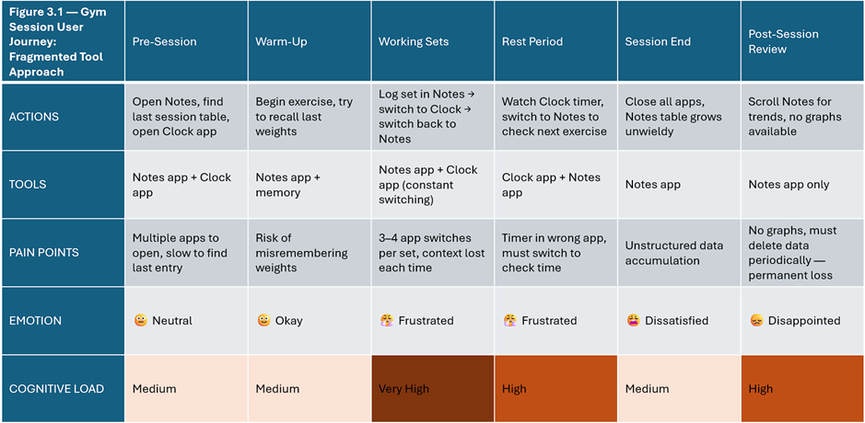

Figure 3.1 — Fragmented tool journey map: touchpoints, tools used, cognitive load, emotional state across a gym session.

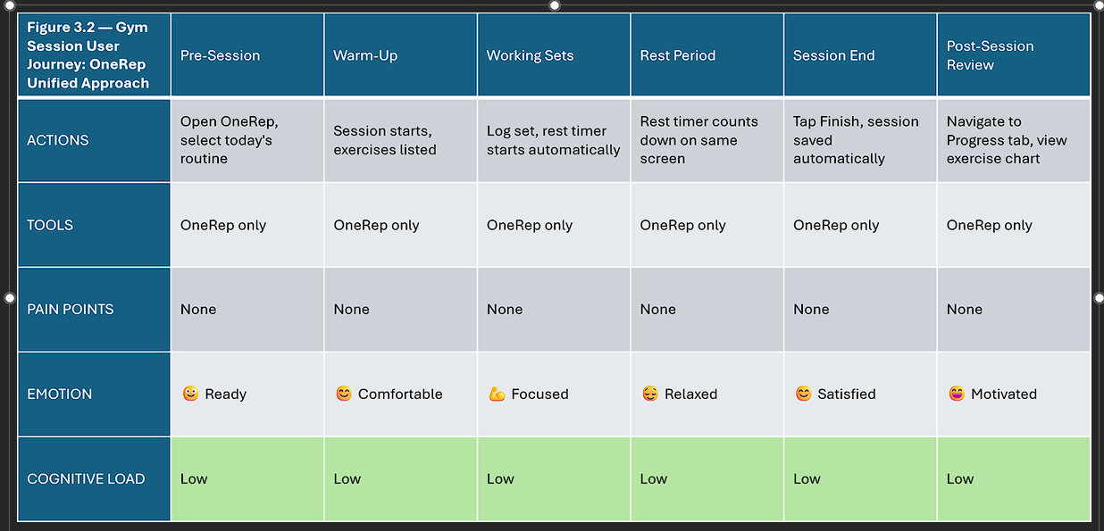

Figure 3.2 — OneRep unified journey map: same session, single application.

The fragmented journey map identifies the following pain points: application switching between a workout log, a rest timer, and a reference tool at every set boundary; loss of session context on each switch; manual transcription of data into inadequately structured formats; and the permanent loss of historical data when accumulated records become unmanageable. The unified journey map demonstrates how each of these friction points is eliminated when the workflow is consolidated within a single application maintaining persistent state throughout the session.

3.6 Autoethnographic Baseline Study
To establish a quantitative baseline against which OneRep's impact on workflow fragmentation could be assessed, a structured autoethnographic observation was conducted by the developer across two gym sessions: one using the fragmented tool combination that motivated this project, and one using OneRep following the completion of the application.
Autoethnography — the systematic, self-reflective study of one's own practice — is an established qualitative research method in HCI and service design contexts (Ellis, Adams and Bochner, 2011). Its application here is constrained to a single-participant observational study and is treated as illustrative rather than generalisable evidence.
The baseline session was conducted using the developer's established fragmented toolchain: the native Notes application for workout logging, the native Clock application for rest timing, and memory for exercise reference. Four metrics were recorded during the session: the number of application switches, the total time spent navigating between applications, the number of cognitive reorientation events — defined as any moment requiring the user to re-establish context after an application switch — and total session length. The replication session was conducted using OneRep under comparable conditions at the same gym facility.
The results are presented in Table 3.1.

Metric | Fragmented Stack | OneRep | Reduction
App switches during session | 23 | 0 | 100%
Time spent switching between apps | 4 min 27 sec | 0 sec | 100%
Cognitive reorientation events | ~23 | 0 | 100%
Session length | 52 min | 72 min | N/A

Table 3.1 — Autoethnographic comparison: fragmented stack versus OneRep.

During the OneRep session, no application switches occurred within the workout window. Rest timer notifications returned the researcher's attention to the application automatically between sets.
The session length difference — 52 minutes versus 72 minutes — reflects natural variation in training volume between two distinct sessions rather than a systematic effect of the tool used. It does not confound the switch and reorientation results, which are zero regardless of session length.
These results should be interpreted as indicative rather than conclusive, given the single-participant design. They are presented alongside the five-participant usability study in Chapter 6 as complementary evidence.

3.7 Functional Requirements
The following functional requirements were derived from the three sources described above. Requirements are presented with a unique identifier, a description, the source from which they were derived, and a priority rating using the MoSCoW method (Must Have, Should Have, Could Have, Won't Have for this release).

ID | Requirement | Source | Priority
FR-01 | The system shall allow users to create and manage a library of exercises, including name, body part, and equipment type | Personal experience | Must Have
FR-02 | The system shall allow users to create custom exercises not present in the default library | Personal experience, PT-1 | Must Have
FR-03 | The system shall allow users to define workout splits comprising named training days | Personal experience | Must Have
FR-04 | The system shall allow users to assign exercises to specific training days within a split | Personal experience | Must Have
FR-05 | The system shall allow users to log a workout session, recording sets with weight and repetition count in real time | Personal experience, PT-1, Gym-goers | Must Have
FR-06 | The system shall provide an integrated rest timer that activates between sets without requiring the user to leave the active session screen | Personal experience, PT-1 | Must Have
FR-07 | The system shall display progress charts showing weight lifted over time for individual exercises | Personal experience, PT-1, Gym-goers | Must Have
FR-08 | The system shall automatically detect and record personal bests for each exercise | Personal experience, PT-1 | Must Have
FR-09 | The system shall notify the user in real time when a new personal best is achieved during an active session | Personal experience, PT-1 | Must Have
FR-10 | The system shall implement a streak tracking mechanism recording consecutive days on which a session has been logged | PT-1, Gamification rationale | Should Have
FR-11 | The system shall implement a badge and achievement system with milestone-based triggers distributed across session frequency, volume, and personal record accumulation | PT-1, Gamification rationale | Should Have
FR-12 | The system shall display population-relative strength benchmarks for major lifts, derived from the Strengthlevel.com public dataset, stratified by user bodyweight and sex | Personal experience | Should Have
FR-13 | The system shall allow users to create an account and authenticate via email and password | Cross-device requirement | Must Have
FR-14 | The system shall synchronise workout data to a remote backend upon user request, preserving the complete historical record across device changes | Personal experience, PT-1, Gym-goers | Must Have
FR-15 | The system shall function fully without a network connection, with synchronisation deferred until connectivity is available | Personal experience | Must Have
FR-16 | The system shall allow users to add session-level and exercise-level notes | Personal experience | Should Have

Table 3.2 — Functional requirements.

3.8 Non-Functional Requirements
ID | Requirement | Rationale
NFR-01 | The application shall be operable with one hand during an active workout session | Users are physically engaged during logging; two-handed interaction is impractical
NFR-02 | The application shall respond to user input within one second under normal operating conditions | Delays during an active session interrupt workflow and increase cognitive load
NFR-03 | All user data shall be stored locally on-device using a persistent SQLite database | Guarantees offline functionality regardless of network conditions
NFR-04 | Remote data transmission shall be encrypted in transit and access-controlled at the row level | User training data is personal; unauthorised access must be prevented
NFR-05 | Authentication credentials shall not be hardcoded in source code | Security requirement; credentials are injected at compile time via environment variables
NFR-06 | The application shall be available free of charge with no in-app purchases or advertisements | Validated by PT-1 and gym-goer feedback as a primary market differentiator
NFR-07 | The application shall be deployable on both iOS and Android from a single codebase | Flutter's cross-platform capability is a core architectural constraint

Table 3.3 — Non-functional requirements

3.9 Design Constraints
The application's architecture was conceived as a five-layer stack (presentation, state management, local data, synchronisation, and remote services) prior to technology selection. An abstract representation is presented in Figure 3.3.
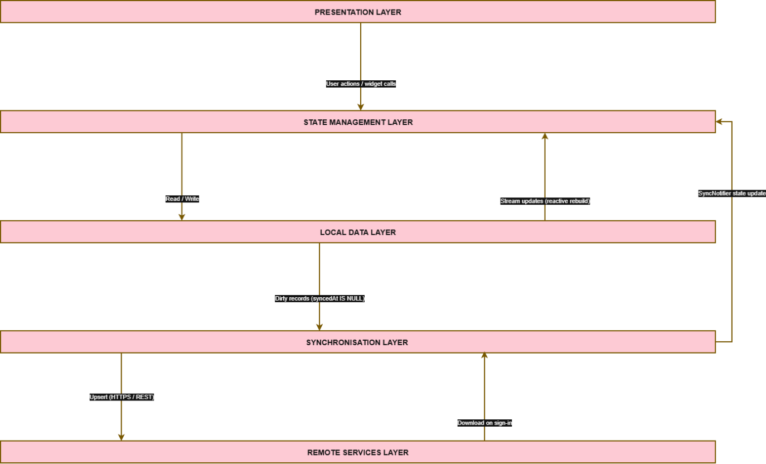

Figure 3.3 — Abstract architecture stack.

The following constraints were established at the outset of the project and shaped all subsequent design and implementation decisions:
Flutter and Dart were selected as the development platform, enabling a single codebase to target both iOS and Android. Flutter's hybrid compilation model — Just-In-Time (JIT) compilation during development, enabling sub-second hot reload for rapid iteration, and Ahead-Of-Time (AOT) compilation for release builds, producing native ARM code with predictable performance — makes it uniquely suited to a single-developer project requiring both development velocity and production-grade output (Flutter, 2026).
Offline-first architecture was mandated by the practical reality of gym environments, which frequently offer poor or absent network connectivity. The application must be fully functional without any network dependency; cloud synchronisation is an enhancement, not a prerequisite.
No subscription model and no advertisements were established as hard constraints from the outset, directly motivated by the identified failure mode of the existing application landscape.
Supabase was selected as the remote backend for authentication and cloud synchronisation, providing a managed PostgreSQL database with row-level security and a Flutter-compatible SDK.
With the requirements and constraints defined, the project proceeds to the design phase. Chapter 4 presents the system architecture, database schema, user interface design, and gamification design that translate the requirements established above into a concrete technical specification.

4 - Design

4.1 Development Methodology
The development of OneRep was conducted using a hybrid methodology combining structured Waterfall planning with iterative Agile development practices. This approach was adopted deliberately in response to the constraints of an academically supervised project with a fixed submission deadline.
The high-level project lifecycle followed a Waterfall structure: a distinct requirements gathering phase preceded system design, which preceded implementation, which preceded evaluation. This sequential framing provided the planning visibility required for academic supervision. However, within the implementation phase, development proceeded in discrete feature-focused sprints characteristic of Agile practice. Each sprint produced a testable, deployable increment of the application, and feedback from supervisor meetings and informal user consultations was incorporated between sprints, resulting in several mid-development requirement additions — most notably the introduction of multiple exercise metric types (weightReps, bodyweightReps, timeOnly, distanceTime) and the gamification layer, neither of which featured in the initial design.
The Git branching strategy adopted throughout the project reflects this hybrid approach. Feature branches were created for each significant development increment with development occurring on a protected main branch accessible only via pull request. This practice enforced code review discipline even within a single-developer project and produced a commit history that serves as an auditable record of development progression.
The choice of methodology is acknowledged to carry limitations. The fixed deadline introduced scope pressure during the final sprints, resulting in some planned improvements — most notably alphabetical sorting and search functionality for the exercise library — being deferred to future work rather than completed within the project timeline.

4.2 System Architecture
OneRep is structured across five distinct architectural layers, each with clearly defined responsibilities. The architecture is illustrated in Figure 4.1.

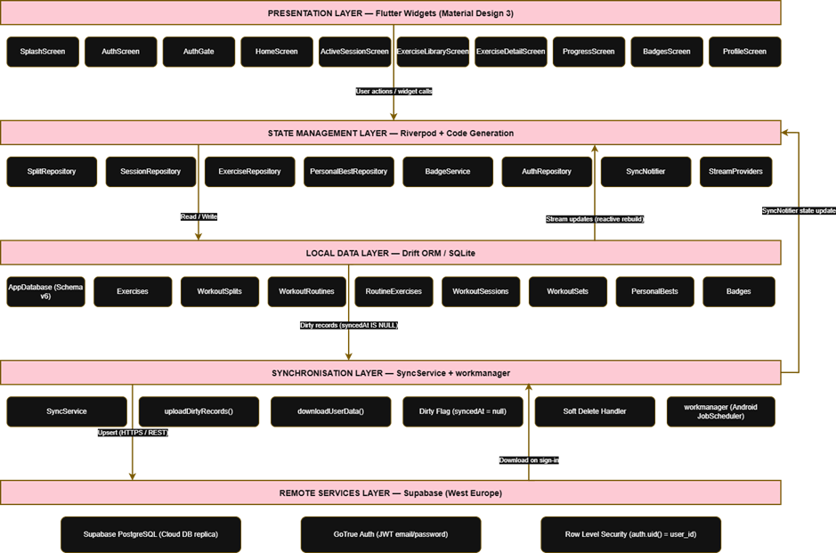

Figure 4.1 – System architecture diagram.

Presentation Layer. The user interface is implemented entirely in Flutter using Material Design 3 (Google, 2026), with a custom deep burgundy and gold colour scheme. All screens are implemented as Flutter widgets — either stateless or stateful — and interact with the application state exclusively through Riverpod providers. No business logic resides in the presentation layer.
State Management Layer. All application state is managed via Riverpod using code generation through the @riverpod annotation. Repository classes function as the primary state containers, exposing reactive streams derived from the local database.
Local Data Layer. All persistent data is stored in a Drift-managed SQLite database on the device. This layer is the single source of truth; all reads and writes are directed here regardless of network state. The database is initialised on first launch with a seed of 40 default exercises.
Synchronisation Layer. A dedicated SyncService class manages the propagation of locally modified records to the remote backend. Synchronisation is upload-only during normal operation; download occurs exclusively at sign-in as a restoration mechanism. The synchronisation layer is intentionally decoupled from Flutter's widget lifecycle, enabling it to operate in a background isolate via the workmanager package.
Remote Services Layer. Supabase provides three services to the application: a managed PostgreSQL database serving as the cloud replica of local data, GoTrue authentication handling JWT-based email and password credentials, and Row Level Security policies enforcing per-user data isolation at the database level.
The data flow from user interaction to remote backup proceeds as follows. A user action triggers a Riverpod repository method, which writes the change to the local Drift database and marks the affected record as dirty by setting its syncedAt column to null. Drift emits a stream update, causing all watching widgets to rebuild with the new data. On the next sync trigger — whether a manual tap, application foreground event, or scheduled background task — SyncService queries all dirty records and upserts them to Supabase.
The offline-first guarantee is enforced architecturally: the Supabase client is never invoked during normal read or write operations. The UI never awaits a network response to display data.

4.3 Database Design
The OneRep database schema is at version 6, having undergone six iterative migrations during development. The schema comprises eight tables organised around a five-level workout hierarchy, supplemented by tables for gamification data and a badges system. The complete entity-relationship diagram is presented in Figure 4.2.


Figure 4.2 — Entity-relationship diagram.

4.3.1 The Workout Hierarchy
The core data model represents the conceptual structure of resistance training as a five-level hierarchy:
Exercises form the foundational dictionary of movements available to the user. Each exercise record stores a name, body part, equipment type, a metric type defining what performance data is captured for that exercise, a flag indicating whether it is a system-provided or user-created exercise, and optional notes. The metric type field supports four values: weightReps (weight and repetition count), bodyweightReps (repetition count only), timeOnly (duration), and distanceTime (distance and time).
WorkoutSplits represent a training programme — a named collection of training days. A typical example is a Push/Pull/Legs split or an Upper/Lower split.
WorkoutRoutines represent individual training days within a split. A Push/Pull/Legs split, for instance, contains three routines: Push Day, Pull Day, and Legs Day.
RoutineExercises is a junction table linking exercises to routines, supporting ordered exercise lists with optional target set and repetition counts. This table allows the same exercise to appear in multiple routines across different splits.
WorkoutSessions represent individual gym visits. A session is optionally linked to a routine — sessions without a routine link are classified as freestyle sessions, enabling ad-hoc workouts that fall outside a planned programme. Sessions carry start and end timestamps; an absent end timestamp indicates a session in progress and excludes the record from synchronisation.
WorkoutSets are the atomic unit of training data — a single logged performance: the exercise performed, the weight used, the repetitions completed, and any applicable duration or distance values. Every set is associated with a session and an exercise.

4.3.2 Gamification Tables
PersonalBests stores the current performance record for each exercise per metric type. A composite unique constraint on (exerciseId, metricType) is used as the upsert target, ensuring each exercise maintains exactly one PR record per metric category. The achieved_at timestamp enables historical PR progression to be visualised over time.
Badges stores the state of all achievement badges. All badge rows are pre-seeded at database creation with earnedAt set to null, representing a locked state. Earning a badge writes the current timestamp to earnedAt. The badge_key column acts as a stable identifier for each badge definition.

4.3.3 Sync Column Design
All eight tables include four additional columns to support the synchronisation architecture: remoteId (a UUID bridge between the local integer primary key and the Supabase row identifier), userId (the authenticated user's Supabase UUID, stamped at sync time), syncedAt (null indicates a dirty record requiring upload), and deletedAt (a soft delete marker enabling remote propagation of deletions). The dual-key design — integer primary keys locally, UUIDs remotely — is discussed in Section 4.5.

4.4 User Interface Design

4.4.1 Design Principles
The OneRep interface was designed against two established HCI frameworks introduced in Chapter 2. Nielsen's ten usability heuristics informed the macro-level structural decisions: visibility of system status is maintained through real-time set logging and persistent sync state indicators; consistency and standards are upheld through Material Design 3 conventions; and error prevention is addressed through soft deletion with implicit undo via swipe gestures rather than destructive confirmation dialogs. Norman's Action Cycle informed the micro-level interaction design, ensuring that the gap between a user's goal — logging a set — and the physical actions required to achieve it is minimised at every step.
NFR-01 (one-handed operability) further constrains all interface decisions to large tap targets, bottom-anchored controls, and minimal navigation depth.

4.4.2 Navigation Structure
The application shell is a bottom navigation bar with four tabs: Splits, Exercises, Progress, and Badges. The tab bar is implemented using an IndexedStack, which renders all four tab screens simultaneously and preserves their widget state across tab switches. This design decision eliminates the latency and visual disruption of rebuilding screens on every tab change.
A full-width freestyle session banner is permanently displayed above the bottom navigation bar on the home screen, providing one-tap access to an unplanned workout session without requiring navigation through the split and routine hierarchy.
The application bar contains four persistent controls: the OneRep wordmark, a profile icon, a manual sync trigger, and a sign-out control.

4.4.3 Screen Map
The complete screen hierarchy is illustrated in Figure 4.3.
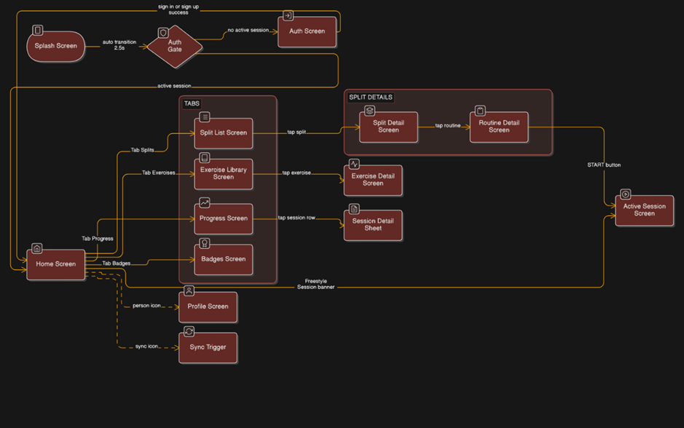

Figure 4.3 – Screen navigation flow.

The primary user journey during an active gym session proceeds as follows: SplitListScreen → SplitDetailScreen → RoutineDetailScreen → ActiveSessionScreen. The ActiveSessionScreen is the most interaction-intensive screen in the application and was given the greatest design attention. Set logging controls adapt dynamically to the selected exercise's metric type, presenting weight and reps fields for weightReps exercises, a reps-only field for bodyweight exercises, duration inputs for timed exercises, and distance and time fields for cardio exercises. A gold animated PR banner is displayed immediately when a new personal best is detected, providing the real-time motivational feedback discussed in Section 2.9.

4.4.4 Visual Design
The application adopts a deep burgundy primary colour with gold accents, a palette chosen to convey premium quality whilst differentiating the application from the blue-dominant aesthetic of the mainstream fitness app market. The gold accent colour is applied consistently to performance indicators, PR banners, earned badges, and active state indicators, creating a visual language in which gold signifies achievement — a deliberate gamification design choice.
Early interface wireframes were produced in Figma prior to implementation to establish the navigation hierarchy, screen layout, and interaction flow before committing to code. Representative wireframes are presented in Appendix J.

4.5 Key Design Decisions

4.5.1 Local Storage: Drift over Alternatives
Drift was selected as the local data layer over the available alternatives for a specific technical reason: the workout data model is fundamentally relational. Querying all sets for a given exercise across all sessions, calculating personal bests, and computing attendance streaks all require JOIN operations across multiple tables. Key-value stores such as SharedPreferences and document stores such as Hive and Isar cannot express these queries natively. Drift provides a fully type-safe SQL layer with compile-time query verification, reactive stream support via Dart's Stream API, and a schema migration system — the complete feature set required by the application's data model.

4.5.2 State Management: Riverpod over Alternatives
Riverpod with code generation was selected over BLoC, Provider, and GetX. BLoC was rejected due to the boilerplate overhead it introduces in a single-developer project with frequent iteration cycles. GetX was rejected due to its coupling of navigation and state management, which complicates testing. Provider, Riverpod's predecessor, lacks compile-time safety. Riverpod's @riverpod annotation eliminates manual provider registration, provides automatic dependency tracking, and integrates seamlessly with Drift's reactive streams via StreamProvider.

4.5.3 Dual-Key Design: Integer Local PKs and UUID Remote Keys
Local records use SQLite autoincrement integer primary keys for performance — integer comparisons and joins are faster than string comparisons on UUID values. However, integer primary keys are not globally unique: two devices creating records offline would generate conflicting IDs. UUID v4 is used as the remote identifier, generated client-side without a server round-trip, ensuring global uniqueness from the point of creation. The remoteId column is null until first sync, at which point it is stamped and used as the stable Supabase row identifier for all subsequent upserts. This design isolates the synchronisation concern entirely from the local data model.

4.5.4 Upload-Only Sync
Bidirectional synchronisation introduces conflict resolution complexity that is disproportionate to the application's use case. OneRep is designed as a single-user, single-device application; there is no collaboration scenario in scope. By designating the local database as the single source of truth and restricting Supabase to a backup and restoration role, conflict resolution is eliminated entirely. Download occurs only at sign-in, restoring the user's data to a new or reset device.

4.5.5 Soft Deletes
Hard deletes cannot be propagated to a remote database if the device is offline when the deletion occurs. A record deleted locally leaves no artefact that can inform the sync service of the required remote operation. Soft deletes solve this by writing a deletedAt timestamp to the record, which the sync service can upload to Supabase. After successful remote propagation, the local record is hard-deleted. All database queries filter on deletedAt IS NULL, rendering soft-deleted records invisible to the UI without any additional application-layer logic.

4.5.6 Supabase over Alternatives
Firebase Realtime Database and Firestore are document stores without native relational query support. The workout data model — with JOINs across sessions, sets, exercises, and personal bests — is a fundamentally relational problem that document stores address awkwardly through denormalisation or multiple round-trip queries. Supabase provides a managed PostgreSQL instance with a REST API, GoTrue authentication, and Row Level Security, all with a generous free tier and a Flutter SDK. A self-hosted PostgreSQL instance was rejected on the grounds of operational overhead beyond the scope of the project.

4.6 Gamification Design
The gamification system was designed as a coherent layer atop the core tracking functionality, implementing the four mechanics identified in the literature review: personal best detection, streak tracking, badge achievements, and the groundwork for future population percentile benchmarking.

4.6.1 Personal Best Detection
PR detection is triggered synchronously after every set is logged. The detection algorithm routes on the exercise's metric type and applies the appropriate comparator: for weightReps exercises, weight is the primary comparator with repetition count as a tiebreaker; for bodyweightReps, repetition count is the sole comparator; for timeOnly exercises, longer duration constitutes a new PR; for distanceTime exercises, a faster time for a given distance is the performance measure. The decision to make weight the primary comparator for weighted exercises reflects the primacy of load progression in strength training theory.
The result of PR detection is surfaced to the user immediately in the active session screen via a gold animated banner, delivering the real-time positive feedback identified in Section 2.9 as critical to the gamification loop. This immediacy — feedback at the moment of achievement rather than post-session — is the implementation of Fogg's convergence of motivation, ability, and trigger (Fogg, 2009).

4.6.2 Streak Tracking
The streak is calculated as the number of consecutive calendar weeks in which at least one session was completed. The weekly granularity — rather than daily — was chosen to accommodate the reality of resistance training programmes, in which rest days are physiologically necessary and a strict daily streak would penalise users following evidence-based training frequencies. The calculation works backwards from the current week, terminating at the first week with no sessions. The current week is permitted to be incomplete without breaking the streak.

4.6.3 Badge and Achievement System
Eight badges are defined, spanning four categories of engagement: session completion (first_workout), volume accumulation (sets_50, sets_500), personal record achievement (first_pr, pr_10), consistency (streak_7_day, streak_30_day), and feature engagement (first_custom_exercise). All badge rows are pre-seeded at database initialisation in a locked state, implementing the goal gradient effect described in Section 2.9: unearned badges are visible and described, creating concrete proximal goals that motivate continued engagement. Badge evaluation is performed after every set and every session completion via the BadgeService, which checks each trigger condition against the current database state.

4.6.4 Population Percentile Benchmarking
The population percentile benchmarking feature displays a user’s personal best for major lifts as a percentile rank within the Strengthlevel.com reference dataset, stratified by bodyweight and sex. Implementation details are presented in Section 5.4.4.
The design decisions documented in this chapter establish the architectural and interaction foundations of OneRep. Chapter 5 describes how these designs were realised in code, documents the significant technical challenges encountered during implementation, and presents the automated test suite that verifies the correctness of the core data layer.

5 - Implementation and Testing

5.1 Implementation Overview
OneRep was implemented as a cross-platform Flutter application targeting Android and iOS from a single Dart codebase. Table 5.1 summarises the complete dependency stack.

Technology | Version | Purpose
Flutter | 3.x SDK | UI framework and widget toolkit
Dart | 3.10+ | Programming language
flutter_riverpod | 2.6.1 | State management framework
riverpod_annotation | 2.6.1 | Code generation annotations
drift | 2.28.2 | Type-safe SQLite ORM
sqlite3_flutter_libs | 0.5.42 | Bundled SQLite native libraries
path_provider | 2.1.2 | Platform file system paths
supabase_flutter | 2.12.0 | Auth, database, and Realtime SDK
workmanager | 0.9.0 | Background task scheduling
fl_chart | 0.66.2 | Line charts and data visualisation
flutter_local_notifications | 18.0.1 | Local push notifications (rest timer)
flutter_launcher_icons | 0.14.1 | Launcher icon generation
flutter_native_splash | 2.4.0 | Native splash screen
freezed_annotation | 2.4.4 | Immutable data class annotations
uuid | 4.5.1 | UUID v4 generation for remote keys
shared_preferences | 2.3.2 | Lightweight key-value preferences

Table 5.1 — OneRep technology stack.

5.2 Core Feature Implementation

5.2.1 Exercise Library
The exercise library is implemented around the exercises table, pre-seeded with 40 default exercises spanning the major muscle groups and movement patterns. Each exercise carries a metricType field that governs how performance data is captured for that exercise across the application.

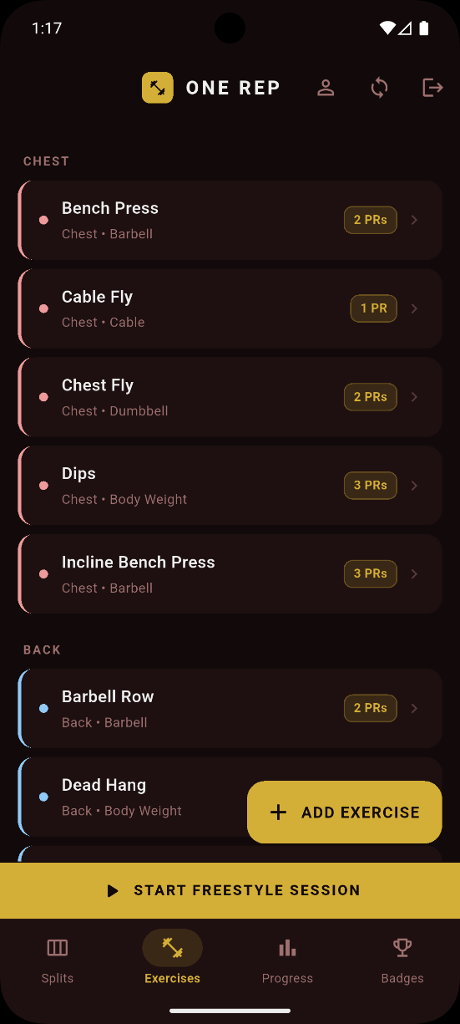

Figure 5.1 — ExerciseLibraryScreen displaying exercises grouped by body part with colour-coded category chips. The floating action button provides access to custom exercise creation.

Users may add custom exercises via a creation dialog specifying name, body part, equipment type, and metric type. Custom exercises are flagged with isCustom = true, which designates them for cloud synchronisation. Default exercises, being seeded identically on every installation, are excluded from the sync surface to avoid redundant network traffic and potential conflict on the unique name constraint.

5.2.2 Workout Structure
The five-level workout hierarchy described in Section 4.3 is implemented across five Drift tables with foreign key constraints enforced at the database level via SQLite's PRAGMA foreign_keys = ON.
The freestyle session entry point is surfaced permanently via the full-width banner on the HomeScreen, accessible with a single tap at any point during the application's use.
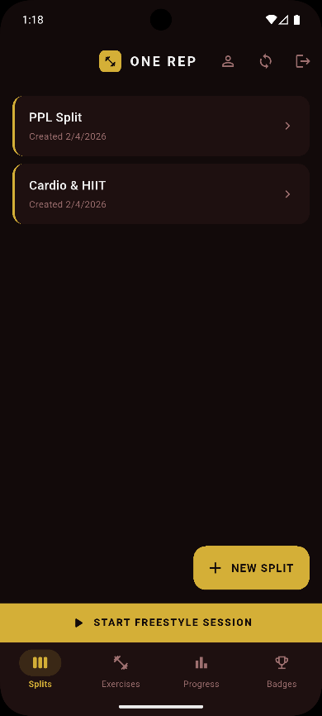
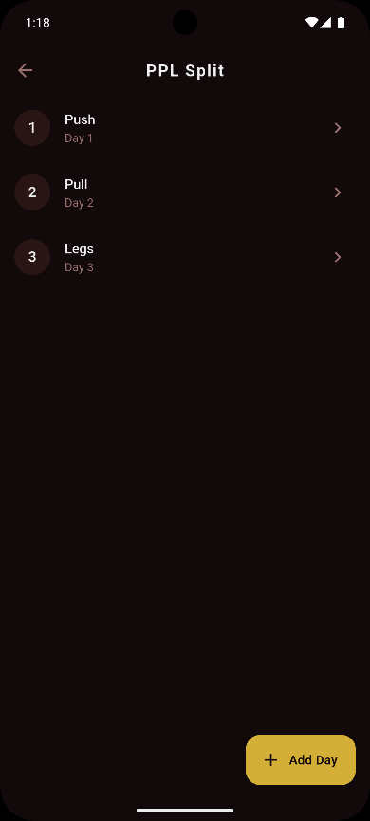

Figure 5.2.1 (left) – SplitListScreen showing all splits user has created.

Figure 5.2.1 (right) - SplitDetailScreen showing routines within a training split.

5.2.3 Active Session Logging
The ActiveSessionScreen is the most interaction-intensive surface in the application and received the greatest implementation effort. Set logging controls adapt to the selected exercise's metricType, as described in Section 4.4.3.
Upon logging a set, the SessionRepository.logSet() method writes the set to the local database and immediately invokes PersonalBestRepository.checkAndSavePr(). If a new personal best is detected, logSet() returns a non-null PrResult containing the exercise name and performance values. The ActiveSessionScreen displays a gold animated banner on receiving a non-null PrResult, delivering real-time motivational feedback at the moment of achievement.
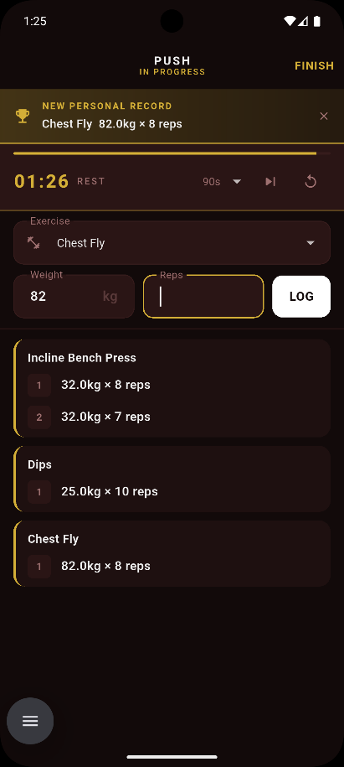

Figure 5.3 — ActiveSessionScreen during an active session showing logged sets grouped by exercise. The gold PR banner is displayed when a new personal best is detected.

5.2.4 Rest Timer
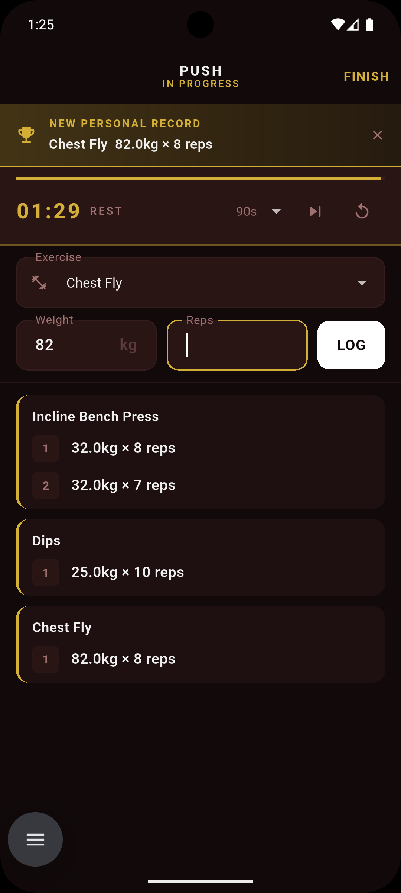
The integrated rest timer is implemented using flutter_local_notifications to deliver a local push notification when the countdown expires, ensuring the alert fires even if the user has briefly navigated away from the active session screen. The timer is initiated automatically upon set logging, removing the need for a manual start action between sets. The countdown is displayed persistently within the ActiveSessionScreen, maintaining visibility of remaining rest time without requiring the user to navigate to a separate screen or application.

Figure 5.4.1 — ActiveSessionScreen displaying the integrated rest timer countdown between sets. The timer initiates automatically upon set logging without user intervention. Three options are available; Select duration (90s default), end timer and restart timer.
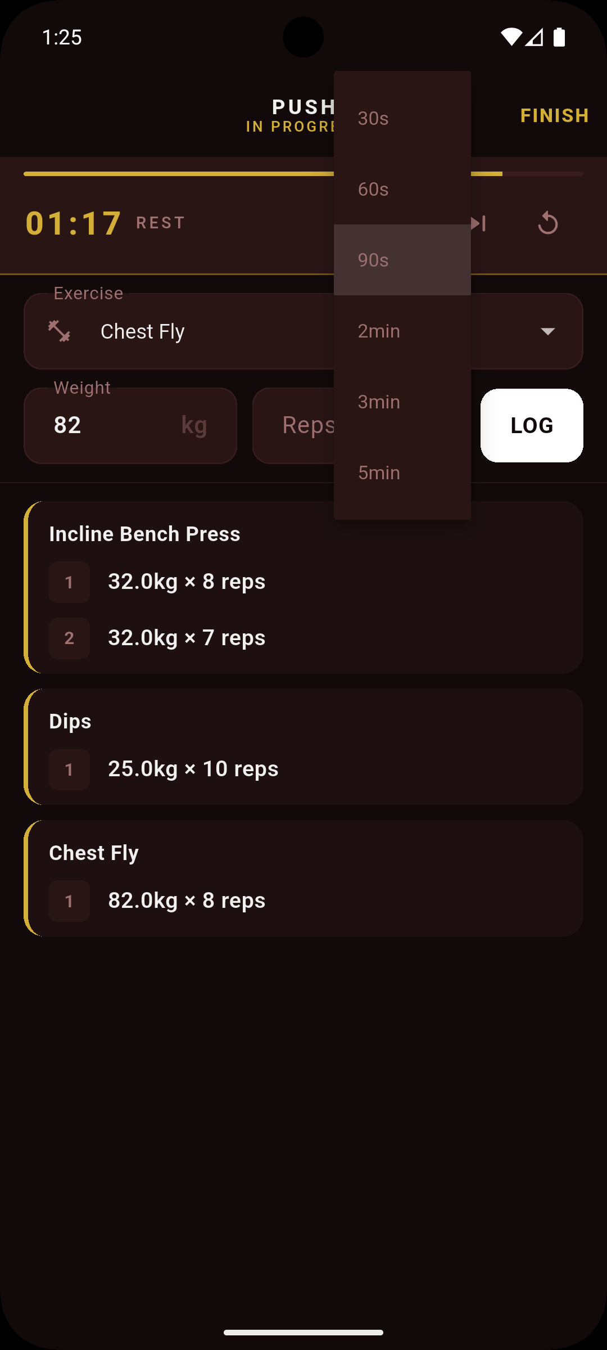

Figure 5.4.2 – Clicking the dropdown allows users to select a timer duration.

5.2.5 Progress Visualisation
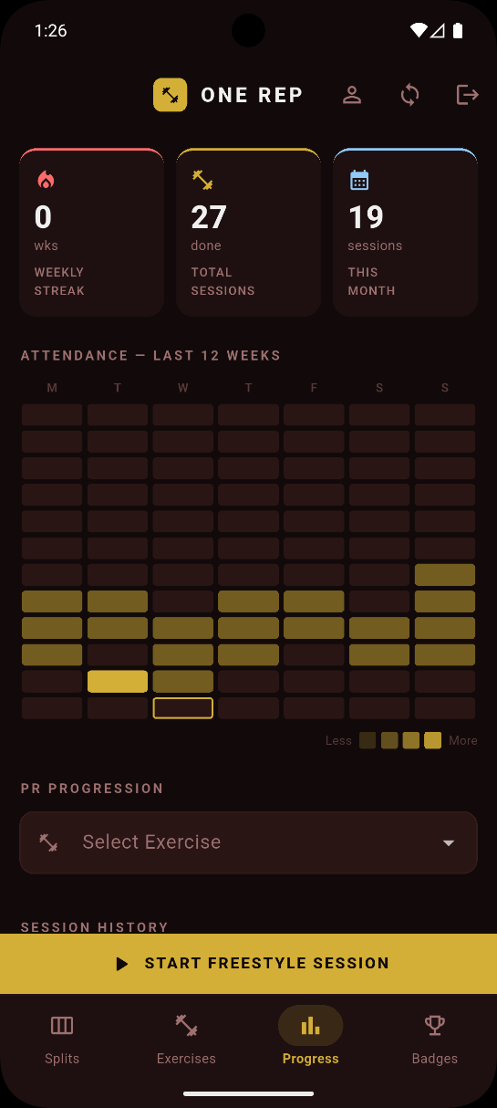
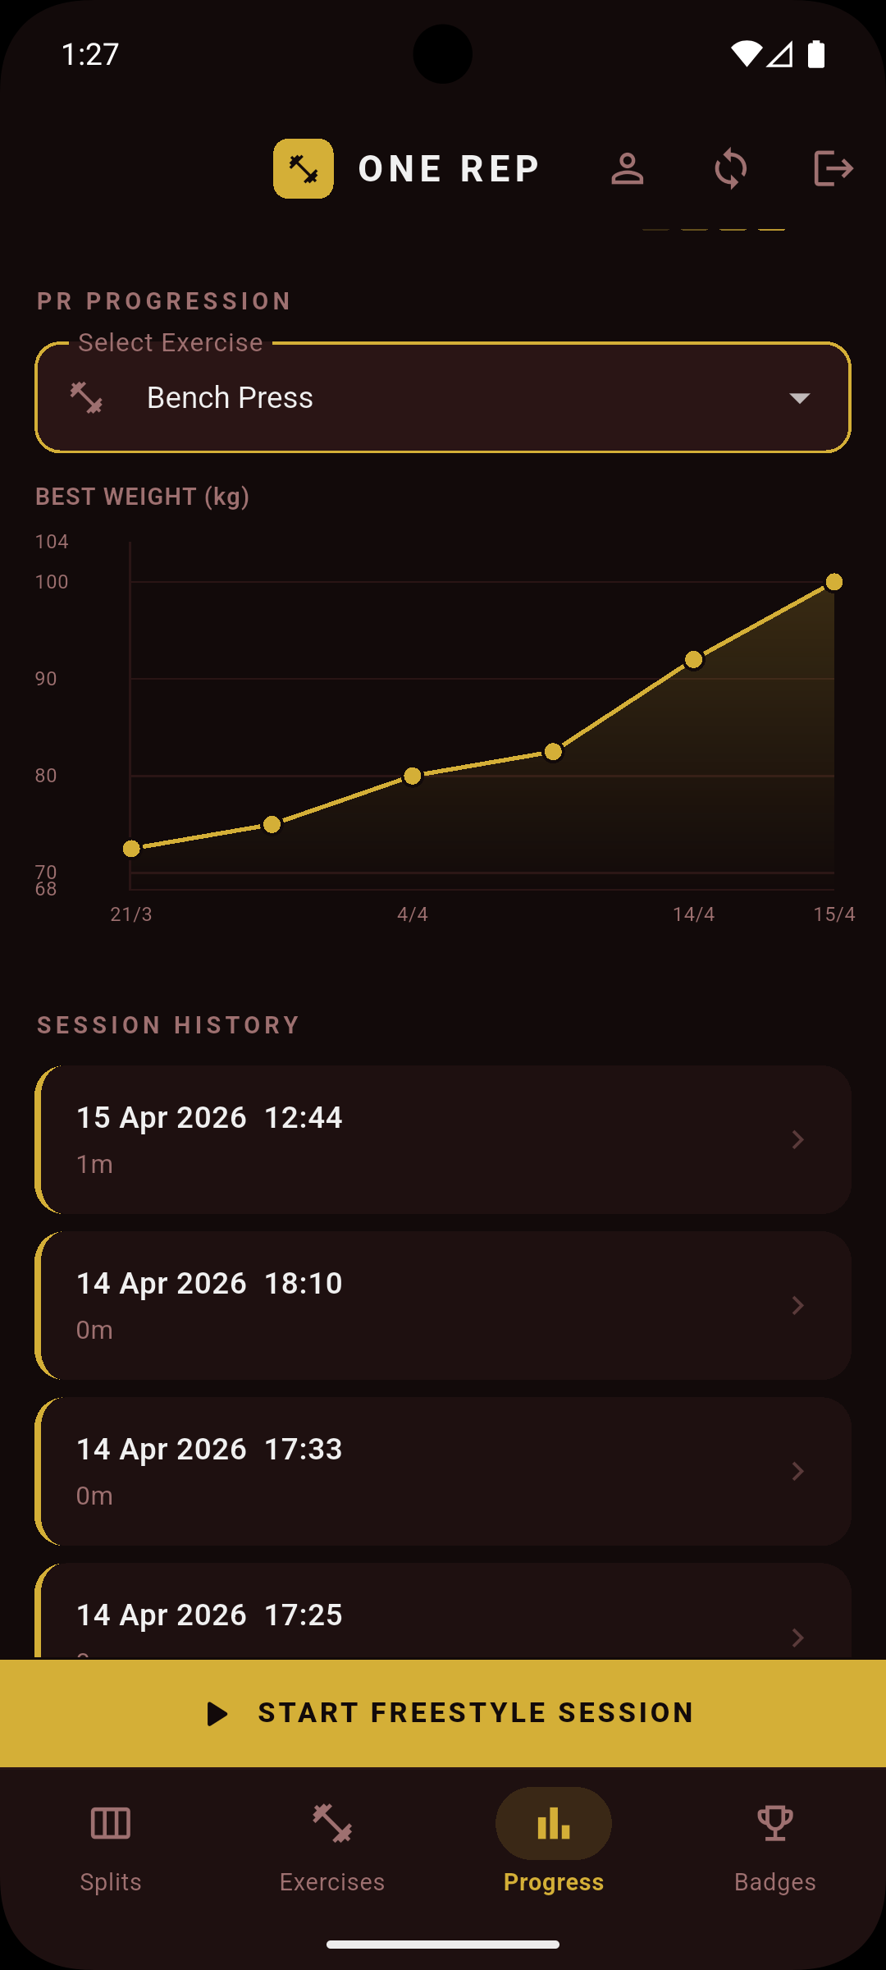
The ProgressScreen provides three distinct data visualisations. Stat cards at the top of the screen display the current weekly streak count, total completed sessions, and sessions logged in the current calendar month. An attendance heatmap renders 12 weeks of session activity aligned to Monday, with gold squares of varying opacity indicating session frequency per day — a visual convention borrowed from code contribution graphs familiar to software developers. The primary analytical tool is a PR progression line chart implemented using fl_chart, displaying the user's best performance over time for a selected exercise.

Figure 5.5 — ProgressScreen showing the weekly streak stat card, twelve-week attendance heatmap aligned to Monday.

Figure 5.5.2 (right) - Shows PR progression line chart for a selected exercise and session history.

5.3 Synchronisation Implementation

5.3.1 Schema Migration History
The Drift database schema reached version 6 during development, reflecting six iterative migration steps as requirements evolved. Key migrations included: the addition of the metricType column to the exercises table and the duration and distance columns to workout_sets (v2 → v3); the introduction of sync columns across all five core tables (v3 → v4); and the addition of the personal_bests and badges tables (v5 → v6). Each migration was implemented using explicit ALTER TABLE ADD COLUMN statements within Drift's onUpgrade callback, as Drift's migration DSL does not support all column constraint types and raw SQL was required for several additions.

5.3.2 Dirty Flag Mechanism
The synchronisation system is built around a dirty flag pattern using the syncedAt column present on all eight syncable tables. A null syncedAt value designates a record as dirty — modified locally but not yet reflected in Supabase. Every insert and update operation in the repository layer sets syncedAt to null. Upon successful upload to Supabase, SyncService stamps syncedAt with the current timestamp, clearing the dirty flag. This mechanism is entirely passive from the UI's perspective: the application writes to the local database unconditionally and the sync layer reads the dirty queue independently, with no blocking dependency between the two operations.

5.3.3 SyncService
SyncService is implemented as a plain Dart class — deliberately free of Flutter bindings — instantiated with an AppDatabase reference and a SupabaseClient reference. This enables operation in a workmanager background isolate. The service exposes two public methods.
uploadDirtyRecords() iterates through all syncable tables in foreign key dependency order: WorkoutSplits → WorkoutRoutines → RoutineExercises → WorkoutSessions → WorkoutSets → PersonalBests → Badges → CustomExercises. This ordering is mandatory; PostgreSQL enforces foreign key constraints. Each table's sync runs within an independent try-catch block, collecting errors in a SyncResult.errors list rather than aborting the entire operation on a single failure.
downloadUserData() is invoked on sign-in and fetches all rows belonging to the authenticated user from Supabase, inserting or updating them into the local database using insertOnConflictUpdate keyed on the record's remoteId. This is the sole mechanism by which data flows from Supabase to the local database, implementing the download-on-restore pattern described in Section 4.5.

5.3.4 Soft Delete Implementation
All deletion operations in OneRep are implemented as soft deletes. When a user deletes a record — for example, by swiping a split card — the repository writes deletedAt = DateTime.now() and syncedAt = null to the local record within a database transaction. Children are soft-deleted before parents within the same transaction to maintain referential consistency. All stream queries in the repository layer filter on deletedAt IS NULL, making the soft-deleted record immediately invisible to the UI without requiring any application-layer deletion logic. On the next sync cycle, SyncService detects the dirty record, upserts the populated deleted_at value to Supabase, and then hard-deletes the local record after confirmed upload. The Supabase download query filters on deleted_at IS NULL, ensuring that previously deleted records are never restored on sign-in.

5.3.5 Authentication Implementation
Authentication is handled by Supabase GoTrue via the AuthRepository, which wraps the signIn, signUp, and signOut methods and catches AuthException, rethrowing sanitised user-facing messages. The application's routing is driven by a StreamProvider watching Supabase's onAuthStateChange stream, consumed by AuthGate at the application root. When the stream emits an event with a non-null session, AuthGate renders HomeScreen; when the session is null, AuthScreen is rendered. This pattern reacts to all authentication events without requiring explicit navigation calls.
On successful sign-in, downloadUserData() restores the user's data from Supabase. On sign-out, clearLocalData() wipes all user-owned rows before the session is cleared.
Row Level Security on all Supabase tables is configured with the policy auth.uid() = user_id. Every row uploaded to Supabase includes the authenticated user's UUID in the user_id column. This policy ensures that a user can only read and write their own rows, even if the application's anon key — which is embedded in the compiled client binary — were to be extracted. The service role key, which bypasses RLS, is never included in the client application.

5.3.6 Background Synchronisation
Background synchronisation is implemented via the workmanager package, which uses Android's JobScheduler to schedule a periodic task with a seven-day interval and a network connectivity constraint. The background callback dispatcher is a top-level Dart function annotated with @pragma('vm:entry-point') to prevent tree-shaking by the Dart compiler. The dispatcher initialises Supabase and AppDatabase independently — without Flutter bindings — and calls uploadDirtyRecords(), returning true on success or false to request a workmanager retry. On iOS, background execution is subject to significant operating system throttling and cannot be guaranteed to execute reliably at the scheduled interval. The manual sync trigger in the application bar is the primary and reliable sync mechanism for iOS users; the background sync provides a secondary best-effort layer.

5.4 Gamification Implementation

5.4.1 Personal Best Detection
PR detection is triggered synchronously within SessionRepository.logSet() after every set is persisted to the local database. The comparator logic per metric type is described in Section 4.6.1.
When a PR is detected, the personal_bests table is updated via an upsert with a conflict target on (exerciseId, metricType), ensuring exactly one PR record per exercise per metric type. The method returns a PrResult object to the calling repository, which propagates it to the ActiveSessionScreen for immediate display.

5.4.2 Streak Calculation
The weekly streak is calculated by getWeeklyStreakProvider in session_repository.dart. The algorithm iterates backwards through 7-day windows aligned to Monday. The streak counter increments for each consecutive week containing at least one session and terminates at the first week with no sessions. The current week is treated as incomplete and does not break the streak if no sessions have yet been logged within it. This weekly granularity, rather than a daily streak, was chosen deliberately to reflect the physiological reality of resistance training: rest days are not failures but necessary components of an effective programme.

5.4.3 Badge System
All eight badge rows are pre-seeded into the badges table at database creation with earnedAt = null. BadgeService.evaluateAll() is called after every set log and every session completion. The method evaluates each of the eight badge triggers in sequence against the current database state: session count for first_workout, total set count for sets_50 and sets_500, the totalPrCount parameter for first_pr and pr_10, a streak calculation for streak_7_day and streak_30_day, and a query for custom exercises for first_custom_exercise. Badge award is idempotent — if earnedAt is already non-null, the trigger check is skipped without writing to the database. BadgesScreen watches the badges table via a StreamProvider and rebuilds automatically when any badge is earned.

5.4.4 Population Percentile Benchmarking
Strength standards data sourced from Strengthlevel.com (accessed March 2026, non-commercial educational use, attribution present in both source code and UI) is stored as compile-time Dart constants in strength_standards_data.dart. Six major compound exercises are supported.
The calculatePercentile() function clamps the user's bodyweight to the table's minimum and maximum bracket, identifies the nearest bracket, and compares the user's best lift against the five threshold values. When the lift falls between two thresholds, linear interpolation produces a smooth integer percentile result. The best lift is compared directly against 1RM standards without conversion — a conservative choice that understates rather than overstates the user's relative strength. The result is displayed in ExerciseDetailScreen as a progress bar coloured by achievement level, a label chip, and a "Top N%" indicator. A Strengthlevel.com attribution is displayed beneath the widget. The widget is hidden entirely for exercises with no standards data, and a nudge card prompts profile completion when bodyweight or sex has not been entered.

5.5 Production Challenges
The development of OneRep encountered several significant technical challenges. Their documentation here serves the dual purpose of academic reflection and practical guidance for future developers encountering analogous problems.
Schema migration complexity. Managing an evolving database schema under Drift's versioned migration system was a persistent challenge. Retroactive addition of columns — most significantly the sync columns added across five tables simultaneously — required explicit ALTER TABLE ADD COLUMN statements in raw SQL, as Drift's migration DSL lacks support for certain column constraint types. The lesson drawn from this experience is that schema design should be finalised as completely as possible before implementation begins.
Riverpod generated file conflicts during branch merges. The .g.dart files produced by Riverpod's code generator were committed to version control in the early stages of the project. When feature branches were subsequently merged, the generated files — having been independently regenerated on each branch — produced conflicting diffs that automated merge strategies could not resolve cleanly. Resolution required manual conflict resolution followed by a full build_runner regeneration. The corrective action taken was to add all .g.dart files to .gitignore, treating them as build artefacts rather than source files.
Companion class Value wrapper semantics. Adding default values to the weight and reps columns in schema v6 caused all test code using WorkoutSetsCompanion.insert() to fail with type errors, as Drift's Companion classes distinguish absent fields from explicitly set ones. Seventy-one test cases required updating to use explicit Value() wrappers.
DateTime timezone mismatch in the attendance heatmap. The attendance heatmap displayed incorrect data for downloaded sessions due to three compounding issues: grid misalignment to Monday, a non-reactive provider (ref.read instead of ref.watch), and UTC timestamp parsing shifting session dates. Resolution required correcting the weekday arithmetic, converting to a StreamProvider, and introducing a _parseLocal() helper
Android adaptive icon rendering. The app icon displayed with an unintended white background on Android 8+ due to adaptive icon rendering. Resolution required separating the icon into a foreground silhouette and explicit background colour via flutter_launcher_icons.
Hero tag conflicts in IndexedStack. Navigation between screens triggered a Flutter assertion error reporting multiple Hero widgets sharing the same tag within a subtree. The IndexedStack renders all four tab screens simultaneously — including their FloatingActionButtons, which use a shared default Hero tag for transition animations. The resolution was to assign unique heroTag values to each FAB: 'split_fab' for SplitListScreen and 'exercise_fab' for ExerciseLibraryScreen.
Git merge conflicts from generated file tracking. Repeated merge conflicts in generated files and independently modified source files required temporary disabling of branch protection to allow force-push after manual resolution. The corrective action was to establish a policy of short-lived feature branches merged frequently to minimise divergence, and to ensure generated files were excluded from version control going forward.

5.6 Testing

5.6.1 Test Strategy
The testing strategy for OneRep distinguishes between three categories of verification: automated unit tests covering the data layer, manual testing covering the UI layer, and structured usability evaluation covering the user experience layer (detailed in Chapter 6).
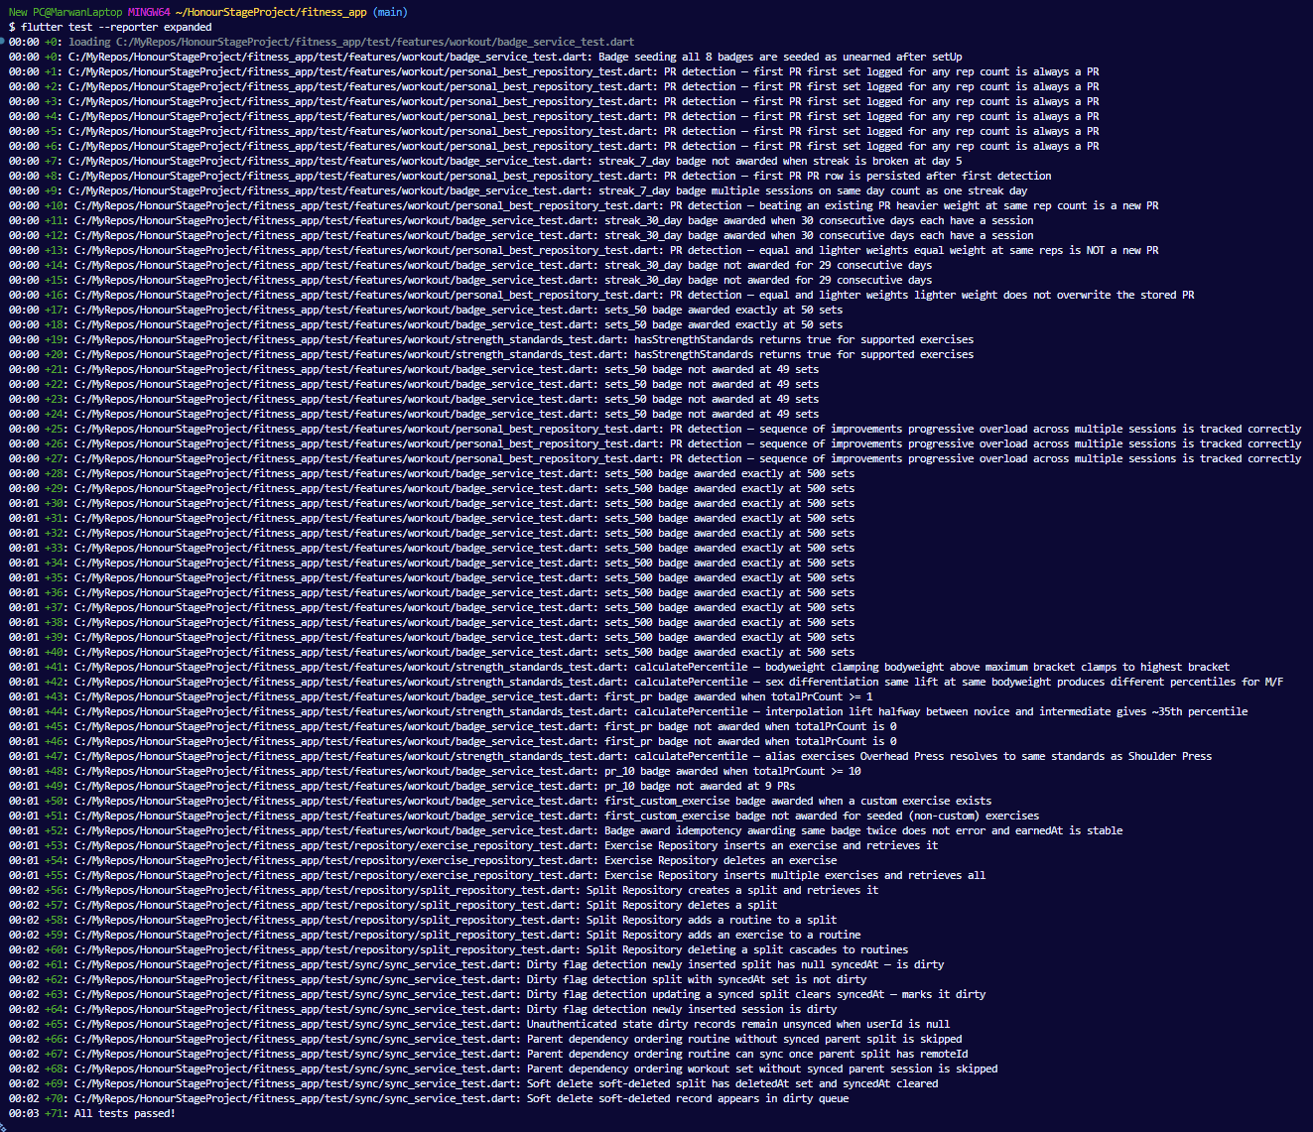
Automated tests target the repository and service classes using in-memory SQLite databases instantiated via Drift's NativeDatabase.memory(). This boundary was chosen because repository logic — PR detection, streak calculation, badge triggering, schema correctness, and sync readiness — is deterministic and fully testable without a UI or network dependency. Widget tests were not written due to the disproportionate setup complexity for a single-developer project under iteration. Supabase network calls are excluded from automated testing by design — the HTTP layer is validated through manual sync testing on device.

Figure 5.6 — Terminal output of flutter test --reporter expanded confirming all 71 tests passing across five test files.

5.6.2 Test Suite
The test suite comprises 71 test executions across five test files, corresponding to approximately 40 distinct test cases. The higher execution count reflects parametrised tests — single test definitions executed across multiple input values to verify boundary conditions efficiently.
The suite covers PR detection across all metric types and boundary conditions, badge trigger verification and idempotency, percentile calculation with interpolation and clamping, exercise CRUD operations, split hierarchy and cascade deletion, and sync readiness logic including dirty flags, parent dependency skipping, and soft delete propagation. Full test descriptions are provided in Appendix N.

5.6.3 Requirement Traceability
Table 5.2 maps the test groups to the functional requirements defined in Chapter 3.
Test Group | Requirements Covered
PersonalBestRepository | FR-08, FR-09
BadgeService | FR-11
Strength Standards | FR-12
ExerciseRepository | FR-01, FR-02
SplitRepository | FR-03, FR-04
SyncService | FR-13, FR-14, FR-15

Table 5.2 — Requirement traceability matrix.

FR-05, FR-06, FR-07, FR-10, and FR-16 are validated through manual testing and the usability study (Chapter 6), as their correctness depends on UI behaviour.
The automated test suite confirms the correctness of the data layer; the question that remains is whether the application, as experienced by real users, fulfils its design objectives. Chapter 6 presents a structured usability evaluation combining heuristic inspection, naturalistic usage, think-aloud sessions, and the System Usability Scale to assess OneRep against both objective usability standards and the subjective experience of its target user population.

6 - Evaluation

6.1 Evaluation Strategy
The evaluation of OneRep was conducted in four phases, combining inspection-based and user-centred methods to assess the application against both objective usability standards and real-world user experience. The phased approach was designed to ensure that the application was in a stable, testable state before participants encountered it, and that participant feedback was grounded in genuine usage rather than first impressions alone.
Phase 1 comprised a heuristic evaluation using Nielsen's (1994) ten heuristics. Phase 2 was a seven-day naturalistic usage period. Phase 3 consisted of structured think-aloud sessions with five task scenarios. Phase 4 was a post-session questionnaire combining the SUS with qualitative questions.
This multi-method design reflects the distinction drawn in the testing and evaluation literature between whether software works and whether it pleases the user (Robinson, 2025). The heuristic evaluation addresses the former through expert inspection; the think-aloud sessions and SUS address the latter through direct user engagement. The seven-day naturalistic period adds ecological validity: participants brought genuine training data to the think-aloud sessions.

6.2 Phase 1 — Heuristic Evaluation
A heuristic evaluation was conducted by the researcher against Nielsen's (1994) ten usability heuristics prior to participant testing. The evaluation identified 12 violations across the application, ranging from cosmetic issues to two severity-4 findings classified as usability catastrophes requiring resolution before participant testing could safely proceed.
The complete violation table is presented in Table 6.1.

ID | Heuristic | Violation | Location | Severity | Status
H01 | Visibility of system status | No loading indicator on splash or sign-in; app may appear frozen | Splash / Auth | 1 | Identified, not resolved
H02 | Visibility of system status | Sync icon provides no feedback confirming successful upload | App Bar | 2 | Resolved
H03 | User control and freedom | No undo or confirmation dialog when swiping to delete a split or routine | SplitListScreen | 3 | Identified, not resolved
H04 | Error prevention | No discard confirmation when navigating away from an active session | ActiveSessionScreen | 4 | Resolved
H05 | Error prevention | Bodyweight field accepts invalid input including negative values | ProfileScreen | 2 | Resolved
H06 | Error prevention | No warning when clearing profile data, risking permanent local data loss | Profile / Auth | 4 | Resolved
H07 | Recognition rather than recall | Empty states are passive text labels with no call to action | Home / Progress | 2 | Identified, not resolved
H08 | Flexibility and efficiency of use | No reordering capability for exercises within a routine | RoutineDetailScreen | 2 | Identified, not resolved
H09 | Aesthetic and minimalist design | Percentile widget leaves a white gap when bodyweight data is absent | ExerciseDetailScreen | 1 | Resolved
H10 | Help users recognise, diagnose and recover from errors | Generic "invalid credentials" message does not identify which field is incorrect | AuthScreen | 2 | Identified, not resolved
H11 | Help and documentation | No onboarding guidance for first-time users creating their first split | SplitListScreen | 2 | Identified, not resolved
H12 | Recognition rather than recall | Exercise library is a single unsorted list requiring extensive scrolling | ExerciseLibraryScreen | 3 | Identified, not resolved

Table 6.1 — Heuristic evaluation violations (baseline, prior to participant testing)

The two severity-4 violations were resolved before participant testing commenced. The two severity-4 violations (H04 and H06) were resolved through confirmation dialogs before participant testing commenced.
H12 (unsorted exercise library) was not resolved within the project timeline. Its predicted impact on participants was confirmed in the subsequent usability study (Section 6.5).

6.3 Phase 2 — Naturalistic Usage Period
Following the heuristic evaluation and the resolution of severity-4 violations, all five participants installed OneRep on their personal Android devices and used the application during their actual gym sessions over a seven-day period. Participants were instructed to use the application during their normal gym sessions and note any moments of confusion or positive surprise.
A brief check-in questionnaire was administered via Google Form on Day 3 to capture early impressions. All five participants reported having used the application during at least some of their gym sessions, with four of five reporting use during every session. The mean ease-of-use rating at the Day 3 midpoint was 4.2 out of 5.
Several themes emerged from the Day 3 responses that were subsequently confirmed during the think-aloud sessions. P1 praised the automatic rest timer and its haptic notification as preventing over-rest between sets. P2 noted friction when navigating the exercise list, corroborating H12 from the heuristic evaluation. P3 requested auto-population of previous session data — a feature gap that was raised consistently across all subsequent data collection phases. P4 reported earning the 7-day streak badge organically and expressed motivation to pursue the 30-day badge. P5 described the exercise page as difficult to navigate.
The naturalistic period ensured that participants arrived at think-aloud sessions with genuine training data and first-hand opinions.

6.4 Participants
Five participants were recruited from the researcher's social network, all of whom were regular gym-goers with active training programmes at the time of the study. Participant demographics are summarised in Table 6.2.
Participant | Gym Experience | Training Frequency | Prior App Experience | Current Tracking Method
P1 | 3–5 years | 4+ times/week | Hevy (briefly) | Notes app
P2 | 1–3 years | 3 times/week | Strava (regularly) | Dedicated fitness app
P3 | 5+ years | 4+ times/week | Trainerize (regularly) | Dedicated fitness app
P4 | 1–3 years | 3 times/week | None (paper journal) | Paper journal
P5 | 6–12 months | Twice/week | None | Notes app

Table 6.2 — Participant demographics.

The sample spans the full target user population identified in Chapter 3: a novice with no prior app experience (P5), intermediate users transitioning from paper and Notes-based tracking (P1, P4), and experienced lifters with established app workflows (P2, P3). The sample provides a reasonable basis for assessing the application across experience levels.
Informed consent was obtained from all five participants prior to the study commencing, via a Google Form containing the full participant information sheet and a digital consent agreement. All participants are referred to by pseudonym (P1–P5) throughout this report. No personally identifiable information is included in any analysis or appendix.

6.5 Phase 3 — Think-Aloud Sessions
Think-aloud sessions were conducted in person with all five participants following the seven-day naturalistic usage period. Each session lasted between 20 and 35 minutes. Participants were asked to narrate their actions, intentions, and reactions as they completed five task scenarios. The researcher observed and recorded hesitations, errors, navigational choices, and verbal comments without intervention. Task completion and approximate task durations were recorded for each participant.

6.5.1 Task Completion Results
All five participants completed all five tasks successfully, yielding a 100% task completion rate. Task durations are summarised in Table 6.3.
Task | P1 | P2 | P3 | P4 | P5 | Notes
T1 — Create split and routine | 1m 05s | 2m 05s | 1m 40s | 3m 30s | 2m 15s | P4 hesitated on routine creation
T2 — Add exercise, start session, log set | 1m 30s | 2m 50s | 3m 05s | 4m 00s | 2m 40s | All delayed by exercise scrolling
T3 — Start rest timer | 10s | 15s | 20s | 35s | 15s | Fastest task across all participants
T4 — Find streak and session count | 40s | 55s | 1m 10s | 2m 10s | 1m 00s | P4 paused to examine heatmap
T5 — Identify earned and unearned badge | 25s | 40s | 50s | 1m 20s | 35s | All completed without hesitation

Table 6.3 — Task completion times by participant.

Task 3 (rest timer initiation) was the fastest task across all participants, with a mean completion time of approximately 19 seconds. This result is particularly significant given that the rest timer was identified in the requirements gathering phase as critically absent from the majority of free fitness applications (PT-1, personal communication, 20 March 2026) — its zero-friction discoverability suggests the implementation successfully addresses this gap.
Task 2 (exercise logging) was the slowest task across all participants. The primary cause in every case was navigation through the unsorted exercise library. P2 remarked:"still scrolling... wow, this is a long list." P3 completed the task but was visibly slowed by the absence of auto-populated previous session data, noting: "wait, it doesn't show me what I did last time? I have to remember my weight? That's a bit of a let-down." The convergence of all five participants on this single friction point constitutes the study's most consistent and actionable finding.

6.5.2 Observational Findings
P1 navigated the application with high confidence throughout, exhibiting no visible learning curve. Their spontaneous reaction to the rest timer — "Oh! It just started. I didn't even have to look for it. That's actually great because I usually just guess" — was the most direct unprompted validation of FR-06 produced during the study.
P2 demonstrated the clearest instance of the exercise navigation problem. P2 demonstrated the clearest instance of the exercise navigation problem during T2. Their post-task comments consistently returned to social comparison features — a desire to see friend leaderboards for personal bests — aligning with the social comparison mechanics discussed in Section 2.8.4.
P3, the most experienced participant and the only regular user of a professional training platform (Trainerize), provided the most technically critical feedback. Their primary concern — the absence of auto-populated previous session data — was raised during the think-aloud, the Day 3 check-in, and the post-session questionnaire, representing the most consistently reported individual feature gap across all data collection phases. Despite this, P3 praised freestyle sessions emphatically, describing them as "so so so helpful" and explaining that the feature resolved a genuine workflow problem: the inability to log an unplanned session without losing the continuity of progress data. This participant's experience constitutes the most direct user-articulated validation of the fragmentation argument: they described, in their own words, a before-and-after comparison in which OneRep's unified approach resolved a problem that their previous tool combination could not.
P4, transitioning from a paper journal, demonstrated the application's accessibility to users with no prior digital tracking experience. Their hesitation during T1 — pausing to locate the routine creation entry point — was the only navigational error observed that was attributable to interface discoverability rather than the exercise list. P4 showed the most pronounced reactions to gamification elements, with the First Workout badge received with evident satisfaction. This participant's trajectory — from paper journal to genuine app engagement within a seven-day period — is a strong indicator of the application's onboarding accessibility.
P5, the least experienced participant with no prior fitness app usage, completed all tasks with confidence and produced the most emotionally resonant qualitative statement of the study: "Seeing my streak grow is the only reason I went to the gym on Tuesday." This statement directly instantiates the gamification mechanism described by Lally et al. (2010) — the streak mechanic creating a loss-aversive motivation that overrides the friction of attending training.

6.6 Phase 4 — SUS Results and Quantitative Analysis

6.6.1 SUS Scores
SUS scores were calculated from post-session questionnaire responses using the standard scoring procedure (Brooke, 1996): for odd-numbered items, the participant's score minus one; for even-numbered items, five minus the participant's score; summed and multiplied by 2.5 to produce a score out of 100.

Participant | SUS Score | Grade | Adjective Rating
P1 | 80.0 | B | Good
P2 | 67.5 | C | OK
P3 | 80.0 | B | Good
P4 | 87.5 | B+ | Excellent
P5 | 85.0 | B+ | Excellent
Mean | 80.0 | B | Good

Table 6.4 — SUS scores by participant.

The mean SUS score of 80.0 exceeds the widely cited industry average of 68 (Bangor, Kortum and Miller, 2008), placing OneRep in the "Good" band and approaching the "Excellent" threshold of 85. Four of five participants scored above the industry average.
P2's score of 67.5 — the single below-average result — is interpretable in context. P2 was the only participant who scored the consistency item (Q6: "I thought there was too much inconsistency in this app") at 4, indicating agreement with the negative statement. The exercise navigation issue (H12) is the primary driver of P2's lower score — a localised, addressable problem rather than a general quality failure.

6.6.2 Item-Level Analysis
Analysis of individual SUS items across all participants reveals a consistent pattern. Item 4 ("I think that I would need the support of a technical person to use this app") received a score of 1 from all five participants — unanimous strong disagreement — indicating that the application is perceived as independently learnable across the full experience range, including P5 who had no prior fitness app experience. Item 5 ("I found the various functions in this app were well integrated") received scores of 4 or 5 from four of five participants, directly supporting the unified design hypothesis: participants perceived the application's features as cohesive rather than fragmented.

6.7 Qualitative Analysis
Qualitative data was gathered from three sources: the Day 3 check-in form, post-task verbal responses during think-aloud sessions, and open-ended post-session questionnaire items. Thematic analysis was conducted following the six-phase procedure described by Braun and Clarke (2006): familiarisation with data, initial code generation, theme identification, theme review, theme definition, and report production. Four themes were identified.

Theme 1 — Frictionless Session Initiation
Session initiation speed was identified as a primary positive across multiple data collection phases. P2 described the session start flow as "tap, tap, go" — a formulation that captures the minimal cognitive overhead of the unified navigation path. P1 described the overall experience as "very natural," and P4 noted that logging felt "actually much faster than writing it in my book" — a direct comparison to their prior paper-based workflow. These responses converge on the central claim of this dissertation: that a unified application reduces the cognitive load of the gym session workflow by eliminating the context-switching inherent in fragmented tool use.
Theme 2 — Exercise Navigation as a Consistent Usability Barrier
Four of five participants identified the exercise library as the primary source of friction in their experience of OneRep. This finding corroborates the severity-3 heuristic violation H12 identified in Phase 1, which was not resolved before testing. The convergence of the heuristic evaluation prediction and independent user reports constitutes a validated finding — the heuristic method correctly identified a real user problem. P2's think-aloud produced the clearest articulation of the issue: the participant scrolled for an extended period, audibly expressing frustration. P4 proposed a specific solution — alphabetical sorting — which is consistent with the standard information architecture pattern for exercise libraries in the existing market (e.g. Hevy, Strong). P5 described the exercise page as "a bit of a chore." This theme represents the most actionable finding of the evaluation and the clearest priority for the next development iteration.
Theme 3 — Gamification Producing Measurable Behavioural Change
The gamification layer produced the strongest qualitative evidence of any feature area. P5's statement that the streak mechanic was "the only reason I went to the gym on Tuesday" is a causally stated behavioural outcome attributable directly to the application's design. This finding is consistent with the habit formation research discussed in Section 2.8.1. P4 earned the 7-day streak badge organically during the naturalistic usage period and expressed motivation to pursue the 30-day badge after the study concluded, indicating that the achievement system successfully created a proximal goal beyond the study period. P1 cited badges and PR tracking as their joint favourite feature. The consistency across participants of varying experience levels suggests broad appeal.
Theme 4 — Freestyle Sessions Resolving the Fragmentation Problem
P3's responses across all data collection phases consistently highlighted freestyle sessions as the application's most significant contribution to their workflow. As a highly experienced user of a professional training platform (Trainerize), P3 represents the most credible evaluator of feature quality in the participant cohort. Their description of freestyle sessions as resolving a genuine problem — the inability to log unplanned workouts without losing progress continuity — is a direct user-articulated instantiation of the dissertation's central argument. Their pre-OneRep workflow for unstructured sessions involved the Notes application, which does not carry forward PRs, progress data, or historical context. OneRep's unified data model makes this continuity automatic. This participant's experience provides the most explicit before-and-after comparison available in the evaluation data.

6.8 Requirements Evaluation
Table 6.5 assesses each functional requirement defined in Chapter 3 against the evaluation evidence.
ID | Requirement | Evidence | Status
FR-01 | Exercise library with CRUD | All participants navigated successfully | Met
FR-02 | Custom exercise creation | Not directly tested in task scenarios | Partially evidenced
FR-03 | Workout split creation | T1 — 100% completion | Met
FR-04 | Exercise assignment to routines | T2 — 100% completion | Met
FR-05 | Real-time session logging | T2 — 100% completion, P4: "much faster than paper" | Met
FR-06 | Integrated rest timer | T3 — fastest task, mean 19s, P1 spontaneous praise | Met
FR-07 | Progress charts | T4 — 100% completion, P3 praised PR progression chart | Met
FR-08 | Automatic PR detection | P3 noted absence of previous weight display (adjacent) | Met
FR-09 | Real-time PR notification | P1 observed gold banner during naturalistic use | Met
FR-10 | Streak tracking | P4 and P5 cited streak as motivational, P5 causal statement | Met
FR-11 | Badge and achievement system | T5 — 100% completion, unprompted positive responses | Met
FR-12 | Strength percentile benchmarking | Implemented, not directly tested in task scenarios | Met
FR-13 | Email and password authentication | All participants authenticated successfully | Met
FR-14 | Cloud sync and cross-device backup | Not directly tested — validated through architecture | Met
FR-15 | Offline-first operation | All sessions conducted without network dependency | Met
FR-16 | Session and exercise notes | Not directly tested in task scenarios | Partially evidenced

Table 6.5 — Requirements evaluation against study evidence.

NFR-01 (one-handed operability) and NFR-02 (sub-one-second response) were implicitly validated — no participant required two-handed input or experienced perceptible delay.
Viewed through the Wundt curve (Section 2.6), the evidence suggests OneRep occupies the optimal stimulation range: SUS Item 4 scores indicate no user overwhelm, whilst gamification responses indicate sufficient engagement. The exercise navigation barrier represents a localised complexity spike resolvable through standard information architecture patterns.

6.9 Limitations
Several limitations of this evaluation must be acknowledged. The participant sample of five is sufficient for identifying the majority of usability problems — Nielsen and Landauer (1993) demonstrated that five evaluators identify approximately 85% of usability issues — but is insufficient for statistical generalisation. The SUS mean of 80.0 and the qualitative themes are indicative rather than conclusive.
Convenience sampling introduces potential bias: all participants were recruited from the researcher's social network and had pre-existing familiarity with the researcher. Participants may have moderated negative feedback to avoid causing offence, a form of social desirability bias (Hawthorne effect).
The seven-day naturalistic usage period, whilst ecologically valid, is insufficient to assess long-term retention or the durability of gamification effects. Whether the streak motivation observed in P5 persists beyond the study period cannot be determined from this data.
Finally, the exercise navigation problem (H12, Theme 2) was a known, unresolved issue at the time of testing. P2’s below-average SUS score may have been higher had this issue been resolved before testing.
Despite these limitations, the evaluation provides a coherent body of quantitative and qualitative evidence against which the research question can be assessed. Chapter 7 draws together the findings from all preceding chapters, revisits the research question and objectives, and identifies directions for future development.

7 - Conclusion

7.1 Summary of Work
This project investigated whether unified, multifunctional mobile application design reduces cognitive load and improves user experience for gym-goers. A cross-platform fitness application — OneRep — was designed, implemented in Flutter, and evaluated through a four-phase usability study. The theoretical basis was established through a literature review drawing on Cognitive Load Theory, Norman's Action Cycle, and gamification frameworks. Requirements were derived from a domain expert interview, peer consultations, and the developer's documented experience. The application consolidates workout logging, exercise library management, rest timing, progress visualisation, gamification, and cloud synchronisation within a single offline-first interface, verified through 71 automated tests and a 12-violation heuristic evaluation, two severity-4 violations of which were resolved before participant testing.

7.2 Research Question Revisited
The central research question was: does a unified, multifunctional mobile application design reduce cognitive load and improve user experience for gym-goers, compared to the fragmented use of multiple single-purpose tools?
The evidence gathered in this project supports an affirmative answer, with appropriate qualification for the scale of the study.
The most direct evidence comes from participants who had previously used fragmented toolchains and described their experience of OneRep in explicit comparative terms. P2, transitioning from Strava and a dedicated fitness app, described the session initiation flow as "tap, tap, go" — an unprompted articulation of reduced navigational overhead that maps directly onto the extraneous cognitive load reduction predicted by Sweller's (1988) framework. P4, transitioning from a paper journal, stated that logging felt "actually much faster than writing it in my book" and completed all five task scenarios within a single session despite having no prior fitness app experience. P3 identified freestyle sessions as resolving a workflow continuity problem their previous tool combination could not, constituting the most explicit before-and-after comparison in the study.
Quantitatively, the mean System Usability Scale score of 80.0 places OneRep in the "Good" band above the industry average of 68 (Bangor, Kortum and Miller, 2008). SUS Item 4 — "I think that I would need the support of a technical person to use this app" — received a score of 1 from all five participants, indicating unanimous perception of independent learnability across the full experience range. SUS Item 5 — "I found the various functions in this app were well integrated" — received scores of 4 or 5 from four of five participants, directly supporting the unified design hypothesis at the level of perceived coherence.
The gamification evidence is the most behaviourally significant finding of the study. The gamification evidence (Section 6.7, Theme 3) is the most behaviourally significant finding — P5's causally stated gym attendance attributable to the streak mechanic is achievable only within a unified application maintaining persistent session data.
These findings must be interpreted within their limitations. A sample of five participants, recruited through convenience sampling from the developer's social network, is insufficient for statistical generalisation. The SUS mean of 80.0 and the qualitative themes are indicative of a clear trend rather than conclusive proof. The seven-day naturalistic usage period, whilst providing ecological validity absent from purely task-based evaluations, is insufficient to assess long-term retention or the durability of gamification effects. Social desirability bias cannot be excluded, though P3's critical responses and P2's below-average SUS score suggest that participants were willing to report genuine dissatisfaction where it existed.
Within these constraints, the evidence consistently points in one direction. Every participant completed every task. The single consistent usability failure — exercise library navigation — was a localised, specific, and addressable defect rather than a structural property of the unified design approach. The weight of evidence supports the conclusion that unified multifunctional design, when executed with structural coherence and journey-oriented intent, reduces the extraneous cognitive load imposed by fragmented tool use in the fitness domain.

7.3 Objectives Review
O1 — Literature review: Completed. Chapter 2 surveyed HCI evolution, mobile constraints, fragmented journeys, multifunctional platforms, cognitive load theory, and gamification.
O2 — Requirements gathering: Completed. Chapter 3 produced sixteen functional and seven non-functional requirements. Fourteen of sixteen were assessed as Met; two were partially evidenced.
O3 — Design and implementation: Completed. Chapters 4 and 5 documented the system architecture, database schema, UI design, gamification design, and full implementation with 71 automated tests.
O4 — Usability evaluation: Completed. A four-phase evaluation with five participants produced a 100% task completion rate and a mean SUS score of 80.0.
O5 — Assessment of hypothesis: Completed in Section 7.2. The evidence supports the hypothesis with appropriate qualification for sample size.
O6 — Process reflection: Completed in Section 7.4. The hybrid methodology, its strengths, and its limitations are critically evaluated.

7.4 Reflection on Process
The hybrid Waterfall-Agile methodology adopted for this project was appropriate but imperfect in practice. The Waterfall skeleton — requirements, design, implementation, evaluation — provided the structural discipline necessary for an academically supervised project with a fixed deadline. The Agile elements — feature branches, iterative sprints, mid-development requirement additions — provided the flexibility necessary when building software whose requirements are partially discovered through the act of building. The tension between these two approaches was most acutely felt during the final development sprint, when the gamification layer, the Supabase synchronisation architecture, and the strength standards feature were all in active development simultaneously. More disciplined sprint planning and earlier schema finalisation would have reduced the migration complexity documented in Section 5.5.
Weekly supervisor meetings with John Whelan were conducted throughout the project and attended consistently. Supervisor guidance was particularly valuable during the early stages when the project scope and research question were not yet concrete, and during the evaluation design phase when the multi-method approach was refined. A Gantt chart documenting the project timeline is presented in Appendix P.
The decision to conduct a seven-day naturalistic usage period before the think-aloud sessions was the most valuable process decision of the evaluation phase. Participants who had used the application in real workouts for a week produced qualitatively richer feedback than participants in purely task-based studies. The most significant qualitative findings would not have been observable in a first-contact session.
The heuristic evaluation, conducted by the researcher prior to participant testing, fulfilled its purpose: two severity-4 violations were identified and resolved before participants encountered the application. The prediction that H12 (unsorted exercise library) would surface in participant testing was confirmed by four of five participants, validating the method's predictive utility even when applied by a developer evaluating their own work.
The principal process limitation is the scale of the usability study. A follow-up with fifteen to twenty participants would produce more generalisable results.

7.5 Future Work
The evaluation and development process identified several directions for future work, ordered here by priority.
Exercise library navigation. The most consistently reported usability failure across both the heuristic evaluation and the participant study is the absence of alphabetical sorting, search functionality, and category filtering in the exercise library. This is the highest-priority improvement for the next development iteration. Its resolution would directly address the primary driver of P2's below-average SUS score and the slowest task time observed across all participants. The implementation is straightforward — Drift supports ORDER BY and WHERE filtering natively — and would require no schema changes.
Auto-populate previous session data. P3's most consistent feedback across all three data collection phases was the absence of auto-populated weight and repetition values from the previous session when logging a new set. This feature is standard in more established applications such as Hevy and Strong, and its absence was the primary reason the most experienced participant in the cohort rated the application slightly below their prior tool. Implementation would require a query to the most recent completed session for each exercise, surfacing the last recorded values as default inputs when a new set is begun.
Social comparison and leaderboard features. P2's request for friend leaderboards, and their interest in sharing the attendance heatmap, indicate strong appetite for social features among competitive users. The population percentile benchmarking feature already implemented in OneRep provides the foundational data model for social comparison. A future extension could allow users to share personal bests, compare lifts with connected friends, or participate in opt-in leaderboards for specific exercises — directly implementing the social comparison mechanics discussed in Section 2.8.4.
Customisation and personalisation. P4 and P5 both requested UI customisation — alternative colour themes, home screen widgets, and personalised dashboards. These features would not alter the core functionality but would increase perceived ownership of the application, which gamification research suggests correlates with sustained engagement (Deterding et al., 2011).
Long-term retention study. The seven-day study window is insufficient to assess whether the gamification effects observed persist over weeks and months. A longitudinal study tracking a larger participant cohort over a minimum of four weeks would provide the evidence base needed to evaluate the durability of the motivational mechanics and the long-term impact of unified design on training consistency.
App Store and Google Play publication. OneRep was developed as an academic case study but is architecturally complete for public release. The application is free, offline-first, and cross-platform — properties that directly address the failure modes of the existing market identified in Chapter 1. Publication would also enable passive data collection at scale, providing the population-level dataset necessary to strengthen the strength percentile benchmarking feature with real user-submitted lifting data rather than externally sourced standards.

7.6 Closing Statement
This project began with a simple observation: the tools available to gym-goers in 2026 fail the people who use them not through any individual deficiency but through their collective fragmentation. The gym session is a coherent, time-bounded workflow. The tools that serve it are not. OneRep was built to test whether that gap is closable, and the evidence gathered in this project — from the literature review through to P5's Tuesday gym session — suggests that it is.
A mean SUS score of 80.0, a 100% task completion rate, and four qualitative themes converging on the value of unified design do not constitute proof in the scientific sense. They constitute, in the language of the discipline, a promising result that merits further investigation at scale. The contribution of this project is to demonstrate that a single free application, built by one developer over one academic year, can produce a measurably better gym session experience than the fragmented combination of tools it replaces — and to provide the theoretical, empirical, and technical foundation from which that demonstration can be extended.

Reference List
Bangor, A., Kortum, P.T. and Miller, J.T. (2008) ‘An empirical evaluation of the System Usability Scale’, International Journal of Human–Computer Interaction, 24(6), pp. 574–594.
Berlyne, D.E. (1960) Conflict, Arousal, and Curiosity. New York: McGraw-Hill.
Braun, V. and Clarke, V. (2006) ‘Using thematic analysis in psychology’, Qualitative Research in Psychology, 3(2), pp. 77–101.
Brooke, J. (1996) ‘SUS: A quick and dirty usability scale’, in Jordan, P.W., Thomas, B., Weerdmeester, B.A. and McClelland, A.L. (eds.) Usability Evaluation in Industry. London: Taylor and Francis, pp. 189–194.
Bubeck, S. et al. (2023) ‘Sparks of artificial general intelligence: Early experiments with GPT-4’, arXiv preprint arXiv:2303.12712.
Csikszentmihalyi, M. (1990) Flow: The Psychology of Optimal Experience. New York: Harper and Row.
Deterding, S., Dixon, D., Khaled, R. and Nacke, L. (2011) ‘From game design elements to gamefulness: Defining gamification’, Proceedings of the 15th International Academic MindTrek Conference, Tampere, Finland, September 2011, pp. 9–15.
Ellis, C., Adams, T.E. and Bochner, A.P. (2011) 'Autoethnography: An overview', Historical Social Research, 36(4), pp. 273–290.
Festinger, L. (1954) ‘A theory of social comparison processes’, Human Relations, 7(2), pp. 117–140.
Fogg, B.J. (2009) ‘A behavior model for persuasive design’, Proceedings of the 4th International Conference on Persuasive Technology, Claremont, California, April 2009, Article 40.
Flutter (2026) Flutter architectural overview. Available at: https://docs.flutter.dev/resources/architectural-overview (Accessed: April 2026).
Google (2026) Material Design 3. Available at: https://m3.material.io (Accessed: April 2026).
González, V.M. and Mark, G. (2004) ‘“Constant, constant, multi-tasking craziness”: Managing multiple working spheres’, Proceedings of the SIGCHI Conference on Human Factors in Computing Systems (CHI ’04), Vienna, Austria. New York: ACM, pp. 113–120.
Hamari, J., Koivisto, J. and Sarsa, H. (2014) ‘Does gamification work? A literature review of empirical studies on gamification’, Proceedings of the 47th Hawaii International Conference on System Sciences, Hawaii, January 2014, pp. 3025–3034.
Hoy, M.B. (2018) ‘Alexa, Siri, Cortana, and more: An introduction to voice assistants’, Computer, 51(1), pp. 72–75.
Hull, C.L. (1932) ‘The goal-gradient hypothesis and maze learning’, Psychological Review, 39(1), pp. 25–43.
Kraemer, W.J. and Ratamess, N.A. (2004) 'Fundamentals of resistance training: progression and exercise prescription', Medicine and Science in Sports and Exercise, 36(4), pp. 674–688.
Lally, P., van Jaarsveld, C.H.M., Potts, H.W.W. and Wardle, J. (2010) ‘How are habits formed: Modelling habit formation in the real world’, European Journal of Social Psychology, 40(6), pp. 998–1009.
Myers, B.A. (1996) ‘A brief history of human-computer interaction technology’, Interactions, 5(2), pp. 44–54.
Nielsen, J. (1994) Usability Engineering. San Francisco: Morgan Kaufmann.
Nielsen, J. and Landauer, T.K. (1993) ‘A mathematical model of the finding of usability problems’, Proceedings of the INTERACT ’93 and CHI ’93 Conference on Human Factors in Computing Systems, Amsterdam, April 1993, pp. 206–213.
Norman, D.A. (2013) The Design of Everyday Things. Revised and expanded edition. New York: Basic Books.
Oulasvirta, A., Tamminen, S., Roto, V. and Kuorelahti, J. (2005) ‘Interaction in 4-second bursts: The fragmented nature of attentional resources in mobile HCI’, Proceedings of the SIGCHI Conference on Human Factors in Computing Systems (CHI ’05), Portland, OR, USA. New York: ACM, pp. 919–928.
Polaine, A., Løvlie, L. and Reason, B. (2013) Service Design: From Insight to Implementation. Brooklyn, NY: Rosenfeld Media.
Porcheron, M., Fischer, J.E., Reeves, S. and Sharples, S. (2018) ‘Voice interfaces in everyday life’, Proceedings of the SIGCHI Conference on Human Factors in Computing Systems (CHI ’18). New York: ACM.
Robinson, P.A. (2025) Testing and Evaluation. 600091 Honours Stage Project lecture slides. University of Hull.
Schoenfeld, B.J. (2010) ‘The mechanisms of muscle hypertrophy and their application to resistance training’, Journal of Strength and Conditioning Research, 24(10), pp. 2857–2872.
Shneiderman, B., Plaisant, C., Cohen, M., Jacobs, S., Elmqvist, N. and Diakopoulos, N. (2017) Designing the User Interface: Strategies for Effective Human–Computer Interaction. 6th edn. Boston, MA: Pearson.
Shortt, M., Tilak, S., Kuznetcova, I., Martini, B. and Akinkuolie, B. (2023) ‘Gamification in mobile-assisted language learning: A systematic review of Duolingo literature from public release of 2012 to early 2020’, Computer Assisted Language Learning, 36(3), pp. 517–554.
Skinner, B.F. (1938) The Behavior of Organisms: An Experimental Analysis. New York: Appleton-Century-Crofts.
Stickdorn, M. and Schneider, J. (2012) This Is Service Design Thinking: Basics, Tools, Cases. Hoboken, NJ: John Wiley & Sons.
Sweller, J. (1988) ‘Cognitive load during problem solving: Effects on learning’, Cognitive Science, 12(2), pp. 257–285.
Strengthlevel.com (2026) Strength Standards. Available at: https://strengthlevel.com/strength-standards (Accessed: March 2026).

