# 001_PORT: Individual UI/UX Portfolio

Name: Marwan Ashhuby

Student Number: 202244071

Date: 28/03/25

## Part 1

### A student seeking mental health support

**Assumptions:**

* The user is a valid student and is successful logged in.
* The student starts at the [Hull Student Portal](https://hull.service-now.com/student).
* They may be feeling overwhelmed, anxious, or in urgent need of help.
* They might not know the exact terminology to search for (e.g., “wellbeing” vs “mental health”).

#### A screenshot of a computer AI-generated content may be incorrect.Cognitive Walkthrough: Step 1 – Landing on the Hubble Portal

User Goal:

Access mental health support via the University of Hull Hubble Portal.

Screenshot Context:

The user is on the main landing page of the Hubble Portal. Several tiles are displayed, one of which is labelled "Inclusion and Wellbeing". The green colour is shown only due to mouse hover.

Step 1 Interaction

Action:  
Click on "Inclusion and Wellbeing" to proceed toward mental health support.

Cognitive Walkthrough Questions:

1. Will the user try to achieve the right effect?

Yes

The user is looking for help with mental health. The word “Wellbeing” matches that goal. There are brief descriptions beneath the titles of the tiles that should confirm this to the user.

2. Will the user notice that the correct action is available?

No

The tiles are not made obvious that they are buttons to redirect users at first glance, this is not until the user hovers the mouse over the tile which changes its colour which suggests it is clickable.

With no distinctive colour or icon before hover, the tile might not stand out unless the user reads every option carefully.

The tile is still part of a clear grid, but nothing visually prioritizes it over others before interaction.

3. Will the user associate the correct action with the effect they are trying to achieve?

No

The term “Wellbeing” helps, but the pairing with “Inclusion” could introduce doubt (i.e., might this be about diversity support rather than mental health?).

Users in distress or in a hurry may not confidently associate this with mental health services. It isn’t until the user reads the tiles description that they are confident this tile is the correct option for them.

4. If the correct action is performed, will the user see that progress is being made toward their goal?

Yes

|  |  |  |  |  |
| --- | --- | --- | --- | --- |
| Issue | Description | Severity | Heuristic Violated | Suggested Improvement |
| Visual feedback only on hover | Tile only changes colour on mouse hover, which isn’t useful on touch devices and may not be noticed. | Medium | Visibility of system status | Use persistent visual indicators or hover alternatives (e.g. icons or titles) to show active/interactable tiles. |
| Vague tile labels | Tile names like “Wellbeing & Inclusion” are not intuitive or action-oriented for users seeking mental health help. | High | Match between system and real world | Use clearer, action-driven labels like “Get Mental Health Support” or “Talk to Someone.” |
| Overload of choices | The dashboard displays many tiles with no hierarchy or grouping, making it hard to identify the correct one. | Medium | Aesthetic and minimalist design | Group similar services and prioritize frequently used actions like support access. |
| No immediate guidance | There is no onboarding, tooltip, or search suggestion for users who may not know what to click. | Medium | Help users recognize, diagnose, and recover from errors | Add a simple “Need help?” or “Find Support” guide or shortcut to support services. |

Clicking the tile leads (changes webpage) to more specific categories or resources, so feedback is immediate and relevant.

|  |  |  |  |  |
| --- | --- | --- | --- | --- |
| Positive | Description | Severity | Heuristic Followed |  |
| Consistent Interaction Design |  |  |  |  |
| Simple, Uncluttered Interface |  |  |  |  |
| Fast Navigation |  |  |  |  |
| Categorized Content |  |  |  |  |

Summary of Step 1

|  |  |  |
| --- | --- | --- |
| Evaluation Point | Rating | Notes |
| Right effect understood | Yes | Clear mental health goal matches “Wellbeing” |
| Correct action visible | No | No strong visual cue until hover |
| Correct mapping | No | “Inclusion” might cause hesitation |
| Feedback provided | Yes | User is taken to appropriate next steps |

#### A screenshot of a computer AI-generated content may be incorrect.Cognitive Walkthrough: Step 2 – Inside "Inclusion and Wellbeing"

User Goal

Access mental health support services.

Screenshot Context

The user has entered the "Inclusion and Wellbeing" section. On screen, several large rectangular tiles are shown, including:

* Raise a concern
* Student Services and Support
* Wellbeing and Inclusion

These tiles change colour (e.g., green) only when hovered over, not when selected.

Step 2 Interaction

Action:  
Click on "Wellbeing and inclusion" tile.

Cognitive Walkthrough Questions

1. Will the user try to achieve the right effect?

Partially

The user likely assumes that “Wellbeing & inclusion” might relate to mental health support. However, this assumption is based on guesswork due to the vague naming. It is quite obvious that the user should choose between the tiles on screen.

2. Will the user notice that the correct action is available?

Partially

The tile is visible and responds to mouse hover (changes green), but:

* There’s no visual indicator of importance or priority.
* No descriptions or icons make it unclear what exactly each tile leads to.
* All tiles look visually equal, which doesn't guide the user’s attention.
* Tiles are very small and should take it much more space on screen.
* Descriptions of what each tile refers to is also missing.

3. Will the user associate the correct action with the effect they are trying to achieve?

Partially

The phrase "Health & Wellbeing" is somewhat aligned with mental health, but it’s broad and non-specific.

Users seeking urgent or specific support (e.g., mental health crisis) may not be confident this is the right place.

4. If the correct action is performed, will the user see that progress is being made toward their goal?

Yes

Assuming they click it, it will bring them closer to the correct support path — but it depends on their understanding that this is the correct choice.

Observed Usability Issues

|  |  |  |  |  |
| --- | --- | --- | --- | --- |
| Issue | Description | Severity | Heuristic Violated | Suggested Improvement |
| Lack of labels/descriptions on tiles | Each tile lacks supporting text or icons, making it unclear what action will occur when clicked. | High | Recognition rather than recall | Add short descriptions or icons under each tile to clarify their purpose. |
| All tiles have similar design priority | Tiles are uniform in colour, size, and emphasis, giving no guidance on which is more important. | Medium | Aesthetic and minimalist design | Use visual hierarchy (e.g., colour, size, position) to highlight key services like mental health support. |
| Vague wording (e.g., "Student Services and Support") | Labels are too broad and can be misinterpreted or overlooked by users in need of specific help. | High | Match between system and real world | Rename tiles to more action-oriented or specific phrases like “Get Mental Health Support” or “Speak to a Counsellor.” |
| No hover/click feedback beyond colour | The only interaction feedback is a colour change on hover, which may not be accessible or obvious to all users. | Medium | Visibility of system status | Add icons or animated hover states to reinforce that the tile is interactive. |
| No clear entry point for urgent support | There is no standout option for users in crisis or needing immediate support. | High | User control and freedom | Perhaps a radical suggestion but adding a distinct tile (e.g., “Need urgent help?”) in a different colour or position to guide those users quickly would bypass a lengthy process to get students in urgent need help quicker. |

Summary of Step 2

|  |  |  |
| --- | --- | --- |
| Evaluation Point | Rating | Notes |
| Right effect understood | Yes | Though based more on guessing than clarity |
| Correct action visible | Partial | Tile is visible, but not clearly *the* right one |
| Correct mapping | Partial | Label is vague; could cause hesitation |
| Feedback provided | Yes | Clicking progresses toward goal |

#### A screenshot of a computer AI-generated content may be incorrect.Cognitive Walkthrough: Step 3 – Health & Wellbeing Section

User Goal

Find and access mental health support services.

Screenshot Context

The user has now entered the Health & Wellbeing page. Several blue clickable links are displayed, such as:

* Payment of tuition fees
* General enquiry form
* Report a concern
* Support for neurodivergent students

Step 3 Interaction

Action:  
Click the "Mental Health Support" article.

Cognitive Walkthrough Questions

1. Will the user try to achieve the right effect?

Yes

The user is now clearly presented with a direct link to "Mental Health Support". This matches their intention precisely.

2. Will the user notice that the correct action is available?

Mostly

The link is visible and labelled clearly, but:

* It’s buried among many similar blue text links and can be very hard to spot.
* There’s no icon, emphasis, or structure to highlight more urgent or critical options like “Mental Health Support.”
* If the user is in distress or anxious, the lack of clear hierarchy might make it harder to quickly spot.

3. Will the user associate the correct action with the effect they are trying to achieve?

Yes

“Mental Health Support” is explicit and unambiguous. There's no confusion about what it offers.

4. If the correct action is performed, will the user see that progress is being made toward their goal?

Yes

Clicking will take the user to a page for accessing support services.

Observed Usability Issues

|  |  |
| --- | --- |
| Issue | Impact |
| Poor visual hierarchy | All links are same style; urgent items not emphasized |
| Lack of icons or structure | Reduces scannability and quick decision-making |
| Small body text and intro | Key context may be missed or skipped |

|  |  |  |  |  |
| --- | --- | --- | --- | --- |
| Issue | Description | Severity | Heuristic Violated | Suggested Improvement |
| Tiles are vague and generic | Similar to the dashboard, the tiles here don’t clearly signal what each option leads to — there’s too much guesswork. | High | Recognition rather than recall | Use more descriptive titles or subtitles, e.g., “Mental Health – Get Help Now.” |
| No hover alternatives | Important for mobile/touch users — the hover effect showing green doesn’t help on touchscreens. | Medium | Flexibility and efficiency of use | Include icons or brief descriptions on tiles that are always visible. |
| No filtering or sorting | There’s no option to sort/filter support topics, which could help a user in crisis find help faster. | High | User control and freedom | Add filters like “Urgent Help,” “Counselling,” “Academic Support,” etc. |
| No search bar provided | Even if a student knew exactly the section they would like to find, there is no option to search for it. | Medium | Help and documentation | Add obvious search bar at the top of the tiles. |

Summary of Step 3

|  |  |  |
| --- | --- | --- |
| Evaluation Point | Rating | Notes |
| Right effect understood | Yes | Link directly reflects user intent |
| Correct action visible | Mostly | Visible, but not emphasized or easy to scan |
| Correct mapping | Yes | Clear language used |
| Feedback provided | Yes | Clicking progresses directly to support |

#### A screenshot of a computer AI-generated content may be incorrect.Cognitive Walkthrough: Step 4 – Accessing mental health and wellbeing support article

User Goal:

Find the form to get mental health assistance.

Screenshot Context

Cognitive Walkthrough Questions

1. Will the user try to achieve the right effect?

Partially

The user may not realise the option to proceed from this page as no immediate suggestion is given. It cannot be confidently said that a student would know to click a link without reading through the entire page; There is a lack of a clear call-to-action that may cause hesitation.

2. Will the user notice that the correct action is available?

Partially

The link to get to the ‘self-referral form’ is somewhat hidden amongst text. The fact it is underlined is the only reason the user has to assume it is a clickable link. This forces the user to read big blocks of text before finding the correct action. A student who is not in the most stable mental state who skims the page to urgently attempts to get assistance would not immediately notice the link to proceed to the next step.

3. Will the user associate the correct action with the effect they are trying to achieve?

Yes

Obvious and unambiguously, the page states “If you would like to access support for your mental health or wellbeing, please fill out our self-referral form.”, with the underlined portion being a link to the form (final step).

4. If the correct action is performed, will the user see that progress is being made toward their goal?

Yes

The user is immediately redirected to the self-referral form, the transition confirms to the user that they are progressing successfully in their user goal.

Observed Usability Issues

|  |  |  |  |  |
| --- | --- | --- | --- | --- |
| Issue | Description | Severity | Heuristic Violated | Suggested Improvement |
| Lack of clear call-to-action | The self-referral link is buried in a paragraph and not visually distinct, which may prevent users from noticing it. | High | Visibility of system status / Recognition rather than recall | Use a prominent button or banner labelled "Access Support" or "Fill Out Self-Referral Form." |
| Poor scannability of content | Users must read large blocks of text to locate the next step. This is especially problematic for distressed students who may not read carefully. | High | Aesthetic and minimalist design | Use headings, bullet points, or bolded keywords to break up content and guide attention. |
| Ambiguous clickable element | The link is only distinguishable by being underlined, which is easy to overlook in a long paragraph. | Medium | Match between system and real world | Turn the link into a clearly styled button to match common design patterns users expect. |
| No feedback until redirection | The system provides no indication that the user is progressing until the page changes. | Low | Visibility of system status | Include a brief message like “Redirecting to referral form…” after clicking. |

Summary of Step 4

|  |  |  |
| --- | --- | --- |
| Evaluation Point | Rating | Notes |
| Right effect understood |  |  |
| Correct action visible |  |  |
| Correct mapping |  |  |
| Feedback provided |  |  |

#### A screenshot of a computer AI-generated content may be incorrect.Cognitive Walkthrough: Step 5 – Submitting the self-referral form.

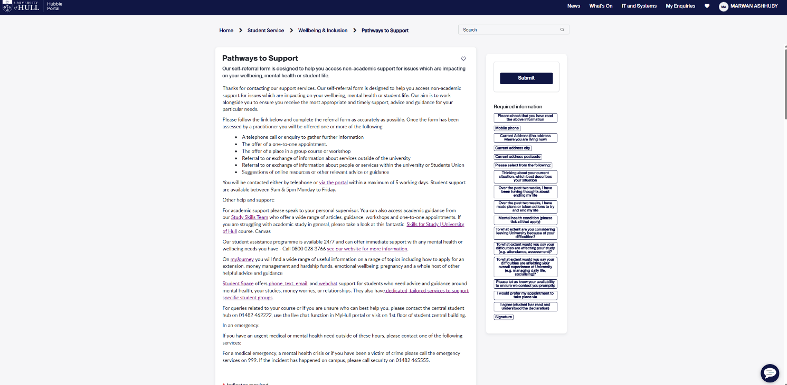

## Part 2