**AQLI – ASSESSMENT**

* 1. **How many GADM2 regions are present in India?**

**Number of GADM2 regions in India: 684**

* 1. **Calculate population weighted pollution average of all years at country (GADM0) level?**

**● Save the country level file as a CSV.**

**● What are the 10 most polluted countries in 2021?**

**Bangladesh(73.9) , India(58.7), Nepal(51.7), Pakistan(44.73),**

**Mongolia(36.039), Myanmar(34.97), D.P.Congo(34.64),**

**Republicof Congo(32.4), Rwanda(32.35), Burundi(31.9)**

* 1. **What was the most polluted GADM2 region in the world in 1998, 2005 and 2021?**

**1998- Unnao ,India, 78.55**

**2005- NCT of Delhi ,98.75**

**2021- NCT of Delhi, 126.51**

* 1. **Plot a population weighted pollution average trendline plot for Uttar Pradesh from1998 to 2021. Save this plot as a high quality PNG file**

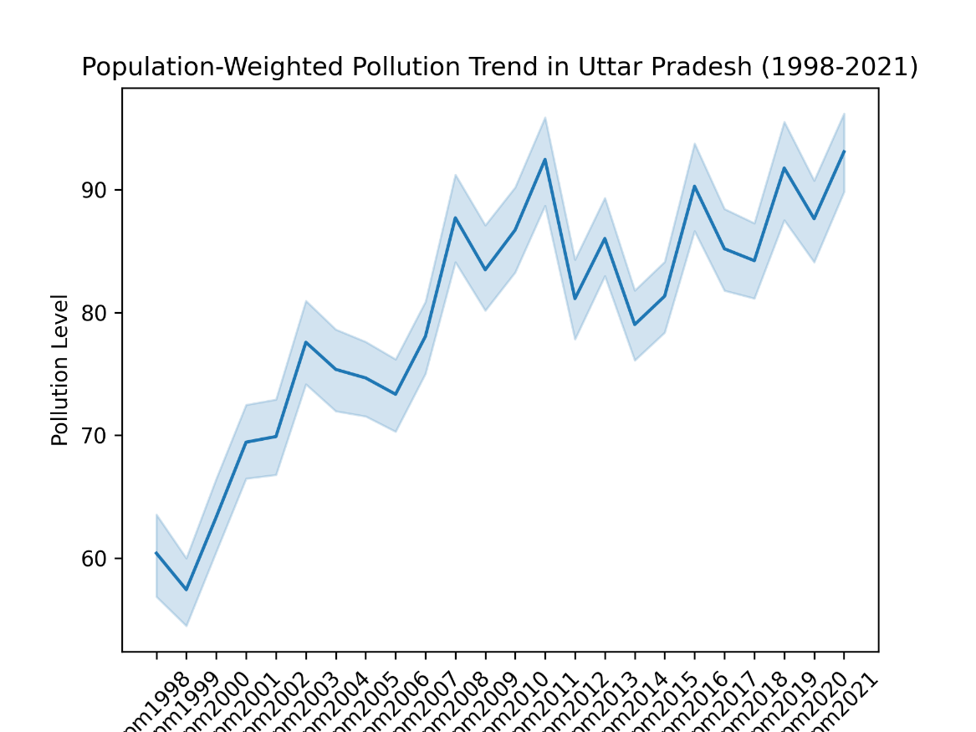

**2. Geospatial tasks and questions**

**2.1 Plot a bar graph for the life years lost relative to the WHO guideline in the 10 mostpolluted countries in the world and also plot them on a global country level map. For the map, the 10 most polluted country boundaries should be filled in with “dark red” and the rest of the map should be grayed out. Save both the bar graph and the map as high quality PNG files.**

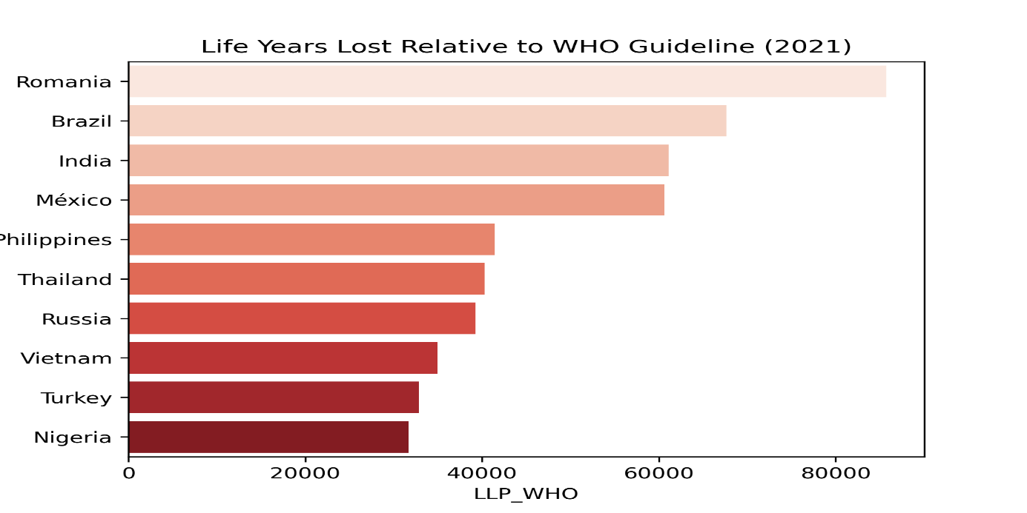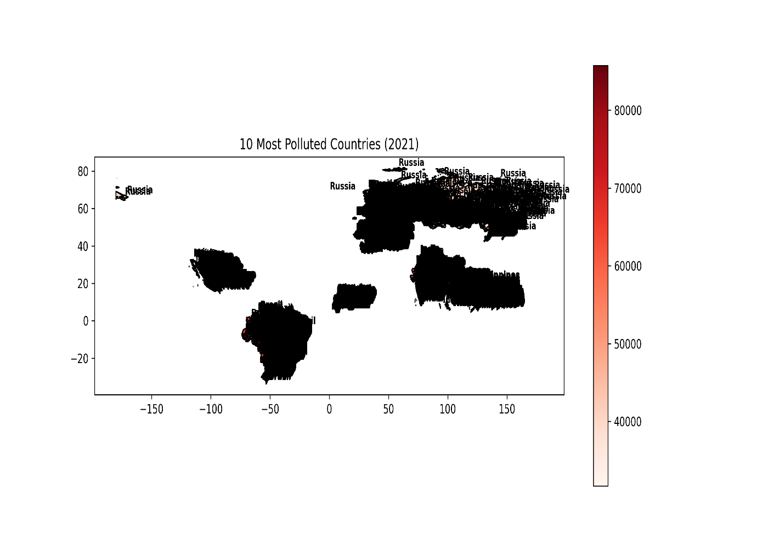

**2.2 Create a potential gain in life expectancy (relative to the WHO guideline) map of eastern v/s western europe at GADM level 2 and save it as a high quality PDF.**

**● Plot should be in AQLI “Potential gain in life expectancy” color scale. Visit AQLI website Index page > See legend for “Potential gain in life expectancy” and infer “exact” colors from that.**

**● You can define east and west europe based on any acceptable definition online, but whatever definition you use - mention the source.**

**● Feel free to add annotations/text boxes etc. to help explain the visualization.**

***Computationally expensive for me to load map data and merging , yet submitting the psuedocodes***

**2.3 Look at the AQLI website > switch to Air pollution tab > plot a static version of the global pollution map you see there, in those “exact” same colors. Export it as a high quality (320 dpi) SVG file.**

***Computationally expensive for me to load map data and merging yet submitting the pseudocodes.***

**4. Verbal reasoning and writing**

**Please read the following excerpt from the AQLI Annual Update 2024 carefully and summarize your key takeaways in three clearly written bullet points. Each bullet should not exceed 30 words.**

**Summary:-**

1. As population is dynamic, pollution in also dynamic on globe, people are breathing air six times dirtier than in cleaner regions, costing them nearly three years of their lives.
2. Some countries set air quality standards, but having rules isn’t enough—they must be enforced. Sadly, 151 countries have no regulations, leaving millions vulnerable to dangerous pollution.
3. One-third of population are in areas failing to achieve air quality standards. Even the wealthier regions are struggling to achieve their tighter standards , and yet 151 countries don’t even have pollution regulations at all.