Project Name: Fund Collection App

**Introduction:**

It is a social application designed to provide the necessary information for people to take the initiative and support each other. This application allows their users to search based on their location for the nearest people in need according to the type of help they could provide. On the other hand, it also allows other people to share information about their needs and ask for help in a modern and less embarrassing way. This software will make it easier for anyone to donate cash they want in a simple way and the least troubling way, because it shows the nearest possible people who need help.

**Client Analysis:**

This project targets all citizens. Usually people donate to the people they actually know that they are in need. This new concept will help the unfortunate people to get a high chance of getting donations through a modern system.

**Feature of My App:**

1. Login
2. Create a New Account
3. Account Details
4. Check Balance
5. Donate Cash
6. Mobile Recharge
7. Add Cash
8. Pay Bills
9. Cash Out
10. Change Password
11. Logout

Login:

MainActivity.Java Source Code:

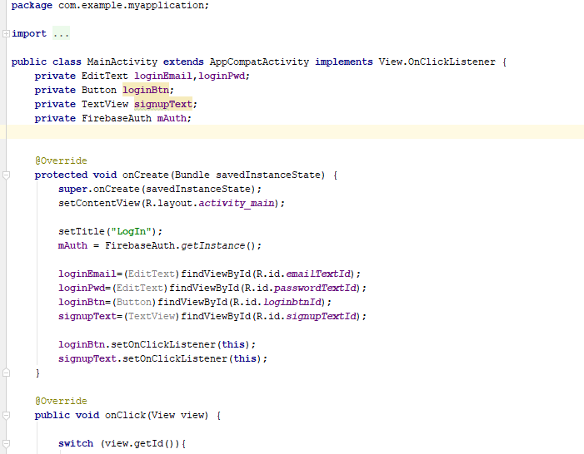

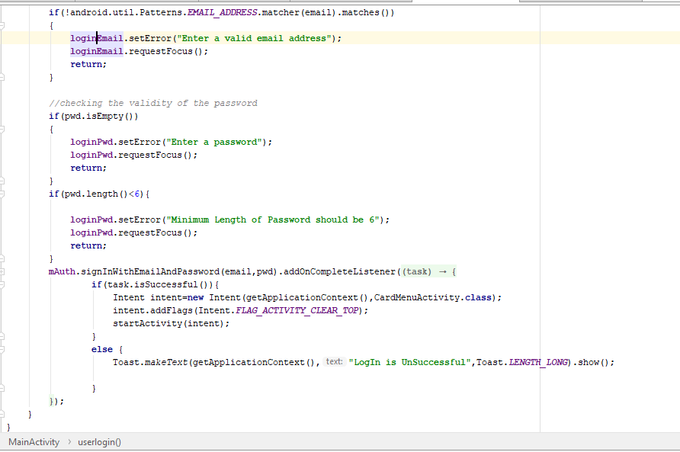

activity_main.xml Source Code

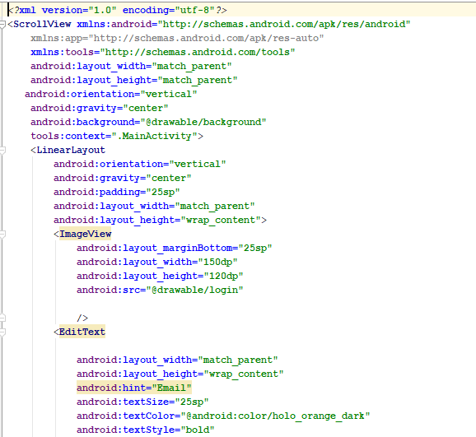

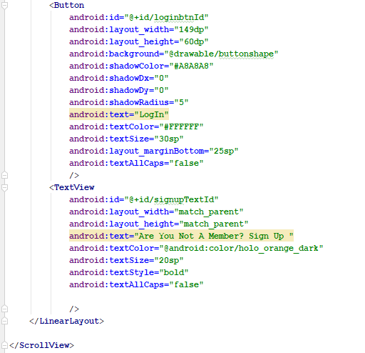

After Run Screen Shot for Login:

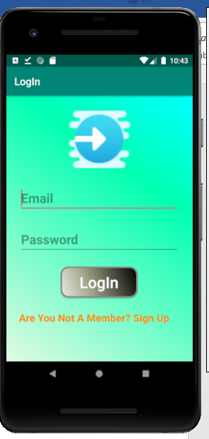

SignUp:

SignUpActivity.Java

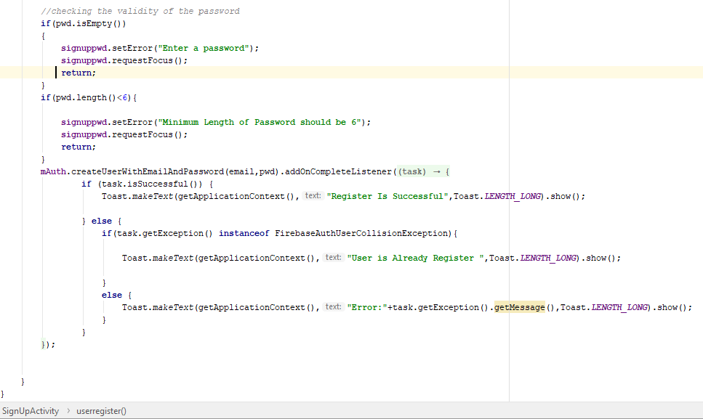

activity_sign_up.xml

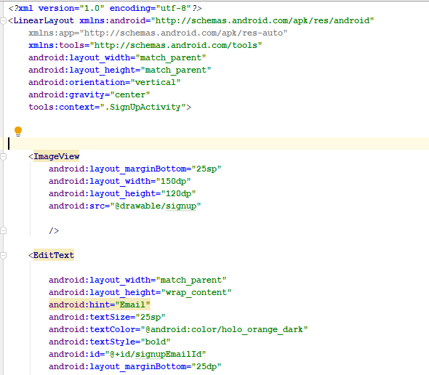

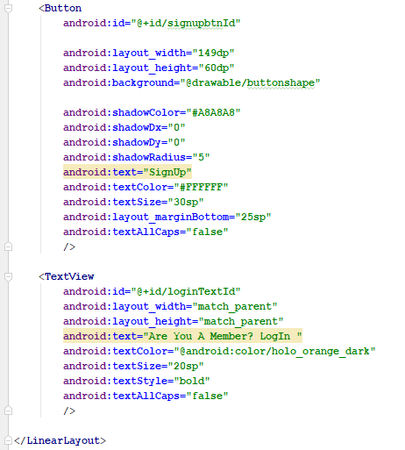

After Run Screen Shot for Sign Up:

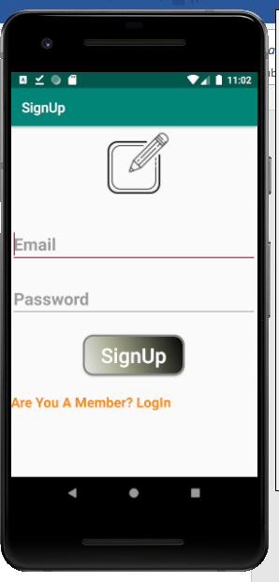

Home Page:

Card_Menu_Activity.java:

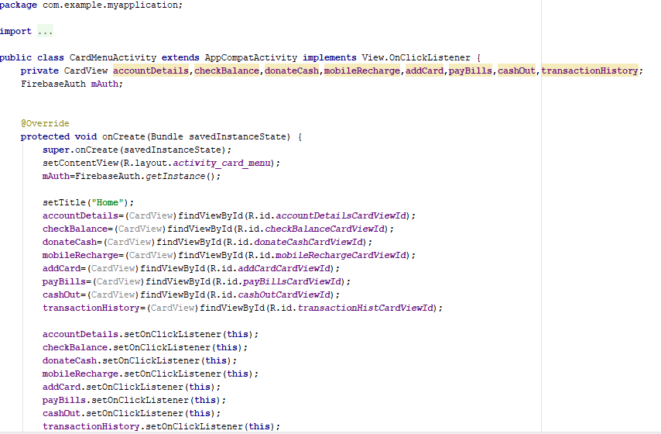

Activity_card_menu.xml:

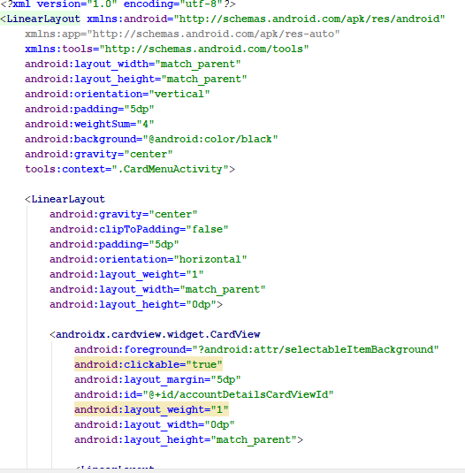

After Run Screen Shot for home Page:

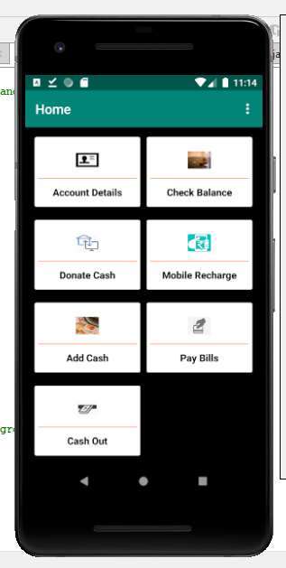

Figure1: First Look

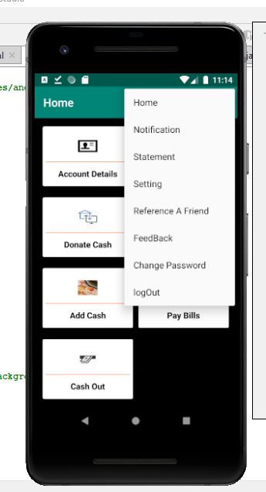

Figure2: Second Look

CheckBalance**:**

Check Balance Activity.java

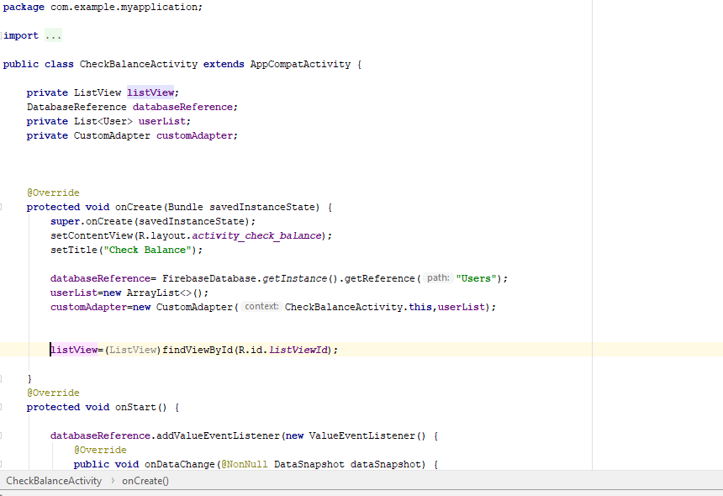

Activity_check_balance.xml:

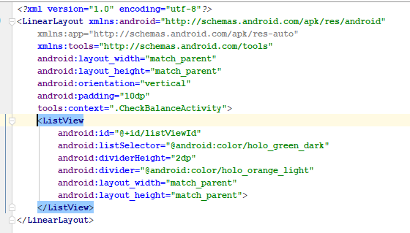

After Run Screen Shot for Check Balance:

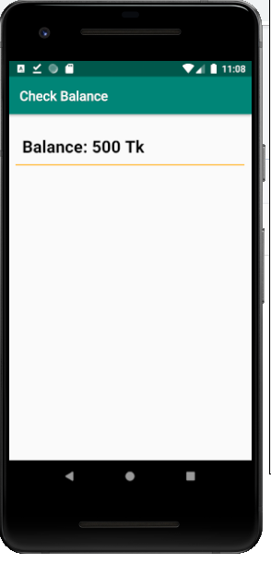

Donate Cash

DonateCashActivity.java:

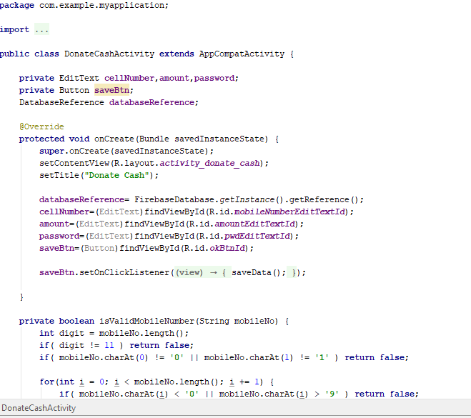

Activity_donate_cash.xml:

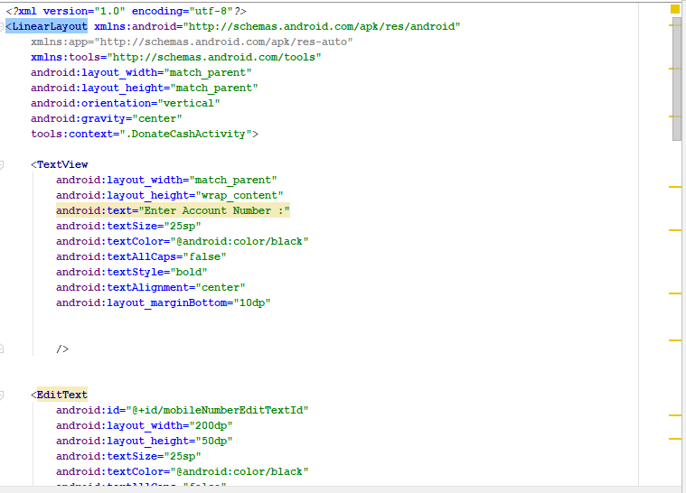

**After Run Screen Shot for Donate Cash:**

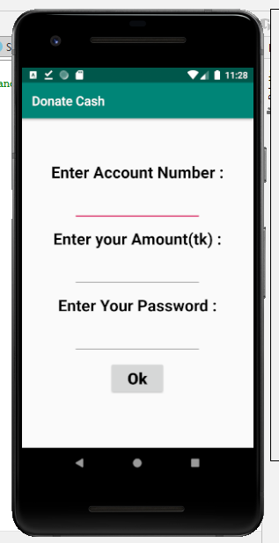

Mobile Reacharge :

MobileReachargeActivity.java:

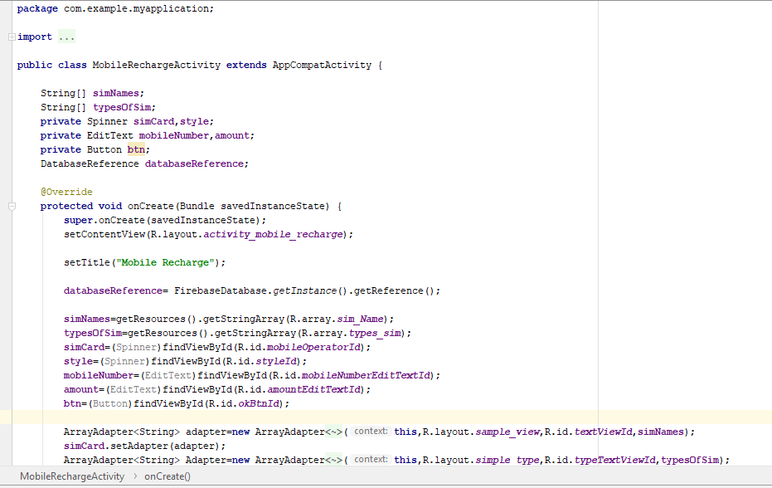

Activity_mobile_recharge.xml:

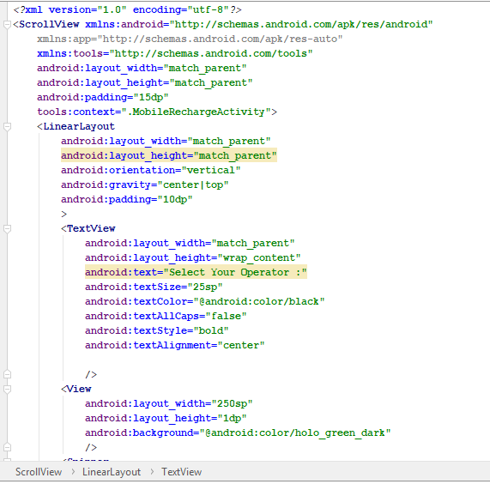

After Run Screen Shot for Mobile Recharge:

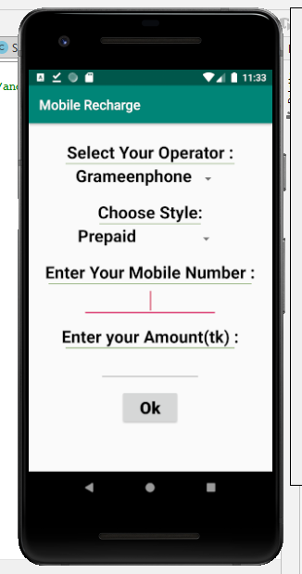

Add Cash:

AddBankActivity.java:

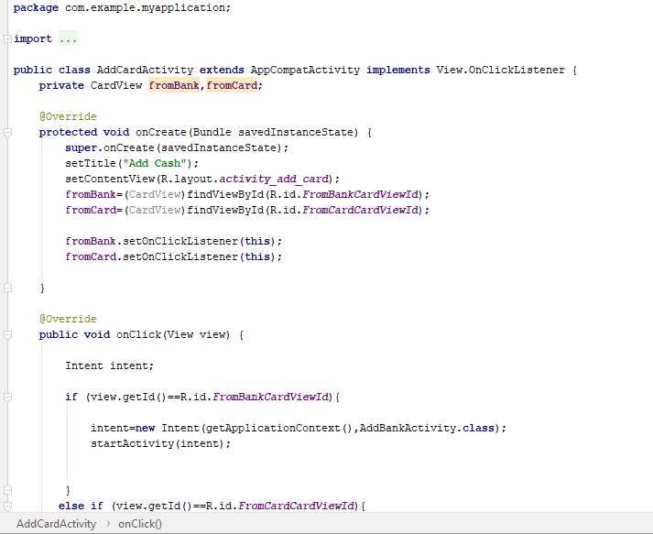

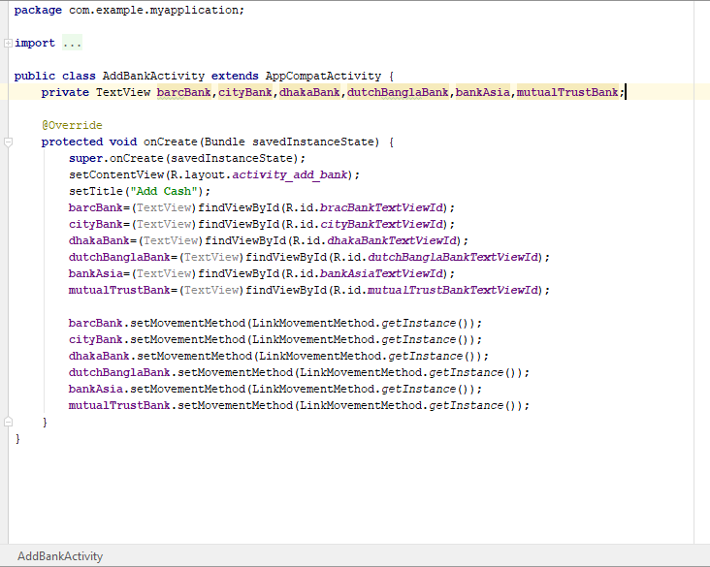

Activity_add_cash.xml:

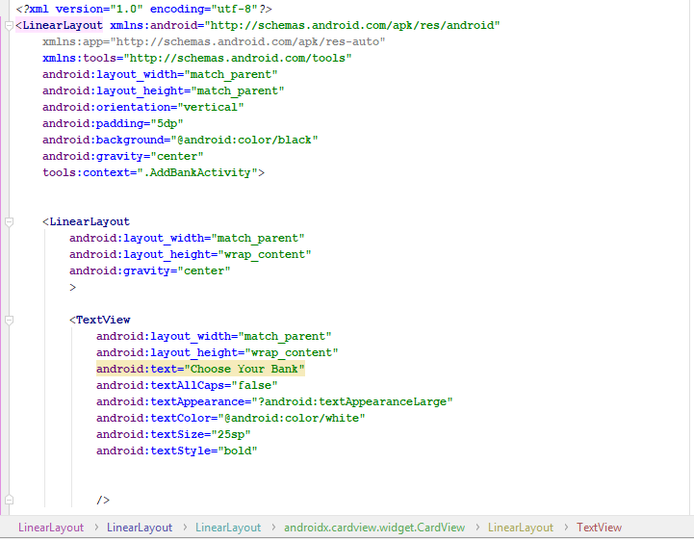

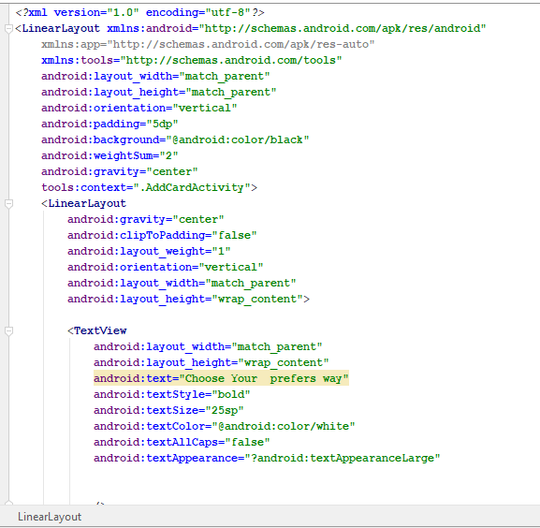\\

After Run Screen Shot For Add Cash:

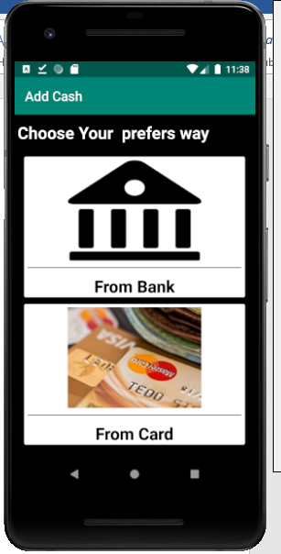

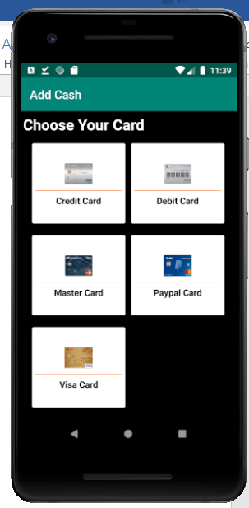

Pay Bills:

PayBillsActivity.java:

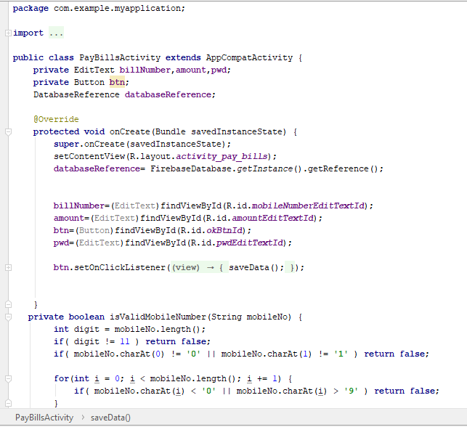

Activity_pay_bills.xml:

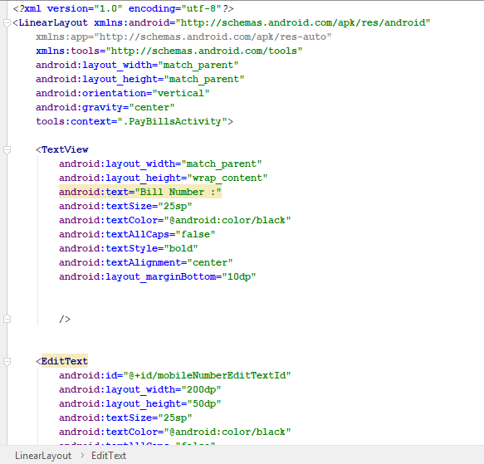

After Run Screen Shot for pay Bills:

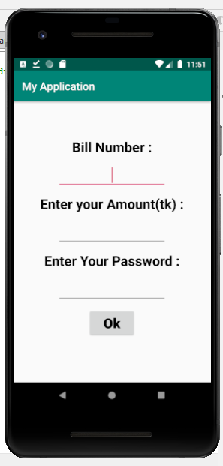

Cash Out:

CashOutActivity.java:

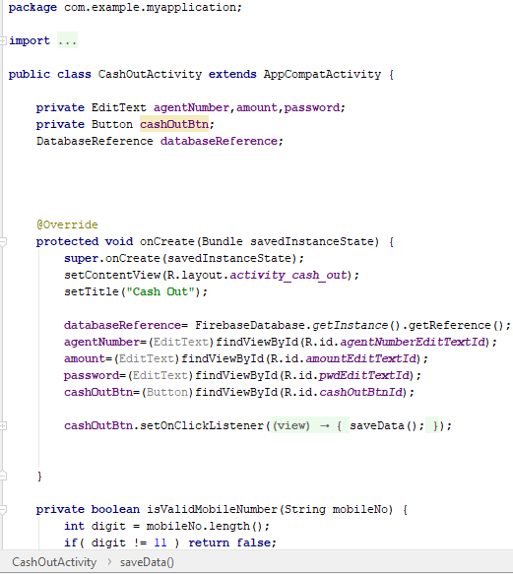

Activity_cash_out.xml:

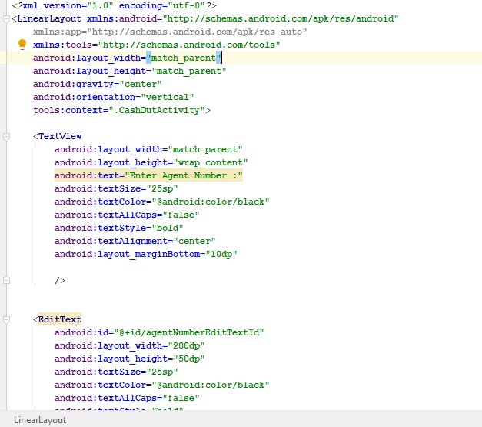

After Run Screen Shot for cash Out:

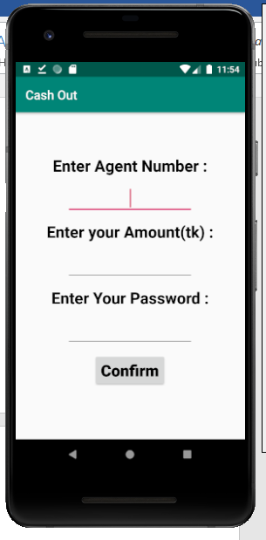

Conclusion:

The concept of this project was actually a personal project that is not aimed to generate profit. This projects has social implications in term of creating a sense of solidarity along with closing the gap for the less fortunate people in terms of quality of life.