Experiment Name: Fundamental of Computer Network

Tracert Command:

The tracert command is a Command Prompt Command that is used to show several details about the path that a packet takes from the computer or device you are on to whatever destination you specify.

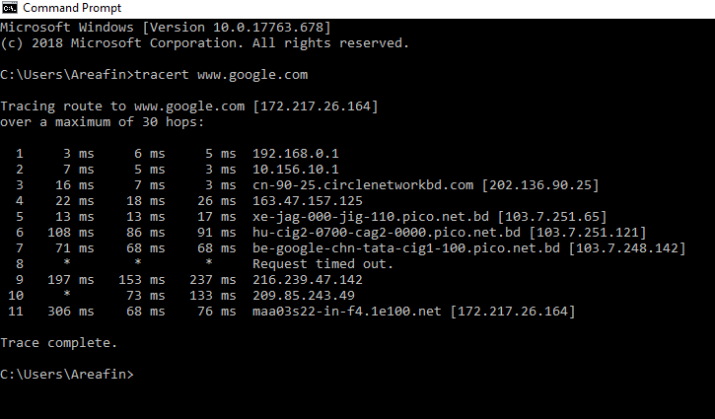

Ping Command:

The ping command is a Command Prompt Command used to test the ability of the source computer to reach a specified destination computer. The ping command is usually used as a simple way to verify that a computer can communicate over the network with another computer or network device.

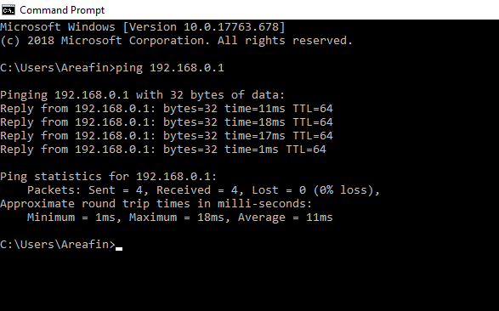

Ping –t Command:

When we use ping –t command the process to be continued until you force it to stop by using Ctrl-C.

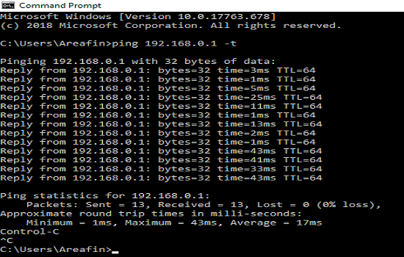

Ipconfig:

In Windows, **ipconfig**is a console application designed to run from the Windows command prompt. This utility allows you to get the IP address information of a Windows computer. It also allows some control over active TCP/IP connections. I**pconfig**replaced the older winipcfg utility.

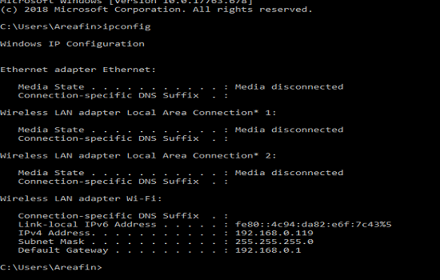

Hub:

A hub also called a network hub, is a common connection point for devices in a network. Hubs are devices commonly used to connect segments of a LAN. The hub contains multiple ports. When a packet arrives at one port, it is copied to the other ports so that all segments of the LAN can see all packets.

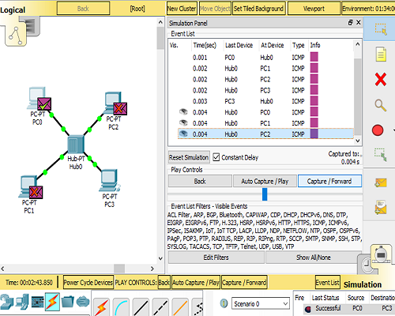

Hub and Switch:

A switch is used to connect various network segments. A network switch is a small hardware device that joins multiple computers together within one local area network (LAN). A hub connects multiple Ethernet devices together, making them act as a single segment. Switching is the technique by which nodes control or switch data to transmit it between specific points on a network.

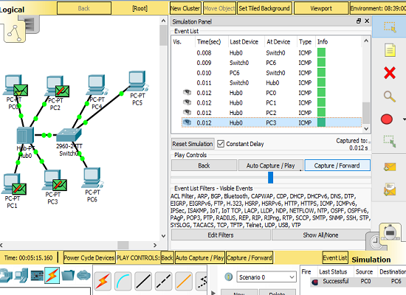

Hub and Switch and Switch:

Switching is the technique by which nodes control or switch data to transmit it between specific points on a network.

