Department of Computer Science and Engineering

Jahangirnagar University

Laboratory Report

CSE 402: Computer Networks Laboratory

Experiment Name: Packet Through a Router

Submitted by:

Md. Ashick Areafin

Class Roll: 2130

Exam Roll: 160054

Session 2015-16

4th year 1st semester

Submitted to:

Dr**. Md. Imdadul Islam**

Professor

Department of Computer Science and Engineering

Jahangirnagar University

Date of Submission: September 5, 2019

**Experiment Name:** Packet Through a Router

**Router:**

Routers are small electronic devices that join multiple computer networks together using either wired or wireless connections. In technical terms, a router is a Layer 3 network gate way device, meaning that it connects two or more networks and that the router operates at the network layer of the OSI model.

**One router:**

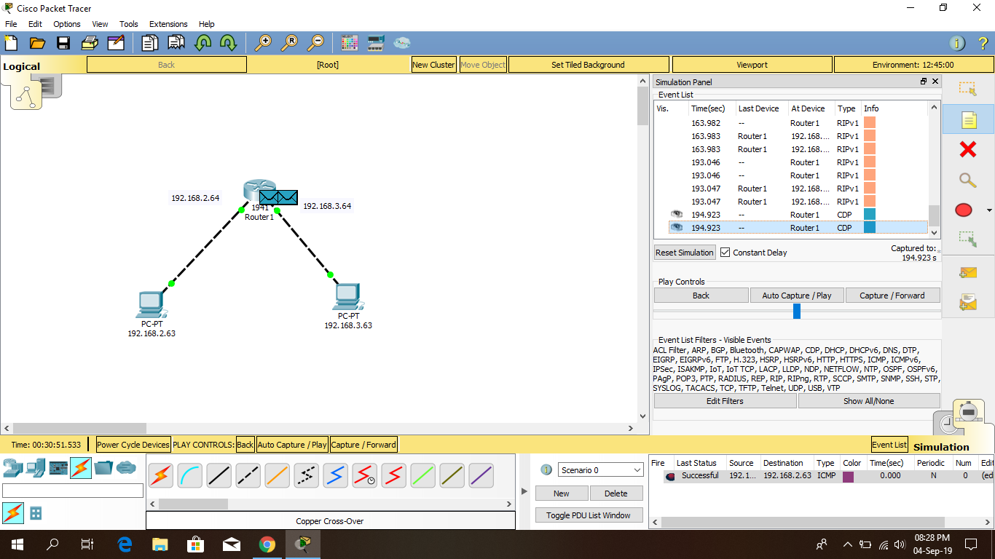

**Two routers:**

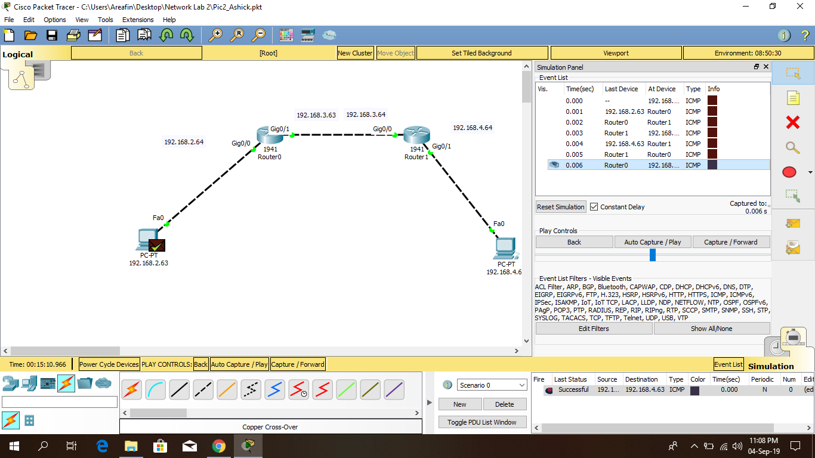

**Two routers & hub:**

**Hub:**

Routers are small electronic devices that join multiple computer networks together using either wired or wireless connections. A hub also called a network hub, is a common connection point for devices in a network. Hubs are devices commonly used to connect segments of a LAN. The hub contains multiple ports. When a packet arrives at one port, it is copied to the other ports so that all segments of the LAN can see all packets.

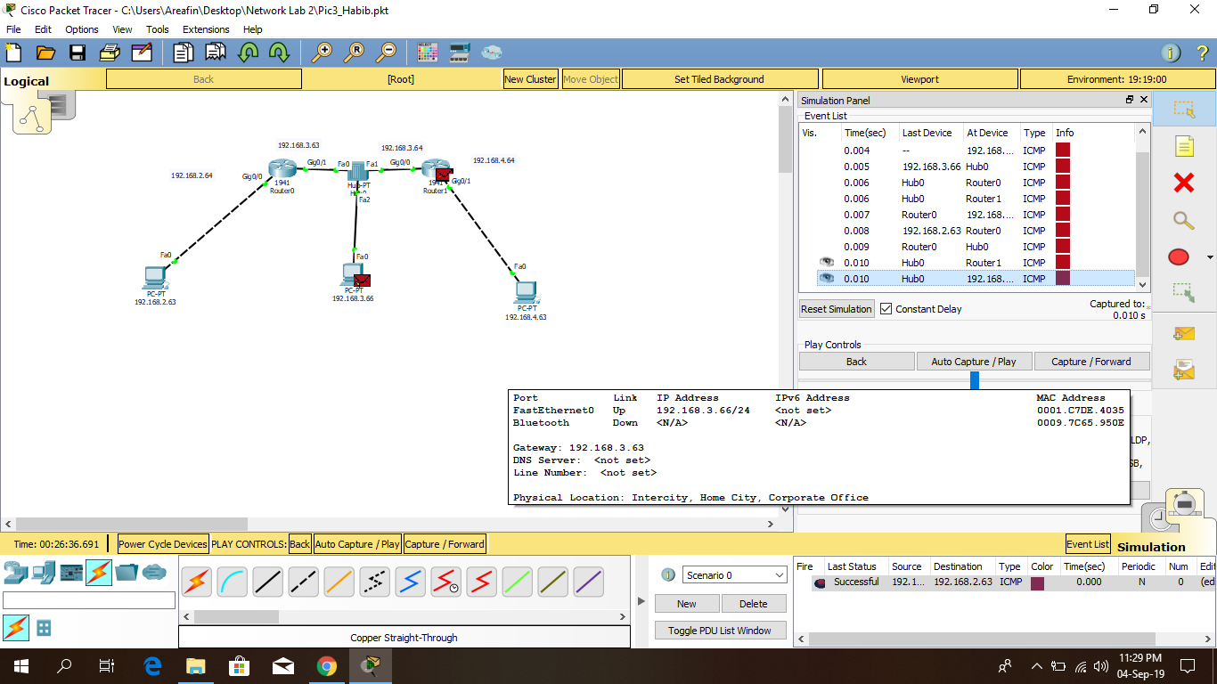

**Three routers:**

