**Experiment Name:** Packet Through a Router

**Router:**

Routers are small electronic devices that join multiple computer networks together using either wired or wireless connections. In technical terms, a router is a Layer 3 network gate way device, meaning that it connects two or more networks and that the router operates at the network layer of the OSI model.

**1.One router**

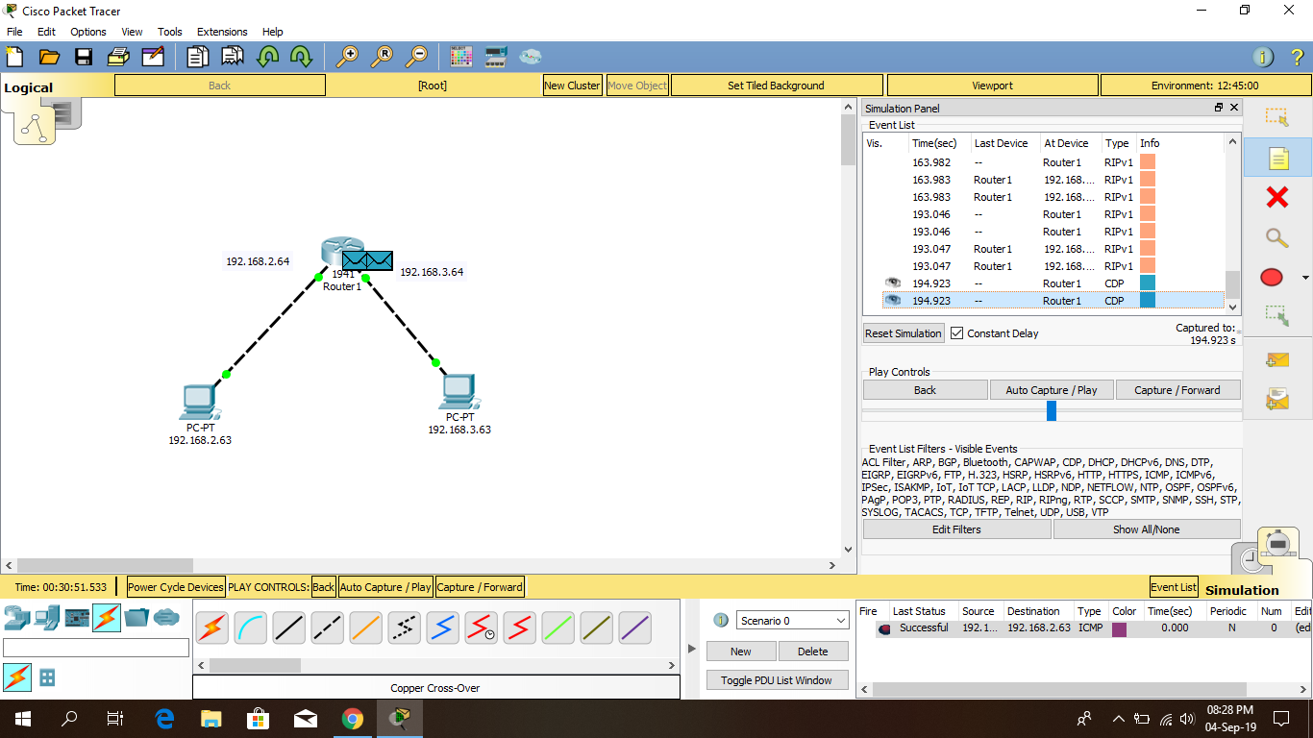

**2.Two routers**

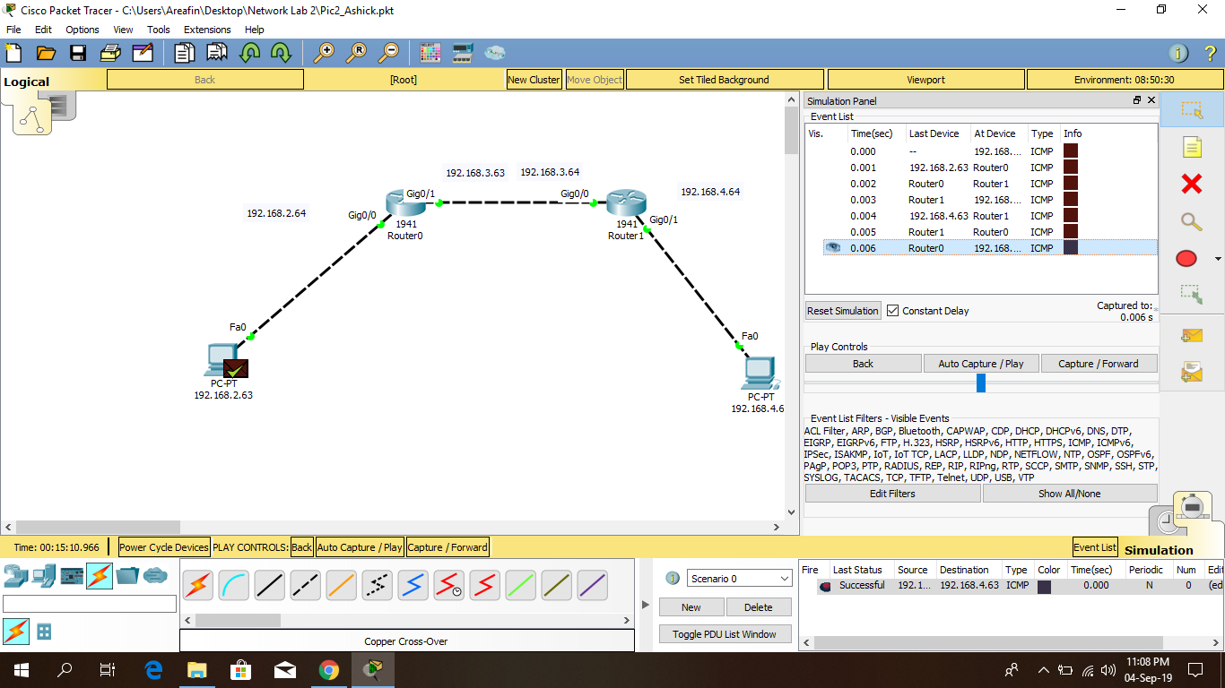

**3.Two routers & hub**

**Hub:**

Routers are small electronic devices that join multiple computer networks together using either wired or wireless connections. A hub also called a network hub, is a common connection point for devices in a network. Hubs are devices commonly used to connect segments of a LAN. The hub contains multiple ports. When a packet arrives at one port, it is copied to the other ports so that all segments of the LAN can see all packets.

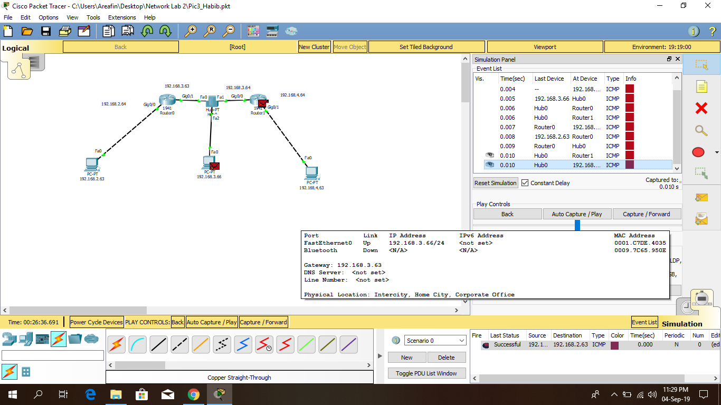

**4.Three routers**

