Experiment Name: Configuration of a Router from Command Line Interface (CLI)

Objective: The router is configured using the command line interface (CLI). This experiment will be helpful for student to configure a route in practical life. So we should be careful to do this experiment.

**One Router and Two PC:**

**Circuit:**

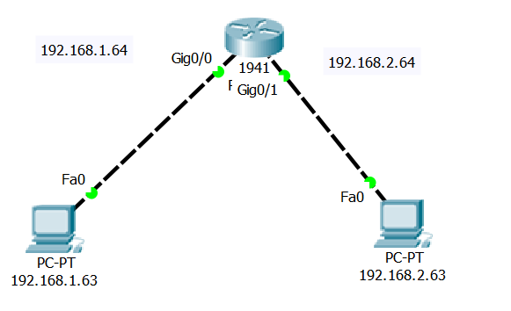

**Configuration the Router from CLI:**

Would you like to enter the initial configuration dialog? [yes/no]: no

Press RETURN to get started!

Router>en

Router#conf t

Enter configuration commands, one per line. End with CNTL/Z.

Router(config)#int Gig0/0

Router(config-if)#ip add 192.168.1.64 255.255.255.0

Router(config-if)#no shut

Router(config-if)#

%LINK-5-CHANGED: Interface GigabitEthernet0/0, changed state to up

%LINEPROTO-5-UPDOWN: Line protocol on Interface GigabitEthernet0/0, changed state to up

exit

Router(config)#int Gig0/1

Router(config-if)#ip add 192.168.2.64 255.255.255.0

Router(config-if)#no shut

Router(config-if)#

%LINK-5-CHANGED: Interface GigabitEthernet0/1, changed state to up

%LINEPROTO-5-UPDOWN: Line protocol on Interface GigabitEthernet0/1, changed state to up

exit

**Result:**

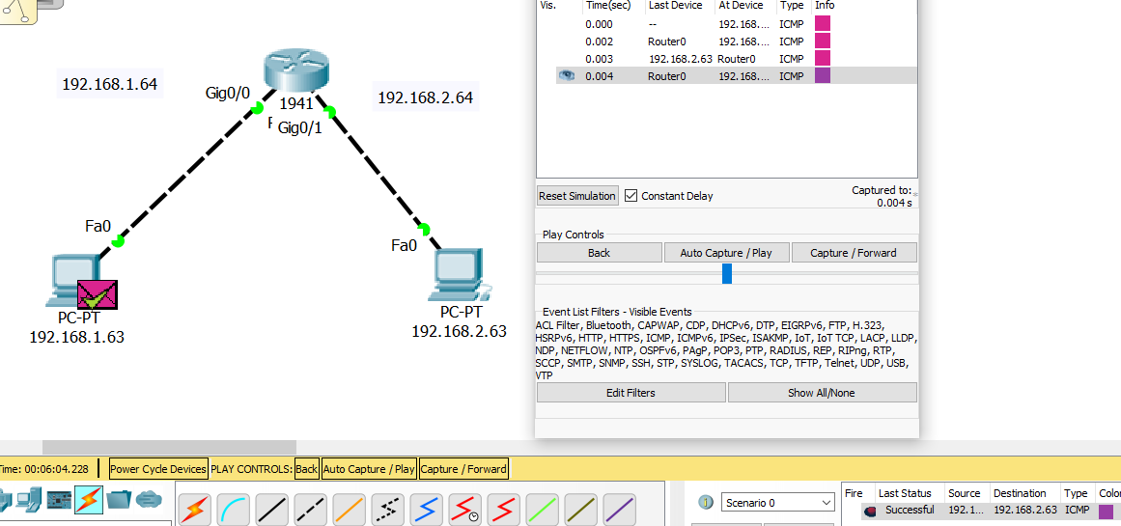

**Two Router and two PC:**

**Circuit:**

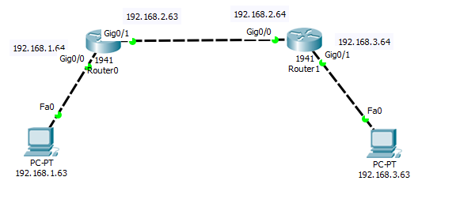**Configuration the Router0 from CLI:**

Would you like to enter the initial configuration dialog? [yes/no]: no

Press RETURN to get started!

Router>en

Router#conf t

Enter configuration commands, one per line. End with CNTL/Z.

Router(config)#int Gig0/0

Router(config-if)#ip add 192.168.1.64 255.255.255.0

Router(config-if)#no shut

Router(config-if)#

%LINK-5-CHANGED: Interface GigabitEthernet0/0, changed state to up

%LINEPROTO-5-UPDOWN: Line protocol on Interface GigabitEthernet0/0, changed state to up

exit

Router(config)#int Gig0/1

Router(config-if)#ip add 192.168.2.63 255.255.255.0

Router(config-if)#no shut

Router(config-if)#

%LINK-5-CHANGED: Interface GigabitEthernet0/1, changed state to up

exit

Router(config)#

%LINEPROTO-5-UPDOWN: Line protocol on Interface GigabitEthernet0/1, changed state to up

Router(config)#ip route 192.168.3.0 255.255.255.0 192.168.2.64

Router(config)#end

Router#

%SYS-5-CONFIG_I: Configured from console by console

en

Router#sh ip route

Codes: L - local, C - connected, S - static, R - RIP, M - mobile, B - BGP

D - EIGRP, EX - EIGRP external, O - OSPF, IA - OSPF inter area

N1 - OSPF NSSA external type 1, N2 - OSPF NSSA external type 2

E1 - OSPF external type 1, E2 - OSPF external type 2, E - EGP

i - IS-IS, L1 - IS-IS level-1, L2 - IS-IS level-2, ia - IS-IS inter area

* - candidate default, U - per-user static route, o - ODR

P - periodic downloaded static route

Gateway of last resort is not set

192.168.1.0/24 is variably subnetted, 2 subnets, 2 masks

C 192.168.1.0/24 is directly connected, GigabitEthernet0/0

L 192.168.1.64/32 is directly connected, GigabitEthernet0/0

192.168.2.0/24 is variably subnetted, 2 subnets, 2 masks

C 192.168.2.0/24 is directly connected, GigabitEthernet0/1

L 192.168.2.63/32 is directly connected, GigabitEthernet0/1

S 192.168.3.0/24 [1/0] via 192.168.2.64

Router#

**Configuration the Router1 from CLI:**

Would you like to enter the initial configuration dialog? [yes/no]: no

Press RETURN to get started!

Router>en

Router#conf t

Enter configuration commands, one per line. End with CNTL/Z.

Router(config)#int Gig0/0

Router(config-if)#ip add 192.168.2.64 255.255.255.0

Router(config-if)#no shut

Router(config-if)#

%LINK-5-CHANGED: Interface GigabitEthernet0/0, changed state to up

%LINEPROTO-5-UPDOWN: Line protocol on Interface GigabitEthernet0/0, changed state to up

exit

Router(config)#int Gig0/1

Router(config-if)#ip add 192.168.3.64 255.255.255.0

Router(config-if)#no shut

Router(config-if)#

%LINK-5-CHANGED: Interface GigabitEthernet0/1, changed state to up

%LINEPROTO-5-UPDOWN: Line protocol on Interface GigabitEthernet0/1, changed state to up

exit

Router(config)#en

% Ambiguous command: "en"

Router(config)#conf t

%Invalid hex value

Router(config)#ip route 192.168.1.0 255.255.255.0 192.168.2.63

Router(config)#end

Router#

%SYS-5-CONFIG_I: Configured from console by console

en

Router#sh ip route

Codes: L - local, C - connected, S - static, R - RIP, M - mobile, B - BGP

D - EIGRP, EX - EIGRP external, O - OSPF, IA - OSPF inter area

N1 - OSPF NSSA external type 1, N2 - OSPF NSSA external type 2

E1 - OSPF external type 1, E2 - OSPF external type 2, E - EGP

i - IS-IS, L1 - IS-IS level-1, L2 - IS-IS level-2, ia - IS-IS inter area

* - candidate default, U - per-user static route, o - ODR

P - periodic downloaded static route

Gateway of last resort is not set

S 192.168.1.0/24 [1/0] via 192.168.2.63

192.168.2.0/24 is variably subnetted, 2 subnets, 2 masks

C 192.168.2.0/24 is directly connected, GigabitEthernet0/0

L 192.168.2.64/32 is directly connected, GigabitEthernet0/0

192.168.3.0/24 is variably subnetted, 2 subnets, 2 masks

C 192.168.3.0/24 is directly connected, GigabitEthernet0/1

L 192.168.3.64/32 is directly connected, GigabitEthernet0/1

Router#

Result:

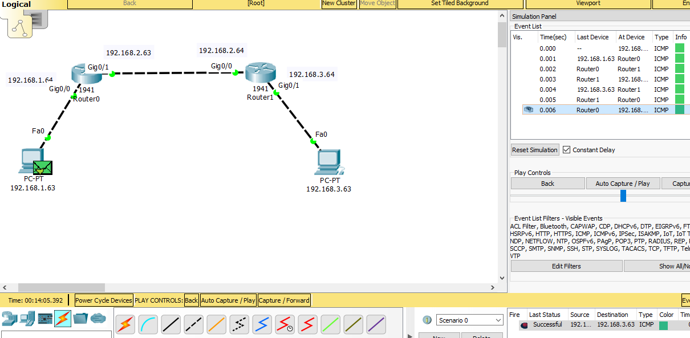

**Three Router and three Pc:**

**Circuit:**

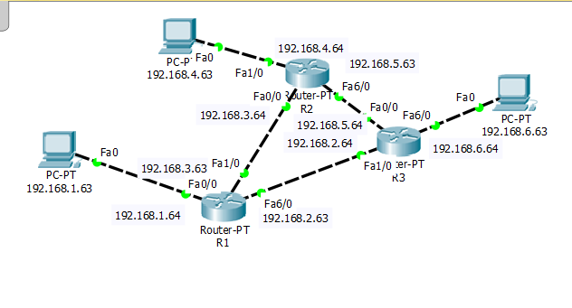

**Configuration the R1 from CLI:**

Would you like to enter the initial configuration dialog? [yes/no]: no

Press RETURN to get started!

Router>en

Router#conf t

Enter configuration commands, one per line. End with CNTL/Z.

Router(config)#int fa0/0

Router(config-if)#ip add 192.168.1.64 255.255.255.0

Router(config-if)#no shut

Router(config-if)#

%LINK-5-CHANGED: Interface FastEthernet0/0, changed state to up

%LINEPROTO-5-UPDOWN: Line protocol on Interface FastEthernet0/0, changed state to up

exit

Router(config)#int fa1/0

Router(config-if)#ip add 192.168.3.63 255.255.255.0

Router(config-if)#no shut

Router(config-if)#

%LINK-5-CHANGED: Interface FastEthernet1/0, changed state to up

exit

Router(config)#int fa6/0

Router(config-if)#ip add 192.168.2.63 255.255.255.0

Router(config-if)#no shut

Router(config-if)#

%LINK-5-CHANGED: Interface FastEthernet6/0, changed state to up

exit

Router(config)#

%LINEPROTO-5-UPDOWN: Line protocol on Interface FastEthernet1/0, changed state to up

%LINEPROTO-5-UPDOWN: Line protocol on Interface FastEthernet6/0, changed state to up

Router(config)#ip route 192.168.4.0 255.255.255.0

Router#

%SYS-5-CONFIG_I: Configured from console by console

conf t

Enter configuration commands, one per line. End with CNTL/Z.

Router(config)#ip route 192.168.4.0 255.255.255.0 192.168.3.64

Router#en

Router#conf t

Enter configuration commands, one per line. End with CNTL/Z.

Router(config)#ip route 192.168.5.0 255.255.255.0 192.168.2.64

Router(config)#end

Router#

%SYS-5-CONFIG_I: Configured from console by console

en

Router#conf t

Enter configuration commands, one per line. End with CNTL/Z.

Router(config)#ip route 192.168.4.0 255.255.255.0 192.168.5.63

Router(config)#ip route 192.168.6.0 255.255.255.0 192.168.2.64

Router(config)#ip route 192.168.5.0 255.255.255.0 192.168.3.64

Router(config)#ip route 192.168.6.0 255.255.255.0 192.168.5.64

Router(config)#end

Router#

%SYS-5-CONFIG_I: Configured from console by console

en

Router#sh ip route

Codes: C - connected, S - static, I - IGRP, R - RIP, M - mobile, B - BGP

D - EIGRP, EX - EIGRP external, O - OSPF, IA - OSPF inter area

N1 - OSPF NSSA external type 1, N2 - OSPF NSSA external type 2

E1 - OSPF external type 1, E2 - OSPF external type 2, E - EGP

i - IS-IS, L1 - IS-IS level-1, L2 - IS-IS level-2, ia - IS-IS inter area

* - candidate default, U - per-user static route, o - ODR

P - periodic downloaded static route

Gateway of last resort is not set

C 192.168.1.0/24 is directly connected, FastEthernet0/0

C 192.168.2.0/24 is directly connected, FastEthernet6/0

C 192.168.3.0/24 is directly connected, FastEthernet1/0

S 192.168.4.0/24 [1/0] via 192.168.3.64

[1/0] via 192.168.5.63

S 192.168.5.0/24 [1/0] via 192.168.2.64

[1/0] via 192.168.3.64

S 192.168.6.0/24 [1/0] via 192.168.2.64

[1/0] via 192.168.5.64

Router#

**Configuration the R2 from CLI:**

Would you like to enter the initial configuration dialog? [yes/no]: no

Press RETURN to get started!

Router>en

Router#conf t

Enter configuration commands, one per line. End with CNTL/Z.

Router(config)#int fa0/0

Router(config-if)#ip add 192.168.3.64 255.255.255.0

Router(config-if)#no shut

Router(config-if)#

%LINK-5-CHANGED: Interface FastEthernet0/0, changed state to up

%LINEPROTO-5-UPDOWN: Line protocol on Interface FastEthernet0/0, changed state to up

exit

Router(config)#int fa1/0

Router(config-if)#ip add 192.168.4.64 255.255.255.0

Router(config-if)#no shut

Router(config-if)#

%LINK-5-CHANGED: Interface FastEthernet1/0, changed state to up

%LINEPROTO-5-UPDOWN: Line protocol on Interface FastEthernet1/0, changed state to up

exit

Router(config)#int fa6/0

Router(config-if)#ip add 192.168.5.63 255.255.255.0

Router(config-if)#no shut

Router(config-if)#

%LINK-5-CHANGED: Interface FastEthernet6/0, changed state to up

exit

Router(config)#int fa6/0

%LINEPROTO-5-UPDOWN: Line protocol on Interface FastEthernet6/0, changed state to up

Router con0 is now available

Press RETURN to get started.

Router>en

Router#conf t

Enter configuration commands, one per line. End with CNTL/Z.

Router(config)#ip route 192.168.6.0 255.255.255.0 192.168.5.64

Router(config)#ip route 192.168.2.0 255.255.255.0 192.168.3.63

Router(config)#ip route 192.168.6.0 255.255.255.0 192.168.2.64

Router(config)#ip route 192.168.1.0 255.255.255.0 192.168.3.63

Router(config)#ip route 192.168.2.0 255.255.255.0 192.168.5.64

Router(config)#ip route 192.168.1.0 255.255.255.0 192.168.2.63

Router(config)#end

Router#

%SYS-5-CONFIG_I: Configured from console by console

en

Router#sh ip route

Codes: C - connected, S - static, I - IGRP, R - RIP, M - mobile, B - BGP

D - EIGRP, EX - EIGRP external, O - OSPF, IA - OSPF inter area

N1 - OSPF NSSA external type 1, N2 - OSPF NSSA external type 2

E1 - OSPF external type 1, E2 - OSPF external type 2, E - EGP

i - IS-IS, L1 - IS-IS level-1, L2 - IS-IS level-2, ia - IS-IS inter area

* - candidate default, U - per-user static route, o - ODR

P - periodic downloaded static route

Gateway of last resort is not set

S 192.168.1.0/24 [1/0] via 192.168.3.63

[1/0] via 192.168.2.63

S 192.168.2.0/24 [1/0] via 192.168.3.63

[1/0] via 192.168.5.64

C 192.168.3.0/24 is directly connected, FastEthernet0/0

C 192.168.4.0/24 is directly connected, FastEthernet1/0

C 192.168.5.0/24 is directly connected, FastEthernet6/0

S 192.168.6.0/24 [1/0] via 192.168.5.64

[1/0] via 192.168.2.64

Router#

**Configuration the R1 from CLI:**

Would you like to enter the initial configuration dialog? [yes/no]: no

Press RETURN to get started!

Router>en

Router#conf t

Enter configuration commands, one per line. End with CNTL/Z.

Router(config)#int fa0/0

Router(config-if)#ip add 192.168.5.64 255.255.255.0

Router(config-if)#no shut

Router(config-if)#

%LINK-5-CHANGED: Interface FastEthernet0/0, changed state to up

%LINEPROTO-5-UPDOWN: Line protocol on Interface FastEthernet0/0, changed state to up

exit

Router(config)#int fa1/0

Router(config-if)#ip add 192.168.2.64 255.255.255.0

Router(config-if)#no shut

Router(config-if)#

%LINK-5-CHANGED: Interface FastEthernet1/0, changed state to up

%LINEPROTO-5-UPDOWN: Line protocol on Interface FastEthernet1/0, changed state to up

exit

Router(config)#int fa6/0

Router(config-if)#ip add 192.168.6.64 255.255.255.0

Router(config-if)#no shut

Router(config-if)#

%LINK-5-CHANGED: Interface FastEthernet6/0, changed state to up

%LINEPROTO-5-UPDOWN: Line protocol on Interface FastEthernet6/0, changed state to up

exit

Router(config)#

Router con0 is now available

Press RETURN to get started.

Router>en

Router#conf t

Enter configuration commands, one per line. End with CNTL/Z.

Router(config)#ip route 192.168.1.0 255.255.255.0 192.168.2.63

Router(config)#ip route 192.168.3.0 255.255.255.0 192.168.5.63

Router(config)#ip route 192.168.1.0 255.255.255.0 192.168.3.63

Router(config)#ip route 192.168.4.0 255.255.255.0 192.168.5.63

Router(config)#ip route 192.168.3.0 255.255.255.0 192.168.2.63

Router(config)#ip route 192.168.4.0 255.255.255.0 192.168.3.64

Router(config)#end

Router#

%SYS-5-CONFIG_I: Configured from console by console

en

Router#sh ip route

Codes: C - connected, S - static, I - IGRP, R - RIP, M - mobile, B - BGP

D - EIGRP, EX - EIGRP external, O - OSPF, IA - OSPF inter area

N1 - OSPF NSSA external type 1, N2 - OSPF NSSA external type 2

E1 - OSPF external type 1, E2 - OSPF external type 2, E - EGP

i - IS-IS, L1 - IS-IS level-1, L2 - IS-IS level-2, ia - IS-IS inter area

* - candidate default, U - per-user static route, o - ODR

P - periodic downloaded static route

Gateway of last resort is not set

S 192.168.1.0/24 [1/0] via 192.168.2.63

[1/0] via 192.168.3.63

C 192.168.2.0/24 is directly connected, FastEthernet1/0

S 192.168.3.0/24 [1/0] via 192.168.5.63

[1/0] via 192.168.2.63

S 192.168.4.0/24 [1/0] via 192.168.5.63

[1/0] via 192.168.3.64

C 192.168.5.0/24 is directly connected, FastEthernet0/0

C 192.168.6.0/24 is directly connected, FastEthernet6/0

Router#

Result:

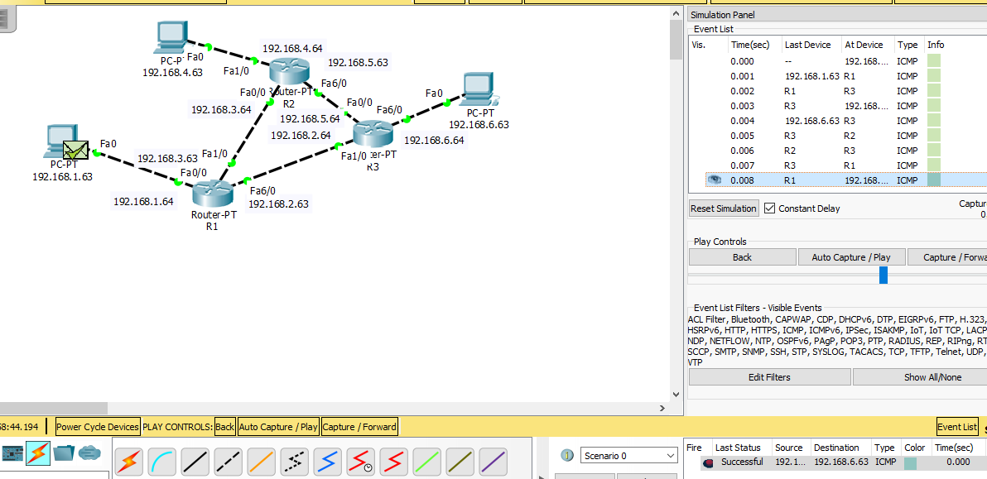

**Wireless Connection:**

**Circuit:**

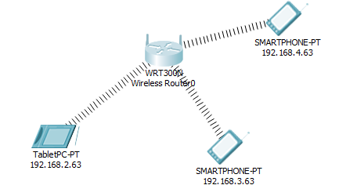

**Result:**

