Department of Computer Science and Engineering

Jahangirnagar University

Savar, Dhaka



**Laboratory Report**

CSE-402: Computer Networks Laboratory

# Submitted by

Md Yeamin Alam

Exam Roll: 150044

Session: 2015-16

4th year 1st Semester

# Submitted to

Dr. Imdadul Islam

Professor

Department of Computer Science and Engineering

Jahangirnagar University

**Experiment No:**09​

**Experiment Name:** Implementation of mail-server.​

**Objectives:**

This Experiment explains how to configure mail-server step by step with practical examples in packet tracer.

**Theory:**

A mail server (or email server) is a computer system that sends and receives email. In many cases, web servers and mail servers are combined in a single machine. However, large ISPs and public email services (such as Gmail and Hotmail) may use dedicated hardware for sending and receiving email.In order for a computer system to function as a mail server, it must include mail server [softwar](https://techterms.com/definition/software)​ [e](https://techterms.com/definition/software).​ This software allows the system administrator to create and manage email accounts for any [domain](https://techterms.com/definition/domain)​ [s](https://techterms.com/definition/domain) hosted on the server.Mail servers send and receive email using standard email [protocol](https://techterms.com/definition/protocol)​ [s](https://techterms.com/definition/protocol).​ For example, the [SMT](https://techterms.com/definition/smtp)​ [P](https://techterms.com/definition/smtp) protocol sends messages and handles outgoing mail requests. The [IMA](https://techterms.com/definition/imap)​ [P](https://techterms.com/definition/imap) and [POP](https://techterms.com/definition/pop3)​ [3](https://techterms.com/definition/pop3) protocols receive messages and are used to process incoming mail. When you [lo](https://techterms.com/definition/log_on)​ [g on](https://techterms.com/definition/log_on) to a mail server using a [webmail](https://techterms.com/definition/webmail) interface or email [clien](https://techterms.com/definition/client)​ [t,](https://techterms.com/definition/client)​ these protocols handle all the connections behind the scenes.

**Procedure:**

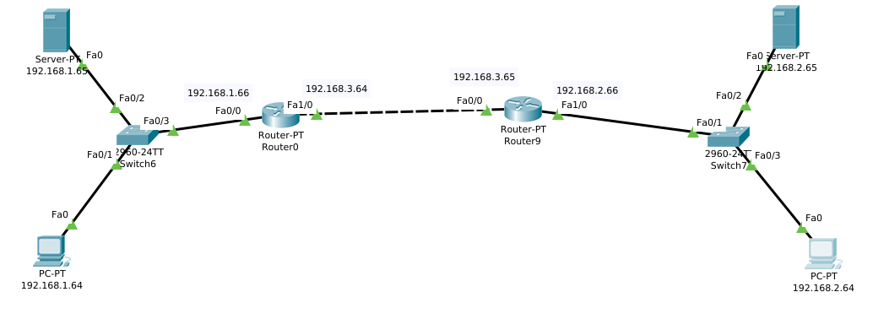

Figure 1: Mail-server Configuration

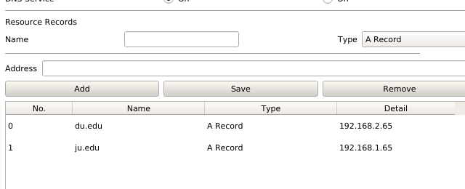

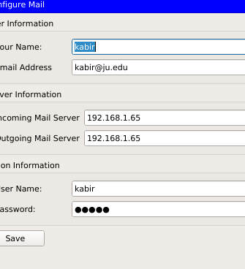

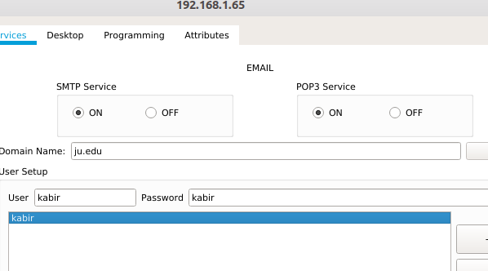

Result:

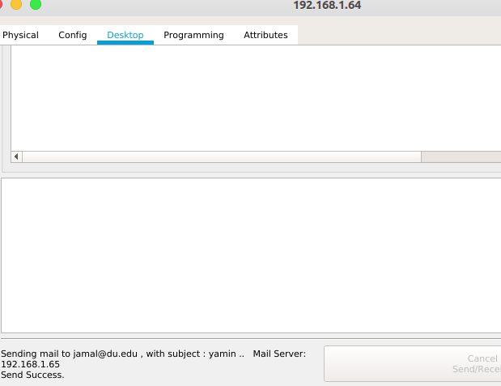

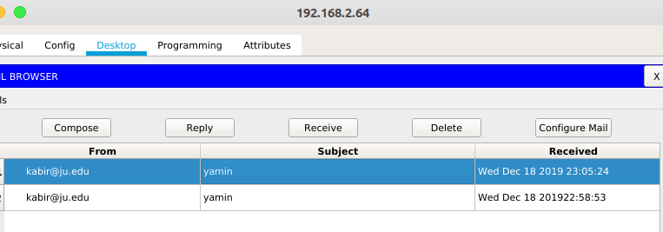

Figure 2: Mail is Sent and got replay

Figure 3:Mail is received