TEAM MEMBER Mohammed Ashif Phase-1 Document Submission 510421106025

Project: Smart public restroom

ABSTRACT

Smart public restrooms are a modern solution to address the need for cleanliness and hygiene in public spaces. One such system, called “Smart Public Toilets using IoE,” was proposed to improve the condition of public toilets and make them accessible to every citizen in a hygienic way. This system utilizes various technologies, including proximity sensors, biometric systems, gas sensors, and a dashboard, to monitor cleanliness, autonomously flush toilets, and prevent bad odors. The goal is to maintain public toilets effectively and ensure a pleasant experience for users.

SMART PUBLIC RESTROOM

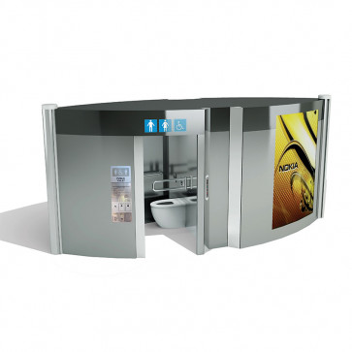

OBJECTIVE:

The objective of a smart public restroom is to improve the hygiene, safety, and sustainability of public restrooms while also providing a more pleasant and convenient experience for users.

Smart public restrooms use a variety of sensors and technologies to monitor and manage the restroom environment, including The data collected from these sensors can be used to automate tasks such as cleaning and maintenance, reduce waste, and identify potential problems before they cause outages or disruptions

Phase 1: Smart public restroom

DEFINITION:

A smart public restroom is a technologically advanced facility designed to enhance cleanliness, hygiene, and user experience. These restrooms leverage technology to optimize resource management, improve public health and safety, and promote sustainability. Some key features of smart public restrooms Improved cleanliness and hygiene: Smart restroom technology enables facility managers to achieve cleanliness and hygiene goals that have a measurable impact on tenant satisfaction and sustainability. By monitoring the sweeper’s activity, smart toilets can maintain the hygiene of the toilet. The cleanliness of the toilet seat can be improved by tracking dirt using an infrared (IR) sensor. This ensures that the restroom remains clean and hygienic for users.

SMART PUBLIC RESTROOM BASED IOT SENSOR:

designed and implemented a smart toilet using IoT embedded sensor devices to detect dirt in the toilet, gas detection and the presence of sweeper. The system also detects the depth of the septic tank and sends a message to a particular organization.

With the advancement of smart restroom technology, facility managers can now confidently achieve cleanliness and hygiene goals that have a measurable impact on tenant satisfaction and sustainability.

You can’t have a healthy building without clean, hygienic restrooms. A recent survey found that about three-quarters, or 74 percent of consumers, agree that if the restroom is not clean, they do not believe the rest of the facility is being cleaned properly.

A modern private restroom in the Internet of Things (IoT) incorporates various smart technologies to enhance user experience, hygiene, and resource management. Here are some key features of a private IoT-enabled restroom:

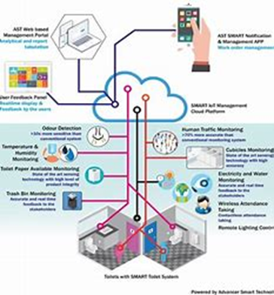

* Smart Access Control:

The restroom door can be equipped with electronic locks that can be controlled through a smartphone app or keycard for added security.

* Occupancy Detection:

IoT sensors can detect when the restroom is occupied or vacant, helping to minimize wait times and improve efficiency.

* Touchless Fixtures:

Faucets, soap dispensers, and flush mechanisms can be automated, minimizing the need for physical contact and promoting hygiene.

* Environment Monitoring:

Sensors can monitor air quality, temperature, and humidity in the restroom, adjusting ventilation and climate control as needed for user comfort.