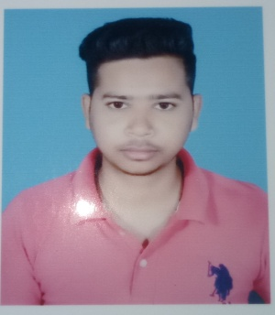 ***Ashif Raza***

**Address:-** Millat Colony Mandai Kalan Hazaribag Jharkhand

**Contact:-** 8580759306, 7870911032

**Email ID:-** [ashifraza7870@gmail.com](mailto:ashifraza7870@gmail.com)

***Career*** ***Objective***

To take a challenging career and grow with honesty, loyalty, good relationship and best performance and translate my experience, knowledge, skills and abilities into value for an organization.

***Academic*** ***Qualification***

**BCA (Pursuing) :** From AISECT University Matwari Hazaribag Jharkhand

**Intermediate** : From Inter Science College Hazaribag Jharkhand in the Year(2018) with 60.8%

**Matriculation**  : From National Public School Hazaribag Jharkhand in the Year(2016) with 8.0 CGPA

***Computer*** ***Skills***

* **HTML**
* **C**
* **Java**
* **Operating System**
* **Ms Word, Ms Excel, Ms PowerPoint, Ms Access**

***Personal*** ***Profile***

**Name**  Ashif Raza

**Father’s Name** Md. Jamil

**Date of Birth** 24-02-2000

**Marital** **Status** Un-Married

**Religion**  Islam

**Nationality** Indian

***Strength*** ***Factor***

Good Strength of Working with team, Strong ability to work creative & determination

***Declaration***

I do hereby declare that the statements made in this documents are true the best of my knowledge and belief