Test NG :

Testing Framework ,

NG – next generation

Inspired by J unit

Test ng overcome the disadvantages of Junit (Unit Testing framework )

Test ng --- E2E testing framework

It is designed to simplify a broad range of testing needs -- unit testing to integration testing

Maven dependency for Test ng

<!-- https://mvnrepository.com/artifact/org.testng/testng -->

<dependency>

<groupId>org.testng</groupId>

<artifactId>testng</artifactId>

<version>6.7</version>

<scope>test</scope>

</dependency>

Features :

1. Generate the report in proper format

Test cases run

Passed

Failed

Skipped

1. Multiple test cases can be grouped

Login ,Payments , profile , Sanity , BVT(Smoke Test) , Regression

1. We can assign priority to test cases
2. Execute test cases parallelly in multiple browsers
3. @Annotation

**package** com.digi;

**import** org.testng.annotations.Test;

**public** **class** NewTest {

@Test(priority=1)

**public** **void** Login()

{

System.***out***.println("Executing method 01");

}

@Test(priority=3)

**public** **void** FundTransfer()

{

System.***out***.println("Executing method 02");

}

@Test(priority=2)

**public** **void** UpdateAddress()

{

System.***out***.println("Executing method 02");

}

}

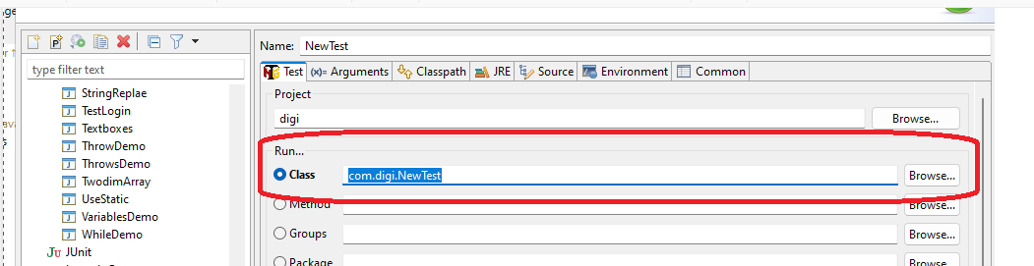

Test Ng.xml

<?xml version="1.0" encoding="UTF-8"?>

<!DOCTYPE suite SYSTEM "https://testng.org/testng-1.0.dtd">

<suite name="Suite">

<test thread-count="5" name="Test">

<classes>

<class name="com.digi.AppTest"/>

</classes>

</test> <!-- Test -->

</suite> <!-- Suite -->

Priority :

Priority value can be positive, negative

Priority values need not be consecutive integers

If more than one test case is having same priority , then alphabetical order of methods will be considered.

Annotations:

|  |  |
| --- | --- |
| **Annotation** | **Description** |
| @BeforeSuite | Runs before suite execution starts |
| @AfterSuite | Runs after all tests are executed |
| @BeforeTest | Runs before first test in a <test> tag is executed |
| @AfterTest | Runs after all the tests in a <test> tag are executed |
| @BeforeGroups | Runs before first test method of the group(s) is executed |
| @AfterGroups | Runs after all the test methods of the group(s) are executed |
| @BeforeClass | Runs before first test in a class is executed |
| @AfterClass | Runs after all the tests in a class are executed |
| @BeforeMethod | Runs before each test in a class is executed |
| @AfterMethod | Runs after each test is executed |

Before Test

Before Method

VerifyRadio button -- Test Method

After Method

Before Method

VerifyCheckbox button -- Test Method

After Method

AfterTest

