2.leap year

s=int(input("Enter starting year"))

e=int(input("Enter ending year"))

if(s<e):

print("leap years are",end=" ")

for i in range(s,e):

if(i%4==0 and i%100!=0 or i%400==0 and i%100==0):

print(i,end=" ")

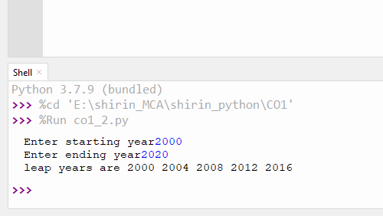

3.

3.a

for i in [-1,2,3,-87,8,87,-9]:

if(i>0):

print(i)

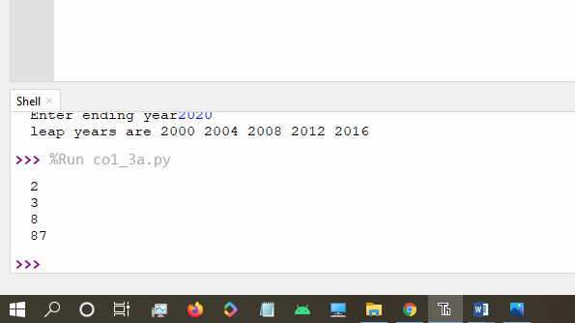

3.b

word=input("Enter word")

print("the original string",word)

for i in word:

if i in ['a','A','e','E','i','I','o','O','u','U']:

print([i],end=" ")

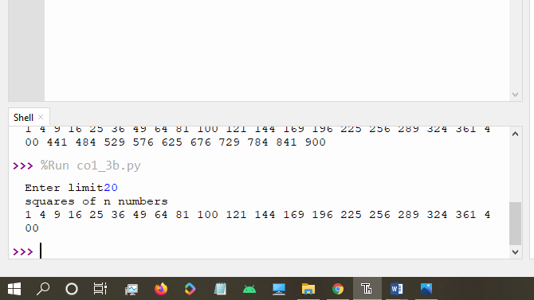

3.c

word=input("Enter word")

print("The original values of character:")

for i in word:

print(i,end=":")

print(ord(i))

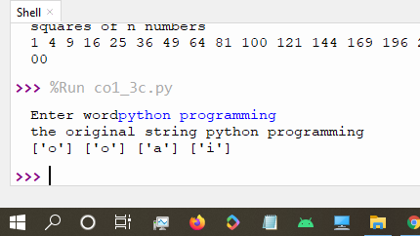

4.

str1=input("enter the string")

wordlist=str1.split()

count= []

for w in wordlist:

count.append(wordlist.count(w))

print("count of the occurrence:" + str(list(zip(wordlist, count))))

output:

Python 3.7.9 (bundled)

>>> %Run co1_4.py

enter the stringpython is a programming language

count of the occurrence:[('python', 1), ('is', 1), ('a', 1), ('programming', 1), ('language', 1)]

>>>

5.

n=[]

s=int(input("Enter a limit"))

print("Enter values")

i=0

while(i<s):

num=input("value:")

n.append(int(num))

i=i+1

print("\n the list after assigning:\n")

i=0

while(i<len(n)):

if(n[i]>100):

print("over")

else:

print(n[i])

i=i+1

6.

list1=['a','b','s','a']

occ=list1.count('a')

print("count=",occ)

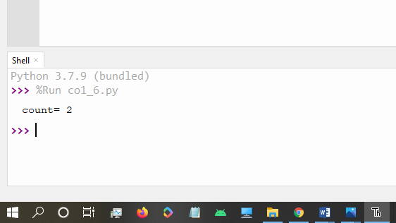

7.

lst=[1,3,5,7,9,11,34]

lst1=[5,13,45,7,20,65,1]

s=int(0)

c=int(0)

if(len(lst)==len(lst1)):

print("List are of same length")

else:

print("list have different length")

for i in range(0,len(lst) and len(lst1)):

s=s+lst[i]

c=c+lst1[i]

if(s==c):

print("equal sum")

else:

print("not same sum")

print("Elements that matched are:")

l=[]

for i in range(0,len(lst)):

for j in range(0,len(lst1)):

if lst[i]==lst1[j]:

l.append(lst[i] and lst1[j])

else:

continue

print(l)

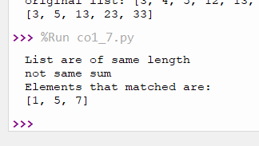

8.

str='onion'

char=str[0]

str=str.replace(char,'$')

print(char+str[1:])

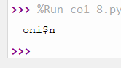

9.

str=input("Enter a string")

print(str[-1]+str[1:-1]+str[0])

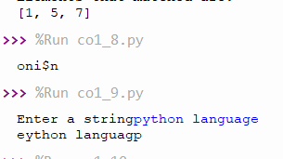

10.

p=3.14

rad=float(input("Enter radius"))

area=p*rad*rad

print("area of circle",area)

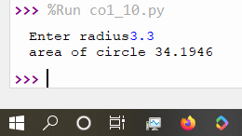

11. x = int(input("Enter 1st number: "))

y = int(input("Enter 2nd number: "))

z = int(input("Enter 3rd number: "))

if (x > y) and (x > z):

largest = x

elif (y > x) and (y > z):

largest = y

else:

largest = z

print("The largest number is",largest)

output:

Python 3.7.9 (bundled)

>>> %Run co1_11.py

Enter 1st number: 3

Enter 2nd number: 2

Enter 3rd number: 10

The largest number is 10

>>>

12.

file=input("Enter filename:")

f=file.split(".")

print("extension of the file is "+f[-1])

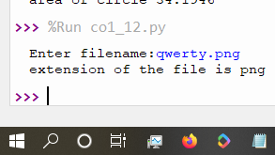

13.

a=[]

n=int(input("Enter limit"))

for i in range(0,n):

b=input("Enter the color:")

a.append(b)

print(a)

print(a[0])

print(a[n-1])

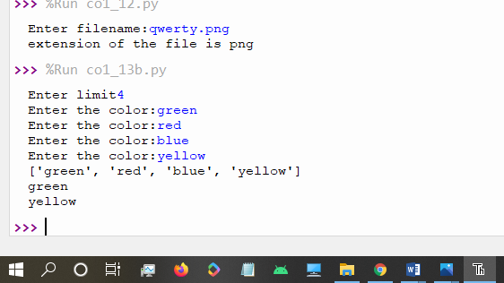

14.

n=int(input("Enter a number:"))

x=int("%s"%n)

y=int("%s%s"%(n,n))

z=int("%s%s%s"%(n,n,n))

print("n+nn+nnn",x+y+z)

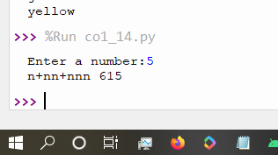

15.

color_list_1=set(["White","pink","blue"])

color_list_2=set(["red","green","pink"])

print(color_list_1.difference(color_list_2))

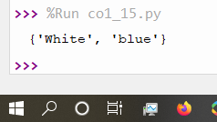

16.

a="programming"

b="lab"

#r1=a[0]

#r2=b[0]

print(b[0]+a[1:]+" "+a[0]+b[1:])

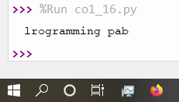

17. import operator

d = {1: 2, 3: 4, 4: 3, 2: 1, 0: 0}

print('Original dictionary : ',d)

sorted_d = sorted(d.items(),key=operator.itemgetter(1))

print('Dictionary in ascending order by value ',sorted_d)

sorted_d = dict( sorted(d.items(),key=operator.itemgetter(1),reverse=True))

print('Dictionary in descending order by value : ',sorted_d)

output:

>>> %Run co1_17.py

Original dictionary : {1: 2, 3: 4, 4: 3, 2: 1, 0: 0}

Dictionary in ascending order by value [(0, 0), (2, 1), (1, 2), (4, 3), (3, 4)]

Dictionary in descending order by value : {3: 4, 4: 3, 1: 2, 2: 1, 0: 0}

>>>

18. d1={'a':100,'b':200}

d2={'x':300,'y':200}

print("dictionary 1=",d1)

print("dictionary 2=",d2)

d=d1.copy()

d.update(d2)

print("merged dictionary:",d)

output:

>>> %Run co1_18.py

dictionary 1= {'a': 100, 'b': 200}

dictionary 2= {'x': 300, 'y': 200}

merged dictionary: {'a': 100, 'b': 200, 'x': 300, 'y': 200}

>>>

19.

#gcd

a=int(input("Enter 1st number"))

b=int(input("Enter 2nd number"))

i=1

while(i<=a and i<=b):

if(a%i==0 and b%i==0):

gcd=i

i=i+1

print("GCD:",gcd)

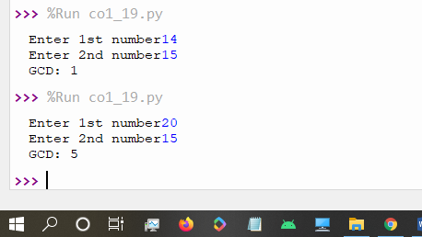

20.

#removing even numbers

num=[3,4,5,12,13,23,33]

n=[]

print("original list:",num)

for i in num:

if(i%2!=0):

n.append(i)

print(n)

