ALCAS Website Enhancement Proposal

Current Website Review

Current Portfolio Showcase
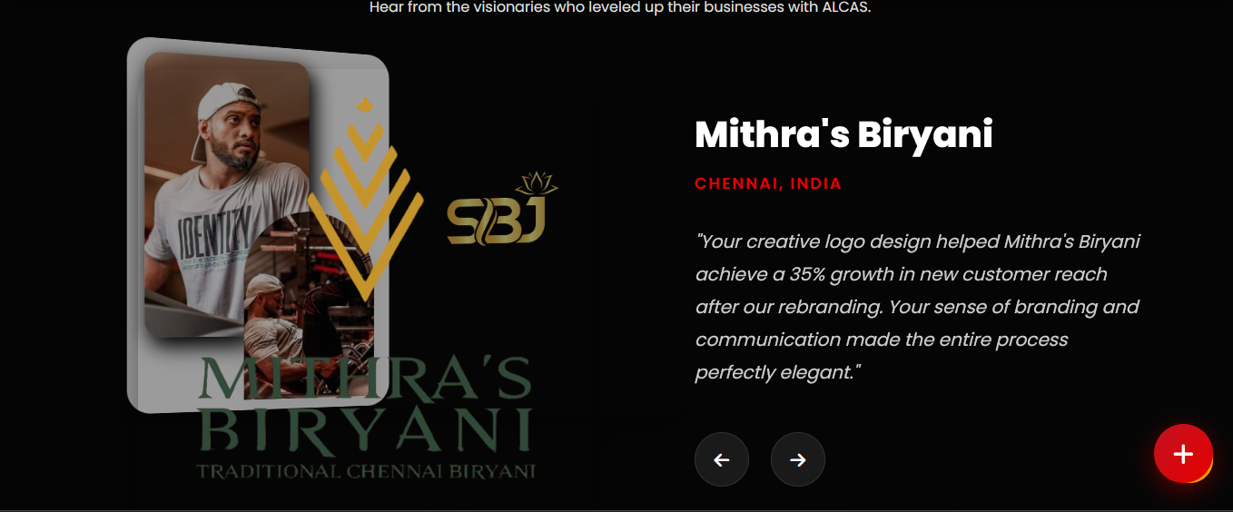

Current Success Stories Section
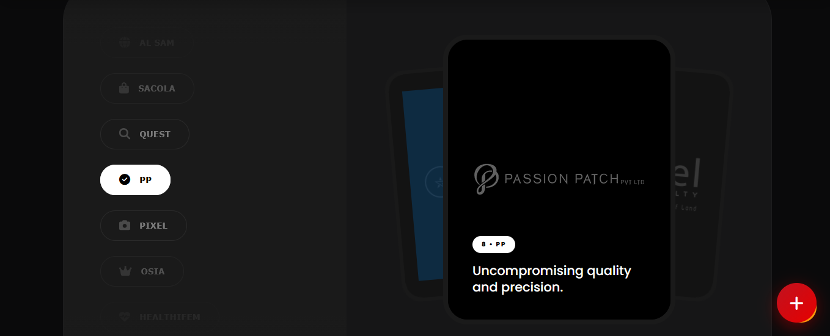

Inspiration: Trusted Brands (Udemy)
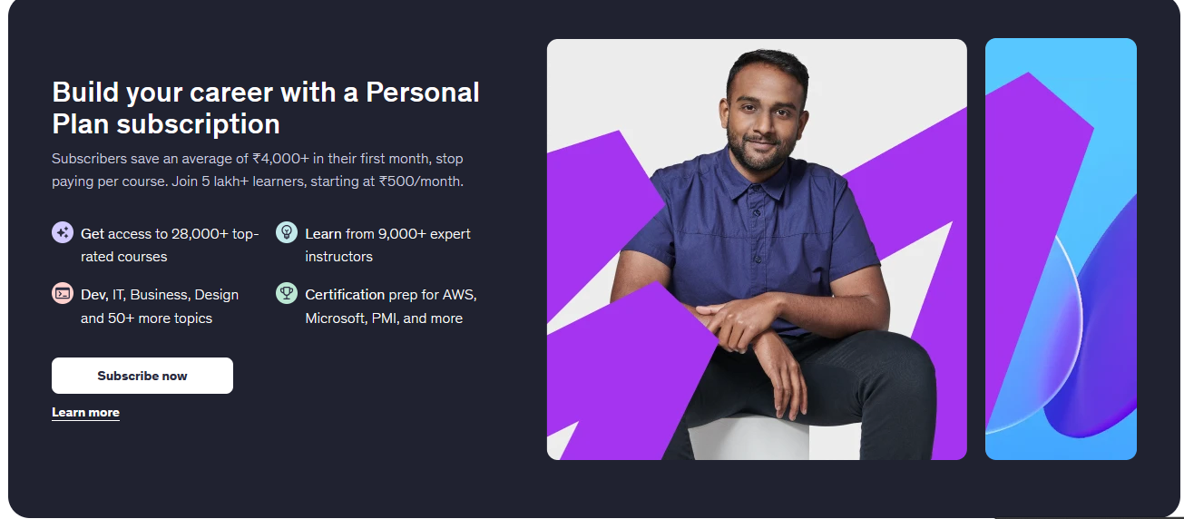

Inspiration: Testimonial Cards (Udemy)
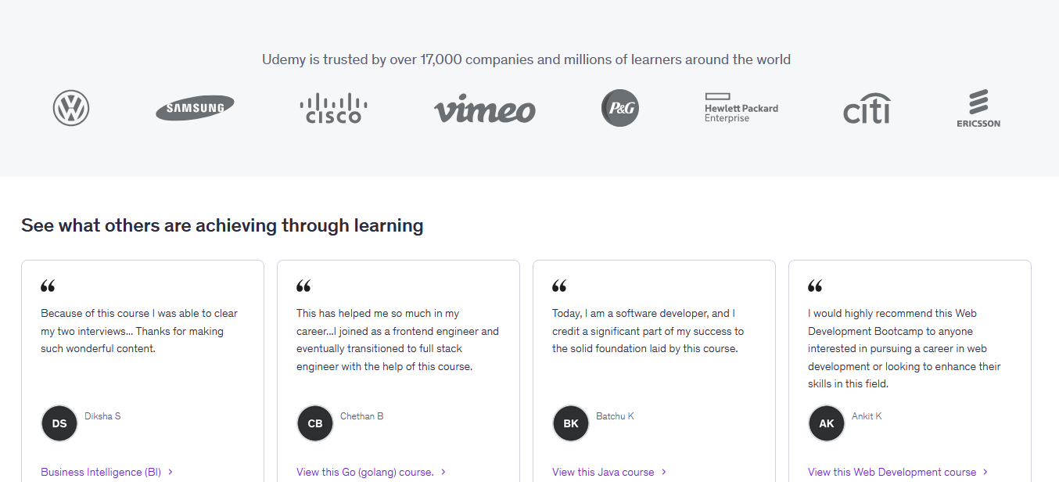

Key Observations
• Success stories can be presented using a structured case-study format.
• Portfolio projects can emphasize outcomes and services more clearly.
• A dedicated trusted-brands section can strengthen social proof.
• Card-based testimonials can improve readability and scanability.

Final Proposed Design
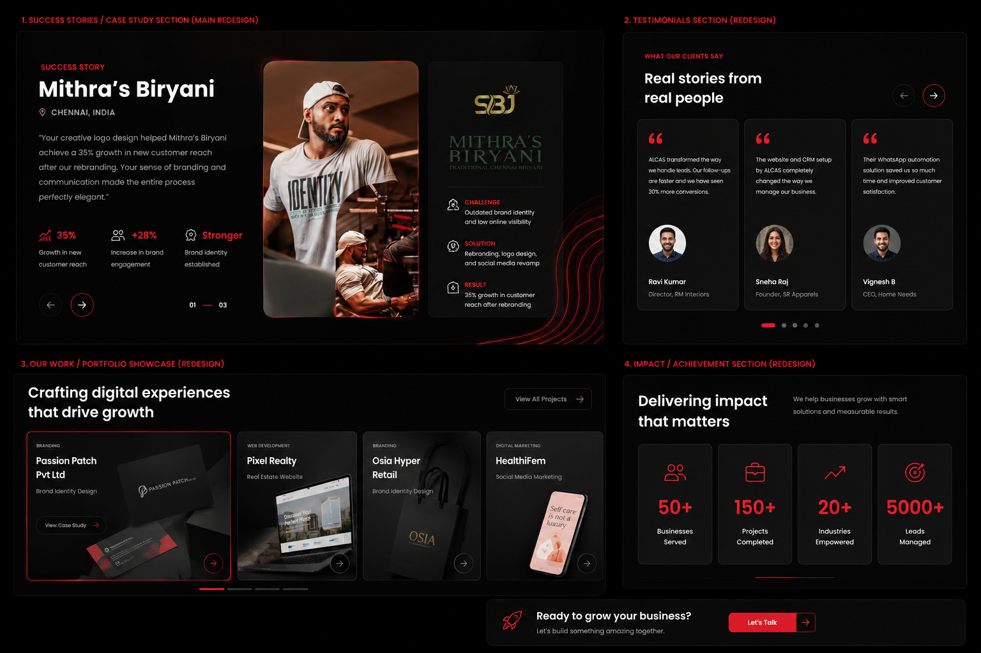
Expected Improvements:
✓ Better Information Architecture
✓ Stronger Social Proof
✓ Improved Project Presentation
✓ Better Content Hierarchy
✓ Enhanced User Experience

