Nginx Vulnerability setup manual :-

1. open nginx configuration file in system

sudo vi /etc/nginx/sites-enabled/default

copy all the content from given path to NGINX config file :- /PROJECT_DIRECTORY/vulnerabilities/nginx_config_file

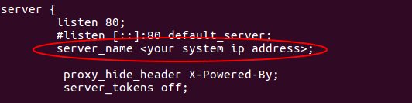
2. set your PUBLIC DOMAIN NAME as server_name

3. Copy the UI index.html or dist path as root path.

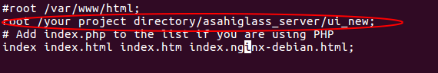
root /your project directory/asahiglass_server/ui_new;

4. Set configuration for default server or unwanted requests.
Use-:
on terminal-:
sudo vi /var/www/html/index.html
then add the html code for bad request response
for example ==> “ <h1> page not found </h1> ”

5. Restart the nginx server
sudo service nginx restart

