
Guangdong University of Technology

Algorithm Design and Analysis Term Paper
MAXIMUM PATH SUM

School School of International Education
Major Computer Science
Grade 2019
ID 3119009450
Name 邹佳豪
Supervisor 饶东宁

2021 5/ 15/

Index
1 Dynamic programming 1
1.1 Definition of dynamic programming 1
1.2.1 Question of coin change 1
1.2.2 Introduction of coin change
2 Question of maximum path sum
2.1 Main body
2.2 Solution
Summary 1
References 1
Appendix 1

1 Dynamic Programming

1.1 Definition of dynamic programming

Dynamic Programming is mainly an optimization over plain recursion. Wherever we see a recursive solution that has repeated calls for same inputs, we can optimize it using Dynamic Programming. The idea is to simply store the results of subproblems, so that we do not have to re-compute them when needed later. This simple optimization reduces time complexities from exponential to polynomial. For example, if we write simple recursive solution for Fibonacci Numbers, we get exponential time complexity and if we optimize it by storing solutions of subproblems, time complexity reduces to linear.

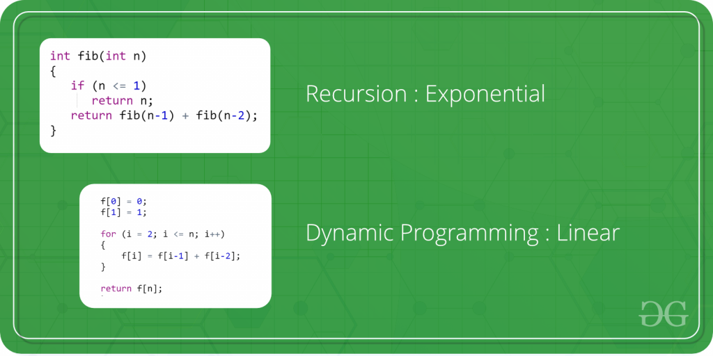
1.2.1 Question of coin change
Given a value N, if we want to make change for N cents, and we have infinite supply of each of S = { S1, S2, .. , Sm} valued coins, how many ways can we make the change? The order of coins doesn’t matter.
For example, for N = 4 and S = {1,2,3}, there are four solutions: {1,1,1,1},{1,1,2},{2,2},{1,3}. So output should be 4. For N = 10 and S = {2, 5, 3, 6}, there are five solutions: {2,2,2,2,2}, {2,2,3,3}, {2,2,6}, {2,3,5} and {5,5}. So the output should be 5.
Recommended: Please solve it on “PRACTICE ” first, before moving on to the solution.
1) Optimal Substructure
To count the total number of solutions, we can divide all set solutions into two sets.
1) Solutions that do not contain mth coin (or Sm).
2) Solutions that contain at least one Sm.
Let count(S[], m, n) be the function to count the number of solutions, then it can be written as sum of count(S[], m-1, n) and count(S[], m, n-Sm).
Therefore, the problem has optimal substructure property as the problem can be solved using solutions to subproblems.
2) Overlapping Subproblems
Following is a simple recursive implementation of the Coin Change problem. The implementation simply follows the recursive structure mentioned above.

1.2.2 Introduction of coin change

// Recursive C program for
// coin change problem.
#include<stdio.h>

// Returns the count of ways we can
// sum S[0...m-1] coins to get sum n
int count( int S[], int m, int n )
{
// If n is 0 then there is 1 solution
// (do not include any coin)
if (n == 0)
return 1;

// If n is less than 0 then no
// solution exists
if (n < 0)
return 0;

// If there are no coins and n
// is greater than 0, then no
// solution exist
if (m <=0 && n >= 1)
return 0;

// count is sum of solutions (i)
// including S[m-1] (ii) excluding S[m-1]
return count( S, m - 1, n ) + count( S, m, n-S[m-1] );
}

// Driver program to test above function
int main()
{
int i, j;
int arr[] = {1, 2, 3};
int m = sizeof(arr)/sizeof(arr[0]);
printf("%d ", count(arr, m, 4));
getchar();
return 0;
}

Output :4

It should be noted that the above function computes the same subproblems again and again. See the following recursion tree for S = {1, 2, 3} and n = 5.
The function C({1}, 3) is called two times. If we draw the complete tree, then we can see that there are many subproblems being called more than once.

2 Question of maximum path sum
Binary Tree Maximum Path Sum
Given a non-empty binary tree, find the maximum path sum.

For this problem, a path is defined as any sequence of nodes from some starting node to any node in the tree along the parent-child connections. The path must contain at least one node and does not need to go through the root.

小五号宋体

Example 1:
Input: [1,2,3]

1
/ \
2 3

Output: 6

Example 2:

Input: [-10,9,20,null,null,15,7]

-10
/ \
9 20
/ \
15 7

Output: 42

Source code:

#include <stdio.h>
#include <climits>
#define NULL 0
struct TreeNode {
int val;
TreeNode* left;
TreeNode* right;
TreeNode(int x) : val(x), left(NULL), right(NULL) {}
};
int max(int a, int b)
{
if (a > b) return a;
return b;
}
class Solution {
public:
int maxPathSum(TreeNode* root) {
int sum = INT_MIN;
help(root, sum);
return sum;
}
int help(TreeNode* root, int& sum)
{
if (root == NULL)
return 0;
int left = max(help(root->left, sum), 0);
int right = max(help(root->right, sum), 0);
if ((left + right + root->val) > sum)
sum = left + right + root->val;
return max(left, right) + root->val;
}
};

Complexity analysis:
Time complexity : O ( n ) O ( n ), where NN is the number of nodes in a binary tree. Visit no more than 22 times on each node.

Space complexity :
O ( n ) O ( n ), where NN is the number of nodes in a binary tree. Spatial layers of complexity depends largely on the recursive call, the maximum number of levels equal to the height of the binary tree, the worst case, the binary tree height equal to the number of nodes in a binary tree.
References
[1]Sanjoy Dasgupta. 算法概论[M]. 机械工业出版社，2009.01
[2]https://www.geeksforgeeks.org/dynamic-programming/
[3] 刘瑜，车紫辉，顾明臣，杜瑾敏著. 算法之美[M]. 中国水利水电出版社，202.11
[4] https://leetcode-cn.com/
[5] 《算法》—— Robert Sedgewick, Kevin Wayne
[6] 《算法设计与分析基础》—— Anany Levitin
Appendix A
Term Paper Scorecard
School | School of International Education |  |  | Major | Computer Science
Name | 邹佳豪 |  |  | ID | 3119009450 | Grade |  | 19
Term Paper Title |  |  | Maximum path sum
Comments:

Score Details
Writing（60） |  | References（10）
 |  | Structure（10）
 |  | Value（10）
 |  | State-of-the-Art（30）
Programming（40） |  | Implementation（20）
 |  | Experience（20）
Final Grade |  | Teacher Name |  | Department |  |  | Date
 |  | 1.Dongning Rao |  | School of Computer |  |  | 2021/05/15
 |  | 2.
 |  | 3.

