**Soft Handoff**

[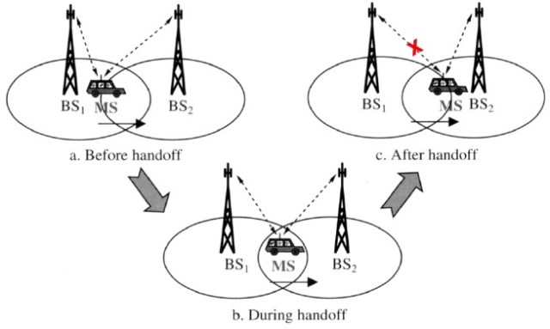](https://i0.wp.com/technobyte.org/wp-content/uploads/2020/05/soft-handoff-types-of-handoff-2.jpg?ssl=1)Soft handoff

Soft Handoff is a feature where a cellular device gets connected to two or more cell BTS (or cell sectors) at the same time. If all the sectors to which the MS is connected to are from the same cell, then it is referred to as a **Softer Handoff.**

[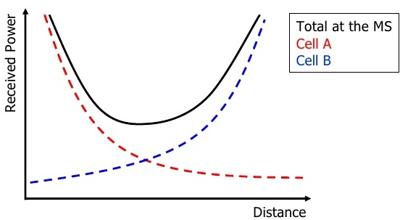](https://i0.wp.com/technobyte.org/wp-content/uploads/2020/05/softer-handoff-types-of-handoff-2.jpg?ssl=1)

Softer handoff

**Advantages**

* It provides better Quality Assurance as a channel is always on stand by in case of power loss in any other channel.
* More than one repeater can send and receive signals to transmit signals to and from mobiles, increasing transfer speed.
* Delay is very low
* Soft Handoffs lead to an increase in the signal to interference ratio, without performance loss. This is known as the **Soft Handover Gain**.

**Disadvantages**

* Only supported for phones that employ CDMA/ WCDMA, and cannot be implemented in LTE or GSM.
* Costlier to implement than Hard Handoff as a channel is always wasted by being the backup.

**Used In**

Soft Handoffs are generally used in MS that employ Code Division Multiple Access (CDMA) or Wideband CDMA (WCDMA), and its associated services, and also in applications that require a continuous connection throughout, possibly for security purposes.

## ****Hard Handoff****

Hard Handoff is a technique that requires the user’s connection to be broken before connecting to another while switching between two BTS and hence is equivalent to “breaking before making”. It is generally implemented in Frequency Division Multiple Access (FDMA) and Time Division Multiple Access (TDMA) based devices and is implemented when the subscriber/user is being connected to a base station with a different radio frequency than the current base station. The following image shows the difference between Soft and Hard Handovers.

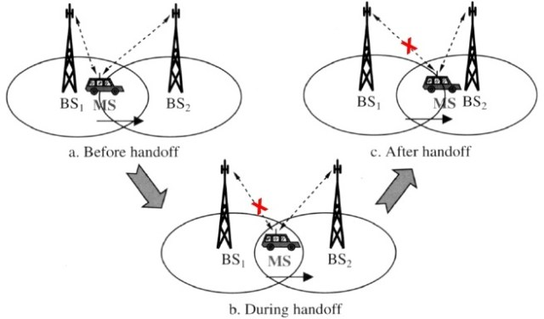

**Advantages**

* Hard Handovers are cheaper as they require only one channel to be active at a time.
* Hard Handoffs are generally implemented more than Soft Handoffs thanks to their efficiency.

**Disadvantages**

* A delay is often experienced while switching, but it generally is quite small such that the user does not experience it.

**Used In**

Apart from being implemented in FDMA and TDMA devices, Hard Handoffs are also used in applications that can afford slight delays, such as VoIP, Internet, and WiMAX.

## ****Mobile-Assisted Handoff****

A mobile-assisted handoff (MAHO) is a process used specifically in GSM networks where a mobile phone assists or helps the BTS to transfer a call to another BTS, with stronger signal strength and improved connectivity.

### ****Advantages****

* Reduced handoff time as the device is responsible for facilitating the handoff.
* Reduced traffic at the BSC/ MSC as the decision to switch is taken by the MS.
* Suitable when handoffs are frequent.

### ****Disadvantages****

* Added load on the processor of the MS in comparing signal strength of nearby BTS.

### ****Used In****

They are primarily used in GSM devices, which is based on the TDMA technique.

## ****Intersystem Handoff****

Intersystem Handoffs come into play when the user moves from one network that is under the jurisdiction of an MSC to another. During this handoff, the call is transferred to the destination MSC, which further tries to allocate a specific bandwidth at the cell site where the user is at present.

### ****Advantages****

* Facilitates roaming and preserves the mobility promise of cellular networks.

### ****Disadvantages****

* This is only possible if the two MSCs are compatible and have the necessary software that can facilitate these handoffs.

### ****Used In****

Intersystem Handoffs are used when the user moves from one system to another.

The handoffs that we just saw are those that happen between two MSCs. Handoffs also happen between two BTSs or cells as well, which we will have a look at in this section.

## ****Intercell Handoffs****

An intercell handoff occurs when an MS is transferred from one BTS to the other, mostly to balance the load on the network. It is generally the BSC that takes control here and acts as the switching agent.

[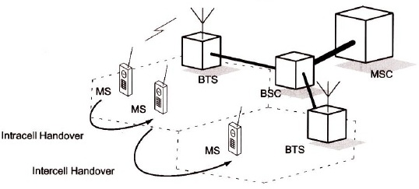](https://i0.wp.com/technobyte.org/wp-content/uploads/2020/05/intracell-and-intercell-handoff-types-of-handoff.jpg?ssl=1)Intracell and Intercell handoff

## ****Intracell Handoffs****

Intracell Handoffs are those that occur between two physical channels within the same cell. The frequency of the channel is changed generally due to interference or similar reasons. Here, the MS remains connected to the same BTS throughout the process.

* **Handoff** is the technique which enables a call to proceed uninterrupted when the user moves from one cell to another
* There are two basic types of Handoffs.

**1) Hard Handoff**

**2) Soft Handoff**

* Handoff process involves 3 main stages a. Handoff Initiation b. Establishing a new connection c. Data transfer to new handoffs.

**1) Hard Handoff:**

* It is also known as “Break before make” connection.
* In this type of handoff the link to the old base station is terminated before the mobile station establishes a link with the new base station.
* It is used in FDMA and TDMA based mobile system. Figure shows the mechanism of hard handoff.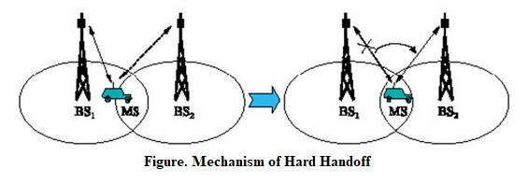
* Hard handoff is classified as

**a) Intra cell handoff:**

* + In Intra cell Handoff, the handover occurs within the same cell.
  + Intra cell handover switches a cell in progress from one physical channel of a cell to another physical channel of the same cell.

**b) Inter cell handoff:**

* + In Inter cell Handoff, the handover occurs between two cells.
  + The inter cell handover switches a cell in progress from one cell to another cell.
  + It can be of two types

**1. Inter BSC:** Here the MS moves from one cell to another cell controlled by the different BSCs.

**2. Inter MSC:** Here the MS moves from one cell to another cell controlled by the different MSCs.

**c) Inter System Handoff:**

* + In inter system handoff; the handover occurs between two systems.
  + This type of handoff occurs when the mobile unit moves from one cellular system to a different cellular system.
  + Example from GSM to UMTS.

**2) Soft Handoff:**

* It is also called as Mobile Directed handoff or make before Break Connection.
* In these types of handoff the link to the old base station is not terminated before the mobile station established a link with the new base station.
* Once the link is established the connection to old BS is terminated.
* It is used in UMTS to improve the signal quality
* It is more seamless handover.