Roll no-27

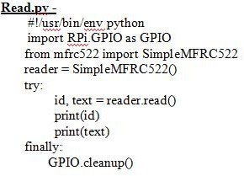

**Practical No-7**

Q.1]Interfacing Raspberry Pi with RFID

# Circuit diagram

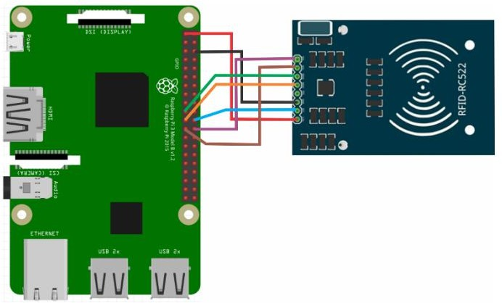

**Pin Configuration-**

* SDA connects to Pin 24.
* SCK connects to Pin 23.
* MOSI connects to Pin 19.
* MISO connects to Pin 21.
* GND connects to Pin 6.
* RST connects to Pin 22.
* 3.3v connects to Pin 1.

# Setting up Raspbian for RFID RC 522-

**Write.py**

import RPi.GPIO as GPIO

from mfrc522 import SimpleMFRC522 reader = SimpleMFRC522()

try:

text = input('New data:')

print("Now place your tag to write") reader.write(text)

print("Written") finally:

GPIO.cleanup()

# Output-

