**Practical No.06**

**Visitor Monitoring with Raspberry Pi and Pi Camera**

**Capturing from Camera:-**

**Code:**

from picamera import PiCamera

from time import sleep

camera = PiCamera()

camera.start_preview()

sleep(5)

camera.capture('/home/pi/Desktop/image.jpg')

camera.stop_preview()

**Output:-**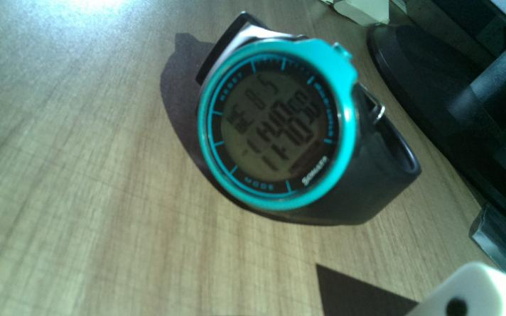

**Recording from Camera:-**

**Code:**

from picamera import PiCamera

from time import sleep

camera = PiCamera()

camera.start_preview()

camera.start_recording('/home/pi/Desktop/videeo.h264')

sleep(5)

camera.stop_recording()

camera.stop_preview()

**Output:-**

