**Practical No: 5**

1. **Raspberry Pi GPS Module Interfacing**

**GPS Module: Interfacing Daigram:**

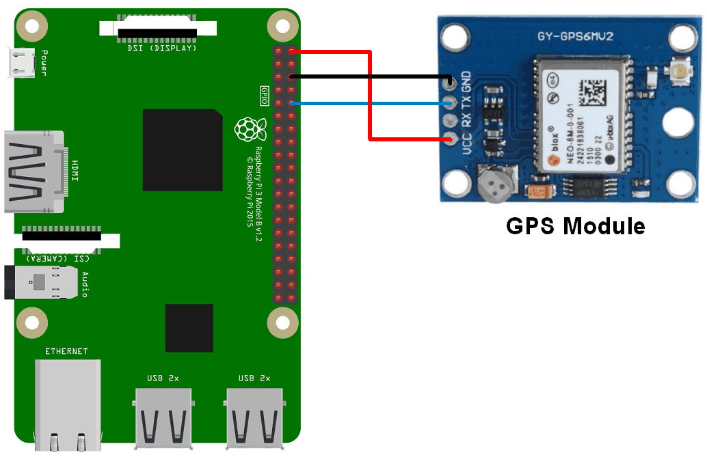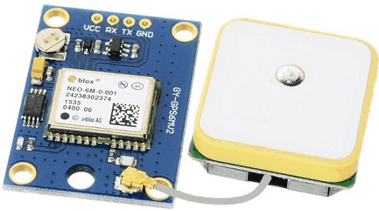

GND Connected to pin 6.

TX Connected to pin 10.

UCC Connected to pin 1.

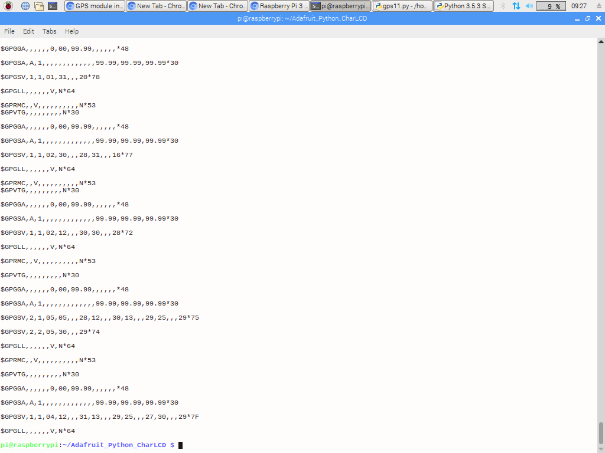**output:**