**Practical No- 9**

**Q.1] Raspberry Pi Based Oscilloscope**

**Circuit Diagram**-

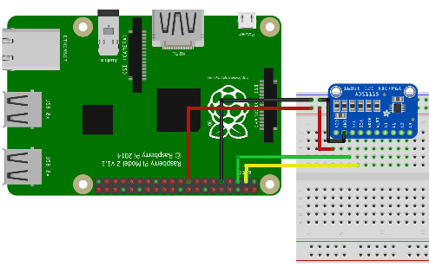

**ADS1115 and Raspberry Pi Connections:**

* VDD – 3.3v
* GND – GND
* SDA – SDA
* SCL – SCL

**Scope.py-**

**import time**

**import matplotlib.pyplot as plt**

**#import numpy**

**from drawnow import \***

**# Import the ADS1x15 module.**

**import Adafruit_ADS1x15**

**# Create an ADS1115 ADC (16-bit) instance.**

**adc = Adafruit_ADS1x15.ADS1115()**

**GAIN = 1**

**val = [ ]**

**cnt = 0**

**plt.ion()**

**# Start continuous ADC conversions on channel 0 using the previous gain value.**

**adc.start_adc(0, gain=GAIN)**

**print('Reading ADS1x15 channel 0')**

**#create the figure function**

**def makeFig():**

**plt.ylim(-5000,5000)**

**plt.title('Osciloscope')**

**plt.grid(True)**

**plt.ylabel('ADC outputs')**

**plt.plot(val, 'ro-', label='Channel 0')**

**plt.legend(loc='lower right')**

**while (True):**

**# Read the last ADC conversion value and print it out.**

**value = adc.get_last_result()**

**print('Channel 0: {0}'.format(value))**

**# Sleep for half a second.**

**time.sleep(0.5)**

**val.append(int(value))**

**drawnow(makeFig)**

**plt.pause(.000001)**

**cnt = cnt+1**

**if(cnt>50):**

**val.pop(0)**

**Output -**

