**Practical No.04**

**Controlling Raspberry Pi with Telegram.**

**Conferring Bot:**

**Lighting LED:**

import sys

import time

import random

import datetime

import telepot

import RPi.GPIO as GPIO

#LED

def on(pin):

GPIO.output(18,GPIO.HIGH)

return

def off(pin):

GPIO.output(18,GPIO.LOW)

return

# to use Raspberry Pi board pin numbers

GPIO.setmode(GPIO.BCM)

# set up GPIO output channel

GPIO.setup(18, GPIO.OUT)

def handle(msg):

chat_id = msg['chat']['id']

command = msg['text']

print('Got command: %s' % command)

if command == 'on':

bot.sendMessage(chat_id,on(18))

elif command =='off':

bot.sendMessage(chat_id,off(18))

bot = telepot.Bot('AAFy13IlEL3paxMxkWrPsn7dEF9gEWbERtE')

bot.message_loop(handle)

print('I am listening...')

while 1:

time.sleep(10)

**Output:-**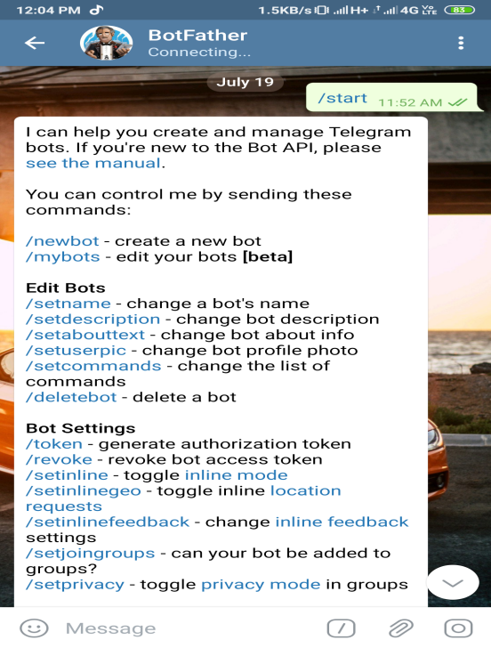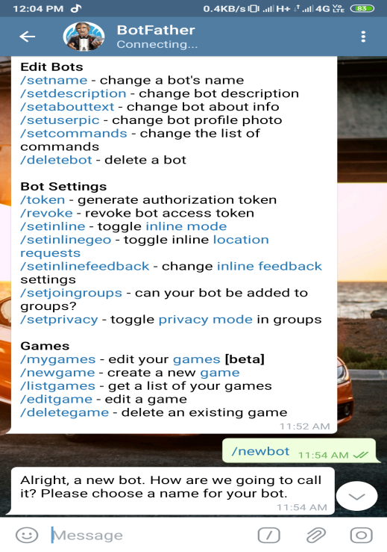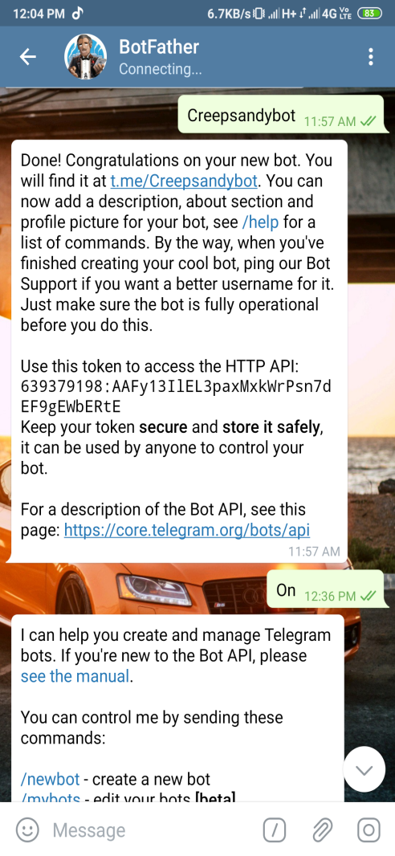

**Talking to AI:-**

import time, datetime

import telepot

from telepot.loop import MessageLoop

now = datetime.datetime.now()

def action(msg):

chat_id = msg['chat']['id']

command = msg['text']

print ('Received: %s' % command)

if command == '/hi':

telegram_bot.sendMessage (chat_id, str("Hi! anu"))

elif command == '/time':

telegram_bot.sendMessage(chat_id, str(now.hour)+str(":")+str(now.minute))

elif command == '/file':

telegram_bot.sendDocument(chat_id, document=open('/home/pi/Desktop/telegram.py'))

telegram_bot = telepot.Bot('AAFy13IlEL3paxMxkWrPsn7dEF9gEWbERtE')

print (telegram_bot.getMe())

MessageLoop(telegram_bot, action).run_as_thread()

print ('Up and Running....')

while 1:

time.sleep(10)

**Output:**

