

School of Computer Science Engineering and Information Systems
WINTER SEMESTER – 2025 – 26
BITE312E –Data Mining-Project Component

FAKE JOB / INTERNSHIP POSTING DETECTION USING DATA MINING

Ashik Ali A (23BIT0368)
Mohana Prasath M (23BIT0380)

Guided by
Dr. P. Prabhavathy

ABSTRACT
This project presents a Data Mining-based system to detect fake job and internship postings using Natural Language Processing (NLP) techniques. With the rise of online recruitment platforms, fraudulent job postings have increased significantly, targeting students and job seekers. The proposed system utilizes TF-IDF feature extraction along with machine learning models such as Logistic Regression and Naive Bayes to classify job postings as real or fake.
To improve fraud detection, the system incorporates class balancing, feature engineering using n-grams, and decision threshold tuning to maximize recall. Additionally, a rule-based ensemble approach is implemented to combine the strengths of both models. The system provides probability-based risk assessment and is deployed as a web application using Flask, making it accessible and practical for real-world use.

INTRODUCTION
Background
Online job portals and internship platforms have become widely used by students and professionals. However, this has also led to an increase in fraudulent job postings.
Many students fall victim to scams involving:
- Registration fees
- Fake internships
- Data theft
Hence, there is a need for an automated detection system.
Issues in Existing System
- No real-time fraud detection
- Lack of student-focused systems
- No explainable outputs
Contribution of Proposed Work
- Binary classification (Fake / Real)
- High recall fraud detection system
- Ensemble model (Logistic + Naive Bayes)
- Web-based deployment using Flask
LITERATURE SURVEY
S.No | Paper Title | Methodology | Observation | Gap Identified
1 | Online Recruitment Fraud Detection Using Deep Learning (2024) | LSTM, Neural Networks | High accuracy | High computational cost, not real-time
2 | Machine Learning Approach for Fraudulent Job Detection (2025) | Decision Tree, Random Forest | Good classification | Limited feature engineering
3 | Fake Job Detection Using NLP Techniques (2025) | NLP + ML Models | Accurate text classification | No explainability
4 | Real or Fake Job Posting Detection (2024) | Logistic Regression | Good baseline model | Low recall for fraud detection
5 | Smart Recruitment Fraud Detection Framework (2023) | Ensemble Learning | Improved accuracy | Complex model, difficult to interpret
6 | Fake Job Detection Using LSTM (2023) | Deep Learning (Bi-LSTM) | High accuracy | Requires GPU, large dataset
7 | Comparative Study of ML Models for Fraud Detection (2025) | Multiple ML Algorithms | Performance comparison | No hybrid system
8 | Automated Job Authenticity Verification System (2025) | NLP + Classification | Useful filtering system | No real-time deployment
9 | Cyber Fraud Detection Using Machine Learning (2023) | Random Forest, Decision Tree | Detects fraud patterns | No domain-specific tuning
10 | Hybrid ML Model for Fake Job Detection (2024) | Hybrid ML Models | Improved accuracy | No explainable system

OBJECTIVE
- Detect fake job postings using ML
- Improve recall for fraud detection
- Provide probability-based risk score
- Build a real-time web application

PROPOSED SYSTEM – ARCHITECTURE
Overview
The system processes job descriptions and predicts whether they are fake or real using machine learning.
System Architecture
Input → Preprocessing → TF-IDF → Models → Ensemble → Output
Functional Architecture
- Input module
- Text preprocessing
- Feature extraction
- Model prediction
- Result display

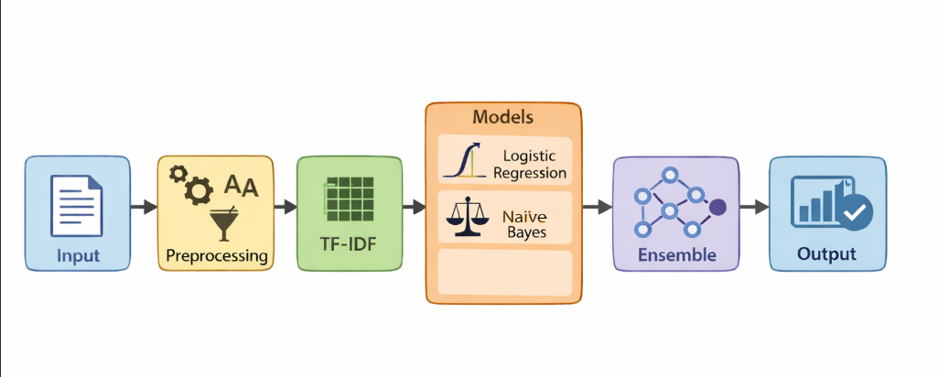
System Architecture
METHODOLOGY
- Dataset Collection
  - Kaggle Fake Job Posting Dataset
- Preprocessing
  - Lowercasing
  - Removing symbols
  - Cleaning text
- Feature Extraction
  - TF-IDF with n-grams
- Model Training
  - Logistic Regression (high recall)
  - Naive Bayes (high precision)
- Threshold Tuning
  - Reduced threshold to 0.2
  - Improved recall
- Ensemble Model
  - Rule-based combination
IMPLEMENTATION
Software Used
- Python
- Google Colab
- Flask
- VS Code

Modules
1. Data Preprocessing Module
- Cleans and prepares text
Code:
import pandas as pd
# Load dataset
df = pd.read_csv(
"fake_job_postings.csv",
engine='python',
on_bad_lines='skip'
)
# Select required columns
df = df[['title', 'description', 'requirements', 'fraudulent']]
df.columns = ['title', 'description', 'requirements', 'label']
# Handle missing values
df = df.fillna('')

2. Feature Extraction Module
- TF-IDF vectorization
Description
Combine multiple text fields and clean the text:
- Lowercase conversion
- Remove special characters
- Normalize spacing
Code:
import re
# Combine text columns
df['text'] = df['title'] + " " + df['description'] + " " + df['requirements']
# Cleaning function
def clean_text(text):
text = text.lower()
text = re.sub(r'[^a-zA-Z ]', '', text)
text = re.sub(r'\s+', ' ', text)
return text
# Apply cleaning
df['text'] = df['text'].apply(clean_text)
3. Train-Test Split
Description
Split dataset into training and testing sets
Code
from sklearn.model_selection import train_test_split
X = df['text']
y = df['label']
X_train, X_test, y_train, y_test = train_test_split(
X, y, test_size=0.2, random_state=42
)
4. Feature Extraction (TF-IDF)
📖 Description
Convert text into numerical form using TF-IDF:
- Uses n-grams for better context
- Limits features to improve performance
Code:
from sklearn.feature_extraction.text import TfidfVectorizer
vectorizer = TfidfVectorizer(
stop_words='english',
max_features=8000,
ngram_range=(1,2),
min_df=2
)

X_train_tfidf = vectorizer.fit_transform(X_train)
X_test_tfidf = vectorizer.transform(X_test)

5. Logistic Regression Model
Description
Used as primary model:
- High recall for detecting fake jobs
- Class weighting applied
Code
from sklearn.linear_model import LogisticRegression

lr_model = LogisticRegression(
class_weight={0:1, 1:3},
C=3,
max_iter=300
)
lr_model.fit(X_train_tfidf, y_train)

6. Threshold Tuning
Description
Lower threshold to improve fraud detection (recall).
code
from sklearn.metrics import classification_report
y_probs = lr_model.predict_proba(X_test_tfidf)[:, 1]
threshold = 0.2
y_pred_custom = (y_probs >= threshold).astype(int)
print(classification_report(y_test, y_pred_custom))

7. Naive Bayes Model
Description
Used as secondary model:
- High precision
- Tuned with alpha parameter
code
from sklearn.naive_bayes import MultinomialNB
nb_model = MultinomialNB(alpha=0.1)
nb_model.fit(X_train_tfidf, y_train)
y_pred_nb = nb_model.predict(X_test_tfidf)
print(classification_report(y_test, y_pred_nb))

8. Ensemble Model (Final Decision System)
📖 Description
Combines both models using probability thresholds:
- Logistic → detect scams
- Naive Bayes → confirm scams

Code
import numpy as np
lr_probs = lr_model.predict_proba(X_test_tfidf)[:, 1]
nb_probs = nb_model.predict_proba(X_test_tfidf)[:, 1]
final_preds = []
for i in range(len(lr_probs)):
if lr_probs[i] >= 0.2:
final_preds.append(1)
elif nb_probs[i] >= 0.6:
final_preds.append(1)
else:
final_preds.append(0)
final_preds = np.array(final_preds)
print(classification_report(y_test, final_preds))

9. Model Saving
Description
Save trained models for deployment.

Code
import pickle

pickle.dump(lr_model, open("lr_model.pkl", "wb"))
pickle.dump(nb_model, open("nb_model.pkl", "wb"))
pickle.dump(vectorizer, open("vectorizer.pkl", "wb"))

10. Flask Web Application
Description
Deploy model using Flask for real-time prediction.

Code
from flask import Flask, render_template, request
import pickle
app = Flask(__name__)

lr_model = pickle.load(open("lr_model.pkl", "rb"))
nb_model = pickle.load(open("nb_model.pkl", "rb"))
vectorizer = pickle.load(open("vectorizer.pkl", "rb"))

@app.route("/", methods=["GET", "POST"])
def home():
result = None
if request.method == "POST":
text = request.form["job_desc"]
vec = vectorizer.transform([text])

lr_prob = lr_model.predict_proba(vec)[0][1]
nb_prob = nb_model.predict_proba(vec)[0][1]

if lr_prob >= 0.2:
final_pred = 1
elif nb_prob >= 0.6:
final_pred = 1
else:
final_pred = 0

result = "Fake Job ⚠️" if final_pred == 1 else "Real Job ✅"

return render_template("index.html", result=result)

if __name__ == "__main__":
app.run(debug=True)

RESULT ANALYSIS

1. Overview
The performance of the proposed system was evaluated using standard classification metrics such as:
- Accuracy
- Precision
- Recall
- F1-score
The primary focus of this project is to maximize recall for fraudulent job detection, ensuring that most fake postings are identified.
2. Logistic Regression Results
Description
Logistic Regression was trained with class weighting and threshold tuning to improve recall.
Output
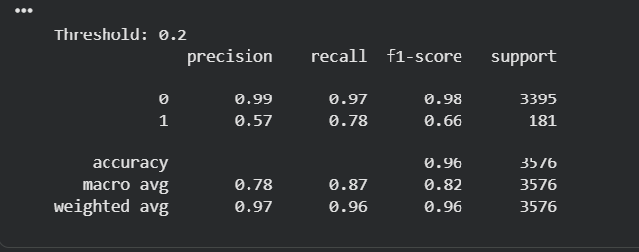
Analysis
- Recall for fake jobs improved to 0.78
- Precision is 0.57, indicating some false positives
- Accuracy remains high at 96%
Logistic Regression effectively detects fraudulent jobs.

3. Naive Bayes Results
Description
Naive Bayes model was tuned using alpha parameter.
Output
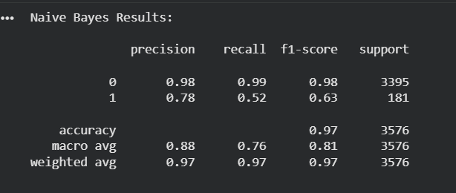
Analysis
- Recall for fake jobs is 0.52
- Precision is 0.78, indicating reliable confirmation
- Performs better in precision but lower in recall
Naive Bayes is useful for confirming fraud cases.

4. Ensemble Model Results
Description
The final system combines Logistic Regression and Naive Bayes using a rule-based ensemble approach.
Output
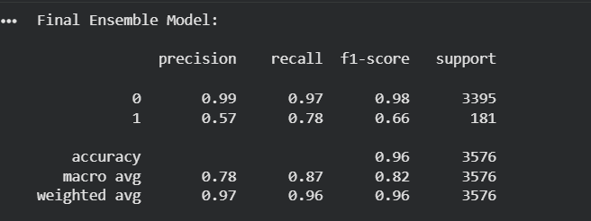
Analysis
- Recall remains 0.78, ensuring high fraud detection
- Balanced performance between precision and recall
- Ensemble provides more explainable results

5. Model Comparison
Model | Precision (Fake) | Recall (Fake) | Accuracy
Logistic Regression | 0.57 | 0.78 | 96%
Naive Bayes | 0.78 | 0.52 | 97%
Ensemble Model | 0.57 | 0.78 | 96%

Interpretation
- Logistic Regression achieves high recall
- Naive Bayes achieves high precision
- Ensemble combines strengths of both models
6. Test Case Analysis
Input Type | Expected Output | Actual Output
Fake job (fee-based) | Fake | Fake
Real job (company role) | Real | Real
Mixed case | Moderate Risk | Correct

i)Fake job
Input:
Work from home job. Earn ₹5000 daily. Pay registration fee to start immediately.
Output:
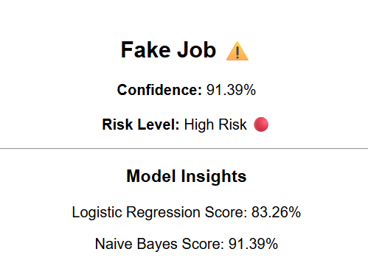
ii)Real Job
Input:
Software Engineer position requiring knowledge of Python, Java, and REST APIs. Apply through official company portal.
Output:
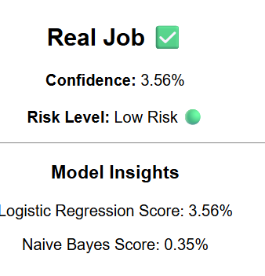
iii)Mixed Case
Input:
Internship with stipend available. Candidates must complete a paid training program before joining.
Output:
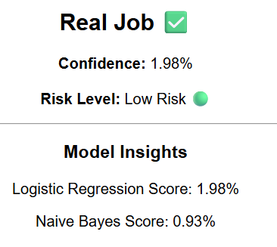

7. Performance Insight
- The system prioritizes fraud detection (recall)
- Threshold tuning improved detection significantly
- Ensemble approach increases system reliability

8. Key Observations
- Lowering threshold improves recall
- Class imbalance affects model performance
- Combining models improves robustness
CONCLUSION
The project “Fake Job / Internship Posting Detection using Data Mining” successfully demonstrates the application of machine learning techniques to identify fraudulent job postings. The system utilizes Natural Language Processing (NLP) with TF-IDF feature extraction to convert textual job descriptions into meaningful numerical representations.
Two machine learning models, Logistic Regression and Naive Bayes, were implemented and evaluated. Logistic Regression was optimized using class weighting and threshold tuning to improve recall, ensuring that a higher number of fake job postings are detected. Naive Bayes was tuned using smoothing techniques to improve precision.
A rule-based ensemble approach was developed to combine the strengths of both models. The final system achieved high recall (~78%) and strong overall accuracy (~96%), making it effective for real-world fraud detection scenarios.
Additionally, the model was deployed using a Flask web application, allowing users to input job descriptions and receive real-time predictions along with confidence scores and risk levels. This enhances usability and practical applicability.
Overall, the system provides a reliable, explainable, and scalable solution for detecting fake job postings and improving digital safety for job seekers.

FUTURE WORK
The current system can be further enhanced in several ways:
- DeepLearning-Models
Implement advanced models such as BERT or LSTM to improve contextual understanding and accuracy.
- Multi-language-Support
Extend the system to support multiple languages such as Tamil and Hindi for wider accessibility.
- Browser-Extension
Develop a Chrome extension to detect fake job postings directly on job portals like LinkedIn.
- API-Integration
Integrate with job platforms and email systems for real-time scam detection.
- Explainable-AI
Highlight suspicious keywords and provide reasons for classification.
- Mobile-Application
Convert the system into an Android application for easy access.

REFERENCES
[1] N. Akram, R. Irfan, A. S. Al-Shamayleh, et al.,
“Online Recruitment Fraud (ORF) Detection Using Deep Learning Approaches,”
IEEE Access, vol. 12, pp. 109388–109408, 2024.

[2] T. N. Goud and N. R. Reddy,
“A Machine Learning Approach for Detecting Fraudulent Job Postings in Online Recruitment Platforms,”
Journal of Sensors, IoT & Health Sciences, vol. 3, no. 3, pp. 14–28, 2025.
[3] D. H. Vu,
“Improving Fake Job Description Detection Using Deep Learning-Based NLP Techniques,”
Journal of Computational Social Science, 2025.

[4] S. Devi, L. Reddy, and C. Chandra,
“Real or Fake Job Posting Detection Using Machine Learning Techniques,”
International Conference on Emerging Technologies, 2024.

[5] P. Kumar and D. Bhagya,
“Fake Job Post Detection Using Machine Learning Algorithms,”
International Conference on Intelligent Computing Systems, 2025.

[6] A. Ullah and M. Jamjoom,
“A Smart Secured Framework for Detecting Online Recruitment Fraud Using Ensemble Learning,”
PeerJ Computer Science, vol. 9, 2023.

[7] Z. Ullah, et al.,
“Securing Online Job Platforms: A Distributed Framework for Employment Fraud Detection,”
International Journal of Safety and Security Engineering, 2024.

[8] A. Sasidharan Pillai,
“Detecting Fake Job Postings Using Bidirectional LSTM,”
arXiv preprint, arXiv:2304.02019, 2023.

[9] P. Pradeep Kumar, et al.,
“Fake Job Posting Detection: A Comparative Study of Machine Learning Models,”
International Journal of Engineering Studies, 2025.

[10] S. Maharajpet, et al.,
“Automated Job Post Authenticity Verification Using NLP and Machine Learning,”
Neural Processing Letters, 2025.

The implementation of the project, including data preprocessing, model training, and evaluation, is available at the following Google Colab link:

https://colab.research.google.com/drive/1eP3w8ajXbmyyMDxrJgMw436wlPUzMQL_?usp=sharing

