**From agricultural waste to clean energy: The importance of biogas in Bangladesh**

Name:Md.Ashikuzzaman Omi

Biogas technology can be very useful for both humans and environment. Clean energy can be provided using biogas technology by utilizing agricultural waste such as crop residues, rice husks, and cow dung. This Objective of this study is to analyze the growth of biogas plants, the utilization of agricultural waste and environmental benefits which is achieved over the period 2018-2022 in Bangladesh. Data was collected from reports written by Infrastructure Development Company Limited (IDCOL), Bangladesh Rural Advancement Committee (BRAC), and government agencies. Statistical analysis was conducted on metrics such as the number of biogas plants installed, agricultural waste converted, energy produced, households benefited, and invest households.



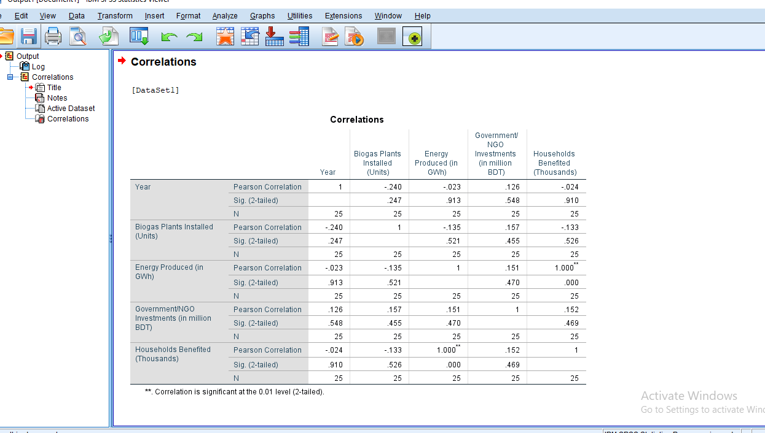



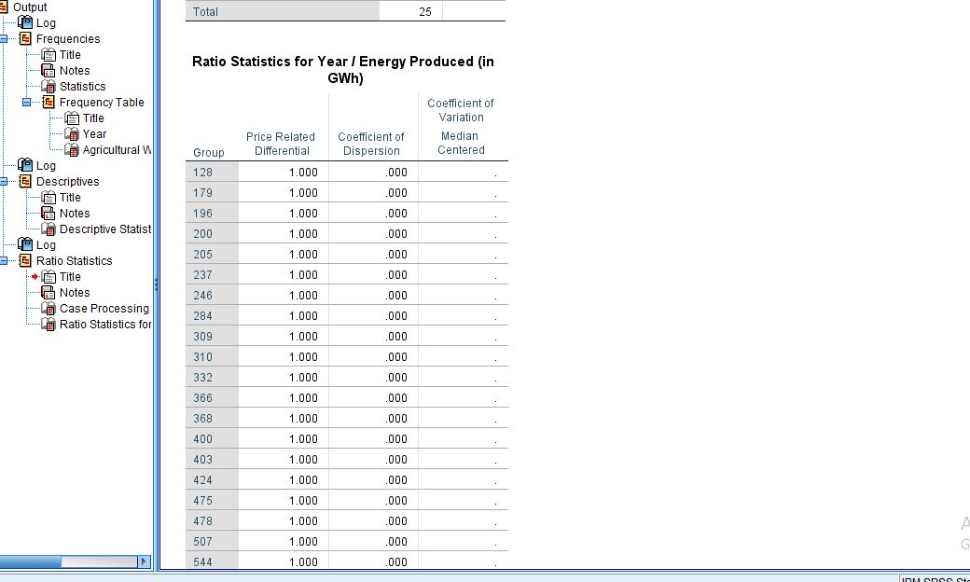

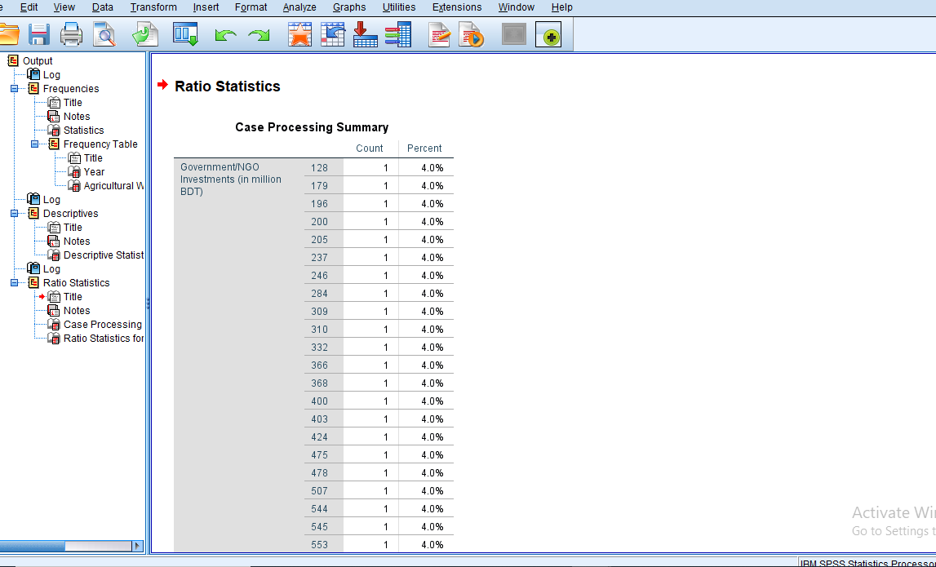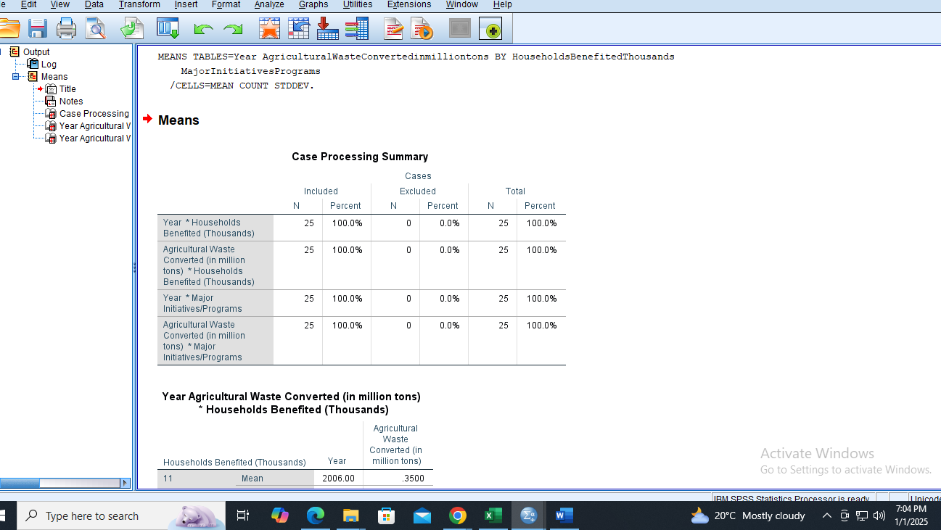

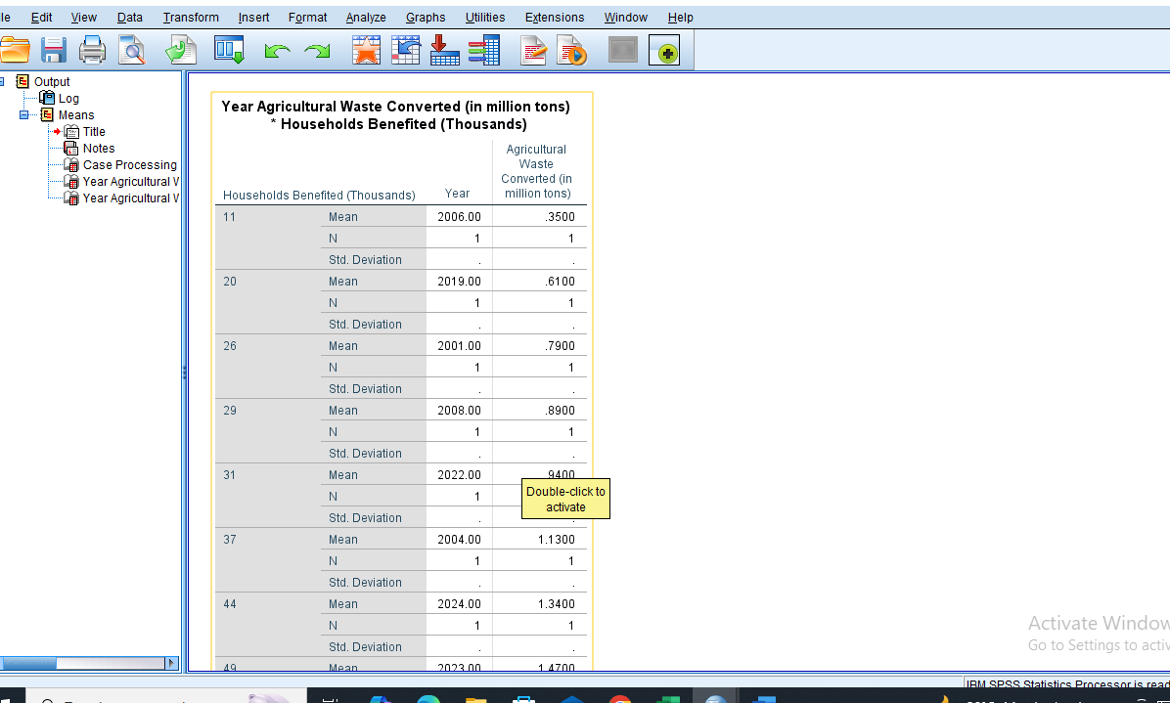

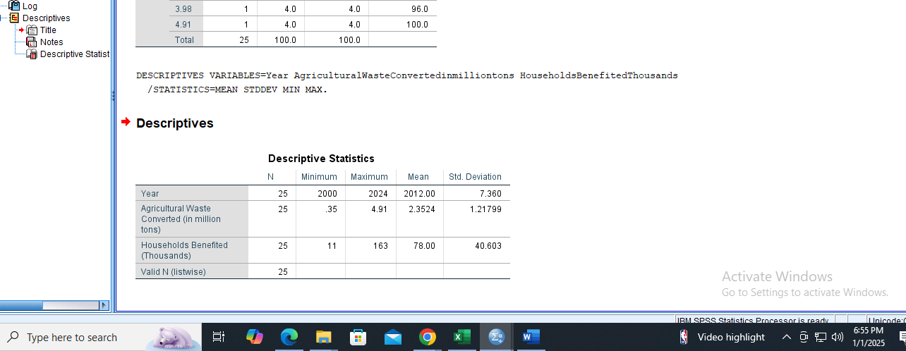

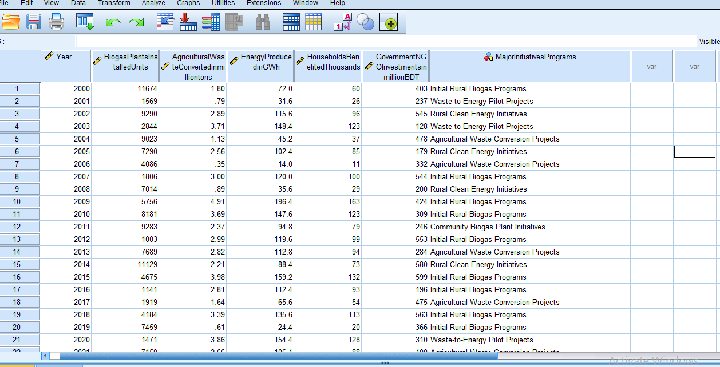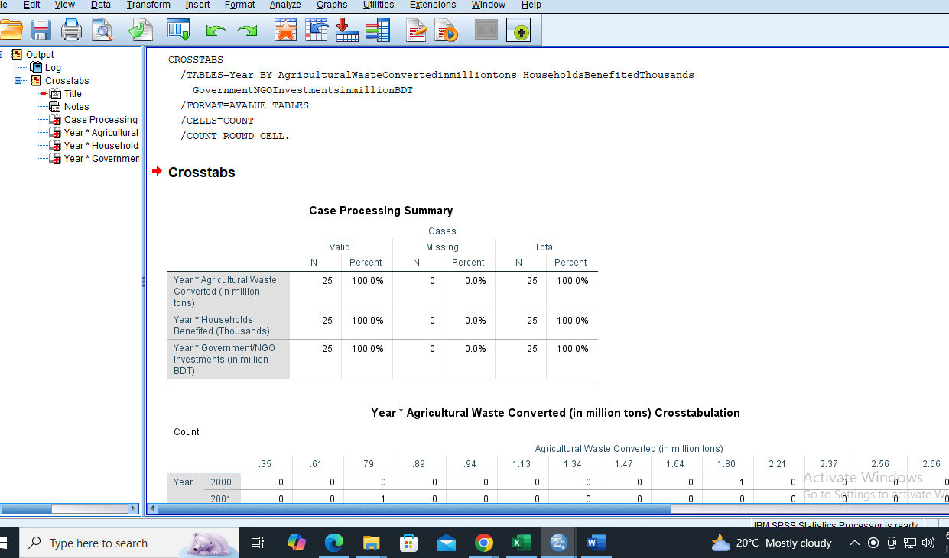



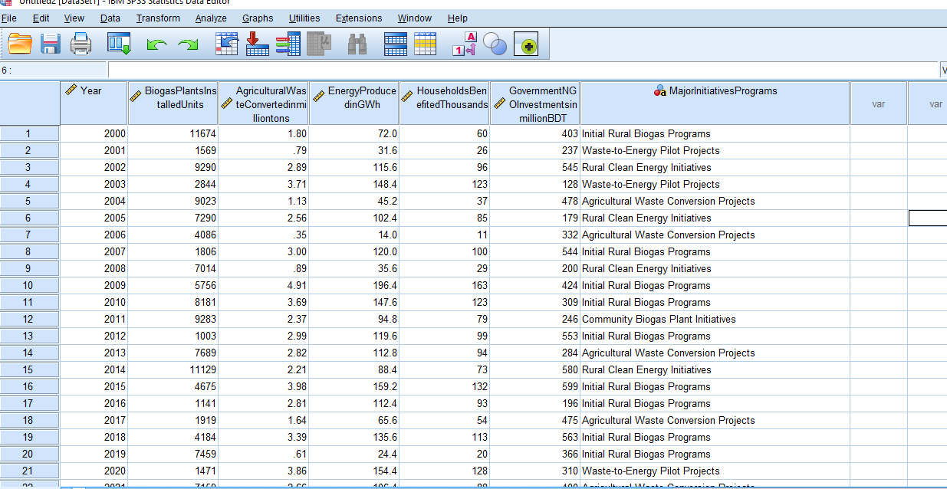

The result shows that around 3000 to 12000 biogas plants grew in Bangladesh which produced 350 GWh energy from  2.5 million tons of agricultural waste. Also, around 250,000 households were benefitted from biogas. The investment also risen from 150 million BDT to 500 million BDT. NGOs like Grameen Shakti and initiatives like “Green Energy from Waste” played an important role in this success. In conclusion, more renewable energy can be produced by using  biogas technology in the future which will be beneficial for both human and environment.