Project Design Phase-II
Data Flow Diagram & User Stories \

Date | 7 March 2026
Team ID | PNT2022TMID00001
Project Name | Predictive Pulse – Risk Prediction System
Maximum Marks | 4 Marks

Data Flow Diagrams:

- Level 0 (Context Diagram):

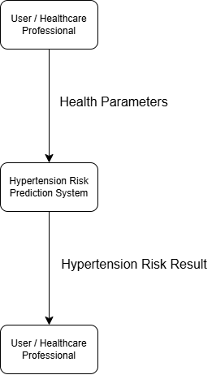

- Level 1 (DFD):

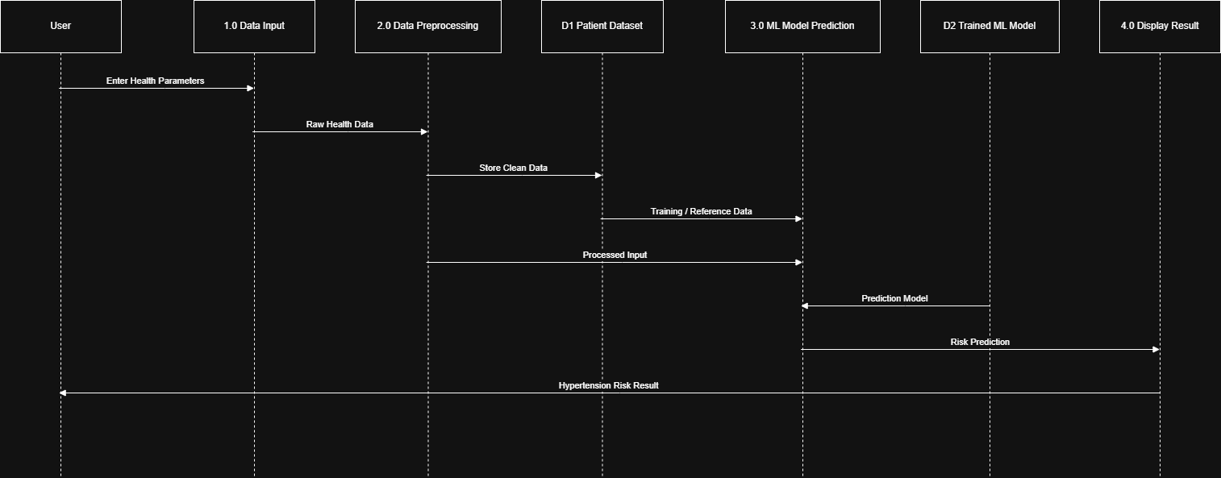

User Stories:

