**Determining Efficacy of Regional Greenhouse Gasses Initiative**

One of the greatest political battles of these past few years is the issue surrounding climate change and its many factors. The media has frequently lambasted the eventual “carbon tax” and politicians have denied global warming with snowballs in hand. Scientists on the other hand have long determined that carbon dioxide (CO2), a greenhouse gas emitted through human activity, has been a major contributor to these instabilities. Some pundits argue cow farts are the real danger, but they fail to realize CO2 comprises about 80.9% of all greenhouse gasses in the U.S.; and also the emissions have been steadily increasing with population growth. In an effort to curb CO2 emissions, the Regional Greenhouse Gas Initiative (RRGI) is a program instated for the Northeast and Mid-Atlantic States (Connecticut, Delaware, Massachusetts, Maryland, Maine, New Hampshire, New Jersey, New York, Rhode Island, and Vermont). Instead of taxing, RGGI uses a market-based cap and trade approach that is – companies who don’t use all of their CO2 allowance can sell their excess for money to others. The program includes:

1. A multi-state CO2 emissions budget
2. Requirements for fossil fuel-fired electric power generators
3. Allocating CO2 allowances
4. Investing proceeds
5. Allowing offsets
6. An emissions and allowance tracking system

RGGI’s compliance period began on January 1, 2009. With only 6 years of data, and a program that’s still developing, it may be hard to say whether or not we’re heading in the right direction. The following line graph shows the total CO2 emissions per quarter:

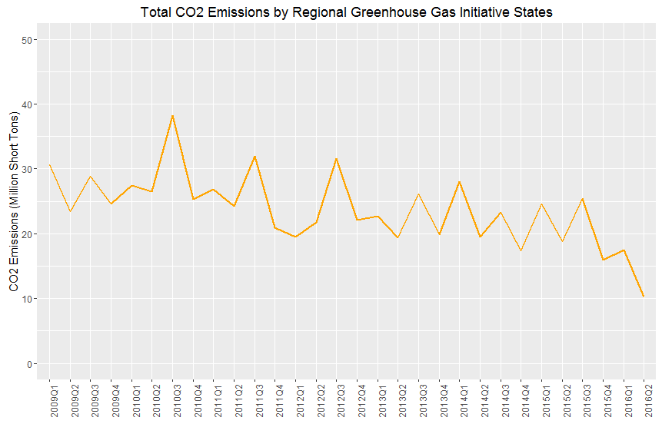

*NJ is omitted because they withdrew from the program in 2011.

We are trending downward, which is a good sign of course. There could be many confounding variables, such as potential downsizing of power plants because of tougher regulation: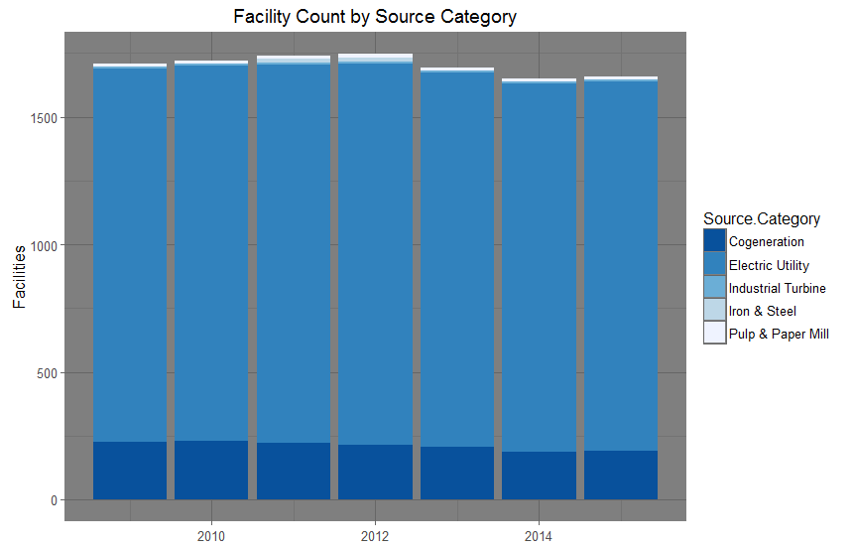

*NJ is omitted because they withdrew from the program in 2011

It looks like there are fewer facilities ever since 2013, though not by much that would affect our statistic. During 2012, they concluded that in 2014, there would need to be stronger regulations. The new enforced cap was 45% than it was prior. In order to determine the effectiveness of the program, we should take data pre 2014, and 2014 +. We can then compare the efficacy of the new cap: 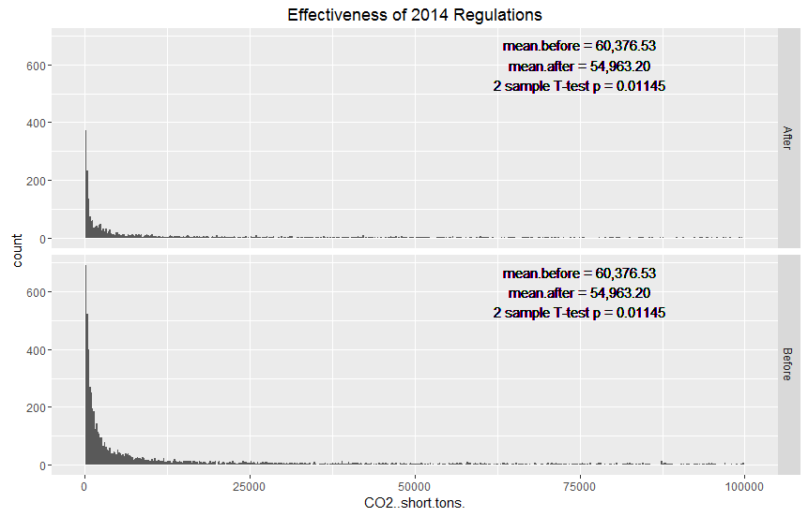

*NJ is omitted because they withdrew from the program in 2011.

The distribution looks skewed, but good enough to do a two sample T-test; the outputs are displayed on the histograms above. What we see here is significant evidence that we have reduced our output on average per facility (~5,000 tons of CO2 per quarter).

The program shows great promise – we can only hope that this initiative gets passed to the rest of U.S. Its only time that we’ve realized our environment comes with a cost, and that we have to do our best to preserve it for future generations.

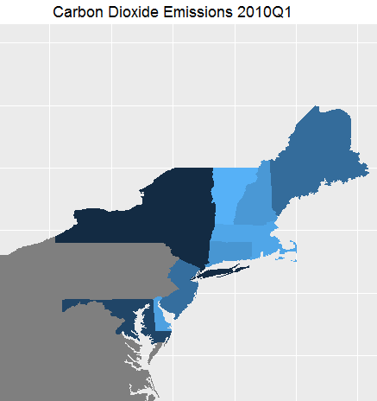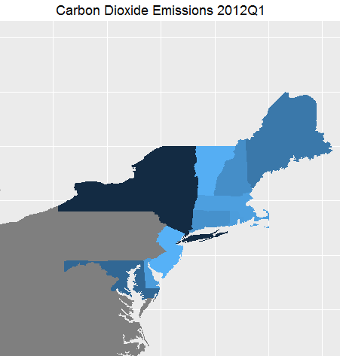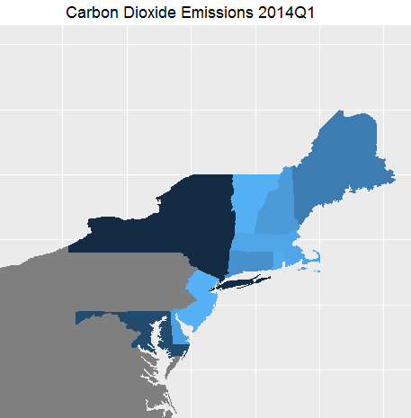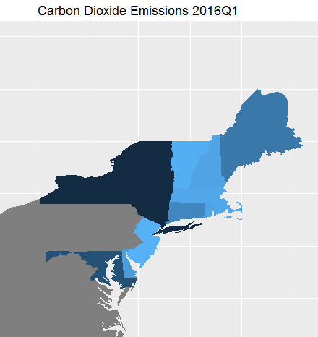

*Heat maps of CO2 emissions by state. Darker colors mean more emissions.