**Project Name: DHCP and HTTP server in packet tracer.**

# Introduction:

In this project we worked about how to configure **DHCP**, **DNS**, and **HTTP** servers along with switches. We learned this configuration by a lab in Cisco packet tracer and try to understand the working of servers, but before stating this lab we also learn basics of servers, switches and routers like why we use servers and why we need servers in our daily life. So, before starting the lab we will discuss about the uses and importance of servers, switches and routers and we also learn the impact of servers in our daily life.

# Tools:

In this project we used switches, routers, DHCP server, DNS server, HTTP server and PC. Here we will tell described some basic concept of these components in detail.

1. **Switch**: – A network switch is a computer networking device that connects devices together on the same network. In other words, we also say that the switch is a networking device which connects a large number of systems on the same network. A switch is a medium through we send and receive data packet from one system to another in a same network. If we want to connect systems from the different networks in that case switch is useless in that situation we use a router to connect systems from different networks.

**2.Router**: - Router is a networking device that connects switches together on the different network. Another way to say that A router is a [networking device](https://en.wikipedia.org/wiki/Networking_device) that forwards [data packets](https://en.wikipedia.org/wiki/Data_packet) between [computer networks](https://en.wikipedia.org/wiki/Computer_network). Routers perform the traffic directing functions on the [Internet](https://en.wikipedia.org/wiki/Internet). A router is connected to two or more data lines from different networks. When a data packet comes in on one of the lines, the router reads the [network address](https://en.wikipedia.org/wiki/Network_address) information in the packet to determine the ultimate destination. Then, using information in its [routing table](https://en.wikipedia.org/wiki/Routing_table) or [routing policy](https://en.wikipedia.org/wiki/Routing_policy), it directs the packet to the next network. The most familiar type of routers are [home and small office routers](https://en.wikipedia.org/wiki/Home_router) that simply forward [IP packets](https://en.wikipedia.org/wiki/IP_packet) between the home computers and the Internet.

**3.DHCP** server: – The DHCP (dynamic host configuration protocol) is a standardized network protocol which is used on internet protocol (IP) networks. DHCP is used to assign IP automatically to the system with the help of a machine called DHCP server. A DHCP server enables computers to request IP addresses and networking parameters automatically. In the absence of a DHCP server, each computer on the network needs to statically (manually) assigned to an IP address.

**4.DNS** server: – DNS (domain name server) is a server which is used to assign names to an IP address. It allows you to connect to any website or network by simple names instead of their IP address. It is really very hard to memorization of IP addresses of any website and network so here DNS help us by convert the number into a name. Now we just type only name instead of IP of any website and network to search it on internet

**5. HTTP** server: – HTTP (hypertext Transfer Protocol) is a medium which is used to make communication in between client and server. The primary function of a HTTP server is to store, process and deliver web pages to clients. Pages delivered are most frequently HTML documents, which may include images, style sheet and scripts in addition to text content.

# Procedure, Design and Implementations:

Now we will configure servers in Cisco packet.

**Step 1:** – First of all we go to the DHCP server and click on it to open it. Then a screen will be open in it, we will click on the desktop option and then click on IP configuration to provide IP address statically to the DHCP server and also give the IP address of the DNS server in the column of DNS server.

**Step 2:** – After that now choose the service option in it to make that server as a DHCP server and it is able to provide an IP address automatically to the other systems. In it, we fill all entries on this server and choose ON option in it as given below to turn on DHCP server. Now our DHCP server is configured successfully. The work on DHCP server will be done completely. Now this machine is able to provide IP addresses to other systems which are connected to that network.

**Step 3:** – Now we configure DNS server by clicking on it. After clicking on the DNS server we click on the desktop option and then click on IP configuration option to provide IP address to the DNS server. In IP configuration option we change it from static to DHCP. Now it has taken IP address automatically from the DHCP server.

**Step 4:** – Now before make this machine a DNS server, we go to HTTP server and provide IP address to it by using DHCP server similarly as DNS server and then after that click on services option to make this machine as an HTTP server. In services we choose HTTP from the left sidebar and now there create a page or edit a page which you want to see in your web browser.

**Step 5:** – After that we again, click on DNS server and then select DNS option from the right sidebar in it and click on it to configure this machine as a DNS

server. In it, we give the name and IP address of the HTTP server and then click on add option in it to provide a name to IP address of the HTTP server which helps us to open that web page by name instead of IP address of the HTTP server and generally name will be easy to memorize by us. After that we choose ON option to start DNS server. Now all servers are configured by us and now we move on PCs to provide IP address to them by using a DHCP server all set now. After that we will go to any PC on that network and then go to the web browser and we type name of our page google.com in it which is given in the DNS server by us to open it in our system browser. And now outcome will be appeared in the form of our page which is made by us in HTTP server. It indicates that all servers are working properly because the messages go to DNS server where it directs it to the http server and the webpage google.com loads from HTTP server to our computer screen. That’s It all servers and PCs working properly and communicate each other.

# Simulation:

1. We are going to apply DHCP on server and PCs will be assigned IP addresses through DHCP.

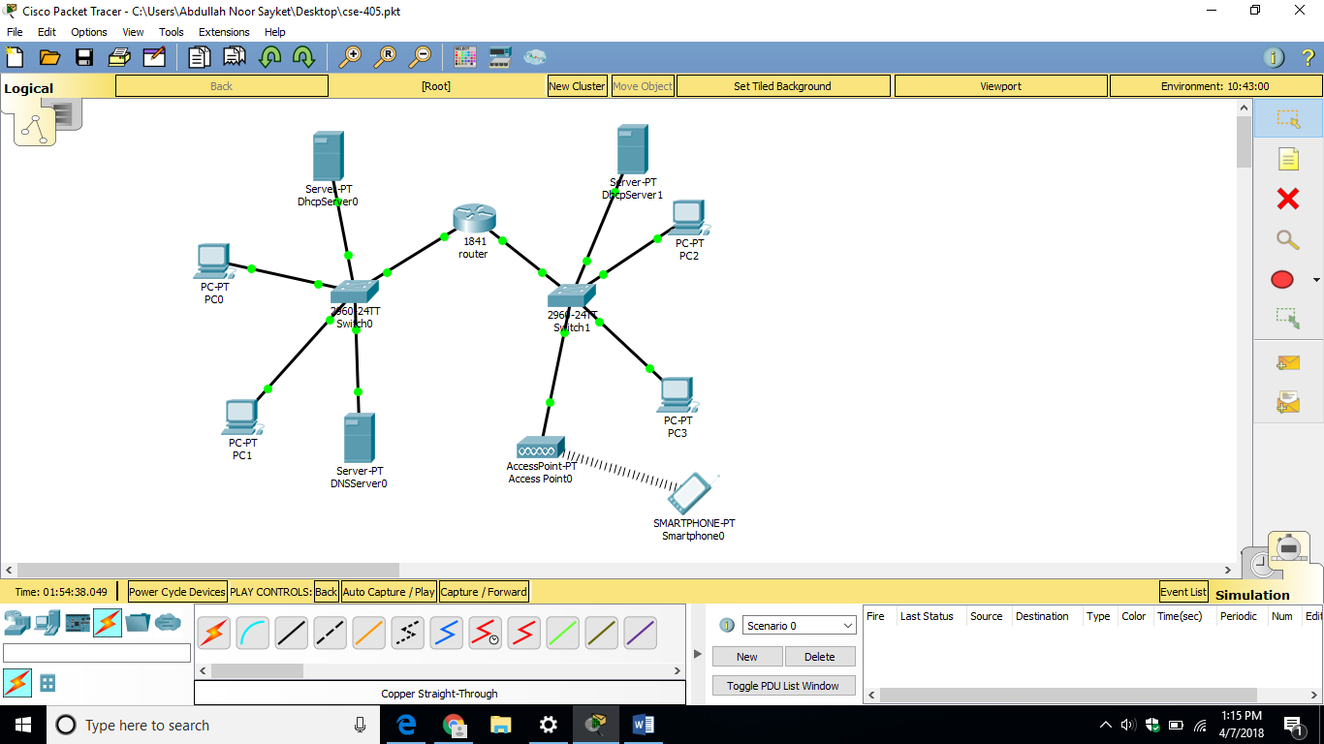

1. Open the server and go to the Desktop tab, click IP Configuration and enter the IP address.

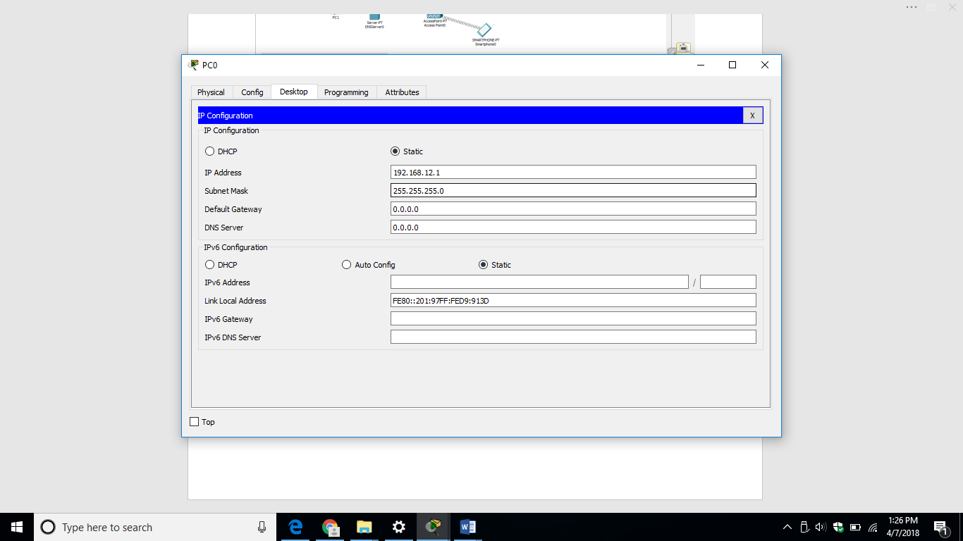

1. Now, go to the Services tab.
2. And go to the DHCP.
   1. Click service ON and Enter IP for default Gateway.
   2. Start IP address.
   3. Maximum number of Users.
   4. Click Save.

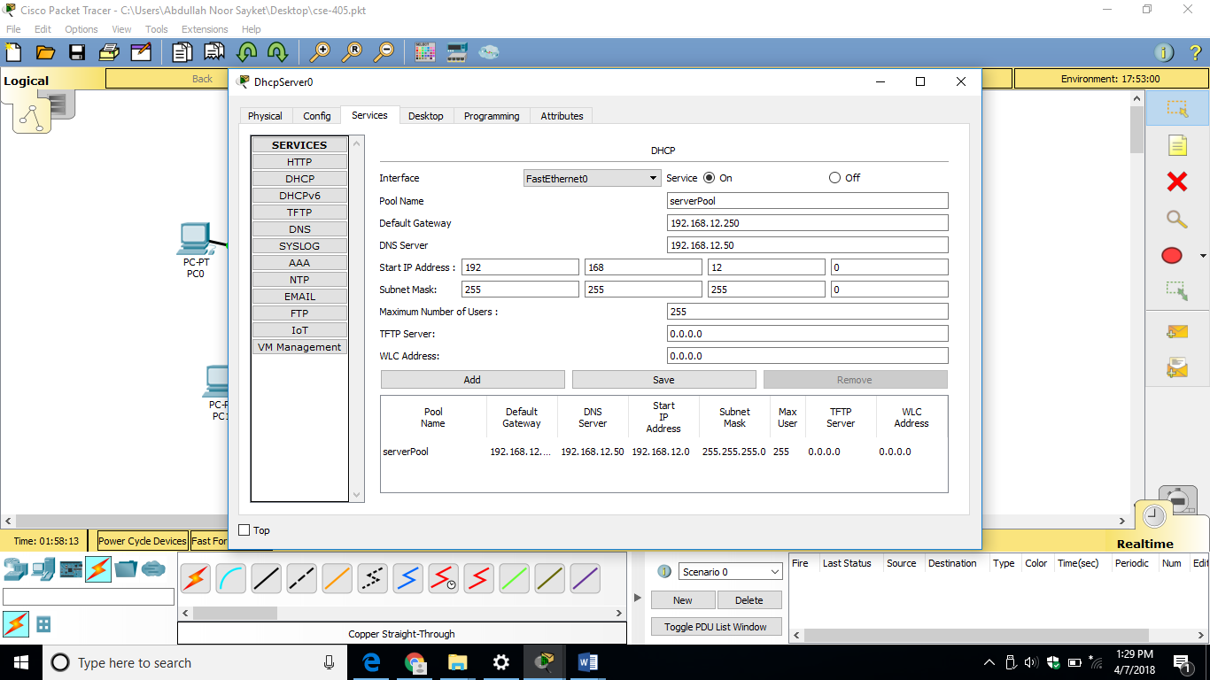

1. Now, click on any PC that is attached to the server, go to IP configuration and select DHCP. We see that DHCP will successfully assign IP address to the PC. We see that “***DHCP request successful.***”

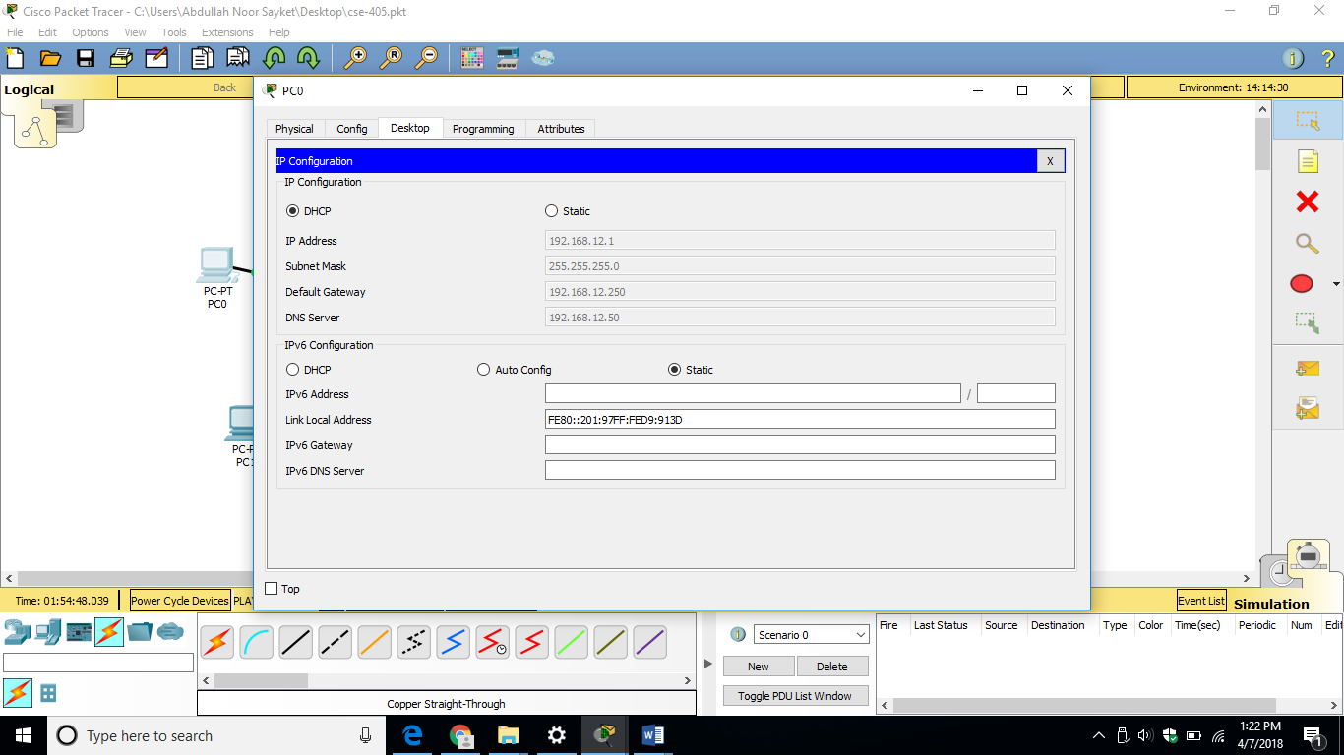

1. In this same way create DHCP request for all pc.
2. When we add PDU we see that simulation become successful.

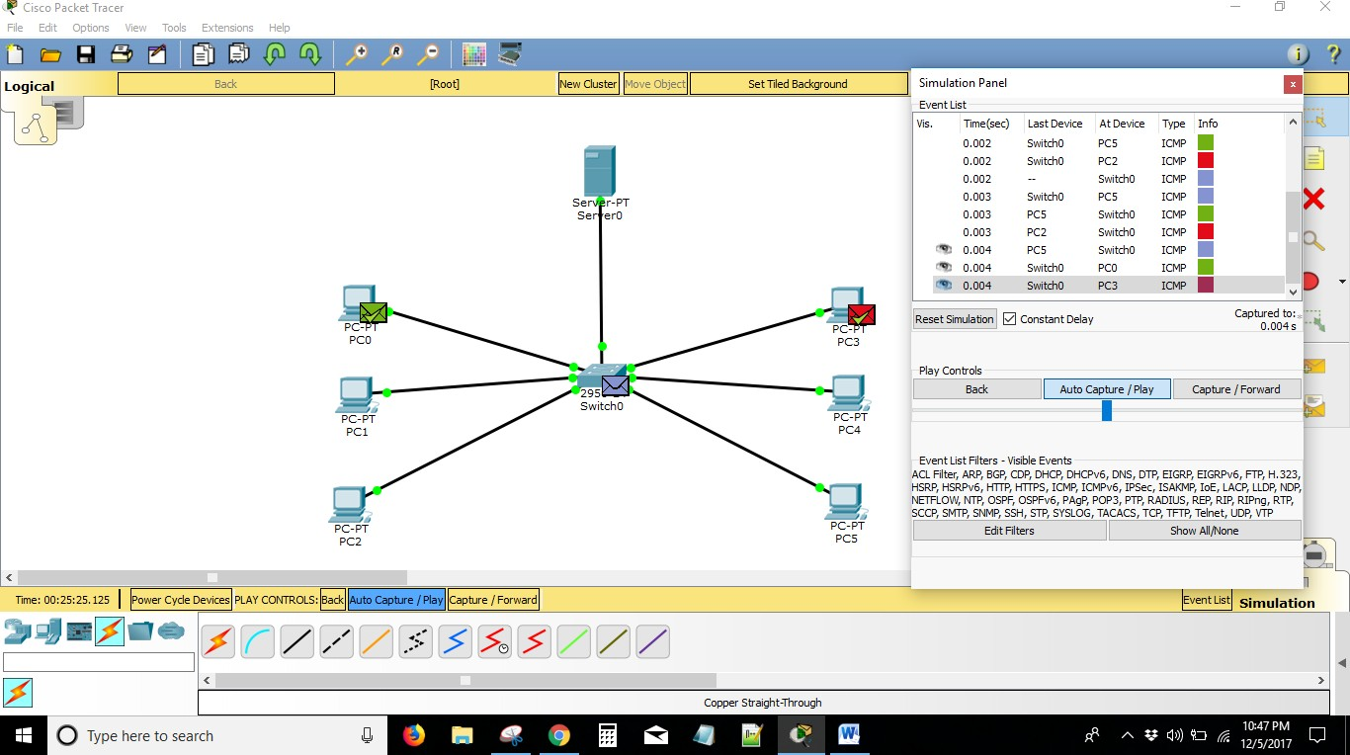

1. In wireless communication smartphone can send the packet and receive the packet successfully

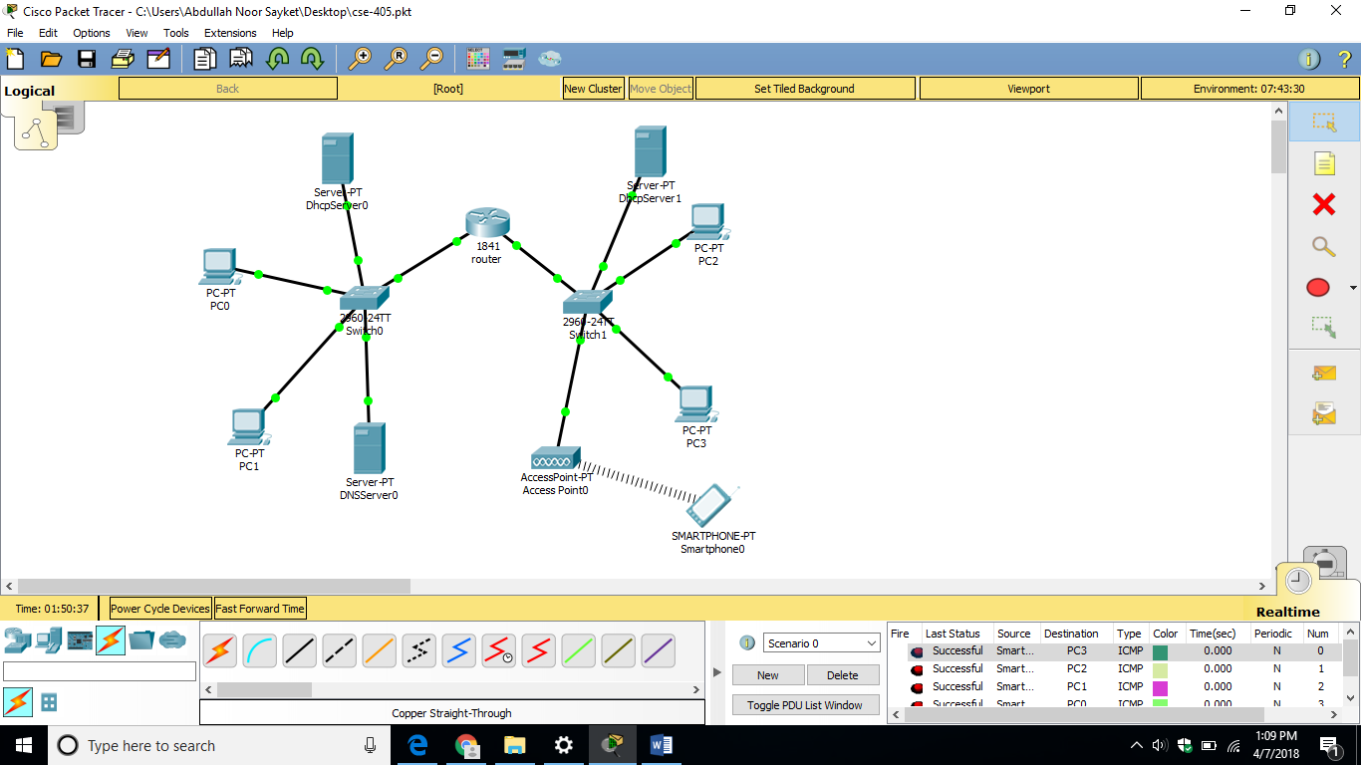

9.Now form service click Service then **HTTP**. Click HTTP service ON. We can also open the website of the server through any PC by going to the Web Browser option and entering the web address.

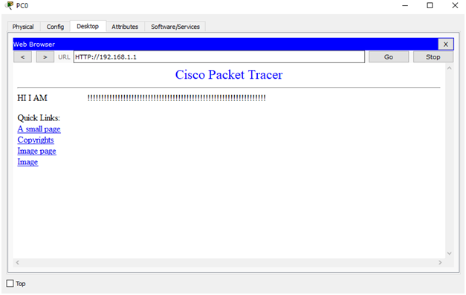

10.And we can ping the server by going to the PC’s command prompt and entering server’s IP address. Click any pc then click command prompt and ping with server. Commend: ping 192.168.1.1 and we see ping was successful.

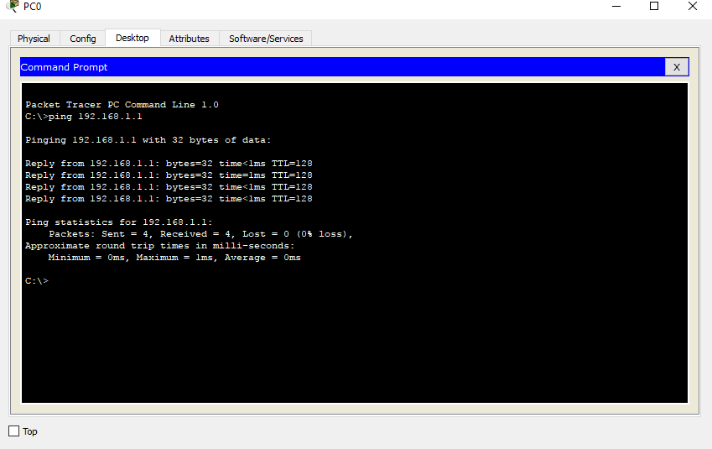

# Conclusion:

We have successfully configured **DHCP**, **DNS** and **Web server (HTTP)** with IPv4 addressing and address translation. From our project we see that all of the servers and PCs are working properly and communicate each other.