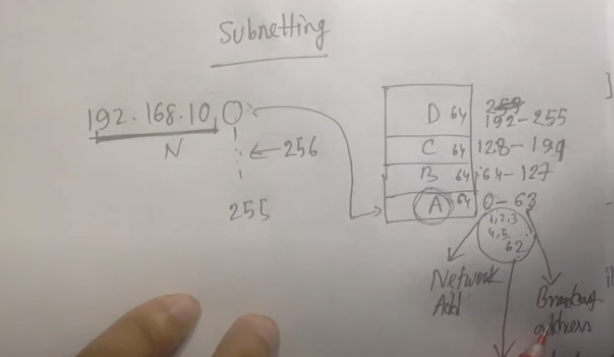

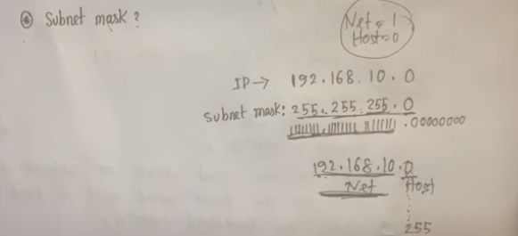

Network address er kono change amra kortay pari na, eita fixed thakay altime . amra host part change kortay pari.

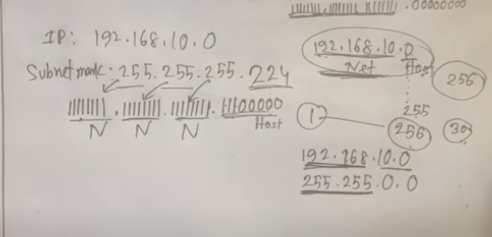

Eikhnay amra jani host bit e 0 diye start hobay kinto c class e total host 256 ta hobay kinto eikhanay amer 256 ta host lagtasay na, like amer 30 ta host ip lagbay taholay baki gula khali poray thakbay ei jonnow amra proper use korar jonnow host er moddee network niye asbo ebong host address takay vag koray felbo. Orthat host address ta er moddee network address create korakai bolay subnetting.

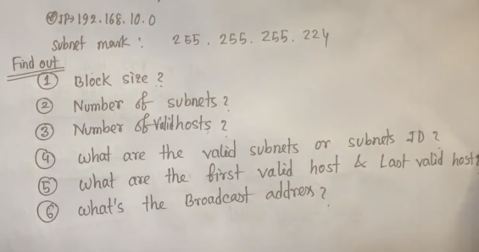

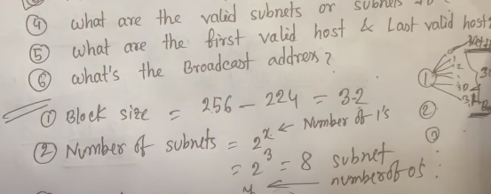

Block size--- total ekta block e koita host thakbay seta ber koray block size diye. Orthat each block e 32 ta koray host thakbay.

Number of subnets ---- 224 er modde koita network address assay 11100000 eikhanay 3 ta network address assay tai 2 the power 3 hoysay. Orthat eikhany 8 ta block hobay total.

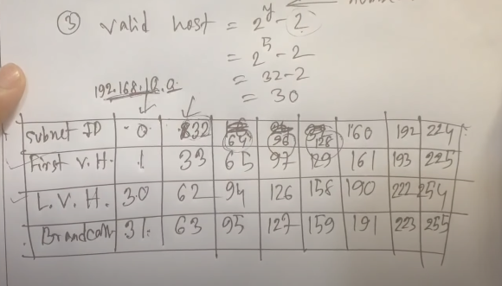

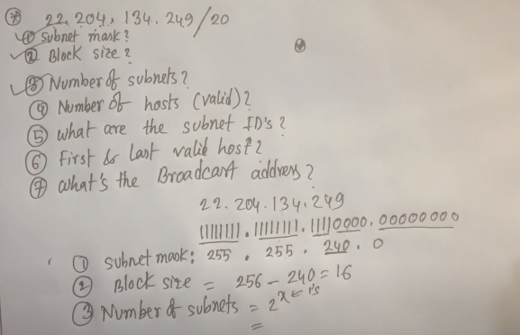

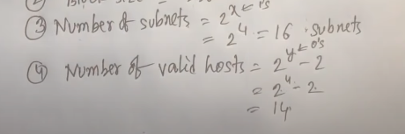

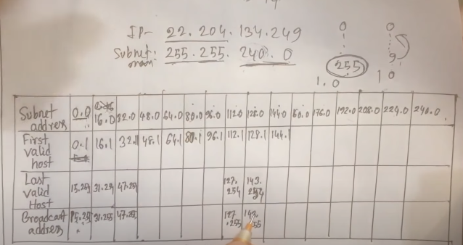

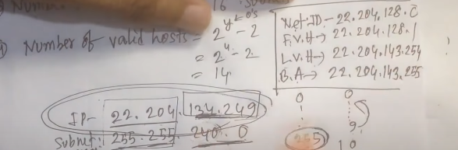

22.204.134.249 er network address F.V.H , L.V.H, Broadcast address ber kortay bolay then math ta kora hoyesay.

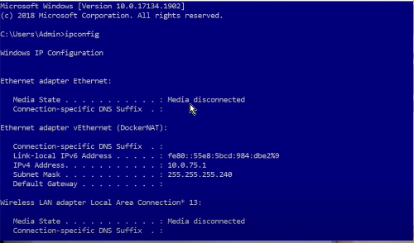

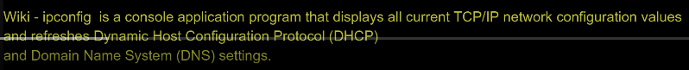

ipconfig dilay pc er address , dns, all details dekha jai.

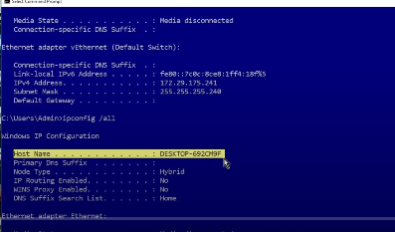

Ipconfig /all --- give us more information



