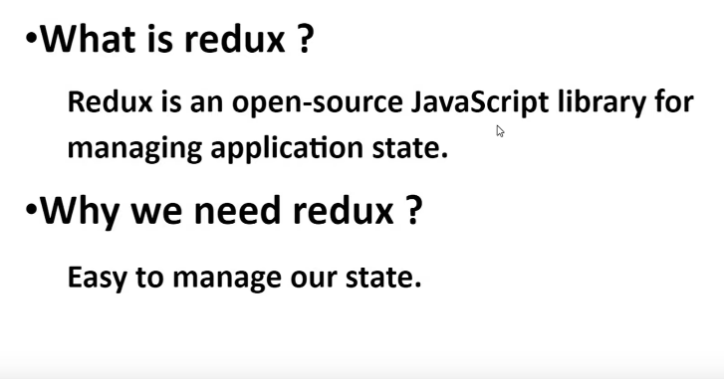

Redux is not part of react. Redux is a third party application. Redux jemon react er sathay babohar kora jai temon aber angular er sathaw use kora jai. Orthat react er sathay er kono relation nai.

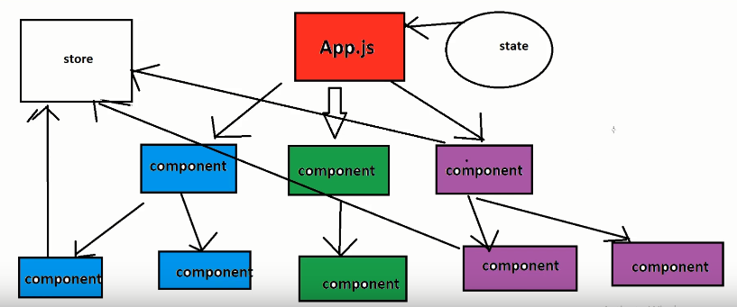

Props simply data pass koray abar ebong state store er kajay use kora hoi. Ekhon redux er kaj hoschay store management kora. Redux er maddomme alada ekta store create kora hoi ekhon parent, child, grandchild jar proyojon sei ei store er kasay call koray proyojonio data niye kaj kopbay. Etay koray onnow karo upor depend kortay hoi na. ekhon directly connection pai all component. Etay koray jamela kom hoi.

Onek boro boro kajae redux use kora hoi. Like ecommerce site jekhanay onek data transfer er kaj hoye thakay. Boro project gulo redux use na korlay onek jamela hoi management kortay. Ejonoow redux er bhumika onek.

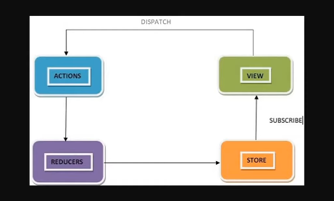

Action- redux e kiso basic kiso action thakay. Like database thekay data niye astay hobay ekhon ei data niye asar kajta koray thakay action.

Reducer- database thakay data niye asar por action er upor depend koray reducer e bola hoi like action Jodi getData or postData hoi then data gulo store e data store kora hoi like data Jodi hoi array then store e data initially empty array diye bollay dibo.

Orthat action er data Jodi get data hoi jeta reducer e check korbay get data naki failed data Jodi get data hoi then store e oivabay store kora hoi abong data update hobay. Ekhon get data Jodi hoi failed data then store e ekta error generate koray rakha jai but data update hobay na.

Successfully data update holay view component e data show korano hobay. Data error holay store e error generate korbo then view e seta show korabo. Esaraw data Jodi failed data hoi then action thekay directly dekhano jabay kono third party use korar maddome.

Action gula ki hobay seta type.js e boltay hoi. Ekhanay action gulo holo increment or decrement.

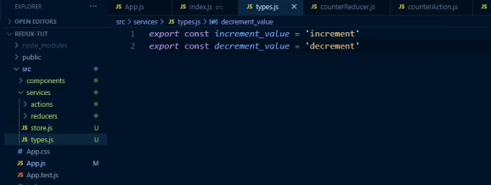

Reducer🡪

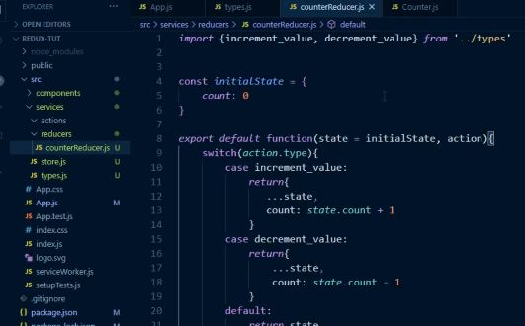

Reducer er action gulai counteraction.js e thakay ekhon counteraction.js e Jodi increment hoi then reducer e jabay ebong increment call hobay ebong 1 increment korbay.

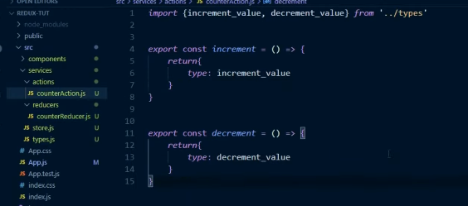

Eker odhik Jodi reducer thakay then sob reducer kay combine korar jonnow index.js e sokol reducer combine kora hoi. Atfirst reducer gula import kortay hobay then combine reducer e add kortay hobay.

Store.js e create store ebong combine er index.js import kortay hobay. Then create store er moddew rootreducer ebong jotogula state thakbay sobgula bolay ditay hobay.

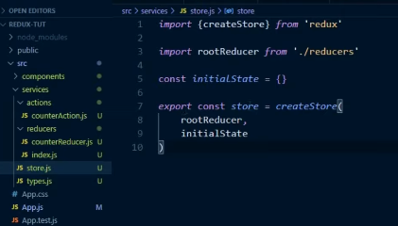

Store.js e root reducer er jonoow app.js othoba index.js er moddew provider ar store import kortay hobay then props er maddome store pass koriye ditay hobay ebong <app/> ta kay provider e wrap koray ditay hobay.

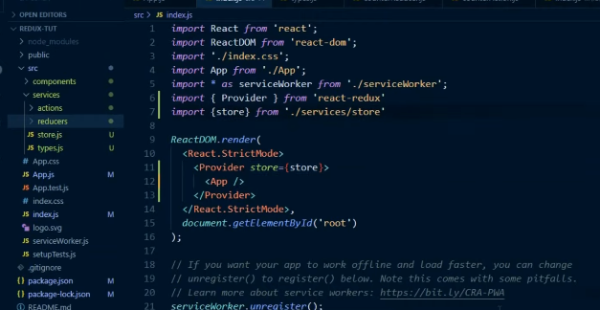

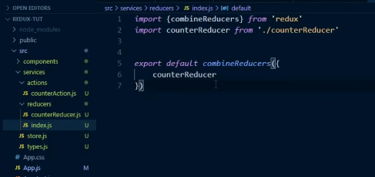

View🡺

Eikhanay redux er method, props connect kora hoi. Then counter action connect kora hoi. Then export default e duita argument pathatay hoi ekta mapstatetoprops eita use kora hoi Jodi state er value thakay ebong proyojon poray then amader eikhanay state er value 0 rakha hoyesay seheto eita eikhanay lagbay. Jodi na lagto then use kortam null. Then increment, decrement method call kora hoyesay. Jodi method er proyojon na porto taholay eita use kortam na.

Mapstatetoprops er maddomme props er maddomme state pass koray dibo ebong count nibo jar moddew state thakbay sathay combine reducer er counterreducer add kortay hobay then count bolay ditay hobay atlast ei count ta counter er moddee ditay hobay.

Atlast button er moddee onclick event use koray increment decrement function use koratay hobay.

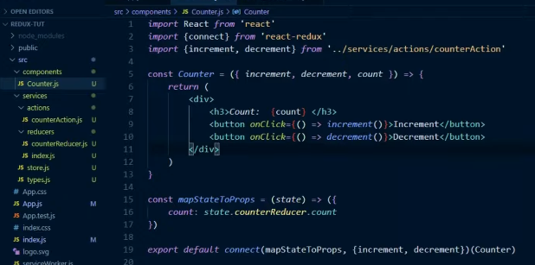

Ekhon increment korbo 5 but decrement korbo 1

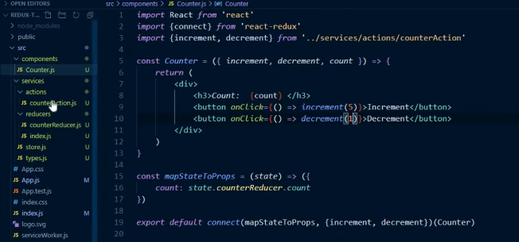

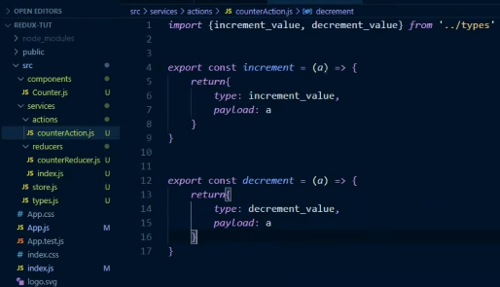

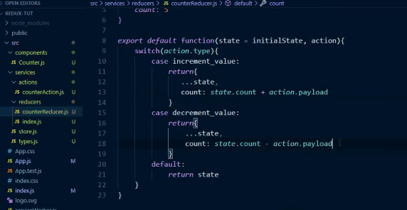

Hook use koray counter er maan inrement ,decrement kora jai. Ekhon hooks duita method provede koray thakay useSelector, useDispatch, jeduita import koray newa hoyesay. Then useSelector er maddome count er maan niye bosabo then button e dispatch use korbo dispatch er moddee increment decrement thakbay.

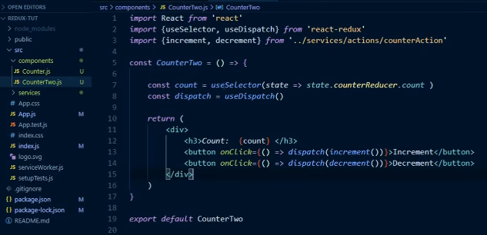

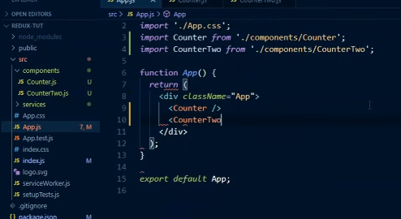

Redux logger er kaj hoschay state er value update hoyota console e dekha jabay. Action er kajgulo view er moddee update koratar majay kaj koray thakay redux-logger.