Flight Delay Prediction System using Machine Learning

Flight Delay Prediction System
This project predicts whether a flight will be Delayed or On Time using Machine Learning.
It uses flight data and shows results through a simple web app built with Streamlit.

What this project does
- Takes flight details as input
- Predicts delay using a trained model
- Shows:
  - Delay probability
  - Final result (Delayed / On Time)

Files in this project
model.py Trains the machine learning model
app.py Web application (Streamlit UI)
arrivals.csv Flight arrival data
depature.csv Flight departure data

rf_model.pkl Saved trained model
features.pkl List of features used by model

feature_importance.png Important features graph
roc_curve.png Model performance graph

About Dataset
The project uses two datasets:
- arrivals.csv
- depature.csv
These are combined into one dataset for training.

How the model works (Simple)

1. Combine Data
Both CSV files are joined into one dataset.

2. Convert Time
Flight time like 10:30 is converted into minutes:
Example:
- 10:30 → 630 minutes

3. Handle Missing Data
If any value is missing → replaced with 0

4. Create Target Column
Delayed = 1 → if flight delay > 0
Delayed = 0 → if no delay

5. Feature Creation
The model uses:
- Departure time
- Hour
- Day of week
- Airport (origin & destination)
- Time category (Morning, Afternoon, Evening)

6. Model Training
- Algorithm: Random Forest
- Learns patterns from past flight data
- Predicts delay for new flights

7. Model Evaluation
The model checks performance using:
- Accuracy
- Precision
- Recall
- Confusion Matrix

Output Graphs

1. Feature Importance
Shows which factors affect delay the most.
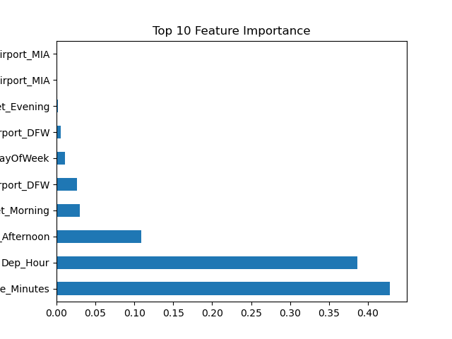

2. ROC Curve
Shows how good the model is at prediction.
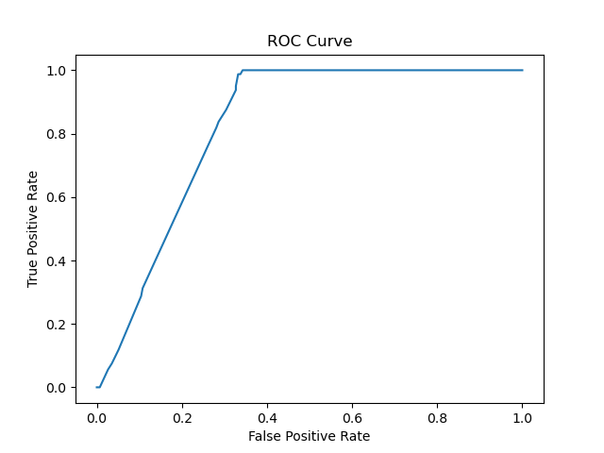

How to run the project

Step 1: Install libraries
pip install pandas numpy matplotlib scikit-learn streamlit joblib

Step 2: Train the model
python model.py
This will create:
- rf_model.pkl
- features.pkl

Step 3: Run the app
streamlit run app.py

How to use the app
- Select flight number
- Choose time
- Select day
- Click Predict
You will see:
- Delay probability
- Final result

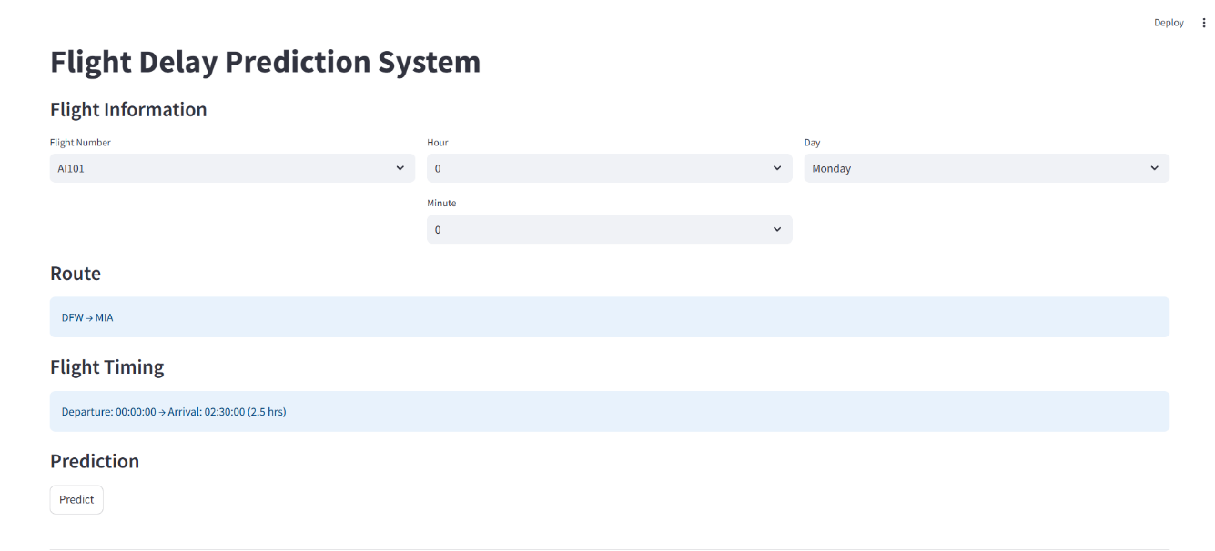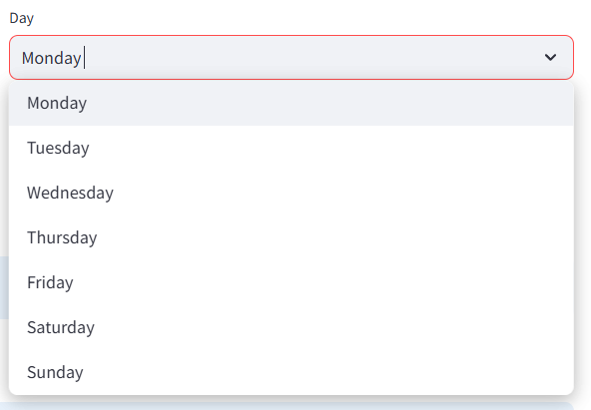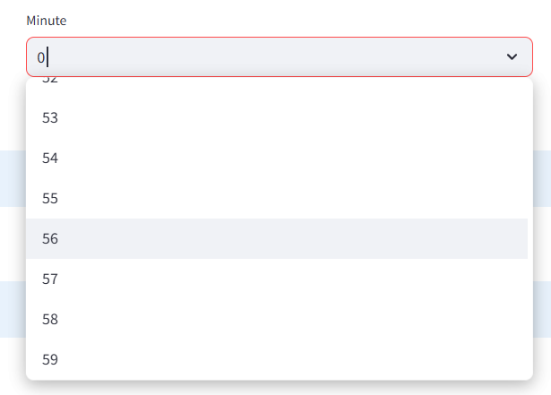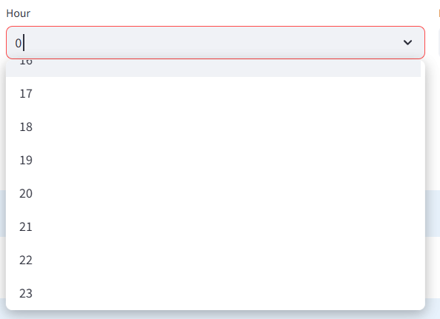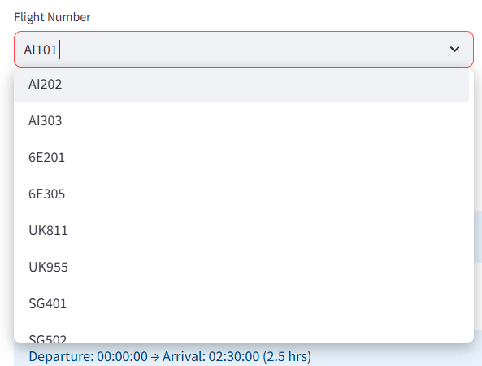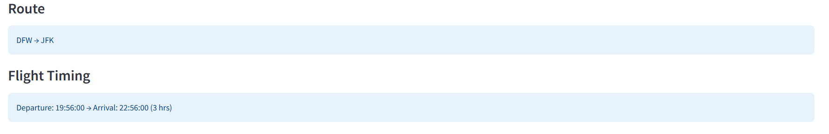
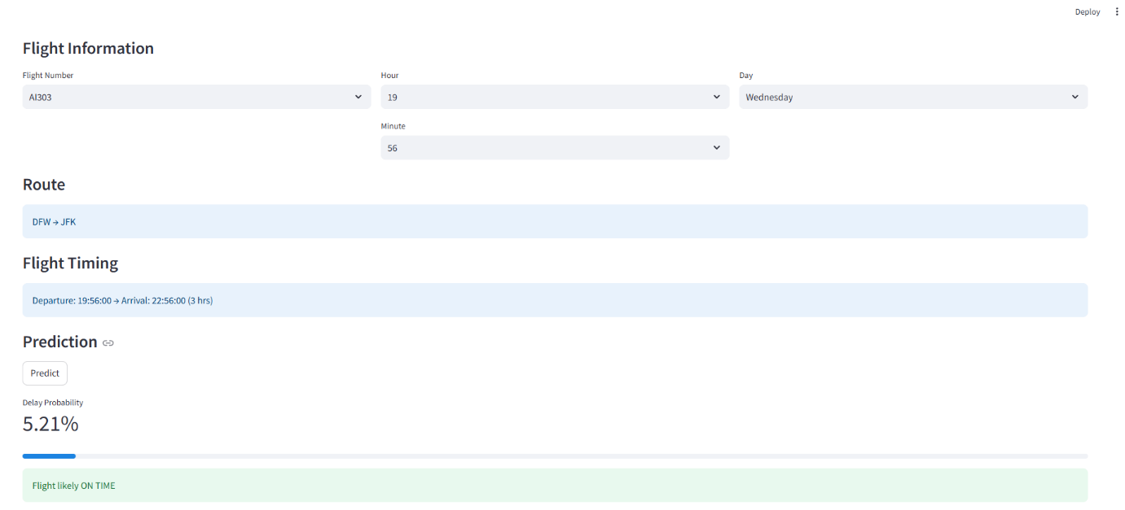

Example Output
- Delay Probability: 5.21%
- Result: On Time

Notes
- Works with limited flight routes
- Accuracy depends on dataset
- Can be improved by adding:
  - Weather data
  - Distance
  - Airline performance

Built With
- Python
- Machine Learning
- Streamlit

