Buying Car Insurance – Data Model Project

Overview
This repository contains a data modeling project for a Buying Car Insurance system, created using Oracle SQL Developer Data Modeler.
The project models the structure, relationships, and workflows involved in purchasing car insurance, including business processes, logical data structures, and mappings.

Key Components

1. Logical Model
- Defines entities such as customers, policies, vehicles, etc.
- Establishes relationships between them.
- Located in: logical/Logical.xml

2. Process Model (PM)
- Represents workflows like:
  - Insurance purchase process
  - Policy validation
  - Data flow between components
- Located in: pm/

3. Data Types
- Custom and structured data definitions used across the model
- Located in: datatypes/

4. Mapping
- Defines relationships between different layers of the model
- Located in: mapping/

Tools Used
- Oracle SQL Developer Data Modeler
- XML-based model configuration

How to Open the Project
- Install Oracle SQL Developer Data Modeler
- Open the application
- Go to:
File → Open
- Select the file:
Buying_Car_Insurance.dmd

Screenshots:

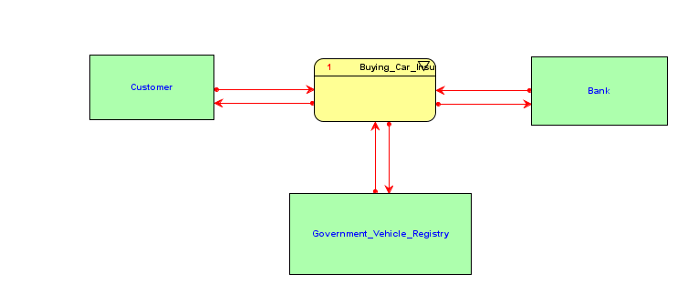
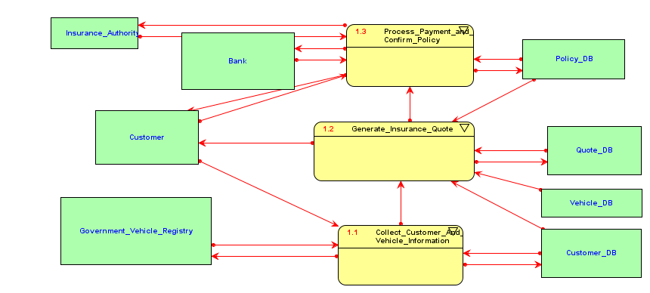

Purpose
This project is useful for:
- Understanding insurance system design
- Practicing data modeling concepts
- Learning process and data flow modeling
- Academic or training use

Notes
- .local files are tool-specific and may vary per environment
- XML files represent internal model structures—avoid manual editing unless necessary

License
This project is for educational purposes.

