Smart Commute Decision System (AI Logic-Based)

Overview
This project is a simple AI-powered decision-making system that helps users decide the best way to commute based on real-world conditions like weather, traffic, and events.
It uses propositional logic and model checking in Python, integrated with a PHP backend and a simple HTML frontend.

Screenshots
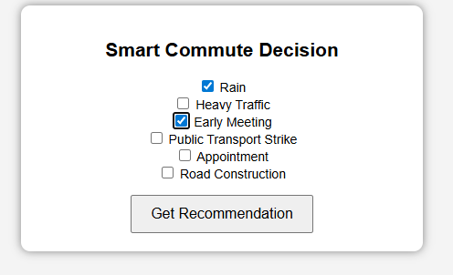

Features
- Logic-based AI decision engine
- Web interface using HTML & PHP
- Real-time recommendations:
  - Work From Home
  - Drive
  - Public Transport
- Handles multiple conditions:
  - Rain
  - Heavy Traffic
  - Early Meeting
  - Public Transport Strike
  - Appointment
  - Road Construction

Technologies Used
- Python – Logic engine & inference system
- PHP – Backend integration
- HTML/CSS – User interface
- XAMPP – Local server

How It Works
- User selects conditions from the web form
- PHP collects input and converts it into JSON
- Data is encoded and passed to Python
- Python applies logical rules using model checking
- Result is returned as JSON
- PHP displays the recommendation

Project Structure
decisionMaking/
decisionMaking.py # AI logic engine
run.php # Backend processor
index.html # User interface
README.md # Project documentation

How to Run

1. Start XAMPP
- Open XAMPP Control Panel
- Start Apache

2. Place project in:
C:\xampp\htdocs\gitworks\decisionMaking

3. Open in browser:
http://localhost/gitworks/decisionMaking/index.html

4. Use the app
- Select conditions
- Click Get Recommendation
- View AI results

Logic Rules Example
- If Rain OR Early Meeting → Work From Home
- If No Rain AND No Traffic → Drive
- If No Strike AND No Rain → Public Transport
- If Appointment → Drive
- If Road Construction → Avoid Driving

Example Output
Work From Home
Drive
Use Public Transport

Future Improvements
- Convert to Flask API (remove PHP dependency)
- Add UI enhancements (icons, colors)
- Add more intelligent rules
- Make mobile responsive

