RIDE IDE & Python in Robot
- RIDE
  - Installation
  - UI
  - Suite Structure
  - Library Importing
  - Writing Text Case

- Python in Robot
  - Writing a Python Library for Robot
  - Importing Custom Library
  - Using Python Function That Receives Argument and Returns Output
RIDE IDE
The Robot Framework IDE (RIDE) is the integrated development environment to implement automated tests for the Robot Framework. The Robot Framework is a generic test-automation framework. A quick overview on the Robot Framework is available from the following introduction slides.

Installation:

Preconditions
- Python
- wxPython
- Robot Framework

wxPython:
sudo python3 -m pip install https://extras.wxpython.org/wxPython4/extras/linux/gtk3/ubuntu-18.04/wxPython-4.0.7.post2-cp37-cp37m-linux_x86_64.whl

RIDE:
pip install robotframework-ride

Note: If wheel error, then have to download the development version of RIDE.

Development Version:
- Download from: https://github.com/robotframework/RIDE/archive/master.zip
- Unzip
- python setup.py install

User Interface:
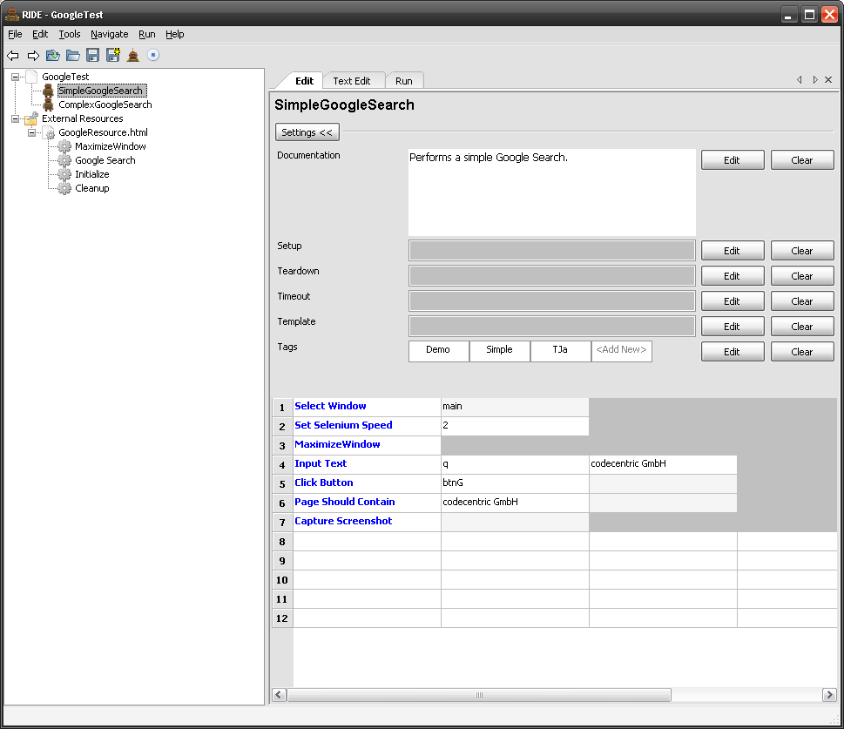

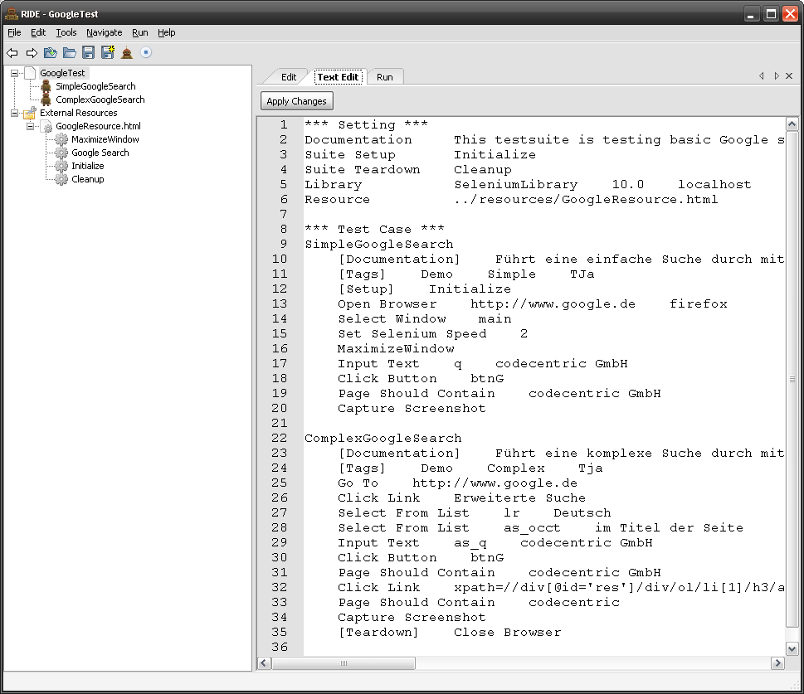

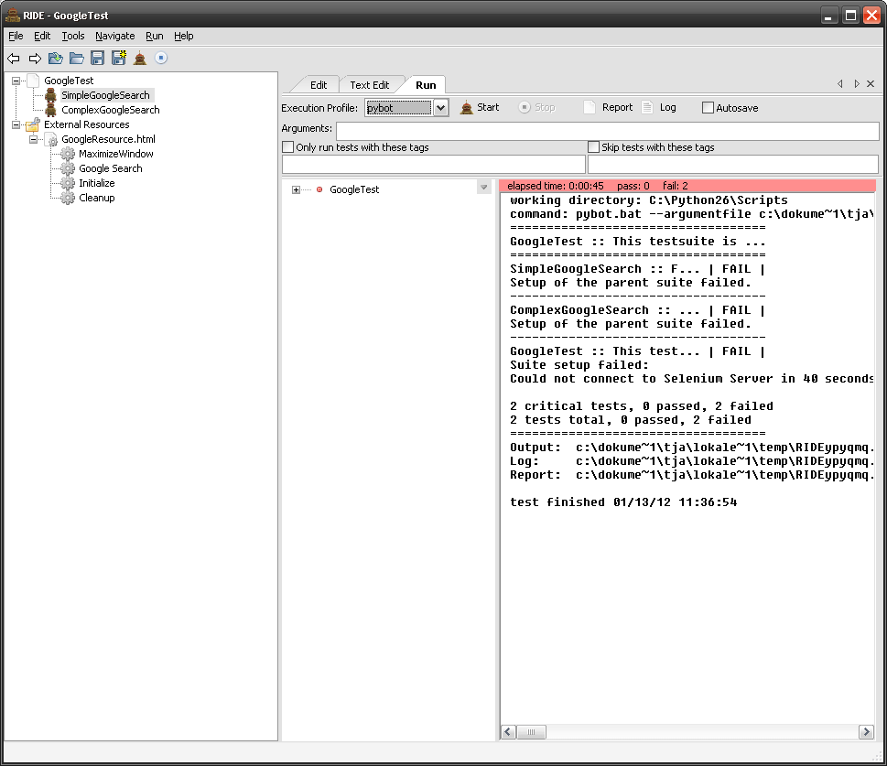

Directory and Suite Structure:
https://www.softwaretestinghelp.com/getting-started-with-robot-framework-ride/

Python in Robot
Writing a Python Library for Robot:

osLibrary.py
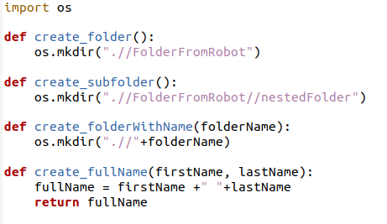

Importing Custom Library:
Library .//osLibrary.py

Using Keywords That Executes Python Function with Return:
