# APIs Documentation;

User registration API:

Validations: Validation rules are used here. We have 3 input field. First we ensure all the input fields are required. Then is the given email is in correct format and then is the given password is at least 6 character long.



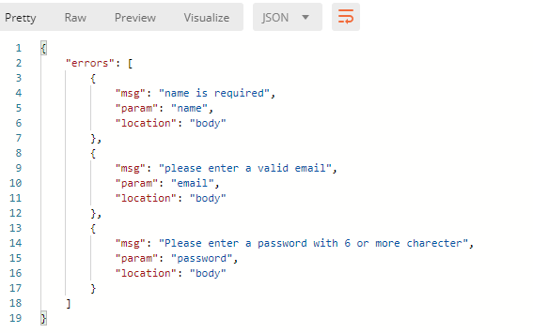

Fig 1.0: responses when all the user fields are empty.



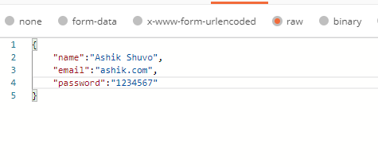

Fig 1.1: Request with invalid email.



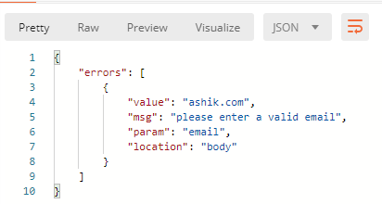

Fig 1.1.1: Respond with error message to put valid email.

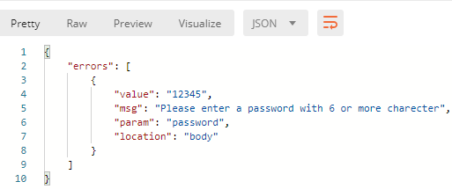

Fig 1.1.2: Respond with error message to put password with valid length.

Login API:  
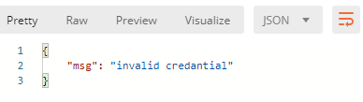

This is the response we get if we try to login with an email address which does not exist.

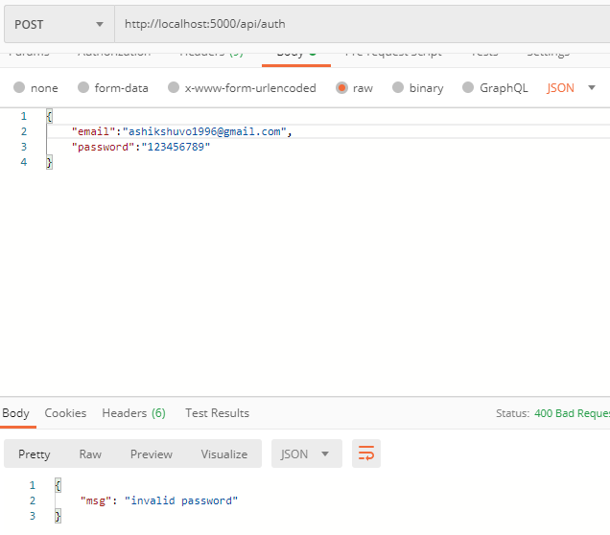

This is the error response if we try to login with incorrect password.

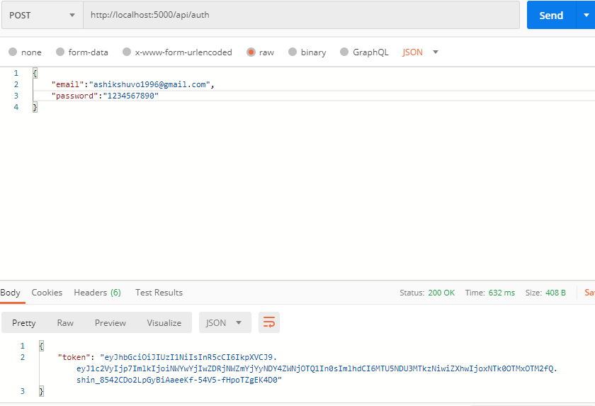

If we input correct password and email we get the jwt token as response.

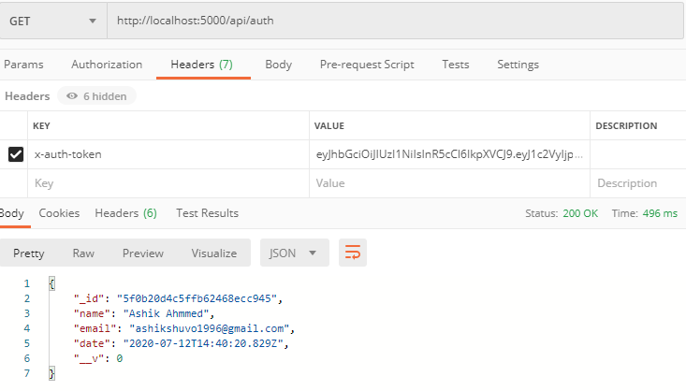

If we hit the middleware with the jwt token get user information as response without the password field.