**Front-End UI/UX Mini Project**

**1. Title Page**

* **Project Title**: *"University Department Info Page"*
* **Submitted By**: 
  + *Ashika Valencia A 2463072*
  + *Kotte Lavanya 2463035*
  + *Spoorthi Kumba 2463059*
* **Course**: *UI/UX Design Fundamentals*
* **Instructor Name***: Mr.Dhiraj*
* **Institution**: *Christ University*
* **Date of Submission**: *11/08/2025*

**2. Abstract**

The University Department Info Page is a responsive and interactive website designed to present comprehensive information about the Department of Artificial Intelligence & Machine Learning at ALS University. Built using only HTML and CSS, the site provides an engaging, user-friendly interface while maintaining the formal aesthetics expected of academic institutions. The website is structured into three core sections: Faculty Spotlight, Course Catalog, and Research Areas. The Faculty Spotlight section features expandable accordion panels that display detailed faculty profiles, implemented using the CSS checkbox hack to ensure interactivity without JavaScript. The Course Catalog organizes academic offerings into a responsive table with hover effects, making it easy to navigate and read across devices. The Research Areas section utilizes an icon-based grid to visually represent the department’s specializations, such as Artificial Intelligence, Deep Learning, and Machine Learning, allowing quick identification of focus domains. The project emphasizes consistent institutional branding through the use of the university’s official color palette and a balanced mix of modern design elements with academic professionalism. Its responsive design ensures compatibility with desktops, tablets, and smartphones, making it accessible to prospective students, researchers, and academic collaborators. By combining structured academic content with intuitive navigation and visually appealing layouts, the University Department Info Page serves as an effective digital gateway to the department’s offerings, achievements, and expertise.

**3. Objectives**

* Present academic content in a formal but visually engaging layout.
* Implement CSS-only interactivity through accordions for faculty bios.
* Organize course details in a responsive, hover-enhanced table.
* Represent research domains using icon-based visual cards.
* Maintain a consistent institutional color scheme for branding.

**4. Scope of the Project**

* Display detailed faculty profiles with expandable accordion sections for easy viewing.
* Provide a structured course catalog in a responsive table format with hover effects.
* Showcase the department’s research areas using an icon-based grid layout.
* Maintain institutional branding with a consistent academic-themed color scheme and design.
* Implement CSS-only interactivity for lightweight, fast-loading performance.
* Ensure responsive design for accessibility across desktops, tablets, and mobile devices.

**5. Tools & Technologies Used**

|  |  |
| --- | --- |
| Tool/Technology | Purpose |
| HTML5 | Markup and content structure |
| CSS3 | Styling and layout management |
| VS Code | Code editor |
| CSS Checkbox Hack | Interactions |

**6. HTML Structure Overview**

* Used semantic tags: <header>, <nav>, <main>, <section>, <footer>
* Structured into reusable sections: About, Projects, Contact
* Navigation menu using <ul> and anchor links for smooth scrolling

**7. CSS Styling Strategy**

* Used external CSS file (style.css)
* Organized with comments and sections
* Techniques used:
  + Flexbox and Grid for layout
  + Media Queries for responsiveness
  + CSS Variables for theme customization
  + Hover effects and transitions
  + Mobile-first design approach

**8. Key Features**

|  |  |
| --- | --- |
| Feature | Description |
| Responsive Design | Adapts seamlessly to all screen sizes |
| Smooth Navigation | Fixed top nav with anchor links |
| Project Cards | Flex-based layout with hover effects |
| Contact Form (non-functional) | Placeholder layout for inputs and button |
| Accessible Fonts & Colors | High contrast and readable typography |

**9. Challenges Faced & Solutions**

|  |  |
| --- | --- |
| Challenge | Solution |
| Overlapping elements on small screens | Used media queries to stack elements |
| Difficulty aligning items using float | Shifted to Flexbox and Grid |
| Typography scaling issue | Used relative units (em/rem) instead of px |

**10. Outcome**

* Achieved a clean, consistent, and visually engaging front-end layout
* All key components function as intended using just HTML and CSS
* Learned about layout responsiveness and UI hierarchy in depth

**11. Future Enhancements**

* Add JavaScript for interactivity (form validation, dynamic content)
* Integrate animations or transitions
* Backend integration for form submission
* Theme toggler (light/dark mode)

**12. Sample Code**

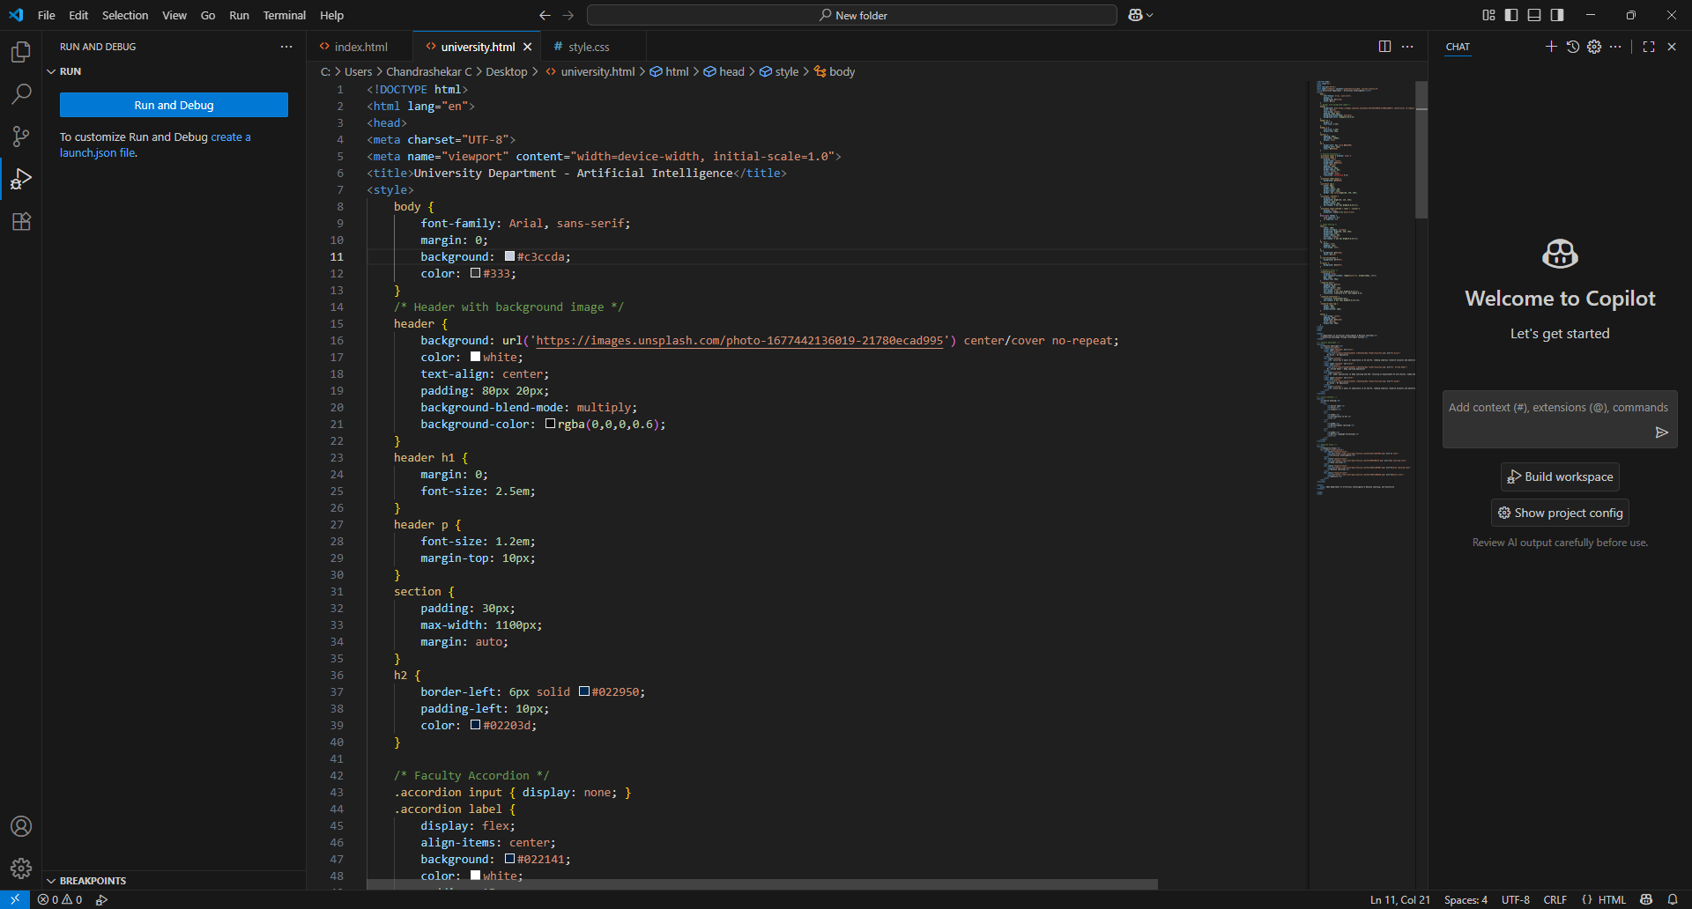

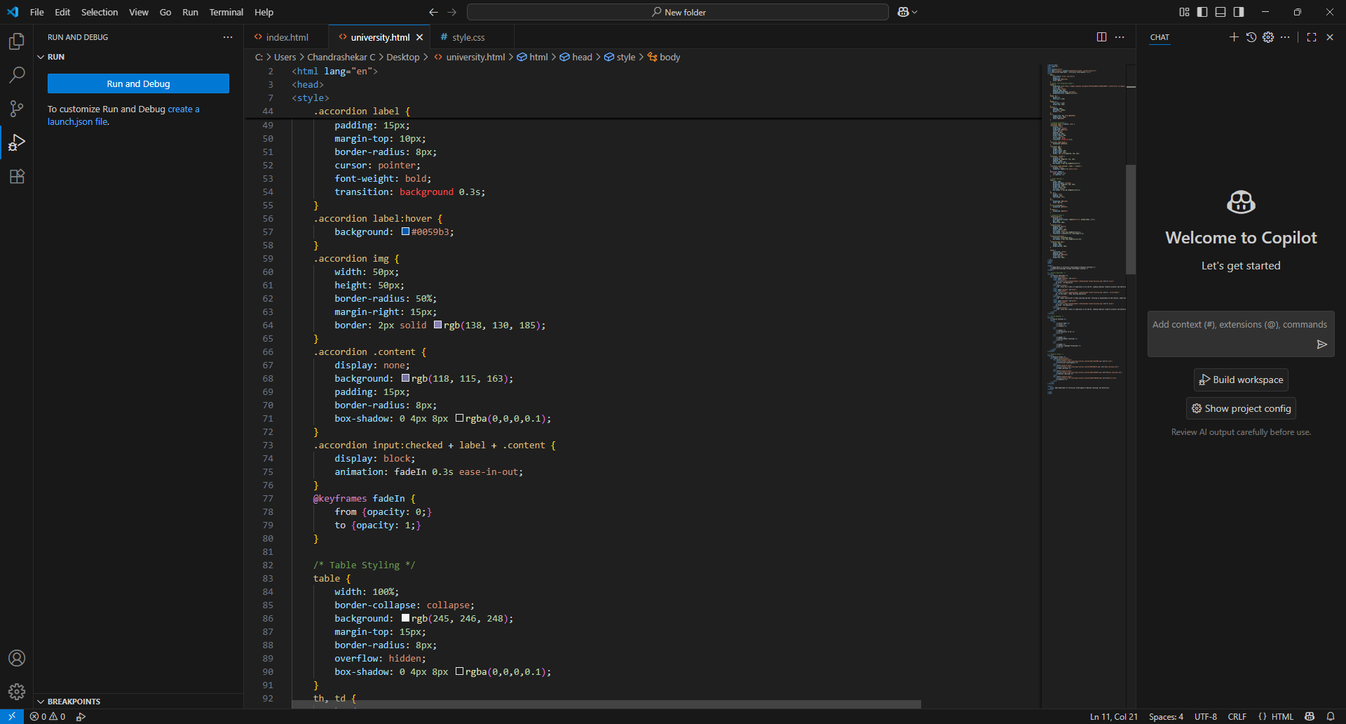

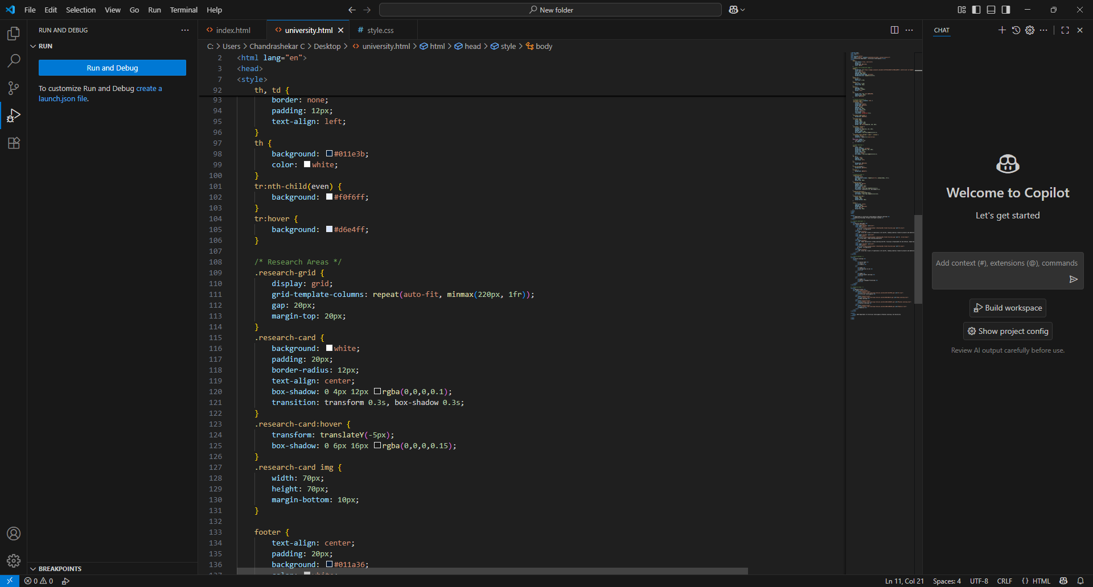

**13. Screenshots of Final Output**

Snip with faculty description:

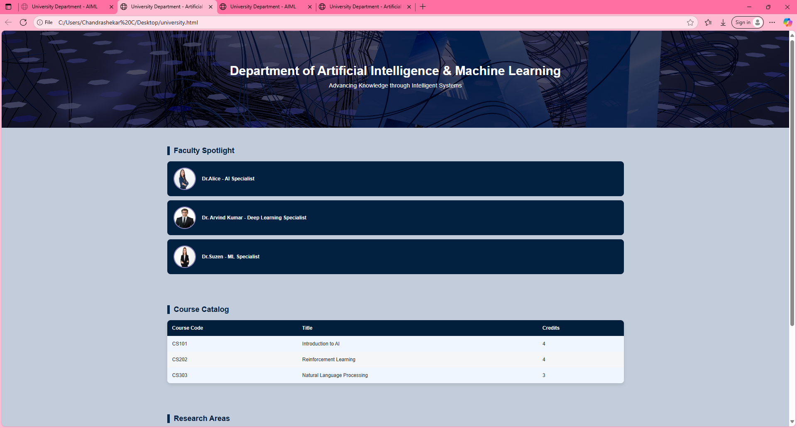

Subject Details &Research fields:

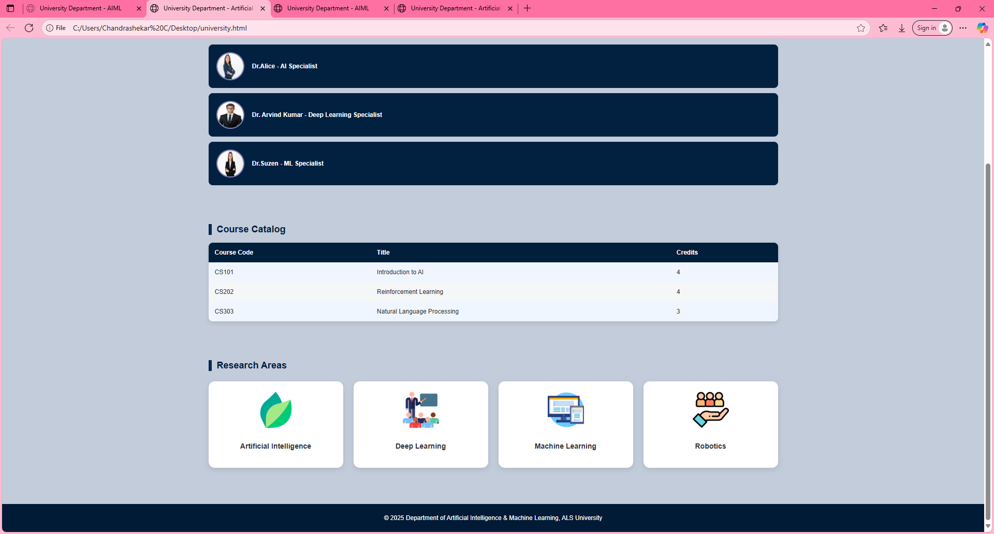

**11. Conclusion**

The University Department Info Page successfully demonstrates how structured academic content can be presented in a formal yet visually appealing manner using only HTML and CSS. Through features like CSS-only accordions, responsive tables, and icon-based research sections, the website meets both functional and aesthetic goals while adhering to an institutional branding style. The project highlights the effectiveness of clean, semantic markup combined with modern CSS techniques to achieve interactivity without JavaScript. Overall, it provides an accessible, responsive, and user-friendly platform for sharing departmental information with students, faculty, and visitors.

**12. References**

* L&T LMS : <https://learn.lntedutech.com/Landing/MyCourse>
* W3schools: https://www.w3schools.com/